Inferential report

# Total interactions

## By university

To compare the amount of post interactions across the different universities, we ran a quasi-poisson regression[1] using university as the sole predictor. The following table presents the regression results and indicates that several universities show significantly more interactions as compared to Ariel University.

z test of coefficients:  
  
 Estimate Std. Error z value Pr(>|z|)  
(Intercept) 5.135017 0.128358 40.0054 < 2.2e-16  
universityBar-Ilan University -0.257080 0.187984 -1.3676 0.17145  
universityBen-Gurion University 0.680747 0.282619 2.4087 0.01601  
universityReichman University -0.181260 0.209917 -0.8635 0.38787  
universityTechnion 1.104292 0.167707 6.5847 4.559e-11  
universityTel Aviv University 0.382124 0.368627 1.0366 0.29992  
universityThe Hebrew University 0.558599 0.284902 1.9607 0.04992  
universityThe Open University -0.228942 0.300834 -0.7610 0.44664  
universityUniversity of Haifa 1.232817 0.237782 5.1847 2.164e-07  
universityWeizmann Institute of Science 0.069417 0.343981 0.2018 0.84007  
   
(Intercept) ***  
universityBar-Ilan University   
universityBen-Gurion University *   
universityReichman University   
universityTechnion ***  
universityTel Aviv University   
universityThe Hebrew University *   
universityThe Open University   
universityUniversity of Haifa ***  
universityWeizmann Institute of Science   
---  
Signif. codes: 0 '***' 0.001 '**' 0.01 '*' 0.05 '.' 0.1 ' ' 1

To view the differences more clearly, we make and summarize predictions for post interactions according to university, and can clearly see that the University of Haifa gets the most engagement with their posts, while Bar-Ilan University gets the least.

university Estimate Pr(>|z|) S 2.5 % 97.5 %  
 Ariel University 170 <0.001 Inf 132.1 218  
 Bar-Ilan University 131 <0.001 915.4 100.4 172  
 Ben-Gurion University 336 <0.001 389.7 204.8 550  
 Reichman University 142 <0.001 646.8 102.3 196  
 Technion 513 <0.001 Inf 414.8 633  
 Tel Aviv University 249 <0.001 188.2 126.5 490  
 The Hebrew University 297 <0.001 366.3 180.4 489  
 The Open University 135 <0.001 239.1 79.3 230  
 University of Haifa 583 <0.001 735.4 393.7 863  
 Weizmann Institute of Science 182 <0.001 196.2 97.4 340  
  
Columns: rowid, university, estimate, p.value, s.value, conf.low, conf.high, rowid_dedup   
Type: invlink(link)

The graph makes these stark differences even more clear:

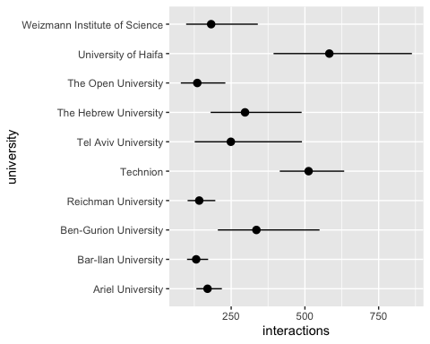

## By category

To compare the amount of post interactions across the different post categories, we ran a quasi-poisson regression using category as the sole predictor. The following table presents the regression results and shows that the category “Supporting our Troops and Hostages” receives more interactions that the rest.

z test of coefficients:  
  
 Estimate Std. Error z value  
(Intercept) 5.57350 0.13827 40.3080  
categoryUpdates and Instructions -0.81885 0.26541 -3.0853  
categoryAcademic Adjustments -0.78817 0.36956 -2.1327  
categorySupporting Our Troops and Hostages 0.54339 0.17639 3.0806  
categoryMarketing of Academic Programs -0.74747 0.17248 -4.3338  
 Pr(>|z|)   
(Intercept) < 2.2e-16 ***  
categoryUpdates and Instructions 0.002034 **   
categoryAcademic Adjustments 0.032950 *   
categorySupporting Our Troops and Hostages 0.002065 **   
categoryMarketing of Academic Programs 1.466e-05 ***  
---  
Signif. codes: 0 '***' 0.001 '**' 0.01 '*' 0.05 '.' 0.1 ' ' 1

To view the differences more clearly, we make and summarize predictions for post interactions according to post category.

category Estimate Pr(>|z|) S 2.5 % 97.5 %  
 Community Support 263 <0.001 Inf 200.8 345  
 Updates and Instructions 116 <0.001 322.5 74.5 181  
 Academic Adjustments 120 <0.001 144.8 61.2 234  
 Supporting Our Troops and Hostages 453 <0.001 Inf 365.9 562  
 Marketing of Academic Programs 125 <0.001 Inf 101.9 153  
  
Columns: rowid, category, estimate, p.value, s.value, conf.low, conf.high, rowid_dedup   
Type: invlink(link)

This information in graph form:

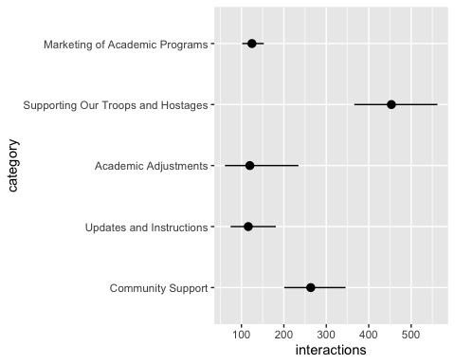

### Controlling for University

As we have established that there are differences in total interactions when comparing different universities, it is possible that the differences we observe across post categories are due to an imbalance in how many posts of each category are posted by each university. Using a quasi-poisson model that predicts total interactions and includes both category and university as predictors is one way to account for this potential imbalance. Model results are presented in the following table:

z test of coefficients:  
  
 Estimate Std. Error z value  
(Intercept) 4.932136 0.183933 26.8149  
universityBar-Ilan University -0.106083 0.169679 -0.6252  
universityBen-Gurion University 0.748608 0.283113 2.6442  
universityReichman University -0.101339 0.195940 -0.5172  
universityTechnion 1.195379 0.156290 7.6485  
universityTel Aviv University 0.559544 0.371460 1.5063  
universityThe Hebrew University 0.637223 0.276226 2.3069  
universityThe Open University -0.094731 0.292911 -0.3234  
universityUniversity of Haifa 1.205022 0.230383 5.2305  
universityWeizmann Institute of Science 0.473281 0.350500 1.3503  
categoryUpdates and Instructions -0.677766 0.240912 -2.8133  
categoryAcademic Adjustments -0.815685 0.365246 -2.2332  
categorySupporting Our Troops and Hostages 0.603493 0.173529 3.4778  
categoryMarketing of Academic Programs -0.584840 0.180418 -3.2416  
 Pr(>|z|)   
(Intercept) < 2.2e-16 ***  
universityBar-Ilan University 0.5318389   
universityBen-Gurion University 0.0081883 **   
universityReichman University 0.6050189   
universityTechnion 2.034e-14 ***  
universityTel Aviv University 0.1319812   
universityThe Hebrew University 0.0210610 *   
universityThe Open University 0.7463827   
universityUniversity of Haifa 1.690e-07 ***  
universityWeizmann Institute of Science 0.1769191   
categoryUpdates and Instructions 0.0049030 **   
categoryAcademic Adjustments 0.0255327 *   
categorySupporting Our Troops and Hostages 0.0005056 ***  
categoryMarketing of Academic Programs 0.0011886 **   
---  
Signif. codes: 0 '***' 0.001 '**' 0.01 '*' 0.05 '.' 0.1 ' ' 1

Most usefully, we can use the model to make predictions for all combinations of category and university, and summarise the predictions by category, averaging across all universities. Doing this, we see that the effect is slightly less pronounced, but the conclusion remains the same: posts in the category “Supporting Our Troops and Hostages” clearly receive more interactions.

category Estimate Pr(>|z|) S 2.5 % 97.5 %  
 Community Support 217.9 <0.001 Inf 166.2 286  
 Updates and Instructions 110.6 <0.001 391.2 74.3 165  
 Academic Adjustments 96.4 <0.001 134.6 49.5 188  
 Supporting Our Troops and Hostages 398.3 <0.001 Inf 319.7 496  
 Marketing of Academic Programs 121.4 <0.001 Inf 99.2 149  
  
Columns: category, estimate, p.value, s.value, conf.low, conf.high   
Type: invlink(link)

As a graph:

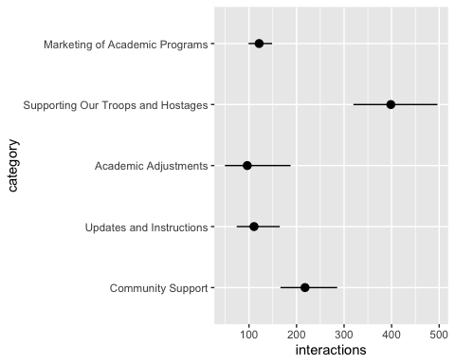

# Positive interactions

## By category

To compare the amount of positive interactions across the different post categories, we ran a quasi-poisson regression using category as the sole predictor. The following table presents the regression results and shows that the category “Supporting our Troops and Hostages” receives more positive interactions that the rest, but not significantly more than the baseline category “Community Support”.

z test of coefficients:  
  
 Estimate Std. Error z value  
(Intercept) 5.32211 0.14469 36.7817  
categoryUpdates and Instructions -0.75430 0.27869 -2.7066  
categoryAcademic Adjustments -0.71103 0.38669 -1.8388  
categorySupporting Our Troops and Hostages 0.23362 0.18134 1.2883  
categoryMarketing of Academic Programs -0.66642 0.17855 -3.7325  
 Pr(>|z|)   
(Intercept) < 2.2e-16 ***  
categoryUpdates and Instructions 0.0067969 **   
categoryAcademic Adjustments 0.0659461 .   
categorySupporting Our Troops and Hostages 0.1976426   
categoryMarketing of Academic Programs 0.0001896 ***  
---  
Signif. codes: 0 '***' 0.001 '**' 0.01 '*' 0.05 '.' 0.1 ' ' 1

To view the differences more clearly, we make and summarize predictions for post interactions according to post category.

category Estimate Pr(>|z|) S 2.5 % 97.5 %  
 Community Support 204.8 <0.001 981.4 154.2 272  
 Updates and Instructions 96.3 <0.001 269.9 60.4 154  
 Academic Adjustments 100.6 <0.001 123.3 49.8 203  
 Supporting Our Troops and Hostages 258.7 <0.001 Inf 208.8 321  
 Marketing of Academic Programs 105.2 <0.001 Inf 85.7 129  
  
Columns: rowid, category, estimate, p.value, s.value, conf.low, conf.high, rowid_dedup   
Type: invlink(link)

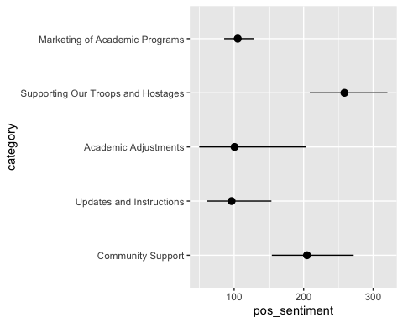

### Controlling for university

As above, we also run a model with university as an additional predictor and summarise predictions averaging over the different universities:

z test of coefficients:  
  
 Estimate Std. Error z value  
(Intercept) 4.449286 0.200454 22.1960  
universityBar-Ilan University -0.083817 0.173941 -0.4819  
universityBen-Gurion University 1.033824 0.279324 3.7012  
universityReichman University 0.099631 0.186655 0.5338  
universityTechnion 1.549612 0.167727 9.2389  
universityTel Aviv University 0.524705 0.202236 2.5945  
universityThe Hebrew University 0.883448 0.313256 2.8202  
universityThe Open University 0.145244 0.320016 0.4539  
universityUniversity of Haifa 1.418720 0.247812 5.7250  
universityWeizmann Institute of Science 0.743670 0.375815 1.9788  
categoryUpdates and Instructions -0.597734 0.252791 -2.3645  
categoryAcademic Adjustments -0.705080 0.378656 -1.8621  
categorySupporting Our Troops and Hostages 0.315753 0.178842 1.7655  
categoryMarketing of Academic Programs -0.473947 0.187681 -2.5253  
 Pr(>|z|)   
(Intercept) < 2.2e-16 ***  
universityBar-Ilan University 0.6298982   
universityBen-Gurion University 0.0002146 ***  
universityReichman University 0.5934992   
universityTechnion < 2.2e-16 ***  
universityTel Aviv University 0.0094724 **   
universityThe Hebrew University 0.0047991 **   
universityThe Open University 0.6499268   
universityUniversity of Haifa 1.034e-08 ***  
universityWeizmann Institute of Science 0.0478362 *   
categoryUpdates and Instructions 0.0180527 *   
categoryAcademic Adjustments 0.0625948 .   
categorySupporting Our Troops and Hostages 0.0774728 .   
categoryMarketing of Academic Programs 0.0115608 *   
---  
Signif. codes: 0 '***' 0.001 '**' 0.01 '*' 0.05 '.' 0.1 ' ' 1

category Estimate Pr(>|z|) S 2.5 % 97.5 %  
 Community Support 160.9 <0.001 887.6 121.0 214  
 Updates and Instructions 88.5 <0.001 325.9 58.4 134  
 Academic Adjustments 79.5 <0.001 116.0 39.9 158  
 Supporting Our Troops and Hostages 220.6 <0.001 Inf 178.5 273  
 Marketing of Academic Programs 100.2 <0.001 Inf 81.8 123  
  
Columns: category, estimate, p.value, s.value, conf.low, conf.high   
Type: invlink(link)

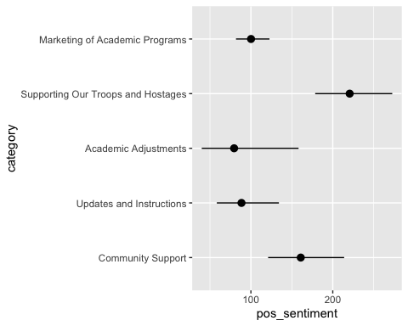

# Negative interactions

## By category

To compare the amount of negative interactions across the different post categories, we ran a quasi-poisson regression using category as the sole predictor. The following table presents the regression results and shows that the category “Supporting our Troops and Hostages” receives more negative interactions that the rest.

z test of coefficients:  
  
 Estimate Std. Error z value  
(Intercept) 2.12744 0.44194 4.8138  
categoryUpdates and Instructions -1.82669 0.82750 -2.2075  
categoryAcademic Adjustments -2.09108 0.58047 -3.6024  
categorySupporting Our Troops and Hostages 2.70355 0.46186 5.8536  
categoryMarketing of Academic Programs -1.60371 0.63415 -2.5289  
 Pr(>|z|)   
(Intercept) 1.481e-06 ***  
categoryUpdates and Instructions 0.0272808 *   
categoryAcademic Adjustments 0.0003153 ***  
categorySupporting Our Troops and Hostages 4.810e-09 ***  
categoryMarketing of Academic Programs 0.0114412 *   
---  
Signif. codes: 0 '***' 0.001 '**' 0.01 '*' 0.05 '.' 0.1 ' ' 1

To view the differences more clearly, we make and summarize predictions for negative interactions according to post category.

category Estimate Pr(>|z|) S 2.5 % 97.5 %  
 Community Support 8.39 <0.001 19.4 3.530 19.96  
 Updates and Instructions 1.35 0.667 0.6 0.343 5.32  
 Academic Adjustments 1.04 0.923 0.1 0.496 2.17  
 Supporting Our Troops and Hostages 125.34 <0.001 940.8 96.355 163.03  
 Marketing of Academic Programs 1.69 0.249 2.0 0.692 4.12  
  
Columns: rowid, category, estimate, p.value, s.value, conf.low, conf.high, rowid_dedup   
Type: invlink(link)

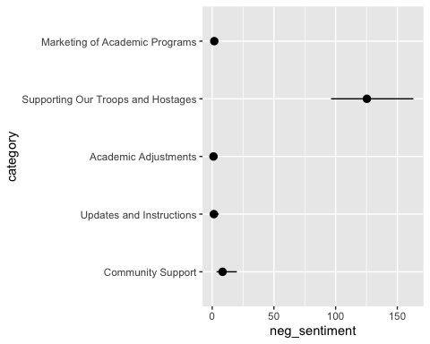

### Controlling for university

As above, we also run a model with university as an additional predictor and summarise predictions averaging over the different universities:

z test of coefficients:  
  
 Estimate Std. Error z value  
(Intercept) 2.290848 0.474778 4.8251  
universityBar-Ilan University -0.025546 0.255519 -0.1000  
universityBen-Gurion University -0.574650 0.697271 -0.8241  
universityReichman University -0.515211 0.358417 -1.4375  
universityTechnion 0.234537 0.414901 0.5653  
universityTel Aviv University 0.302404 0.592015 0.5108  
universityThe Hebrew University -0.280187 0.412927 -0.6785  
universityThe Open University -1.057492 0.698936 -1.5130  
universityUniversity of Haifa 0.052845 0.356712 0.1481  
universityWeizmann Institute of Science -0.658726 0.603874 -1.0908  
categoryUpdates and Instructions -1.813210 0.823610 -2.2015  
categoryAcademic Adjustments -2.192517 0.605912 -3.6185  
categorySupporting Our Troops and Hostages 2.645298 0.466689 5.6682  
categoryMarketing of Academic Programs -1.630002 0.629911 -2.5877  
 Pr(>|z|)   
(Intercept) 1.399e-06 ***  
universityBar-Ilan University 0.9203615   
universityBen-Gurion University 0.4098595   
universityReichman University 0.1505871   
universityTechnion 0.5718812   
universityTel Aviv University 0.6094879   
universityThe Hebrew University 0.4974301   
universityThe Open University 0.1302791   
universityUniversity of Haifa 0.8822286   
universityWeizmann Institute of Science 0.2753456   
categoryUpdates and Instructions 0.0276979 *   
categoryAcademic Adjustments 0.0002963 ***  
categorySupporting Our Troops and Hostages 1.443e-08 ***  
categoryMarketing of Academic Programs 0.0096627 **   
---  
Signif. codes: 0 '***' 0.001 '**' 0.01 '*' 0.05 '.' 0.1 ' ' 1

category Estimate Pr(>|z|) S 2.5 % 97.5 %  
 Community Support 7.680 <0.001 18.3 3.260 18.10  
 Updates and Instructions 1.253 0.748 0.4 0.316 4.97  
 Academic Adjustments 0.857 0.717 0.5 0.373 1.97  
 Supporting Our Troops and Hostages 108.196 <0.001 648.8 79.566 147.13  
 Marketing of Academic Programs 1.505 0.381 1.4 0.603 3.75  
  
Columns: category, estimate, p.value, s.value, conf.low, conf.high   
Type: invlink(link)

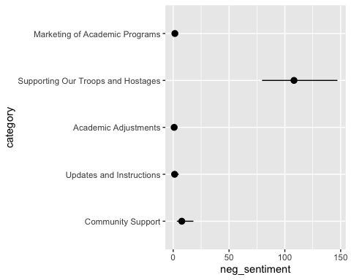

1. One of the standard ways to analyze count outcomes (such as the number of interactions with a post).