Demonstration code: Parvovirus time-series analysis in R

V Brookes, M Ward, R Iglesias

24 October 2019

# Time-series analysis of the parvovirus dataset

First, load the required packages (libraries).

To manipulate and plot the data:

# Chunk 2 ----  
  
library(ggplot2)  
library(plyr)  
library(dplyr)

##   
## Attaching package: 'dplyr'

## The following objects are masked from 'package:plyr':  
##   
## arrange, count, desc, failwith, id, mutate, rename, summarise,  
## summarize

## The following objects are masked from 'package:stats':  
##   
## filter, lag

## The following objects are masked from 'package:base':  
##   
## intersect, setdiff, setequal, union

library(lubridate)

##   
## Attaching package: 'lubridate'

## The following object is masked from 'package:plyr':  
##   
## here

## The following object is masked from 'package:base':  
##   
## date

To conduct time-series analyses and read the data from github:

# Chunk 3 ----  
  
library(tseries)  
library(vars)

## Loading required package: MASS

##   
## Attaching package: 'MASS'

## The following object is masked from 'package:dplyr':  
##   
## select

## Loading required package: strucchange

## Loading required package: zoo

##   
## Attaching package: 'zoo'

## The following objects are masked from 'package:base':  
##   
## as.Date, as.Date.numeric

## Loading required package: sandwich

## Loading required package: urca

## Loading required package: lmtest

library(forecast)  
library(RCurl)

## Loading required package: bitops

##   
## Attaching package: 'RCurl'

## The following object is masked from 'package:lmtest':  
##   
## reset

Now load the parvo dataset, and inspect it using the summary, str, head and tail functions:

# Chunk 4 ----  
  
dataSource_CPV = getURL("https://raw.githubusercontent.com/vbrookes/Timeseries_analysis/master/Parvo_TS_clean.csv")  
ParvoD <- read.csv(text = dataSource_CPV, header = T)  
summary(ParvoD)

## Case.ID Case.Date Day Week   
## Min. : 1 26/11/2012: 10 Min. : 1.0 Min. : 1.0   
## 1st Qu.: 2882 17/01/2011: 9 1st Qu.: 418.0 1st Qu.: 59.0   
## Median : 6990 5/11/2010 : 9 Median : 920.0 Median :131.0   
## Mean : 8220 12/05/2010: 8 Mean : 949.7 Mean :135.3   
## 3rd Qu.:13372 19/05/2010: 8 3rd Qu.:1459.0 3rd Qu.:208.0   
## Max. :20245 25/11/2013: 8 Max. :2218.0 Max. :316.0   
## (Other) :2935   
## Cases Events   
## Min. : 1.0 Min. :1   
## 1st Qu.: 1.0 1st Qu.:1   
## Median : 1.0 Median :1   
## Mean : 1.2 Mean :1   
## 3rd Qu.: 1.0 3rd Qu.:1   
## Max. :13.0 Max. :1   
##

str(ParvoD)

## 'data.frame': 2987 obs. of 6 variables:  
## $ Case.ID : int 1 693 695 697 46 632 3 4 701 5 ...  
## $ Case.Date: Factor w/ 1423 levels "1/02/2010","1/02/2011",..: 1261 1261 1410 174 396 448 818 865 865 40 ...  
## $ Day : int 1 1 4 7 12 13 20 21 21 27 ...  
## $ Week : int 1 1 1 1 2 2 3 3 3 4 ...  
## $ Cases : int 1 1 1 1 1 1 1 1 1 1 ...  
## $ Events : int 1 1 1 1 1 1 1 1 1 1 ...

head(ParvoD)

## Case.ID Case.Date Day Week Cases Events  
## 1 1 6/10/2009 1 1 1 1  
## 2 693 6/10/2009 1 1 1 1  
## 3 695 9/10/2009 4 1 1 1  
## 4 697 12/10/2009 7 1 1 1  
## 5 46 17/10/2009 12 2 1 1  
## 6 632 18/10/2009 13 2 1 1

tail(ParvoD)

## Case.ID Case.Date Day Week Cases Events  
## 2982 20244 26/10/2015 2212 315 1 1  
## 2983 20150 26/10/2015 2212 315 1 1  
## 2984 20243 27/10/2015 2213 316 1 1  
## 2985 20183 28/10/2015 2214 316 1 1  
## 2986 20234 30/10/2015 2216 316 1 1  
## 2987 20245 1/11/2015 2218 316 2 1

Check for duplicated or missing data:

## Duplication  
# Chunk 5 ----  
  
which(duplicated(ParvoD)) # anyDuplicated() does the same thing

## integer(0)

AllCompleteData = unique(ParvoD) # Can check that the dataset is the same length  
  
#missing values in entire data set  
ParvoD$complete<-complete.cases(ParvoD) # shows you if there are missing values in the row. If row is complete=TRUE  
length(ParvoD$complete)

## [1] 2987

missingData <- ParvoD[which(ParvoD$complete == "FALSE"),]  
missingData

## [1] Case.ID Case.Date Day Week Cases Events complete   
## <0 rows> (or 0-length row.names)

Re-check your data, for example: How many observations are there? What are the data types of each column? Are they suitable for analysis?

Note that the column ‘Case.Date’ is a factor.

Convert it to date format, and find the minumum and maximum dates in the dataset. Also, add columns for week and month for aggregation purposes later in analysis:

# Chunk 6 ----  
  
length(ParvoD$complete) # total events

## [1] 2987

str(ParvoD)

## 'data.frame': 2987 obs. of 7 variables:  
## $ Case.ID : int 1 693 695 697 46 632 3 4 701 5 ...  
## $ Case.Date: Factor w/ 1423 levels "1/02/2010","1/02/2011",..: 1261 1261 1410 174 396 448 818 865 865 40 ...  
## $ Day : int 1 1 4 7 12 13 20 21 21 27 ...  
## $ Week : int 1 1 1 1 2 2 3 3 3 4 ...  
## $ Cases : int 1 1 1 1 1 1 1 1 1 1 ...  
## $ Events : int 1 1 1 1 1 1 1 1 1 1 ...  
## $ complete : logi TRUE TRUE TRUE TRUE TRUE TRUE ...

sum(ParvoD$Cases) # total cases

## [1] 3584

sum(ParvoD$Events) # total events

## [1] 2987

## Save Case.Date to Date in a new column, with as.Date format  
ParvoD$Date = as.Date(ParvoD$Case.Date, "%d/%m/%Y")  
  
## Remove rows with no date (this should also have been detected in the previous chunk of code).  
ParvoD <- subset(ParvoD,!(is.na(ParvoD["Date"]) ))  
  
## Add columns that are by week or month  
ParvoD$byWeek = cut(ParvoD$Date, breaks="1 week")   
ParvoD$byMonth = cut(ParvoD$Date, breaks="1 month")   
  
## find the minimum and maximum dates of observations  
min(ParvoD$Date, na.rm = T)

## [1] "2009-10-06"

max(ParvoD$Date, na.rm = T)

## [1] "2015-11-01"

Summarise dataset by week and month, using ddply from the plyr package:

# Chunk 7 ----  
  
#### Aggregate data by week  
ParvoW = ddply(ParvoD, c("byWeek"), summarise,  
 Cases = sum(Cases),  
 Events = sum(Events))  
ParvoW$byWeek <- as.Date(ParvoW$byWeek, format = "%Y-%m-%d")  
str(ParvoW)

## 'data.frame': 315 obs. of 3 variables:  
## $ byWeek: Date, format: "2009-10-05" "2009-10-12" ...  
## $ Cases : int 3 3 1 3 3 1 4 1 2 8 ...  
## $ Events: int 3 3 1 3 3 1 4 1 2 5 ...

summary(ParvoW)

## byWeek Cases Events   
## Min. :2009-10-05 Min. : 1.00 Min. : 1.000   
## 1st Qu.:2011-04-14 1st Qu.: 5.00 1st Qu.: 5.000   
## Median :2012-10-15 Median : 9.00 Median : 8.000   
## Mean :2012-10-15 Mean :11.38 Mean : 9.483   
## 3rd Qu.:2014-04-17 3rd Qu.:16.00 3rd Qu.:13.000   
## Max. :2015-10-26 Max. :45.00 Max. :30.000

ParvoM = ddply(ParvoD, c("byMonth"), summarise,  
 Cases = sum(Cases),  
 Events = sum(Events))  
ParvoM$byMonth <- as.Date(ParvoM$byMonth, format = "%Y-%m-%d")  
str(ParvoM)

## 'data.frame': 74 obs. of 3 variables:  
## $ byMonth: Date, format: "2009-10-01" "2009-11-01" ...  
## $ Cases : int 9 9 21 49 66 66 104 114 62 51 ...  
## $ Events : int 9 9 18 45 62 60 93 97 55 44 ...

summary(ParvoM)

## byMonth Cases Events   
## Min. :2009-10-01 Min. : 2.00 Min. : 1.00   
## 1st Qu.:2011-04-08 1st Qu.: 29.25 1st Qu.:22.00   
## Median :2012-10-16 Median : 43.00 Median :34.00   
## Mean :2012-10-15 Mean : 48.43 Mean :40.36   
## 3rd Qu.:2014-04-23 3rd Qu.: 66.00 3rd Qu.:54.50   
## Max. :2015-11-01 Max. :115.00 Max. :97.00

Now create a dummy time-series of weeks based on these time periods and merge with the time-series. This identifies weeks (or months) with no cases. Note that some time-series have many zero values at the time points.

# Chunk 8 ----  
  
# Create time sequence with 1 week intervals  
data.length <- length(ParvoW$byWeek)  
min.date = min(ParvoW$byWeek)  
max.date = max(ParvoW$byWeek)  
  
# Check length  
length(ParvoW$Events)

## [1] 315

all.dates <- seq(min.date, max.date, by="week")  
all.dates.frame <- data.frame(list(byWeek=all.dates)) # Make it into a data frame so that we can merge it   
  
# Merge data with weekly Parvo data  
ParvoW <- merge(all.dates.frame, ParvoW, all = T)  
# Change NAs to 0  
ParvoW$Cases[is.na(ParvoW$Cases)] <- 0  
ParvoW$Events[is.na(ParvoW$Events)] <- 0  
  
# summary  
summary(ParvoW)

## byWeek Cases Events   
## Min. :2009-10-05 Min. : 0.00 Min. : 0.000   
## 1st Qu.:2011-04-11 1st Qu.: 5.00 1st Qu.: 4.000   
## Median :2012-10-15 Median : 9.00 Median : 8.000   
## Mean :2012-10-15 Mean :11.31 Mean : 9.423   
## 3rd Qu.:2014-04-21 3rd Qu.:16.00 3rd Qu.:13.000   
## Max. :2015-10-26 Max. :45.00 Max. :30.000

# check structure  
str(ParvoW)

## 'data.frame': 317 obs. of 3 variables:  
## $ byWeek: Date, format: "2009-10-05" "2009-10-12" ...  
## $ Cases : num 3 3 1 3 0 3 1 4 1 2 ...  
## $ Events: num 3 3 1 3 0 3 1 4 1 2 ...

# Check length  
length(ParvoW$Events) # Note that in this dataset, there must be 2 weeks with 0 cases (because this is two weeks longer).

## [1] 317

We can also create a monthly times-series.

# Chunk 9 ----  
  
# Create time sequence with 1 month intervals  
data.lengthM <- length(ParvoM$byMonth)  
min.dateM = min(ParvoM$byMonth)  
max.dateM = max(ParvoM$byMonth)  
  
# Check length  
length(ParvoM$Cases)

## [1] 74

all.dates <- seq(min.dateM, max.dateM, by="month")  
all.dates.frame <- data.frame(list(byMonth=all.dates)) # Make it into a data frame so that we can merge it   
  
# Merge data with monthly Parvo data  
ParvoM <- merge(all.dates.frame, ParvoM, all = T)  
# Change NAs to 0  
ParvoM$Cases[which(is.na(ParvoM$Cases))] <- 0  
ParvoM$Events[which(is.na(ParvoM$Events))] <- 0  
  
# summary  
summary(ParvoM)

## byMonth Cases Events   
## Min. :2009-10-01 Min. : 2.00 Min. : 1.00   
## 1st Qu.:2011-04-08 1st Qu.: 29.25 1st Qu.:22.00   
## Median :2012-10-16 Median : 43.00 Median :34.00   
## Mean :2012-10-15 Mean : 48.43 Mean :40.36   
## 3rd Qu.:2014-04-23 3rd Qu.: 66.00 3rd Qu.:54.50   
## Max. :2015-11-01 Max. :115.00 Max. :97.00

# check structure  
str(ParvoM)

## 'data.frame': 74 obs. of 3 variables:  
## $ byMonth: Date, format: "2009-10-01" "2009-11-01" ...  
## $ Cases : num 9 9 21 49 66 66 104 114 62 51 ...  
## $ Events : num 9 9 18 45 62 60 93 97 55 44 ...

write.csv(ParvoM, 'D:/Users/vbrookes/Dropbox (Sydney Uni)/Parvo_timeseries/Parvo_Month.csv')  
# Check length  
length(ParvoM$Events)

## [1] 74

## Exploratory analysis

### Plot the weekly time-series

Here, we use ggplot. The following code is used to make the plots attractive and is a useful ‘publication-ready’ theme:

# Chunk 10 ----  
  
themeVB = theme(axis.text.x = element_text(colour = "black", angle = 90, hjust=1,vjust=0.5, size = 11),   
 axis.line = element_line(colour = "black"),   
 axis.text.y = element_text(colour = "black"),  
 axis.ticks = element_line(colour = "black"),  
 axis.title.y = element_text(vjust=1.5),  
 panel.grid.major = element_line(colour = "grey93"),  
 panel.grid.minor = element_line(colour = "white"),  
 panel.background = element_blank(),  
 legend.background = element_rect(colour = NA),   
 legend.key = element_rect(fill = 'transparent'))

The blue line is the smoothed number of cases with a shaded 95% confidence interval. You can change the smoothing method (here, we have used ‘auto’).

There seems to be an overall decreasing trend in the number of weekly reported cases. Seasonality is also possible but difficult to determine using this plot.

# Chunk 11 ----  
  
ggplot(ParvoW, aes(x = byWeek, y = Events, group = 1)) +  
 geom_bar(stat="identity", width = 0.5, colour = "black") +  
 stat_smooth(aes(y = Events), method='auto', level=0.95) +   
 themeVB +  
 scale_x_date() +  
 xlab("Year") +  
 ylab("Events")

## `geom_smooth()` using method = 'loess' and formula 'y ~ x'

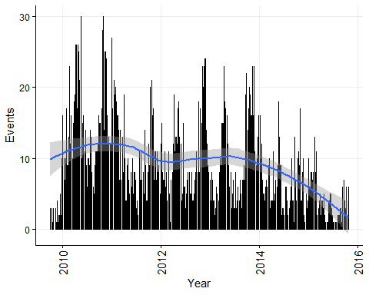

ggplot(ParvoM, aes(x = byMonth, y = Events, group = 1)) +  
 geom_bar(stat="identity", width = 0.5, colour = "black") +  
 stat_smooth(aes(y = Events), method='auto', level=0.95) +   
 themeVB +  
 scale_x_date() +  
 xlab("Year") +  
 ylab("Events")

## `geom_smooth()` using method = 'loess' and formula 'y ~ x'

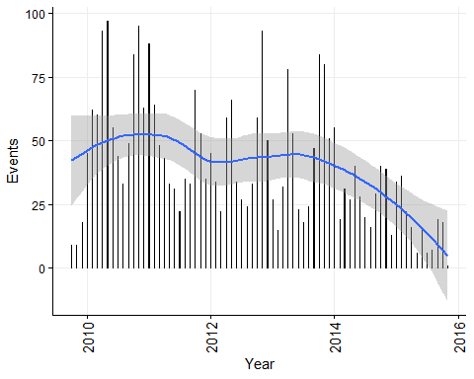

### Convert the data to an R recognised time-series

Here, we use the ts function from the stats package.

frequency = 52 is specified because there are 52 weeks (sort of) in a year.

# Chunk 12 ----  
  
Parvo_ts_data <- ts(ParvoW$Events, start = c(2009, 40), frequency =52)  
  
Parvo_ts_dataM <- ts(ParvoM$Events, start = c(2009, 10), frequency =12)

There are a decreasing number of events over time.

We can quantify this trend using linear regression with predictor variables for trend (by week or month per year) and seasonality (week or month)

The weekly change in the number of cases is -1.22 events/week/year (95% CI -1.57 - -0.87), confirming that the long-term trend is decreasing reported cases.

# Chunk 13 ----  
  
# Weekly ts dataset  
fit_Parvo_data = ts_all_model <- lm(Parvo_ts_data ~ time(Parvo_ts_data) + factor(cycle(Parvo_ts_data)))  
summary(fit_Parvo_data)

##   
## Call:  
## lm(formula = Parvo_ts_data ~ time(Parvo_ts_data) + factor(cycle(Parvo_ts_data)))  
##   
## Residuals:  
## Min 1Q Median 3Q Max   
## -17.2400 -2.8324 -0.1095 2.7762 14.9429   
##   
## Coefficients:  
## Estimate Std. Error t value Pr(>|t|)   
## (Intercept) 2474.6667 360.1895 6.870 4.59e-11 ***  
## time(Parvo_ts_data) -1.2229 0.1790 -6.833 5.74e-11 ***  
## factor(cycle(Parvo_ts_data))2 -1.6432 3.2057 -0.513 0.60868   
## factor(cycle(Parvo_ts_data))3 -3.6196 3.2057 -1.129 0.25988   
## factor(cycle(Parvo_ts_data))4 -3.0961 3.2057 -0.966 0.33503   
## factor(cycle(Parvo_ts_data))5 -2.4059 3.2058 -0.751 0.45362   
## factor(cycle(Parvo_ts_data))6 -5.7158 3.2058 -1.783 0.07574 .   
## factor(cycle(Parvo_ts_data))7 -4.8589 3.2058 -1.516 0.13080   
## factor(cycle(Parvo_ts_data))8 -2.5021 3.2058 -0.780 0.43581   
## factor(cycle(Parvo_ts_data))9 -5.1452 3.2058 -1.605 0.10970   
## factor(cycle(Parvo_ts_data))10 -4.1217 3.2059 -1.286 0.19969   
## factor(cycle(Parvo_ts_data))11 -7.2648 3.2059 -2.266 0.02426 *   
## factor(cycle(Parvo_ts_data))12 -3.7413 3.2059 -1.167 0.24427   
## factor(cycle(Parvo_ts_data))13 -5.0511 3.2060 -1.576 0.11633   
## factor(cycle(Parvo_ts_data))14 -1.0276 3.2060 -0.321 0.74882   
## factor(cycle(Parvo_ts_data))15 -0.6708 3.2061 -0.209 0.83444   
## factor(cycle(Parvo_ts_data))16 -1.6473 3.2061 -0.514 0.60784   
## factor(cycle(Parvo_ts_data))17 -1.1237 3.2062 -0.350 0.72625   
## factor(cycle(Parvo_ts_data))18 -0.9336 3.2063 -0.291 0.77115   
## factor(cycle(Parvo_ts_data))19 -1.5767 3.2063 -0.492 0.62331   
## factor(cycle(Parvo_ts_data))20 -1.2199 3.2064 -0.380 0.70392   
## factor(cycle(Parvo_ts_data))21 -4.8630 3.2065 -1.517 0.13056   
## factor(cycle(Parvo_ts_data))22 -3.5062 3.2065 -1.093 0.27520   
## factor(cycle(Parvo_ts_data))23 -3.9826 3.2066 -1.242 0.21534   
## factor(cycle(Parvo_ts_data))24 -6.9591 3.2067 -2.170 0.03088 *   
## factor(cycle(Parvo_ts_data))25 -4.9356 3.2068 -1.539 0.12497   
## factor(cycle(Parvo_ts_data))26 -7.2454 3.2069 -2.259 0.02468 *   
## factor(cycle(Parvo_ts_data))27 -9.7219 3.2070 -3.031 0.00268 **   
## factor(cycle(Parvo_ts_data))28 -8.0317 3.2071 -2.504 0.01287 *   
## factor(cycle(Parvo_ts_data))29 -8.3415 3.2072 -2.601 0.00982 **   
## factor(cycle(Parvo_ts_data))30 -5.6514 3.2073 -1.762 0.07922 .   
## factor(cycle(Parvo_ts_data))31 -6.4612 3.2074 -2.014 0.04497 *   
## factor(cycle(Parvo_ts_data))32 -7.9377 3.2075 -2.475 0.01396 *   
## factor(cycle(Parvo_ts_data))33 -7.9141 3.2076 -2.467 0.01425 *   
## factor(cycle(Parvo_ts_data))34 -7.5573 3.2077 -2.356 0.01921 *   
## factor(cycle(Parvo_ts_data))35 -7.8671 3.2079 -2.452 0.01484 *   
## factor(cycle(Parvo_ts_data))36 -4.5103 3.2080 -1.406 0.16092   
## factor(cycle(Parvo_ts_data))37 -5.9867 3.2081 -1.866 0.06313 .   
## factor(cycle(Parvo_ts_data))38 -6.4632 3.2083 -2.015 0.04496 *   
## factor(cycle(Parvo_ts_data))39 -0.4397 3.2084 -0.137 0.89110   
## factor(cycle(Parvo_ts_data))40 -3.2181 3.0894 -1.042 0.29853   
## factor(cycle(Parvo_ts_data))41 -3.9089 3.0895 -1.265 0.20691   
## factor(cycle(Parvo_ts_data))42 -2.0282 3.0895 -0.656 0.51209   
## factor(cycle(Parvo_ts_data))43 1.2810 3.0896 0.415 0.67875   
## factor(cycle(Parvo_ts_data))44 0.3045 3.0897 0.099 0.92156   
## factor(cycle(Parvo_ts_data))45 1.1452 3.2058 0.357 0.72121   
## factor(cycle(Parvo_ts_data))46 -0.4979 3.2058 -0.155 0.87668   
## factor(cycle(Parvo_ts_data))47 0.5256 3.2058 0.164 0.86990   
## factor(cycle(Parvo_ts_data))48 -0.2842 3.2058 -0.089 0.92941   
## factor(cycle(Parvo_ts_data))49 -5.0941 3.2058 -1.589 0.11325   
## factor(cycle(Parvo_ts_data))50 -5.7372 3.2057 -1.790 0.07465 .   
## factor(cycle(Parvo_ts_data))51 -5.8804 3.2057 -1.834 0.06773 .   
## factor(cycle(Parvo_ts_data))52 -5.1902 3.2057 -1.619 0.10663   
## ---  
## Signif. codes: 0 '***' 0.001 '**' 0.01 '*' 0.05 '.' 0.1 ' ' 1  
##   
## Residual standard error: 5.552 on 264 degrees of freedom  
## Multiple R-squared: 0.3429, Adjusted R-squared: 0.2135   
## F-statistic: 2.65 on 52 and 264 DF, p-value: 2.098e-07

confint(fit_Parvo_data)

## 2.5 % 97.5 %  
## (Intercept) 1765.456986 3183.8763478  
## time(Parvo_ts_data) -1.575252 -0.8704618  
## factor(cycle(Parvo_ts_data))2 -7.955196 4.6688959  
## factor(cycle(Parvo_ts_data))3 -9.931691 2.6924233  
## factor(cycle(Parvo_ts_data))4 -9.408192 3.2159579  
## factor(cycle(Parvo_ts_data))5 -8.718035 3.9061665  
## factor(cycle(Parvo_ts_data))6 -12.027884 0.5963824  
## factor(cycle(Parvo_ts_data))7 -11.171074 1.4532723  
## factor(cycle(Parvo_ts_data))8 -8.814272 3.8101694  
## factor(cycle(Parvo_ts_data))9 -11.457477 1.1670738  
## factor(cycle(Parvo_ts_data))10 -10.434022 2.1906521  
## factor(cycle(Parvo_ts_data))11 -13.577241 -0.9524290  
## factor(cycle(Parvo_ts_data))12 -10.053801 2.5711639  
## factor(cycle(Parvo_ts_data))13 -11.363702 1.2614307  
## factor(cycle(Parvo_ts_data))14 -7.340276 5.2850381  
## factor(cycle(Parvo_ts_data))15 -6.983525 5.6419862  
## factor(cycle(Parvo_ts_data))16 -7.960114 4.6656081  
## factor(cycle(Parvo_ts_data))17 -7.436710 5.1892374  
## factor(cycle(Parvo_ts_data))18 -7.246647 5.3795406  
## factor(cycle(Parvo_ts_data))19 -7.889924 4.7365177  
## factor(cycle(Parvo_ts_data))20 -7.533209 5.0935021  
## factor(cycle(Parvo_ts_data))21 -11.176501 1.4504937  
## factor(cycle(Parvo_ts_data))22 -9.819800 2.8074927  
## factor(cycle(Parvo_ts_data))23 -10.296440 2.3311655  
## factor(cycle(Parvo_ts_data))24 -13.273087 -0.6451543  
## factor(cycle(Parvo_ts_data))25 -11.249742 1.3785331  
## factor(cycle(Parvo_ts_data))26 -13.559737 -0.9311056  
## factor(cycle(Parvo_ts_data))27 -16.036406 -3.4074036  
## factor(cycle(Parvo_ts_data))28 -14.346416 -1.7170277  
## factor(cycle(Parvo_ts_data))29 -14.656432 -2.0266446  
## factor(cycle(Parvo_ts_data))30 -11.966456 0.6637458  
## factor(cycle(Parvo_ts_data))31 -12.776488 -0.1458565  
## factor(cycle(Parvo_ts_data))32 -14.253193 -1.6221182  
## factor(cycle(Parvo_ts_data))33 -14.229906 -1.5983727  
## factor(cycle(Parvo_ts_data))34 -13.873292 -1.2412865  
## factor(cycle(Parvo_ts_data))35 -14.183353 -1.5508598  
## factor(cycle(Parvo_ts_data))36 -10.826754 1.8062409  
## factor(cycle(Parvo_ts_data))37 -12.303495 0.3300155  
## factor(cycle(Parvo_ts_data))38 -12.780244 -0.1462027  
## factor(cycle(Parvo_ts_data))39 -6.757000 5.8775864  
## factor(cycle(Parvo_ts_data))40 -9.301169 2.8649790  
## factor(cycle(Parvo_ts_data))41 -9.992041 2.1743117  
## factor(cycle(Parvo_ts_data))42 -8.111491 4.0550805  
## factor(cycle(Parvo_ts_data))43 -4.802377 7.3644283  
## factor(cycle(Parvo_ts_data))44 -5.778985 6.3880693  
## factor(cycle(Parvo_ts_data))45 -5.167074 7.4574767  
## factor(cycle(Parvo_ts_data))46 -6.810169 5.8142719  
## factor(cycle(Parvo_ts_data))47 -5.786606 6.8377411  
## factor(cycle(Parvo_ts_data))48 -6.596382 6.0278843  
## factor(cycle(Parvo_ts_data))49 -11.406167 1.2180347  
## factor(cycle(Parvo_ts_data))50 -12.049291 0.5748590  
## factor(cycle(Parvo_ts_data))51 -12.192423 0.4316907  
## factor(cycle(Parvo_ts_data))52 -11.502229 1.1218629

# Monthly ts dataset  
fit_Parvo_dataM = ts_all_model <- lm(Parvo_ts_dataM ~ time(Parvo_ts_dataM) + factor(cycle(Parvo_ts_dataM)))  
summary(fit_Parvo_dataM)

##   
## Call:  
## lm(formula = Parvo_ts_dataM ~ time(Parvo_ts_dataM) + factor(cycle(Parvo_ts_dataM)))  
##   
## Residuals:  
## Min 1Q Median 3Q Max   
## -61.136 -8.408 -0.440 9.684 40.143   
##   
## Coefficients:  
## Estimate Std. Error t value Pr(>|t|)   
## (Intercept) 11640.477 2758.508 4.220 8.25e-05 ***  
## time(Parvo_ts_dataM) -5.760 1.371 -4.202 8.77e-05 ***  
## factor(cycle(Parvo_ts_dataM))2 -10.187 12.028 -0.847 0.4004   
## factor(cycle(Parvo_ts_dataM))3 -12.207 12.030 -1.015 0.3143   
## factor(cycle(Parvo_ts_dataM))4 5.107 12.033 0.424 0.6728   
## factor(cycle(Parvo_ts_dataM))5 2.087 12.036 0.173 0.8629   
## factor(cycle(Parvo_ts_dataM))6 -15.433 12.041 -1.282 0.2048   
## factor(cycle(Parvo_ts_dataM))7 -23.287 12.047 -1.933 0.0579 .   
## factor(cycle(Parvo_ts_dataM))8 -22.473 12.054 -1.864 0.0671 .   
## factor(cycle(Parvo_ts_dataM))9 -10.160 12.062 -0.842 0.4029   
## factor(cycle(Parvo_ts_dataM))10 4.440 11.595 0.383 0.7031   
## factor(cycle(Parvo_ts_dataM))11 5.777 11.599 0.498 0.6202   
## factor(cycle(Parvo_ts_dataM))12 -11.147 12.028 -0.927 0.3577   
## ---  
## Signif. codes: 0 '***' 0.001 '**' 0.01 '*' 0.05 '.' 0.1 ' ' 1  
##   
## Residual standard error: 20.83 on 61 degrees of freedom  
## Multiple R-squared: 0.3766, Adjusted R-squared: 0.254   
## F-statistic: 3.071 on 12 and 61 DF, p-value: 0.00193

confint(fit_Parvo_dataM)

## 2.5 % 97.5 %  
## (Intercept) 6124.499204 17156.4553418  
## time(Parvo_ts_dataM) -8.500586 -3.0188946  
## factor(cycle(Parvo_ts_dataM))2 -34.238596 13.8652191  
## factor(cycle(Parvo_ts_dataM))3 -36.261871 11.8484507  
## factor(cycle(Parvo_ts_dataM))4 -18.953980 29.1671835  
## factor(cycle(Parvo_ts_dataM))5 -21.981589 26.1547494  
## factor(cycle(Parvo_ts_dataM))6 -39.511363 8.6444796  
## factor(cycle(Parvo_ts_dataM))7 -47.376631 0.8030383  
## factor(cycle(Parvo_ts_dataM))8 -46.577392 1.6304221  
## factor(cycle(Parvo_ts_dataM))9 -34.280307 13.9599606  
## factor(cycle(Parvo_ts_dataM))10 -18.746145 27.6260150  
## factor(cycle(Parvo_ts_dataM))11 -17.416897 28.9710099  
## factor(cycle(Parvo_ts_dataM))12 -35.198552 12.9052624

### Decompose the time-series

The observed data is composed of trend, cycle, seasonal and random variation.

The function decompose is from the base package stats, and uses moving averages to smooth the time-series. We also demonstrate the function ‘stl’ from the stats package which uses loess smoothing.

The data are illustrated as follows:

Observed - the actual data.

Trend - the overall upward or downward movement of the data points. It is not necessarily linear.

Seasonal - any monthly/yearly pattern of the data points.

Random (remainder) - unexplainable part of the data.

# Chunk 14 ----  
  
# Weekly ts dataset  
Decompose_ts <- decompose(Parvo_ts_data)  
summary(Decompose_ts)

## Length Class Mode   
## x 317 ts numeric   
## seasonal 317 ts numeric   
## trend 317 ts numeric   
## random 317 ts numeric   
## figure 52 -none- numeric   
## type 1 -none- character

plot(Decompose_ts)

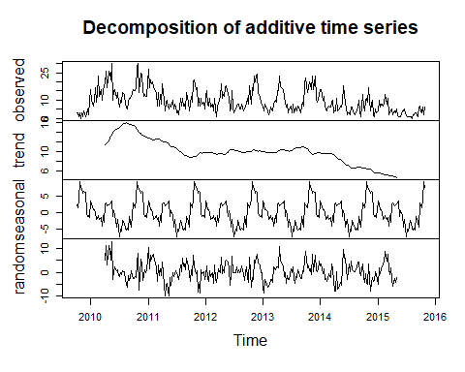

plot(Decompose_ts$trend + Decompose_ts$random, ylab = "trend + random components") # can also plot combinations

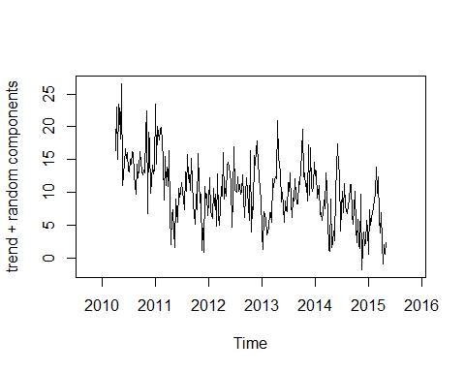

Decompose_ts_loess <- stl(Parvo_ts_data, s.window="periodic")  
plot(Decompose_ts_loess)

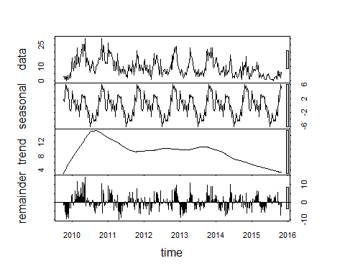

# Monthly ts dataset  
Decompose_tsM <- decompose(Parvo_ts_dataM)  
summary(Decompose_tsM)

## Length Class Mode   
## x 74 ts numeric   
## seasonal 74 ts numeric   
## trend 74 ts numeric   
## random 74 ts numeric   
## figure 12 -none- numeric   
## type 1 -none- character

plot(Decompose_tsM)

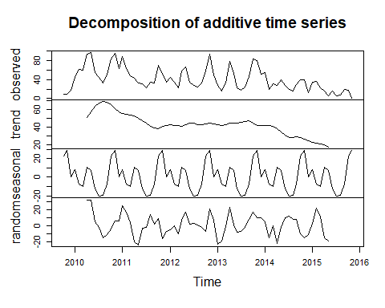

Decompose_ts_loessM <- stl(Parvo_ts_dataM, s.window="periodic")  
plot(Decompose_ts_loessM)

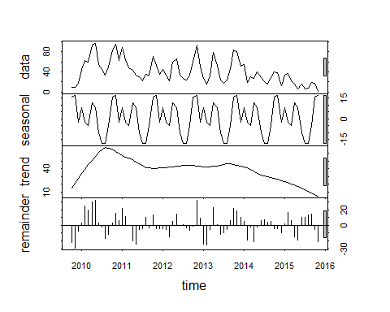

## There looks like seasonality. Add a week and month column to ParvoW to investigate further  
ParvoW$Year = year(ParvoW$byWeek)  
ParvoW$Week = week(ParvoW$byWeek)  
ParvoW$Month = month(ParvoW$byWeek)  
  
ggplot(ParvoW, aes(y=Events, x = Week)) + geom_boxplot(aes(group=Week), fill = 'grey90') + themeVB

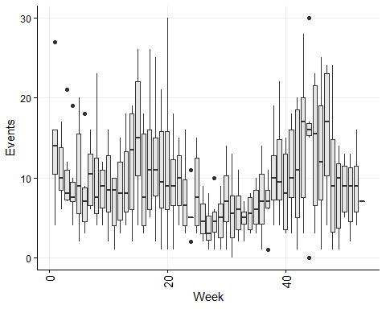

ggplot(ParvoW, aes(y=Events, x = Month)) + geom_boxplot(aes(group=Month), fill = 'grey90') + themeVB

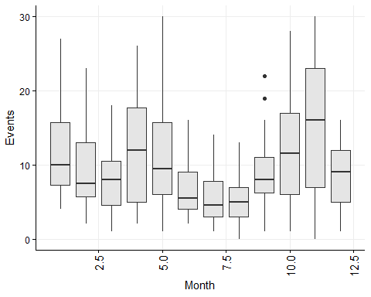

ggplot(ParvoW, aes(y=Events, x = Year)) + geom_boxplot(aes(group=Year), fill = 'grey90') + themeVB

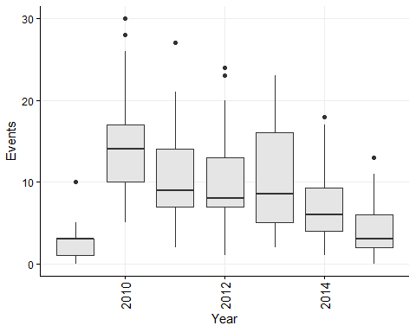

Given the apparent seasonality in both the weekly and monthly time-series, it is interesting to visually compare the two seasonal plots from the ‘decomposed’ data.

# Chunk 15 ----  
  
### Compare the seasonality plots  
  
plot(Decompose_tsM$seasonal)   
lines(Decompose_ts$seasonal, col = 'red')

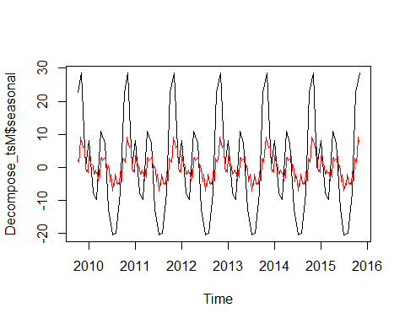

# Time-series analysis using autoregressive models

In this example, we fit an ARIMA model. ARIMA is an abbreviation for ‘AutoRegressive Integrated Moving Average’.

Auto Regressive (AR) terms refer to the number of lagged values in the model. In the non-seasonal part of the model, the order of lagged values is termed ‘p’, and in the seasonal part of the model the order of lagged values is termed ‘P’.

Moving Average (MA) terms refer to the number of lagged errors in the model. In the non-seasonal part of the model, the order of lagged errors is termed ‘q’, and in the seasonal part of the model the order of lagged errors is termed ‘Q’.

Integration (I) terms refer to the number of difference used to make the time series stationary. In the non-seasonal part of the model, the order of differences is termed ‘d’, and in the seasonal part of the model the order of differences is termed ‘D’.

Overall, the model includes the following variables:

ARIMA: (p, d, q) (P, D, Q)m

where m refers to the number of observations in a seasonal cycle.

#### Assumptions of ARIMA models

Data should be stationary - this means that the properties of the series do not depend on the time when it is captured, i.e. trend and seasonality are removed to leave ‘white-noise’. Note that a series with cyclic behaviour can also be considered stationary because cyclic behaviours have unpredictable wavelengths. A stationary series will have constant variance (see below)

#### Steps to be followed for ARIMA modeling:

1. Exploratory analysis - to determine values for (p, d, q) (P, D, Q)m
2. Fit the model
3. Diagnostic measures to assess model fit

## 1. Exploratory analysis for ARIMA modelling

We start by assessing the need for differencing to determine values for d and D.

### Tests for stationarity (is there a need to ‘first difference’ the data?)

It is important that the data to which the ARIMA model is fitted are stationary. Observations in a non-stationary time-series demonstrate structure that is dependent on the time index. Inducing stationarity means removing trend, seasonality and possibly cyclicity (if it is predictable).

There are several methods to check for stationarity:

1. View plots of time-series for obvious trend, or examine the autocorrelation function (ACF) plots. There should be little autocorrelation in stationary data, so an ACF plot should decrease to zero rapidly, and stay at zero.
2. Summary statistics Check for significant differences in mean and variance between sections of data. We do not demonstrate this in the current study because these are starighforward statistical tests.
3. Statistical tests These tests determine whether the expectations of stationarity are met or violated.

In our example dataset, we initially re-examine the time series and examine an ACF plot of the weekly and monthly events. We observe decreasing trend and the ACF plot demonstrates that there is autocorrelation for 10 and 2 lags in the weekly and monthly series, respectively. These time-series are not stationary.

We then run ndiffs from the forecast package to assess how many first differences are needed to induce stationarity. ndiffs suggests 1 first difference for each time series. After differencing the data, the time-series plots appears level (no trend) and the ACF plots show limited autocorrelation (one lag) in the first few lags.

# Chunk 16 ----  
  
## Tests for stationarity  
# Weekly data  
Parvo_ts_data %>% ggtsdisplay(theme = themeVB)

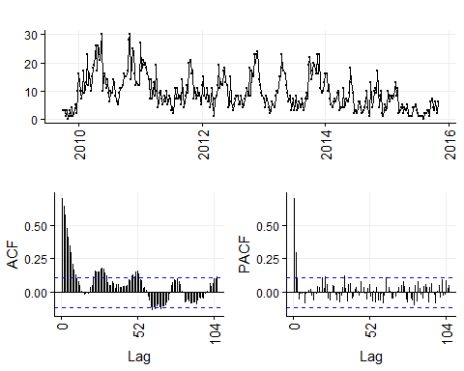

ndiffs(Parvo_ts_data) # 1 difference estimated to induce stationarity

## [1] 1

nsdiffs(Parvo_ts_data) # No differencing required to induce stationarity

## [1] 0

Parvo_ts_data %>% diff() %>% ggtsdisplay(theme = themeVB) # Assess differenced ts and ACF and PACF plots.

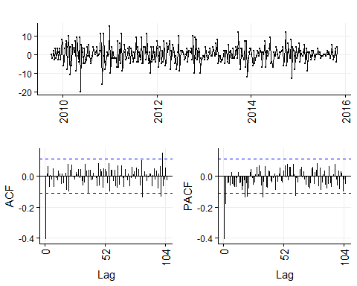

# Monthly data  
Parvo_ts_dataM %>% ggtsdisplay(theme = themeVB)

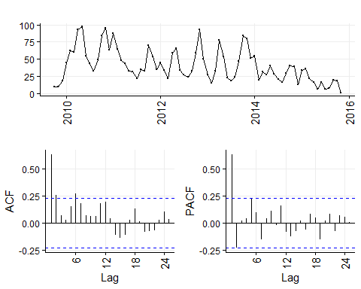

ndiffs(Parvo_ts_dataM) # 1 difference estimated to induce stationarity

## [1] 1

nsdiffs(Parvo_ts_dataM) # No differencing required to induce stationarity

## [1] 0

Parvo_ts_dataM %>% diff() %>% ggtsdisplay(theme = themeVB) # Assess differenced ts and ACF and PACF plots.

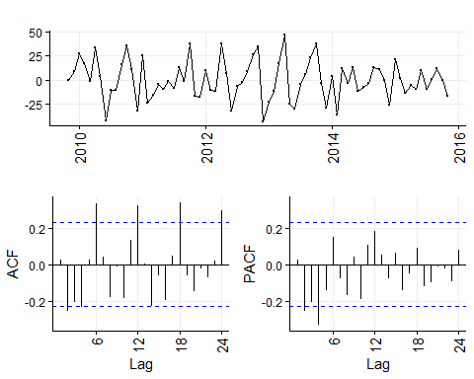

We further check for stationarity in the time-series using statisical tests. [This website](https://rpubs.com/richkt/269797) is a useful resource.

Frequently used tests include:

1. Ljung-Box test for independence (Null hypothesis = time independance in a given period of lags. A low P value suggests that the data are not consistent with independance)
2. Augmented Dickey-Fuller (ADF) t-statistic test for unit root (note that a series with a trend line will have a unit root and result in a large P value, i.e. the null hypothesis is that there is a unit root present.)
3. Kwiatkowski-Phillips-Schmidt-Shin (KPSS) for level or trend stationarity (null hypothesis is that the time-series is stationary).

# Chunk 17 ----  
  
## Weekly time-series tests for stationarity  
# 1.   
Box.test(Parvo_ts_data, lag = 52, type="Ljung-Box")

##   
## Box-Ljung test  
##   
## data: Parvo_ts_data  
## X-squared = 764.84, df = 52, p-value < 2.2e-16

# 2.  
adf.test(Parvo_ts_data, alternative = "stationary", k = 104)

##   
## Augmented Dickey-Fuller Test  
##   
## data: Parvo_ts_data  
## Dickey-Fuller = -1.3184, Lag order = 104, p-value = 0.8638  
## alternative hypothesis: stationary

# 3.  
kpss.test(Parvo_ts_data, null = 'Trend') # The null hypothesis is a time trend with stationary error.

## Warning in kpss.test(Parvo_ts_data, null = "Trend"): p-value greater than  
## printed p-value

##   
## KPSS Test for Trend Stationarity  
##   
## data: Parvo_ts_data  
## KPSS Trend = 0.10897, Truncation lag parameter = 5, p-value = 0.1

kpss.test(Parvo_ts_data, null = 'Level') # The null hypothesis is that the series is white noise.

## Warning in kpss.test(Parvo_ts_data, null = "Level"): p-value smaller than  
## printed p-value

##   
## KPSS Test for Level Stationarity  
##   
## data: Parvo_ts_data  
## KPSS Level = 1.1935, Truncation lag parameter = 5, p-value = 0.01

## Monthly time-series tests for stationarity  
# 1.   
Box.test(Parvo_ts_dataM, lag = 12, type="Ljung-Box")

##   
## Box-Ljung test  
##   
## data: Parvo_ts_dataM  
## X-squared = 53.87, df = 12, p-value = 2.883e-07

# 2.  
adf.test(Parvo_ts_dataM, alternative = "stationary", k = 24)

##   
## Augmented Dickey-Fuller Test  
##   
## data: Parvo_ts_dataM  
## Dickey-Fuller = -0.84262, Lag order = 24, p-value = 0.9536  
## alternative hypothesis: stationary

# 3.  
kpss.test(Parvo_ts_dataM, null = 'Trend') # The null hypothesis is a time trend with stationary error.

## Warning in kpss.test(Parvo_ts_dataM, null = "Trend"): p-value greater than  
## printed p-value

##   
## KPSS Test for Trend Stationarity  
##   
## data: Parvo_ts_dataM  
## KPSS Trend = 0.086265, Truncation lag parameter = 3, p-value = 0.1

kpss.test(Parvo_ts_dataM, null = 'Level') # The null hypothesis is that the series is white noise.

##   
## KPSS Test for Level Stationarity  
##   
## data: Parvo_ts_dataM  
## KPSS Level = 0.71758, Truncation lag parameter = 3, p-value =  
## 0.01195

We difference the time-series, then test for stationarity again.

# Chunk 18 ----  
  
## Weekly time-series tests for stationarity  
# 1.   
Box.test(diff(Parvo_ts_data), lag=52, type="Ljung-Box")

##   
## Box-Ljung test  
##   
## data: diff(Parvo_ts_data)  
## X-squared = 96.191, df = 52, p-value = 0.0001887

# 2.  
adf.test(diff(Parvo_ts_data), alternative = "stationary", k = 104)

##   
## Augmented Dickey-Fuller Test  
##   
## data: diff(Parvo_ts_data)  
## Dickey-Fuller = -2.352, Lag order = 104, p-value = 0.428  
## alternative hypothesis: stationary

# 3.  
kpss.test(diff(Parvo_ts_data), null = 'Trend') # The null hypothesis is a time trend with stationary error.

## Warning in kpss.test(diff(Parvo_ts_data), null = "Trend"): p-value greater  
## than printed p-value

##   
## KPSS Test for Trend Stationarity  
##   
## data: diff(Parvo_ts_data)  
## KPSS Trend = 0.016653, Truncation lag parameter = 5, p-value = 0.1

kpss.test(diff(Parvo_ts_data), null = 'Level') # The null hypothesis is that the series is white noise.

## Warning in kpss.test(diff(Parvo_ts_data), null = "Level"): p-value greater  
## than printed p-value

##   
## KPSS Test for Level Stationarity  
##   
## data: diff(Parvo_ts_data)  
## KPSS Level = 0.025954, Truncation lag parameter = 5, p-value = 0.1

## Monthly time-series tests for stationarity  
# 1.   
Box.test(diff(Parvo_ts_dataM), lag=12, type="Ljung-Box")

##   
## Box-Ljung test  
##   
## data: diff(Parvo_ts_dataM)  
## X-squared = 38.561, df = 12, p-value = 0.0001243

# 2.  
adf.test(diff(Parvo_ts_dataM), alternative = "stationary", k = 24)

##   
## Augmented Dickey-Fuller Test  
##   
## data: diff(Parvo_ts_dataM)  
## Dickey-Fuller = -1.9387, Lag order = 24, p-value = 0.6003  
## alternative hypothesis: stationary

# 3.  
kpss.test(diff(Parvo_ts_dataM), null = 'Trend') # The null hypothesis is a time trend with stationary error.

## Warning in kpss.test(diff(Parvo_ts_dataM), null = "Trend"): p-value greater  
## than printed p-value

##   
## KPSS Test for Trend Stationarity  
##   
## data: diff(Parvo_ts_dataM)  
## KPSS Trend = 0.032465, Truncation lag parameter = 3, p-value = 0.1

kpss.test(diff(Parvo_ts_dataM), null = 'Level') # The null hypothesis is that the series is white noise.

## Warning in kpss.test(diff(Parvo_ts_dataM), null = "Level"): p-value greater  
## than printed p-value

##   
## KPSS Test for Level Stationarity  
##   
## data: diff(Parvo_ts_dataM)  
## KPSS Level = 0.091647, Truncation lag parameter = 3, p-value = 0.1

### Interpreting ACF and PACF plots to determine p, d, P and D.

From our tests of stationarity, we know that ‘d’ in the non-seasonal part of the ARIMA model is likely to be 1, and ‘D’ in the seasonal part of the model is likely to be zero.

We now use the ACF and PACF plots of the differenced data to estimate the p and q values in the non-seasonal section of the ARIMA model.

# Chunk 19 ----  
  
## Examine ACF and PACF plots of differenced time-series again to estimate p, P, q and Q.  
# Weekly data  
Parvo_ts_data %>% diff() %>% ggtsdisplay(theme = themeVB) # Assess differenced ts and ACF and PACF plots.



# Monthly data  
Parvo_ts_dataM %>% diff() %>% ggtsdisplay(theme = themeVB) # Assess differenced ts and ACF and PACF plots.



The ACF plot of the weekly time series has a fast initial decay with only the first lag significant. This indicates MA(1) for the weekly ARIMA model. The ACF plot of the monthly time series has limited autocorrelation at 2 lags. This could indicate AR(0-2) for the monthly ARIMA model.

The PACF plot for the weekly data has a fast decay with significant partial autocorrelation in the first two lags significant. This suggests AR(2). The PACF plot for the monthly data limited partial autocorrelation significant. This suggests AR(0-2) for the monthly ARIMA model.

[Click here for more information about selected parameters for ARIMA models…](https://rpubs.com/riazakhan94/arima_with_example)

[…and here.](https://support.minitab.com/en-us/minitab/18/help-and-how-to/modeling-statistics/time-series/how-to/partial-autocorrelation/interpret-the-results/partial-autocorrelation-function-pacf/)

For seasonality, there are spikes in the weekly ACF at approximately 2 years, indicating MA(1-3). There are 3 spikes around 6 months in the PACF, indicating AR(1-3).

For seasonality in the monthly data, there are consistent spikes at 6 months, suggesting MA(2), and limted spikes in the PACF, suggesting AR(0-1).

## 2. Fit an ARIMA model

An ARIMA model with a seasonal component can be called a SARIMA model.

Based on exploratory analysis, we expect that the structure is:

Weekly ARIMA: (2, 1, 1) (1-3, 0, 1-3) [52]

Monthly ARIMA: (0-2, 1, 0-2) (0-1, 0, 2) [12]

Initially we use an automated function auto.arima to determine the model structure. This will run very slowly if all models are tested. In the current study, the models were initially run with stepwise = T, and the same models were defined as when auto.arima was run without this argument. Therefore, we exclude stepwise = T from this code simpler to increase computational speed.

We then fit other plausible models based on the exploratory analysis. We select the final model based on lowest AIC.

# Chunk 20 ----  
  
Auto_Arima = auto.arima(Parvo_ts_data)  
summary(Auto_Arima)

## Series: Parvo_ts_data   
## ARIMA(3,1,1)(1,0,0)[52] with drift   
##   
## Coefficients:

## Warning in sqrt(diag(x$var.coef)): NaNs produced

## ar1 ar2 ar3 ma1 sar1 drift  
## -0.2209 -0.0671 -0.0155 -0.28 0.1117 -0.0926  
## s.e. 0.0015 NaN 0.0008 NaN NaN 0.1475  
##   
## sigma^2 estimated as 18.9: log likelihood=-909.94  
## AIC=1833.87 AICc=1834.24 BIC=1860.16  
##   
## Training set error measures:  
## ME RMSE MAE MPE MAPE MASE ACF1  
## Training set 0.1599227 4.299481 3.303407 -Inf Inf 0.5512612 -0.004982498

plot(forecast(Auto_Arima, 100))

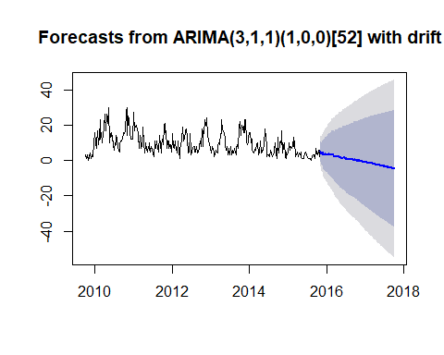

confint(Auto_Arima)

## Warning in sqrt(diag(vcov(object))): NaNs produced

## 2.5 % 97.5 %  
## ar1 -0.22377041 -0.21806631  
## ar2 NaN NaN  
## ar3 -0.01703369 -0.01401343  
## ma1 NaN NaN  
## sar1 NaN NaN  
## drift -0.38169498 0.19639837

checkresiduals(Auto_Arima)

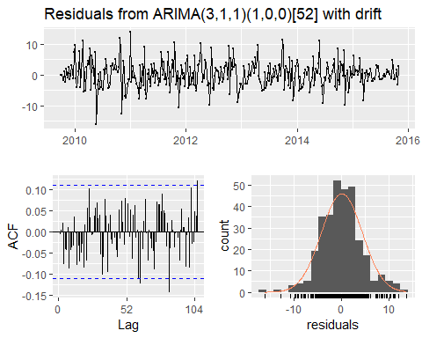

##   
## Ljung-Box test  
##   
## data: Residuals from ARIMA(3,1,1)(1,0,0)[52] with drift  
## Q* = 65.322, df = 57, p-value = 0.2101  
##   
## Model df: 6. Total lags used: 63

The automated function has slected a model with structure ARIMA(3,1,1)(1,0,0)[52] with drift. The drift term creates a trend in the forecast time-series.

# Chunk 21 ----  
  
Auto_ArimaM = auto.arima(Parvo_ts_dataM)  
summary(Auto_ArimaM)

## Series: Parvo_ts_dataM   
## ARIMA(2,1,1)(2,0,0)[12]   
##   
## Coefficients:  
## ar1 ar2 ma1 sar1 sar2  
## 0.7976 -0.2931 -0.9028 0.1562 0.2939  
## s.e. 0.1445 0.1349 0.1120 0.1241 0.1361  
##   
## sigma^2 estimated as 289.2: log likelihood=-309.67  
## AIC=631.33 AICc=632.61 BIC=645.08  
##   
## Training set error measures:  
## ME RMSE MAE MPE MAPE MASE  
## Training set -0.8649256 16.30082 13.35613 -43.75883 66.48852 0.6088825  
## ACF1  
## Training set -0.016731

plot(forecast(Auto_ArimaM,24))

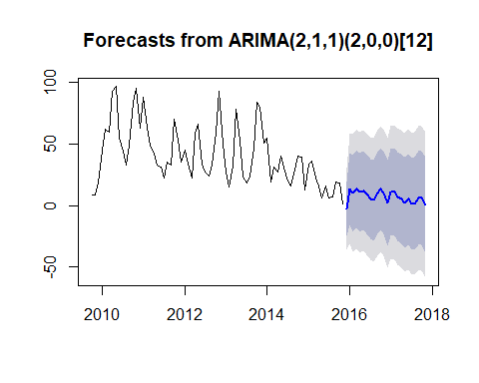

confint(Auto_ArimaM)

## 2.5 % 97.5 %  
## ar1 0.51445880 1.08072576  
## ar2 -0.55744923 -0.02881166  
## ma1 -1.12243907 -0.68326091  
## sar1 -0.08702874 0.39948777  
## sar2 0.02719195 0.56070413

checkresiduals(Auto_ArimaM)

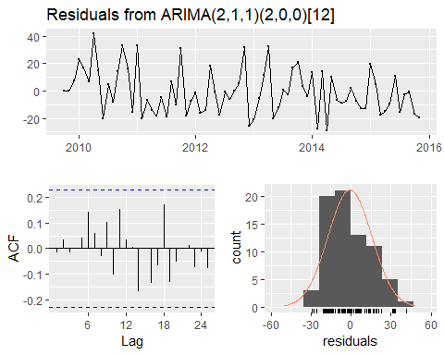

##   
## Ljung-Box test  
##   
## data: Residuals from ARIMA(2,1,1)(2,0,0)[12]  
## Q* = 9.0685, df = 10, p-value = 0.5256  
##   
## Model df: 5. Total lags used: 15

The automated functions suggest:

Weekly ARIMA (3,1,1)(1,0,0)[52] with drift, AICc=1834.24

Monthly ARIMA (2,1,1)(2,0,0)[12], AICc=632.61

We test other, simpler model structures which are still within the estimated parameters from time series exploration:

# Chunk 22 ----  
  
### Weekly time series models  
## Weekly ARIMA: (2, 1, 1) (1-3, 0, 1-3) [52]  
## fitted: (3,1,1)(1,0,0)[52] with drift, AICc=1834.24  
  
fit1 = Arima(Parvo_ts_data, order = c(2, 1, 1), seasonal = c(1, 0, 0))  
summary(fit1)

## Series: Parvo_ts_data   
## ARIMA(2,1,1)(1,0,0)[52]   
##   
## Coefficients:  
## ar1 ar2 ma1 sar1  
## 0.4620 0.3052 -0.9855 0.1169  
## s.e. 0.0559 0.0558 0.0133 0.0603  
##   
## sigma^2 estimated as 18.08: log likelihood=-904.79  
## AIC=1819.58 AICc=1819.77 BIC=1838.36  
##   
## Training set error measures:  
## ME RMSE MAE MPE MAPE MASE ACF1  
## Training set -0.07217848 4.217939 3.29608 -Inf Inf 0.5500386 -0.03497213

plot(forecast(fit1,100))

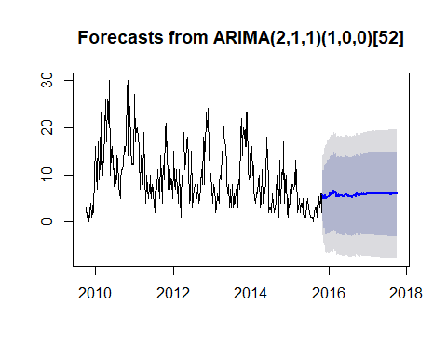

confint(fit1)

## 2.5 % 97.5 %  
## ar1 0.352490442 0.5715407  
## ar2 0.195782287 0.4145399  
## ma1 -1.011501759 -0.9594912  
## sar1 -0.001165745 0.2350279

checkresiduals(fit1)

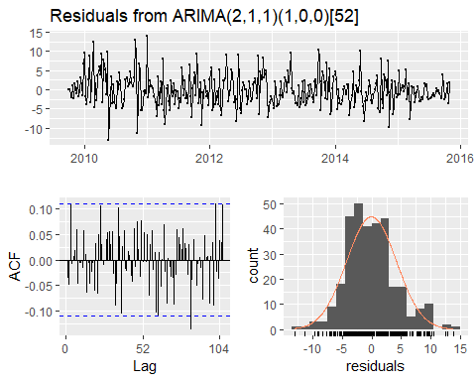

##   
## Ljung-Box test  
##   
## data: Residuals from ARIMA(2,1,1)(1,0,0)[52]  
## Q* = 60.566, df = 59, p-value = 0.4191  
##   
## Model df: 4. Total lags used: 63

fit2 = Arima(Parvo_ts_data, order = c(2, 1, 1), seasonal = c(0, 0, 1))  
summary(fit2)

## Series: Parvo_ts_data   
## ARIMA(2,1,1)(0,0,1)[52]   
##   
## Coefficients:  
## ar1 ar2 ma1 sma1  
## -0.3206 -0.1059 -0.1822 0.1082  
## s.e. 0.6803 0.3097 0.6928 0.0586  
##   
## sigma^2 estimated as 18.78: log likelihood=-910.18  
## AIC=1830.36 AICc=1830.55 BIC=1849.14  
##   
## Training set error measures:  
## ME RMSE MAE MPE MAPE MASE ACF1  
## Training set 0.00654623 4.299126 3.302973 -Inf Inf 0.5511889 -0.000116437

plot(forecast(fit2,100))

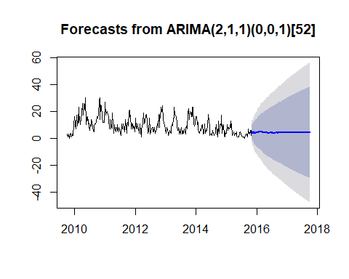

confint(fit2)

## 2.5 % 97.5 %  
## ar1 -1.654048780 1.0127577  
## ar2 -0.712904310 0.5010499  
## ma1 -1.540119325 1.1757347  
## sma1 -0.006698454 0.2230720

checkresiduals(fit2)

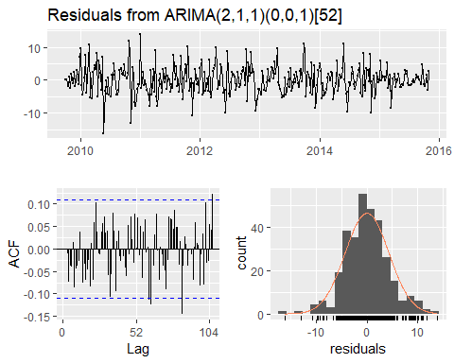

##   
## Ljung-Box test  
##   
## data: Residuals from ARIMA(2,1,1)(0,0,1)[52]  
## Q* = 65.577, df = 59, p-value = 0.2594  
##   
## Model df: 4. Total lags used: 63

fit3 = Arima(Parvo_ts_data, order = c(2, 1, 1), seasonal = c(1, 0, 0), include.drift = T) # *** This model is the best weekly model  
summary(fit3)

## Series: Parvo_ts_data   
## ARIMA(2,1,1)(1,0,0)[52] with drift   
##   
## Coefficients:  
## ar1 ar2 ma1 sar1 drift  
## 0.4620 0.3023 -1.0000 0.1123 -0.0228  
## s.e. 0.0271 0.0347 0.0095 0.0380 0.0111  
##   
## sigma^2 estimated as 17.89: log likelihood=-903.6  
## AIC=1819.2 AICc=1819.47 BIC=1841.73  
##   
## Training set error measures:  
## ME RMSE MAE MPE MAPE MASE ACF1  
## Training set 0.239633 4.188925 3.252542 -Inf Inf 0.542773 -0.03663276

plot(forecast(fit3,100))

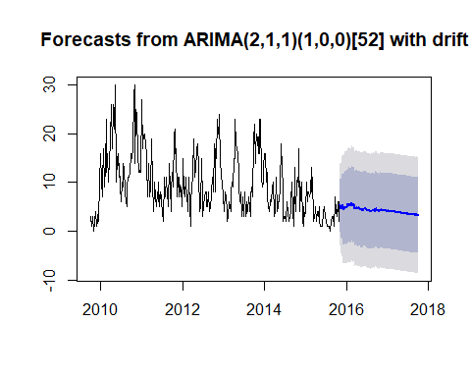

confint(fit3)

## 2.5 % 97.5 %  
## ar1 0.40892020 0.5151448697  
## ar2 0.23420620 0.3704037654  
## ma1 -1.01863686 -0.9813614681  
## sar1 0.03777440 0.1869119301  
## drift -0.04465446 -0.0009709036

checkresiduals(fit3)

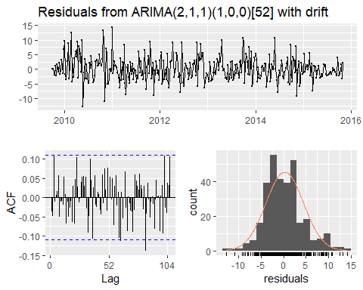

##   
## Ljung-Box test  
##   
## data: Residuals from ARIMA(2,1,1)(1,0,0)[52] with drift  
## Q* = 60.48, df = 58, p-value = 0.3864  
##   
## Model df: 5. Total lags used: 63

### monthly time series models  
## Monthly ARIMA: (0-2, 1, 0-2) (0-1, 0, 2) [12]  
## Auto fitted: (2,1,1)(2,0,0)[12], AICc=632.61  
  
fit4 = Arima(Parvo_ts_dataM, order = c(1, 1, 1), seasonal = c(1, 0, 0))  
summary(fit4)

## Series: Parvo_ts_dataM   
## ARIMA(1,1,1)(1,0,0)[12]   
##   
## Coefficients:  
## ar1 ma1 sar1  
## 0.6992 -0.9741 0.3425  
## s.e. 0.1237 0.0648 0.1195  
##   
## sigma^2 estimated as 315.6: log likelihood=-313.24  
## AIC=634.47 AICc=635.06 BIC=643.63  
##   
## Training set error measures:  
## ME RMSE MAE MPE MAPE MASE  
## Training set -0.478025 17.27936 14.34423 -48.01381 72.26332 0.6539282  
## ACF1  
## Training set 0.10414

plot(forecast(fit4, 24))

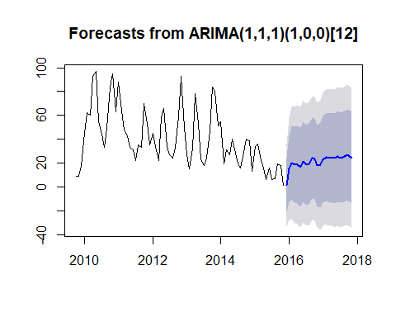

confint(fit4)

## 2.5 % 97.5 %  
## ar1 0.4567312 0.9417214  
## ma1 -1.1012459 -0.8470436  
## sar1 0.1083085 0.5766908

checkresiduals(fit4)

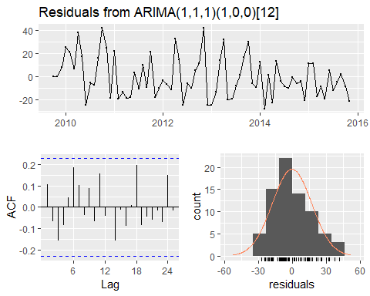

##   
## Ljung-Box test  
##   
## data: Residuals from ARIMA(1,1,1)(1,0,0)[12]  
## Q* = 13.434, df = 12, p-value = 0.3383  
##   
## Model df: 3. Total lags used: 15

fit5 = Arima(Parvo_ts_dataM, order = c(2, 1, 1), seasonal = c(0, 0, 1))  
summary(fit5)

## Series: Parvo_ts_dataM   
## ARIMA(2,1,1)(0,0,1)[12]   
##   
## Coefficients:  
## ar1 ar2 ma1 sma1  
## 0.7398 -0.2685 -0.9041 0.1761  
## s.e. 0.1297 0.1299 0.0853 0.1156  
##   
## sigma^2 estimated as 317.3: log likelihood=-312.43  
## AIC=634.87 AICc=635.77 BIC=646.32  
##   
## Training set error measures:  
## ME RMSE MAE MPE MAPE MASE  
## Training set -0.6784402 17.20082 13.94435 -46.66232 69.09401 0.6356984  
## ACF1  
## Training set -0.01497955

plot(forecast(fit5, 24))

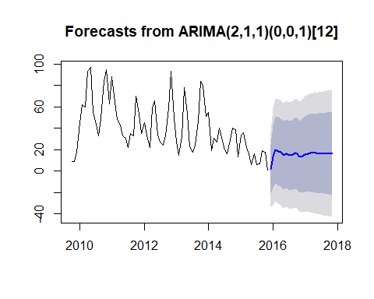

confint(fit5)

## 2.5 % 97.5 %  
## ar1 0.48560490 0.99392851  
## ar2 -0.52298029 -0.01392542  
## ma1 -1.07138134 -0.73683305  
## sma1 -0.05048666 0.40260207

checkresiduals(fit5)

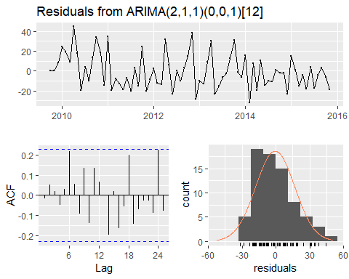

##   
## Ljung-Box test  
##   
## data: Residuals from ARIMA(2,1,1)(0,0,1)[12]  
## Q* = 14.416, df = 11, p-value = 0.2108  
##   
## Model df: 4. Total lags used: 15

fit6 = Arima(Parvo_ts_dataM, order = c(2, 1, 1), seasonal = c(2, 0, 0), include.drift = T)  
summary(fit6)

## Series: Parvo_ts_dataM   
## ARIMA(2,1,1)(2,0,0)[12] with drift   
##   
## Coefficients:  
## ar1 ar2 ma1 sar1 sar2 drift  
## 0.8313 -0.2963 -1.0000 0.1516 0.2841 -0.5061  
## s.e. 0.1186 0.1278 0.0381 0.1222 0.1353 0.2061  
##   
## sigma^2 estimated as 279.2: log likelihood=-308.64  
## AIC=631.29 AICc=633.01 BIC=647.32  
##   
## Training set error measures:  
## ME RMSE MAE MPE MAPE MASE  
## Training set 1.927427 15.89803 12.60622 -36.89273 64.13716 0.5746953  
## ACF1  
## Training set -0.02974478

plot(forecast(fit6, 24))

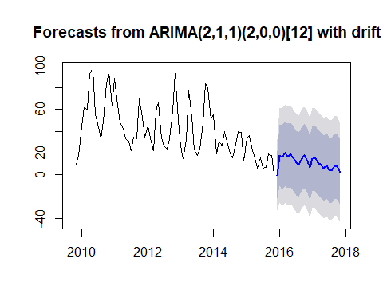

confint(fit6)

## 2.5 % 97.5 %  
## ar1 0.59891581 1.06376762  
## ar2 -0.54670833 -0.04585074  
## ma1 -1.07463500 -0.92535175  
## sar1 -0.08791284 0.39101991  
## sar2 0.01888095 0.54933999  
## drift -0.91008622 -0.10210976

checkresiduals(fit6)

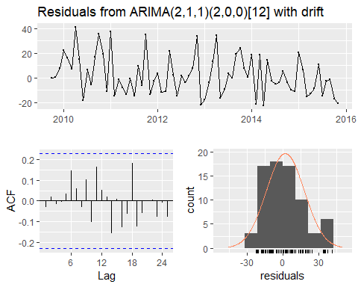

##   
## Ljung-Box test  
##   
## data: Residuals from ARIMA(2,1,1)(2,0,0)[12] with drift  
## Q* = 9.2198, df = 9, p-value = 0.4172  
##   
## Model df: 6. Total lags used: 15

fit7 = Arima(Parvo_ts_dataM, order = c(1, 1, 0), seasonal = c(1, 0, 0))  
summary(fit7)

## Series: Parvo_ts_dataM   
## ARIMA(1,1,0)(1,0,0)[12]   
##   
## Coefficients:  
## ar1 sar1  
## -0.0276 0.3670  
## s.e. 0.1184 0.1136  
##   
## sigma^2 estimated as 350.6: log likelihood=-317.31  
## AIC=640.63 AICc=640.97 BIC=647.5  
##   
## Training set error measures:  
## ME RMSE MAE MPE MAPE MASE  
## Training set -0.3311234 18.34056 14.86254 -33.96177 64.98723 0.677557  
## ACF1  
## Training set -0.003681255

plot(forecast(fit7, 24))

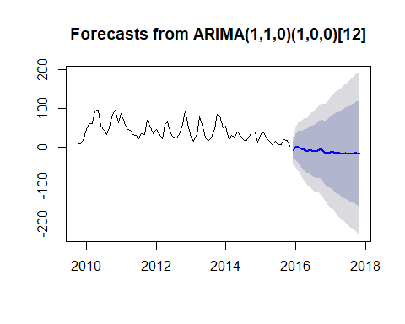

confint(fit7)

## 2.5 % 97.5 %  
## ar1 -0.2596615 0.2044482  
## sar1 0.1443652 0.5895377

checkresiduals(fit7)

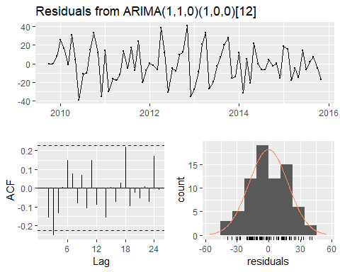

##   
## Ljung-Box test  
##   
## data: Residuals from ARIMA(1,1,0)(1,0,0)[12]  
## Q* = 17.913, df = 13, p-value = 0.1609  
##   
## Model df: 2. Total lags used: 15

The final models are ‘fit3’ for the weekly time-series and the auto-fitted model for the monthly time-series. Each has the lowest AICc of tested models, and produces a plausible forecast of the original time series. The residuals are reasonably Normaly distributed and the ACF plot of the residuals and Ljung-Box tests suggest that the residuals are time independent.

# Multivariate forecasting with time-series

In this section, we first consider how to modify an ARIMA model to include a predictor (other than the univariate time-series). We use the example of rainfall as a predictor of parvovirus events, and select monthly rainfall at Mudgee, NSW (mean centre of parvovirus event data).

1. Prepare, describe and decompose the rainfall series.

# Chunk 23 ----  
  
dataSource_Rain = getURL("https://raw.githubusercontent.com/vbrookes/Timeseries_analysis/master/Mudgee_Monthly_rainfall.csv")  
RainfallM = read.csv(text = dataSource_Rain, header = T)  
summary(RainfallM)

## Date Rain_mm   
## 1/01/2010: 1 Min. : 5.40   
## 1/01/2011: 1 1st Qu.: 24.80   
## 1/01/2012: 1 Median : 47.50   
## 1/01/2013: 1 Mean : 56.45   
## 1/01/2014: 1 3rd Qu.: 75.40   
## 1/01/2015: 1 Max. :214.40   
## (Other) :68

str(RainfallM)

## 'data.frame': 74 obs. of 2 variables:  
## $ Date : Factor w/ 74 levels "1/01/2010","1/01/2011",..: 55 62 69 1 7 13 19 25 31 37 ...  
## $ Rain_mm: num 34 16 121.4 46.4 90 ...

head(RainfallM)

## Date Rain_mm  
## 1 1/10/2009 34.0  
## 2 1/11/2009 16.0  
## 3 1/12/2009 121.4  
## 4 1/01/2010 46.4  
## 5 1/02/2010 90.0  
## 6 1/03/2010 89.0

tail(RainfallM)

## Date Rain_mm  
## 69 1/06/2015 55.20  
## 70 1/07/2015 61.60  
## 71 1/08/2015 30.40  
## 72 1/09/2015 5.40  
## 73 1/10/2015 44.00  
## 74 1/11/2015 101.45

RainfallM$Date = as.character(RainfallM$Date, format = "%d/%m/%Y")  
RainfallM$Date = as.Date(RainfallM$Date, "%d/%m/%Y")  
  
RainfallM$byMonth = cut(RainfallM$Date, breaks="1 month")   
RainfallM$byMonth <- as.Date(RainfallM$byMonth, format = "%Y-%m-%d")  
  
# summary  
summary(RainfallM)

## Date Rain_mm byMonth   
## Min. :2009-10-01 Min. : 5.40 Min. :2009-10-01   
## 1st Qu.:2011-04-08 1st Qu.: 24.80 1st Qu.:2011-04-08   
## Median :2012-10-16 Median : 47.50 Median :2012-10-16   
## Mean :2012-10-15 Mean : 56.45 Mean :2012-10-15   
## 3rd Qu.:2014-04-23 3rd Qu.: 75.40 3rd Qu.:2014-04-23   
## Max. :2015-11-01 Max. :214.40 Max. :2015-11-01

# check structure  
str(RainfallM)

## 'data.frame': 74 obs. of 3 variables:  
## $ Date : Date, format: "2009-10-01" "2009-11-01" ...  
## $ Rain_mm: num 34 16 121.4 46.4 90 ...  
## $ byMonth: Date, format: "2009-10-01" "2009-11-01" ...

# Check length  
length(RainfallM$Dates)

## [1] 0

ggplot(RainfallM, aes(x = byMonth, y = Rain_mm, group = 1)) +  
 geom_bar(stat="identity", width = 0.5, colour = "black") +  
 stat_smooth(aes(y = Rain_mm), method='auto', level=0.95) +   
 themeVB +  
 scale_x_date() +  
 xlab("Year") +  
 ylab("Rainfall")

## `geom_smooth()` using method = 'loess' and formula 'y ~ x'

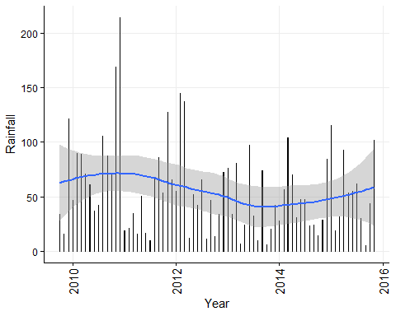

Rainfall_ts_data <- ts(RainfallM$Rain_mm, start = c(2009, 10), frequency =12)  
  
Decompose_tsRainM <- decompose(Rainfall_ts_data)  
summary(Decompose_tsRainM)

## Length Class Mode   
## x 74 ts numeric   
## seasonal 74 ts numeric   
## trend 74 ts numeric   
## random 74 ts numeric   
## figure 12 -none- numeric   
## type 1 -none- character

plot(Decompose_tsRainM)

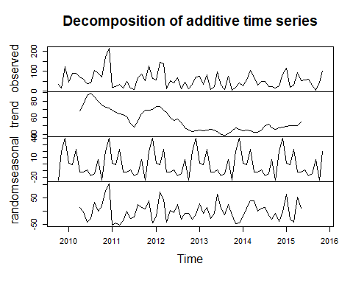

Quantitatively assess the trend, seasonality and stationarity of the data.

# Chunk 24 ----  
  
# Assess trend and seasonality  
fit_Rain_dataM = lm(Rainfall_ts_data ~ time(Rainfall_ts_data) + factor(cycle(Rainfall_ts_data)))  
summary(fit_Rain_dataM)

##   
## Call:  
## lm(formula = Rainfall_ts_data ~ time(Rainfall_ts_data) + factor(cycle(Rainfall_ts_data)))  
##   
## Residuals:  
## Min 1Q Median 3Q Max   
## -66.87 -28.45 -4.26 21.10 108.41   
##   
## Coefficients:  
## Estimate Std. Error t value Pr(>|t|)   
## (Intercept) 8079.93470 5220.28469 1.548 0.1268   
## time(Rainfall_ts_data) -3.98680 2.59392 -1.537 0.1295   
## factor(cycle(Rainfall_ts_data))2 4.79890 22.76256 0.211 0.8337   
## factor(cycle(Rainfall_ts_data))3 23.69447 22.76564 1.041 0.3021   
## factor(cycle(Rainfall_ts_data))4 -10.80997 22.77077 -0.475 0.6367   
## factor(cycle(Rainfall_ts_data))5 -10.11107 22.77795 -0.444 0.6587   
## factor(cycle(Rainfall_ts_data))6 -5.56883 22.78718 -0.244 0.8078   
## factor(cycle(Rainfall_ts_data))7 -11.44660 22.79846 -0.502 0.6174   
## factor(cycle(Rainfall_ts_data))8 -13.04770 22.81178 -0.572 0.5694   
## factor(cycle(Rainfall_ts_data))9 0.08453 22.82713 0.004 0.9971   
## factor(cycle(Rainfall_ts_data))10 -21.79568 21.94315 -0.993 0.3245   
## factor(cycle(Rainfall_ts_data))11 15.72798 21.95060 0.717 0.4764   
## factor(cycle(Rainfall_ts_data))12 43.16777 22.76256 1.896 0.0626 .  
## ---  
## Signif. codes: 0 '***' 0.001 '**' 0.01 '*' 0.05 '.' 0.1 ' ' 1  
##   
## Residual standard error: 39.42 on 61 degrees of freedom  
## Multiple R-squared: 0.2273, Adjusted R-squared: 0.07531   
## F-statistic: 1.495 on 12 and 61 DF, p-value: 0.1507

confint(fit_Rain_dataM)

## 2.5 % 97.5 %  
## (Intercept) -2358.669697 18518.539091  
## time(Rainfall_ts_data) -9.173656 1.200063  
## factor(cycle(Rainfall_ts_data))2 -40.717660 50.315460  
## factor(cycle(Rainfall_ts_data))3 -21.828250 69.217183  
## factor(cycle(Rainfall_ts_data))4 -56.342943 34.723008  
## factor(cycle(Rainfall_ts_data))5 -55.658402 35.436267  
## factor(cycle(Rainfall_ts_data))6 -51.134624 39.996954  
## factor(cycle(Rainfall_ts_data))7 -57.034937 34.141733  
## factor(cycle(Rainfall_ts_data))8 -58.662667 32.567263  
## factor(cycle(Rainfall_ts_data))9 -45.561143 45.730205  
## factor(cycle(Rainfall_ts_data))10 -65.673724 22.082360  
## factor(cycle(Rainfall_ts_data))11 -28.164962 59.620922  
## factor(cycle(Rainfall_ts_data))12 -2.348793 88.684327

# Tests for stationarity  
Rainfall_ts_data %>% ggtsdisplay(theme = themeVB)

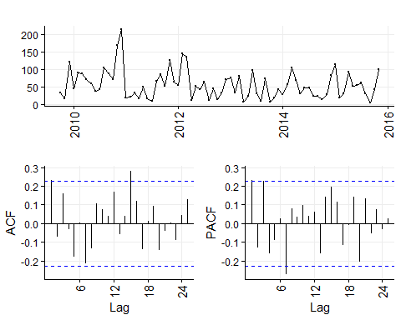

# We run `ndiffs` and `nsdiffs` (seasonal) from the `forecast` package to assess how many first differences are needed to induce stationarity.  
ndiffs(Rainfall_ts_data)

## [1] 0

nsdiffs(Rainfall_ts_data)

## [1] 0

## Monthly time-series tests for stationarity  
# 1.   
Box.test(Rainfall_ts_data, lag = 12, type="Ljung-Box")

##   
## Box-Ljung test  
##   
## data: Rainfall_ts_data  
## X-squared = 18.627, df = 12, p-value = 0.09794

# 2.  
adf.test(Rainfall_ts_data, alternative = "stationary", k = 24)

## Warning in adf.test(Rainfall_ts_data, alternative = "stationary", k = 24):  
## p-value greater than printed p-value

##   
## Augmented Dickey-Fuller Test  
##   
## data: Rainfall_ts_data  
## Dickey-Fuller = -0.071898, Lag order = 24, p-value = 0.99  
## alternative hypothesis: stationary

# 3.  
kpss.test(Rainfall_ts_data, null = 'Trend')

## Warning in kpss.test(Rainfall_ts_data, null = "Trend"): p-value greater  
## than printed p-value

##   
## KPSS Test for Trend Stationarity  
##   
## data: Rainfall_ts_data  
## KPSS Trend = 0.052388, Truncation lag parameter = 3, p-value = 0.1

kpss.test(Rainfall_ts_data, null = 'Level')

## Warning in kpss.test(Rainfall_ts_data, null = "Level"): p-value greater  
## than printed p-value

##   
## KPSS Test for Level Stationarity  
##   
## data: Rainfall_ts_data  
## KPSS Level = 0.30441, Truncation lag parameter = 3, p-value = 0.1

There is no quantitative evidence for trend and seasonality of monthly rainfall in Mudgee. Also, the raw time-series appears to be stationary; significant correlations appear at lag 15, but not in the first few lags, the functions ‘ndiff’ and ‘nsdiff’ indicate that differencing is not required, and statistical tests indicate stationarity.

1. We can therefore, use the raw rainfall series in the model.

# Chunk 25 ----  
  
# Make a matrix of lagged predictors (0, 1, 2 or 3 lags).  
RainLag <- cbind(  
 AdLag0 = Rainfall_ts_data,  
 AdLag1 = stats::lag(Rainfall_ts_data, k = 1),  
 AdLag2 = stats::lag(Rainfall_ts_data, k = 2),  
 AdLag3 = stats::lag(Rainfall_ts_data, k = 3)) %>%  
 head(NROW(Rainfall_ts_data))  
  
# Restrict data so models use same fitting period  
fit1 <- auto.arima(Parvo_ts_dataM[4:70], xreg=RainLag[4:70,1])  
fit2 <- auto.arima(Parvo_ts_dataM[4:70], xreg=RainLag[4:70,1:2])  
fit3 <- auto.arima(Parvo_ts_dataM[4:70], xreg=RainLag[4:70,1:3])  
fit4 <- auto.arima(Parvo_ts_dataM[4:70], xreg=RainLag[4:70,1:4])  
  
c(fit1[["aicc"]],fit2[["aicc"]],fit3[["aicc"]],fit4[["aicc"]])

## [1] 589.1365 584.9810 586.0320 585.4477

fit <- auto.arima(Parvo_ts_dataM, xreg=RainLag[,1:3])  
summary(fit)

## Series: Parvo_ts_dataM   
## Regression with ARIMA(0,1,0)(0,0,2)[12] errors   
##   
## Coefficients:  
## sma1 sma2 AdLag0 AdLag1 AdLag2  
## 0.0862 0.4990 0.0957 0.1886 0.1186  
## s.e. 0.1432 0.2115 0.0525 0.0502 0.0540  
##   
## sigma^2 estimated as 275.6: log likelihood=-298.37  
## AIC=608.73 AICc=610.07 BIC=622.22  
##   
## Training set error measures:  
## ME RMSE MAE MPE MAPE MASE  
## Training set -0.6847001 16.24539 12.63194 -28.4403 54.7225 0.575868  
## ACF1  
## Training set 0.001659539

confint(fit)

## 2.5 % 97.5 %  
## sma1 -0.194470125 0.3669198  
## sma2 0.084559741 0.9134938  
## AdLag0 -0.007165825 0.1985386  
## AdLag1 0.090110552 0.2870869  
## AdLag2 0.012724438 0.2243913

checkresiduals(fit)

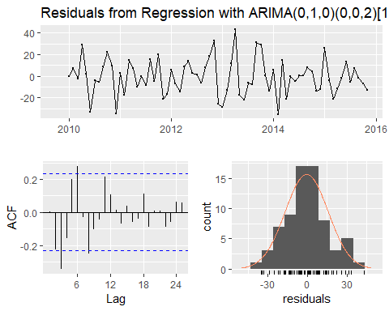

##   
## Ljung-Box test  
##   
## data: Residuals from Regression with ARIMA(0,1,0)(0,0,2)[12] errors  
## Q* = 36.086, df = 10, p-value = 8.135e-05  
##   
## Model df: 5. Total lags used: 15

# forecast is fitted with trimmed data otherwise error message: 'Upper prediction intervals are not finite.' due to NAs in lagged rainfall data.  
fcast <- forecast(fit3, h = 20, xreg=RainLag[4:70,1:3])  
   
autoplot(fcast) + xlab("Year") + ylab("Events")

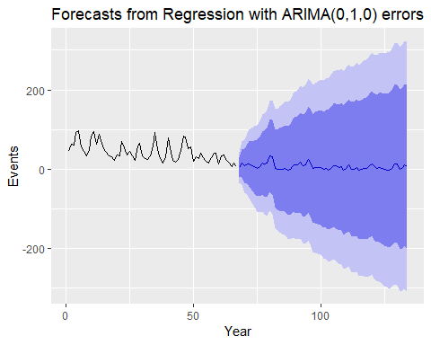

An increase in rainfall in the previous 2 months is associated with an increase in parvo events. This model has a lower AICc (610.07) than the model without rainfall as a predictor (AICc = 632.61). The forecast plot confidence intervals are still very wide.

### Vector auto-regression (VAR) models

In these models, there no assumptions about the direction of prediction and the potential influence of one time-series on the other is symmetrical. Therefore, parvo events could predict rainfall, or rainfall could predict parvo events. Obviously, this is a ridiculous suggestion in this context, but it can be useful to give insights in other contexts. Examples could include exploration of the direction of disease spread between two populations (we want to explore causation). It is also useful for forecasting when we simply want a mathematically useful predictive model (we have made a prior causal model and are interested in predictions in one direction).

Initially we examine the correlation between lags of monthly parvo reports and rainfall using cross-correlation plots.

# Chunk 26 ----  
  
ccf(Parvo_ts_dataM, Rainfall_ts_data, type = 'correlation')

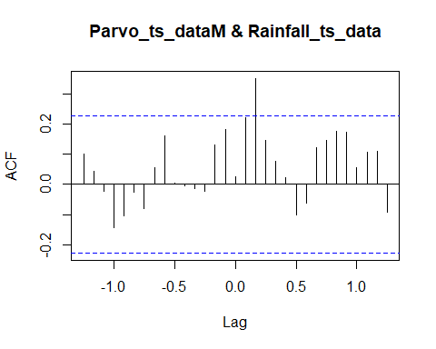 There appears to be cross-correlation between parvo events and rainfall at +2 months (rainfall leads parvo events on this side of the plot… which is also biologically sensible :-)).

The model we are going to fit is a VAR model (no I or MA), so data need to be differenced to induce stationarity if necessary prior to model fitting. A predictive equation is fitted for each parvo events and rainfall. The equations are symmetrical (same number of predictor variables and lags).

# Chunk 27 ----  
  
# Difference Parvo data because model is VARMA (no I)  
ParvoM_diff = diff(Parvo_ts_dataM)  
  
Differenced_data <- cbind(ParvoM_diff, Rainfall_ts_data) # Combine in a dataframe with the rainfall data.  
Differenced_data[is.na(Differenced_data)] <- 0 # Convert first value from NA to 0

In our example, we have two variables (parvo events and rainfall, k = 2). We need to determine the number of AR lags (p) for each equation in the model. We use the VARselect function to estimate the p order in the model.

The output gives: 1. AIC - For VAR models, we the BIC (SC) is preferable, because AIC tends to select large numbers of lags. 2. HQ - Hannan-Quinn criterion 3. SC - another name for the BIC (SC stands for Schwarz Criterion, after Gideon Schwarz who proposed it) 4. FPE - “Final Prediction Error” criterion.

The number of coefficients estimated in a VAR = k+pk2. Note that because every variable is assumed to influence every other variable in the system, it makes a direct interpretation of the estimated coefficients difficult.

# Chunk 28 ----  
  
# estimate orders for AR(p) and MA(q) between parvo events and rainfall  
library(vars)  
VARselect(Differenced_data, lag.max = 12, type = "const") # AR(p) = 1 if use SC (BIC), or p = 4 if use the other information criteria.

## $selection  
## AIC(n) HQ(n) SC(n) FPE(n)   
## 4 4 1 4   
##   
## $criteria  
## 1 2 3 4 5  
## AIC(n) 13.41217 13.39258 13.30062 13.17956 13.25029  
## HQ(n) 13.49299 13.52728 13.48920 13.42203 13.54664  
## SC(n) 13.61802 13.73566 13.78094 13.79712 14.00508  
## FPE(n) 668187.14652 655582.27185 598721.72745 531623.77958 572564.43269  
## 6 7 8 9 10  
## AIC(n) 13.35469 13.32362 13.3147 13.42150 13.36591  
## HQ(n) 13.70492 13.72773 13.7727 13.93338 13.93167  
## SC(n) 14.24671 14.35288 14.4812 14.72523 14.80688  
## FPE(n) 638779.39943 623554.67441 623747.0729 702355.16589 674422.90712  
## 11 12  
## AIC(n) 13.48327 13.56223  
## HQ(n) 14.10291 14.23575  
## SC(n) 15.06146 15.27766  
## FPE(n) 772645.69114 855383.04320

# Automated model fit  
Mod1 <- VAR(Differenced_data, p=1, type = "const") # automated  
Mod1

##   
## VAR Estimation Results:  
## =======================   
##   
## Estimated coefficients for equation ParvoM_diff:   
## ================================================   
## Call:  
## ParvoM_diff = ParvoM_diff.l1 + Rainfall_ts_data.l1 + const   
##   
## ParvoM_diff.l1 Rainfall_ts_data.l1 const   
## 0.06779822 0.10898642 -6.20340599   
##   
##   
## Estimated coefficients for equation Rainfall_ts_data:   
## =====================================================   
## Call:  
## Rainfall_ts_data = ParvoM_diff.l1 + Rainfall_ts_data.l1 + const   
##   
## ParvoM_diff.l1 Rainfall_ts_data.l1 const   
## 0.1854748 0.2506427 42.7428547

summary(Mod1)

##   
## VAR Estimation Results:  
## =========================   
## Endogenous variables: ParvoM_diff, Rainfall_ts_data   
## Deterministic variables: const   
## Sample size: 73   
## Log Likelihood: -689.54   
## Roots of the characteristic polynomial:  
## 0.3283 0.009813  
## Call:  
## VAR(y = Differenced_data, p = 1, type = "const")  
##   
##   
## Estimation results for equation ParvoM_diff:   
## ============================================   
## ParvoM_diff = ParvoM_diff.l1 + Rainfall_ts_data.l1 + const   
##   
## Estimate Std. Error t value Pr(>|t|)   
## ParvoM_diff.l1 0.0678 0.1194 0.568 0.5720   
## Rainfall_ts_data.l1 0.1090 0.0582 1.872 0.0653 .  
## const -6.2034 3.9966 -1.552 0.1251   
## ---  
## Signif. codes: 0 '***' 0.001 '**' 0.01 '*' 0.05 '.' 0.1 ' ' 1  
##   
##   
## Residual standard error: 19.84 on 70 degrees of freedom  
## Multiple R-Squared: 0.04828, Adjusted R-squared: 0.02109   
## F-statistic: 1.775 on 2 and 70 DF, p-value: 0.1769   
##   
##   
## Estimation results for equation Rainfall_ts_data:   
## =================================================   
## Rainfall_ts_data = ParvoM_diff.l1 + Rainfall_ts_data.l1 + const   
##   
## Estimate Std. Error t value Pr(>|t|)   
## ParvoM_diff.l1 0.1855 0.2436 0.761 0.4490   
## Rainfall_ts_data.l1 0.2506 0.1187 2.111 0.0384 *   
## const 42.7429 8.1534 5.242 1.6e-06 ***  
## ---  
## Signif. codes: 0 '***' 0.001 '**' 0.01 '*' 0.05 '.' 0.1 ' ' 1  
##   
##   
## Residual standard error: 40.48 on 70 degrees of freedom  
## Multiple R-Squared: 0.0615, Adjusted R-squared: 0.03468   
## F-statistic: 2.293 on 2 and 70 DF, p-value: 0.1085   
##   
##   
##   
## Covariance matrix of residuals:  
## ParvoM_diff Rainfall_ts_data  
## ParvoM_diff 393.6 -218.7  
## Rainfall_ts_data -218.7 1638.2  
##   
## Correlation matrix of residuals:  
## ParvoM_diff Rainfall_ts_data  
## ParvoM_diff 1.0000 -0.2724  
## Rainfall_ts_data -0.2724 1.0000

serial.test(Mod1, lags.pt=12)

##   
## Portmanteau Test (asymptotic)  
##   
## data: Residuals of VAR object Mod1  
## Chi-squared = 60.176, df = 44, p-value = 0.05278

Mod2 <- VAR(Differenced_data, p=4, type = "const") # automated  
Mod2

##   
## VAR Estimation Results:  
## =======================   
##   
## Estimated coefficients for equation ParvoM_diff:   
## ================================================   
## Call:  
## ParvoM_diff = ParvoM_diff.l1 + Rainfall_ts_data.l1 + ParvoM_diff.l2 + Rainfall_ts_data.l2 + ParvoM_diff.l3 + Rainfall_ts_data.l3 + ParvoM_diff.l4 + Rainfall_ts_data.l4 + const   
##   
## ParvoM_diff.l1 Rainfall_ts_data.l1 ParvoM_diff.l2   
## -0.12612139 0.08036881 -0.23760011   
## Rainfall_ts_data.l2 ParvoM_diff.l3 Rainfall_ts_data.l3   
## 0.13623172 -0.31163388 -0.11432214   
## ParvoM_diff.l4 Rainfall_ts_data.l4 const   
## -0.36440792 -0.01166325 -5.66543045   
##   
##   
## Estimated coefficients for equation Rainfall_ts_data:   
## =====================================================   
## Call:  
## Rainfall_ts_data = ParvoM_diff.l1 + Rainfall_ts_data.l1 + ParvoM_diff.l2 + Rainfall_ts_data.l2 + ParvoM_diff.l3 + Rainfall_ts_data.l3 + ParvoM_diff.l4 + Rainfall_ts_data.l4 + const   
##   
## ParvoM_diff.l1 Rainfall_ts_data.l1 ParvoM_diff.l2   
## 0.25266461 0.38468136 0.32449908   
## Rainfall_ts_data.l2 ParvoM_diff.l3 Rainfall_ts_data.l3   
## -0.23646772 0.01717014 0.21493518   
## ParvoM_diff.l4 Rainfall_ts_data.l4 const   
## 0.18977775 -0.14593788 44.59590673

summary(Mod2)

##   
## VAR Estimation Results:  
## =========================   
## Endogenous variables: ParvoM_diff, Rainfall_ts_data   
## Deterministic variables: const   
## Sample size: 70   
## Log Likelihood: -643.678   
## Roots of the characteristic polynomial:  
## 0.8163 0.8163 0.7091 0.7091 0.643 0.643 0.6323 0.6323  
## Call:  
## VAR(y = Differenced_data, p = 4, type = "const")  
##   
##   
## Estimation results for equation ParvoM_diff:   
## ============================================   
## ParvoM_diff = ParvoM_diff.l1 + Rainfall_ts_data.l1 + ParvoM_diff.l2 + Rainfall_ts_data.l2 + ParvoM_diff.l3 + Rainfall_ts_data.l3 + ParvoM_diff.l4 + Rainfall_ts_data.l4 + const   
##   
## Estimate Std. Error t value Pr(>|t|)   
## ParvoM_diff.l1 -0.12612 0.12112 -1.041 0.30187   
## Rainfall_ts_data.l1 0.08037 0.05744 1.399 0.16683   
## ParvoM_diff.l2 -0.23760 0.11217 -2.118 0.03825 *   
## Rainfall_ts_data.l2 0.13623 0.06052 2.251 0.02800 *   
## ParvoM_diff.l3 -0.31163 0.11220 -2.778 0.00727 **  
## Rainfall_ts_data.l3 -0.11432 0.05887 -1.942 0.05675 .   
## ParvoM_diff.l4 -0.36441 0.11621 -3.136 0.00264 **  
## Rainfall_ts_data.l4 -0.01166 0.05815 -0.201 0.84171   
## const -5.66543 5.34005 -1.061 0.29290   
## ---  
## Signif. codes: 0 '***' 0.001 '**' 0.01 '*' 0.05 '.' 0.1 ' ' 1  
##   
##   
## Residual standard error: 17.31 on 61 degrees of freedom  
## Multiple R-Squared: 0.3499, Adjusted R-squared: 0.2646   
## F-statistic: 4.104 on 8 and 61 DF, p-value: 0.00058   
##   
##   
## Estimation results for equation Rainfall_ts_data:   
## =================================================   
## Rainfall_ts_data = ParvoM_diff.l1 + Rainfall_ts_data.l1 + ParvoM_diff.l2 + Rainfall_ts_data.l2 + ParvoM_diff.l3 + Rainfall_ts_data.l3 + ParvoM_diff.l4 + Rainfall_ts_data.l4 + const   
##   
## Estimate Std. Error t value Pr(>|t|)   
## ParvoM_diff.l1 0.25266 0.27317 0.925 0.35864   
## Rainfall_ts_data.l1 0.38468 0.12955 2.969 0.00426 **   
## ParvoM_diff.l2 0.32450 0.25298 1.283 0.20445   
## Rainfall_ts_data.l2 -0.23647 0.13649 -1.732 0.08825 .   
## ParvoM_diff.l3 0.01717 0.25304 0.068 0.94612   
## Rainfall_ts_data.l3 0.21494 0.13276 1.619 0.11060   
## ParvoM_diff.l4 0.18978 0.26209 0.724 0.47178   
## Rainfall_ts_data.l4 -0.14594 0.13115 -1.113 0.27018   
## const 44.59591 12.04326 3.703 0.00046 ***  
## ---  
## Signif. codes: 0 '***' 0.001 '**' 0.01 '*' 0.05 '.' 0.1 ' ' 1  
##   
##   
## Residual standard error: 39.04 on 61 degrees of freedom  
## Multiple R-Squared: 0.2003, Adjusted R-squared: 0.09537   
## F-statistic: 1.909 on 8 and 61 DF, p-value: 0.07474   
##   
##   
##   
## Covariance matrix of residuals:  
## ParvoM_diff Rainfall_ts_data  
## ParvoM_diff 299.6 -135.9  
## Rainfall_ts_data -135.9 1524.0  
##   
## Correlation matrix of residuals:  
## ParvoM_diff Rainfall_ts_data  
## ParvoM_diff 1.0000 -0.2012  
## Rainfall_ts_data -0.2012 1.0000

serial.test(Mod2, lags.pt=12)

##   
## Portmanteau Test (asymptotic)  
##   
## data: Residuals of VAR object Mod2  
## Chi-squared = 29.716, df = 32, p-value = 0.5826

# we plot forecasts from each predictive equation  
forecast(Mod1) %>%  
 autoplot() + xlab("Year")

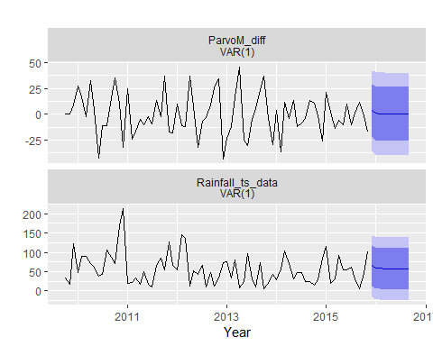

forecast(Mod2) %>%  
 autoplot() + xlab("Year")

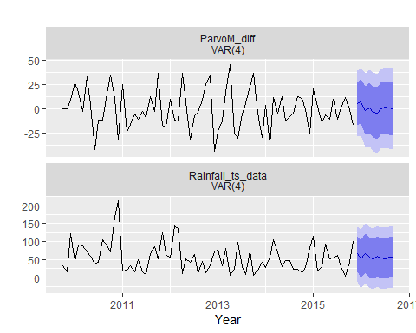

In the model with p = 1, there are three coefficients estimated for each equation (1 lag each for rainfall and parvo events as predictors of parvo events [and rainfall events], and 1 constant). In this model, none of the coeffcients for the parvo events equation are significantly predictive and in the Portmanteau test, P = 0.05 (rejecting the null hypothesis of no correlation between residuals).

In the model with p = 4, there are 18 coefficients (9 for each equation). There are significant predictors of parvo events (previous parvo events and rainfall at lags 2, 3 and 4). In the Portmanteau test, P = 0.58 (consistent with the null hypothesis of no correlation between residuals).

We would select the model with p = 4 as more useful for prediction of parvo events. In this case, we have no interest in prediction of rainfall, but this predictive equation would also be of interest if a plausible causal relationship was agreed ‘a priori’.

For further information about vector auto-regressive models and other extensions of time-series analysis and forecasting, we recommend:

Hyndman, R.J., & Athanasopoulos, G. (2018) Forecasting: principles and practice, 2nd edition, OTexts: Melbourne, Australia. OTexts.com/fpp2. Accessed on 24/10/2019.

An online copy of this book can be found [here](https://otexts.com/fpp2/).