**Corepoint Disaster Recovery Information**

|  |  |  |
| --- | --- | --- |
| **Systems Inbound** | **Systems Outbound** | **Requirements** |
| Allscripts | Allscripts | Windows Server 2012 R2 or more recent |
| Aria | Aria | Minimum 4 core processors |
| Censitrac | CardioNet | Minimum 12 GB RAM |
| Cerner Millennium | Centricity EP Lab | 72 GB application drive |
| Cerner HUB | CEP | 60 GB data drive |
| Epiphany EKG | Cerner Millennium | Microsoft SQL Server or SQL Server Express |
| HIE Networks | Cerner HUB | Google Chrome Browser |
| IHEAL | Cipherhealth |  |
| Lawson | Dell Clinical Cloud Archive (DCCA) |  |
| MModal | Epiphany EKG |  |
| OmniCell | Florida State ENS HIE |  |
| One Blood | Healthtouch |  |
| McKesson PACS | HIE Networks |  |
| McKesson STAR | IHEAL |  |
| Prosolv | McKesson PACS |  |
| Pulmonary Function Lab | McKesson STAR |  |
| Pyxis | Merge Hemo |  |
| McKesson Star | MModal |  |
| State ENS | NRC Picker |  |
| Sunquest | Nursecall |  |
| SupplyScan | Optilink |  |
| Teletracking | Pulmonary Function Lab |  |
| VRAD | Prosolv |  |
|  | Pyxis |  |
|  | Relay Health |  |
|  | Sleep Center |  |
|  | Spacelabs |  |
|  | State ENS |  |
|  | Sunquest |  |
|  | Supplyscan |  |
|  | Telcor |  |
|  | VRAD |  |
|  |  |  |
|  |  |  |

**Disaster Recovery Corepoint Interface Engine Certification Test Plan**

Purpose

This document outlines the validation steps to be completed by the Interface Engine Team to confirm that a successful restore of the Corepoint Interface Engine has been completed following a disaster.

Pre-requisites

Once a quarter the Interface Engine Team will do the following (*refer to Appendix A for technical details*):

* Capture then run 1000 production HL7 Star ADT messages through the Star to Cerner Action List and record the results on the newly recovered Prod box.
* Note: The 1000 messages will include almost all of the ADT message types/trigger events but a verification will need to be done to ensure some of the following messages have been captured:
  + A17 - Swap Patients
  + A34 - Merge patient info.- Patient ID only
* Capture then run the following production HL7 Order/Result messages:
  + 1000 Lab Orders going outbound from Cerner to Sunquest
  + 500 General Lab Results going outbound from Sunquest to Cerner
  + 500 production Microbiology Results going outbound from Sunquest to Cerner
  + 1000 Pharmacy Orders going outbound from Cerner to Pyxis

Engine Validation Steps

1. Run the most recent quarterly-generated messages on the newly restored Interface Engine:
   * ADTs
   * Lab Orders
   * Gen Lab & Micro Results
   * Pyxis Orders
2. Compare the output with the output from the quarterly runs and confirm they match

The Corepoint Interface Engine will be certified to have been successfully restored if the above output exercise matches.

***Appendix A***

**Selecting Engine Logs as Test Messages**

* Open the Corepoint Engine Monitor.
* Select a connection on the Connections tab and left click it.
* Select View Logs.

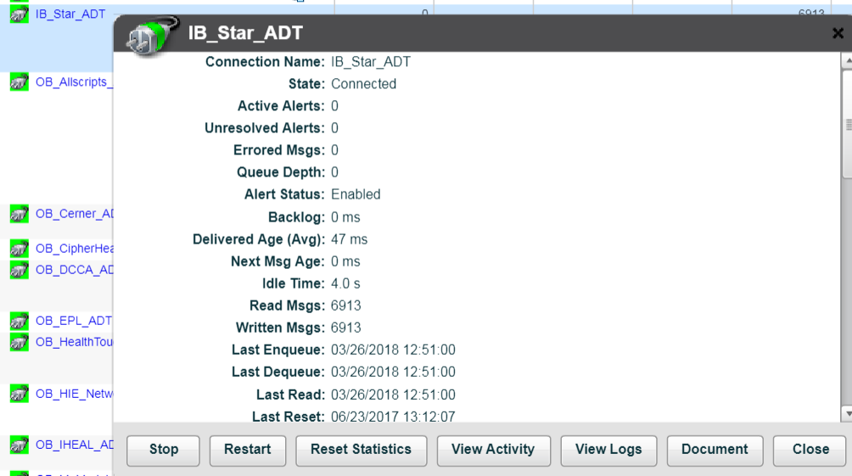

* In the View Logs screen, select whether you’d like to see messages received, or messages sent.
* To change the search criteria to only select certain types of messages, like only ADT-A03, select View/Edit Search Criteria.

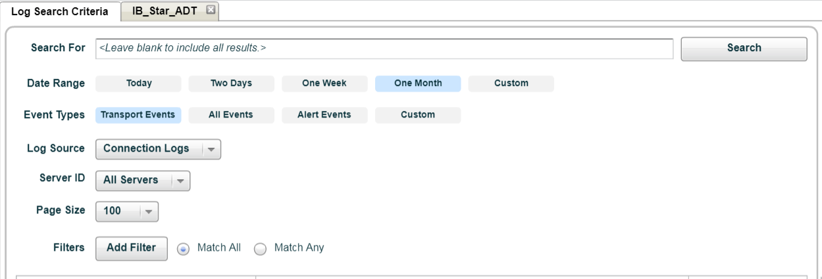

* The search page allows you to select the date range and the event type. It also allows you to apply a custom filter to select only certain types of messages.
* To apply a filter, on the search page click Show Advanced Search Options.
* Click Add Filter.
* The popup allows us to generate a filter.
  + For example, if we enter MSH-9-2 contains A03, we will filter out all messages except A03 messages.

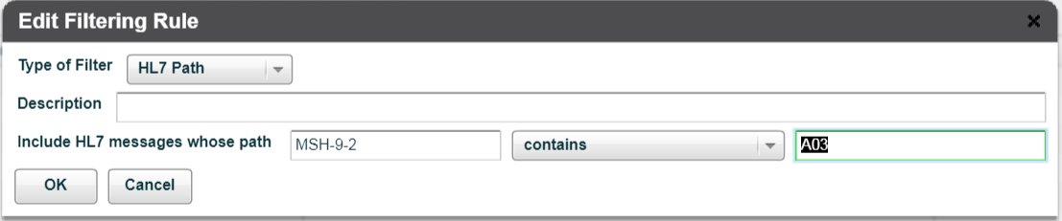

* By applying the filter and searching, we can generate a set of test messages.

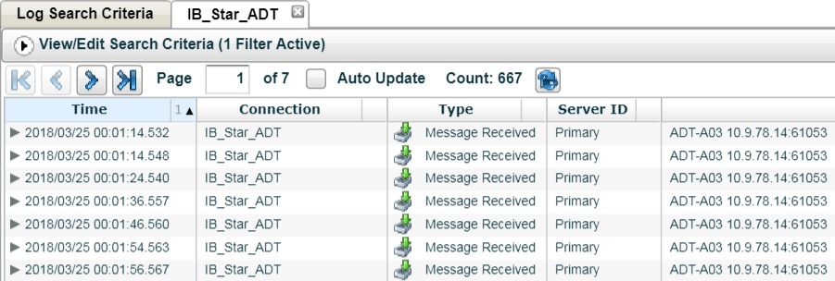

**Generating Our Test Sets for Disaster Recovery**

* For our disaster recovery test sets, we will capture engine log test messages every quarter and ensure that we have adequate message type coverage by using the procedure outlined above.
  + For example, we will be sure to capture less frequently encountered ADT, like A17 and A34.
* After the engine has been restored from a backup server, we will run the test messages generated from the engine logs through the interface engine to ensure the Corepoint engine is functioning properly.
* If any of the test messages present behavior that varies from the behavior we expect, we will investigate why those changes have taken place and correct the problem if necessary.