R Markdown Coding Challenge

Vaibhav Shelar

2025-02-27

library(knitr)

* [Link of manuscript](https://doi.org/10.1094/PDIS-06-21-1253-RE)
* [GitHub flavored .md file](Coding%20Challenge%204/R-Markdown-Coding-Challenge.md)

## File Tree

library("fs")  
fs::dir_tree(path = "D:/Spring 2025/PLPA7820/Class-Reports/Assignments/Coding Challenge 4")

## D:/Spring 2025/PLPA7820/Class-Reports/Assignments/Coding Challenge 4  
## ├── R Markdown Coding Challenge.Rmd  
## ├── R-Markdown-Coding-Challenge.docx  
## ├── R-Markdown-Coding-Challenge.html  
## ├── R-Markdown-Coding-Challenge.md  
## ├── R-Markdown-Coding-Challenge.pdf  
## └── R-Markdown-Coding-Challenge_files  
## └── figure-gfm  
## ├── unnamed-chunk-6-1.png  
## ├── unnamed-chunk-7-1.png  
## ├── unnamed-chunk-8-1.png  
## └── unnamed-chunk-9-1.png

## Q1

# YAML Header:

YAML header is a short blob of text, specially formatted with key: value pairs tags, that seats at the top of our Rmarkdown document. It contains YAML arguments such as “Title”, “Author”, and “Output”, demarcated by three dashes (—) on either end.

# Literate Programming:

A methodology that combines a programming language with a documentation language, thereby making programs more robust, more portable, more easily maintained, and arguably more fun to write than programs that are written only in a high-level language.

## Q2

# Load dataset of MycotoxinData  
Mycotoxin_Data <- read.csv("D:/Spring 2025/PLPA7820/Class-Reports/MycotoxinData.csv", na.strings = "na")

# structure of the dataframe  
str(Mycotoxin_Data)

## 'data.frame': 375 obs. of 6 variables:  
## $ Treatment : chr "Fg" "Fg" "Fg" "Fg" ...  
## $ Cultivar : chr "Wheaton" "Wheaton" "Wheaton" "Wheaton" ...  
## $ BioRep : int 2 2 2 2 2 2 2 2 2 3 ...  
## $ MassperSeed_mg: num 10.29 12.8 2.85 6.5 10.18 ...  
## $ DON : num 107.3 32.6 416 211.9 124 ...  
## $ X15ADON : num 3 0.85 3.5 3.1 4.8 3.3 6.9 2.9 2.1 0.71 ...

# plotting data using ggplota2 (Boxplot)  
  
library(ggplot2)  
  
cbbPalette <- c("#000000", "#E69F00", "#56B4E9", "#009E73", "#F0E442", "#0072B2", "#D55E00", "#CC79A7")

library(ggplot2)  
library(ggpubr)

DONplot.pwc <- ggplot(Mycotoxin_Data, aes(x = Treatment, y = DON, fill = Cultivar)) +  
 geom_boxplot(outliers = F) +   
 xlab("") +   
 ylab("DON (ppm)") +   
 geom_point(alpha = 0.6, pch = 21, color = "black", position = position_jitterdodge()) +  
 scale_color_manual(values = c(cbbPalette[3], cbbPalette[4])) +  
 scale_fill_manual(values = c(cbbPalette[3], cbbPalette[4])) +  
 theme_classic() +  
 facet_wrap(~Cultivar) +  
 stat_compare_means(method = "t.test", label = "p.signif",   
 comparisons = list(c("NTC", "Fg"),   
 c("Fg", "Fg + 37"),   
 c("Fg + 37", "Fg + 40"),   
 c("Fg + 40", "Fg + 70")))  
  
DONplot.pwc

## Warning: Removed 8 rows containing non-finite outside the scale range  
## (`stat_boxplot()`).

## Warning: Removed 8 rows containing non-finite outside the scale range  
## (`stat_signif()`).

## Warning: Removed 8 rows containing missing values or values outside the scale range  
## (`geom_point()`).

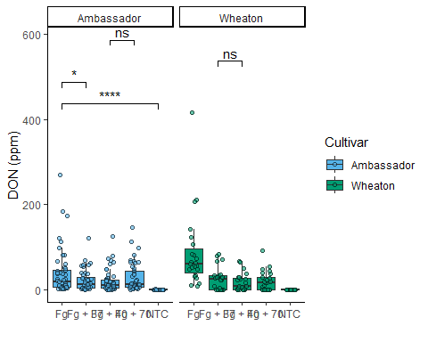

X15ADONplot.pwc <- ggplot(Mycotoxin_Data, aes(x = Treatment, y = X15ADON, fill = Cultivar)) +  
 geom_boxplot(outlier.shape = NA) +   
 xlab("") +   
 ylab("15ADON") +   
 geom_point(alpha = 0.6, pch = 21, color = "black", position = position_jitterdodge()) +  
 scale_color_manual(values = c(cbbPalette[3], cbbPalette[4])) +  
 scale_fill_manual(values = c(cbbPalette[3], cbbPalette[4])) +  
 theme_classic() +  
 facet_wrap(~Cultivar) +  
 stat_compare_means(method = "t.test", label = "p.signif",   
 comparisons = list(  
 c("NTC", "Fg"),   
 c("Fg", "Fg + 37"),   
 c("Fg + 37", "Fg + 40"),   
 c("Fg + 40", "Fg + 70")  
 ))   
  
X15ADONplot.pwc

## Warning: Removed 10 rows containing non-finite outside the scale range  
## (`stat_boxplot()`).

## Warning: Removed 10 rows containing non-finite outside the scale range  
## (`stat_signif()`).

## Warning: Removed 10 rows containing missing values or values outside the scale range  
## (`geom_point()`).

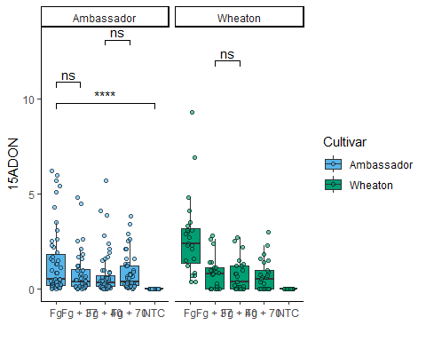

Seed.massplot.pwc <- ggplot(Mycotoxin_Data, aes(x = Treatment, y = MassperSeed_mg, fill = Cultivar)) +  
 geom_boxplot(outliers = F) +   
 xlab("") +   
 ylab("Seed Mass (mg)") +   
 geom_point(alpha = 0.6, pch = 21, color = "black", position = position_jitterdodge()) +  
 scale_color_manual(values = c(cbbPalette[3], cbbPalette[4])) +  
 scale_fill_manual(values = c(cbbPalette[3], cbbPalette[4])) +  
 theme_classic() +  
 facet_wrap(~Cultivar) +  
 stat_compare_means(method = "t.test", label = "p.signif",   
 comparisons = list(c("NTC", "Fg"),   
 c("Fg", "Fg + 37"),   
 c("Fg + 37", "Fg + 40"),   
 c("Fg + 40", "Fg + 70")))  
  
Seed.massplot.pwc

## Warning: Removed 2 rows containing non-finite outside the scale range  
## (`stat_boxplot()`).

## Warning: Removed 2 rows containing non-finite outside the scale range  
## (`stat_signif()`).

## Warning: Removed 2 rows containing missing values or values outside the scale range  
## (`geom_point()`).

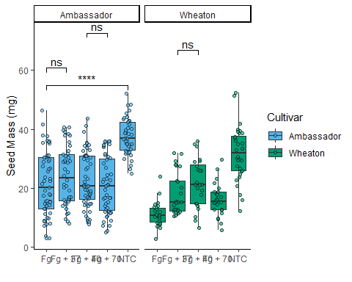

Combineplot.pwc <- ggarrange(  
 DONplot.pwc,  
 X15ADONplot.pwc,   
 Seed.massplot.pwc,   
 labels = c("A", "B", "C"),  
 nrow = 1,  
 ncol = 3,  
 common.legend = TRUE,  
 legend = "bottom"  
)

## Warning: Removed 8 rows containing non-finite outside the scale range  
## (`stat_boxplot()`).

## Warning: Removed 8 rows containing non-finite outside the scale range  
## (`stat_signif()`).

## Warning: Removed 8 rows containing missing values or values outside the scale range  
## (`geom_point()`).

## Warning: Removed 8 rows containing non-finite outside the scale range  
## (`stat_boxplot()`).

## Warning: Removed 8 rows containing non-finite outside the scale range  
## (`stat_signif()`).

## Warning: Removed 8 rows containing missing values or values outside the scale range  
## (`geom_point()`).

## Warning: Removed 10 rows containing non-finite outside the scale range  
## (`stat_boxplot()`).

## Warning: Removed 10 rows containing non-finite outside the scale range  
## (`stat_signif()`).

## Warning: Removed 10 rows containing missing values or values outside the scale range  
## (`geom_point()`).

## Warning: Removed 2 rows containing non-finite outside the scale range  
## (`stat_boxplot()`).

## Warning: Removed 2 rows containing non-finite outside the scale range  
## (`stat_signif()`).

## Warning: Removed 2 rows containing missing values or values outside the scale range  
## (`geom_point()`).

Combineplot.pwc

