R Markdown tutorial

Vaibhav Shelar

2025-02-25

#This is an example of a R code.

## mpg cyl disp hp   
## Min. :10.40 Min. :4.000 Min. : 71.1 Min. : 52.0   
## 1st Qu.:15.43 1st Qu.:4.000 1st Qu.:120.8 1st Qu.: 96.5   
## Median :19.20 Median :6.000 Median :196.3 Median :123.0   
## Mean :20.09 Mean :6.188 Mean :230.7 Mean :146.7   
## 3rd Qu.:22.80 3rd Qu.:8.000 3rd Qu.:326.0 3rd Qu.:180.0   
## Max. :33.90 Max. :8.000 Max. :472.0 Max. :335.0   
## drat wt qsec vs   
## Min. :2.760 Min. :1.513 Min. :14.50 Min. :0.0000   
## 1st Qu.:3.080 1st Qu.:2.581 1st Qu.:16.89 1st Qu.:0.0000   
## Median :3.695 Median :3.325 Median :17.71 Median :0.0000   
## Mean :3.597 Mean :3.217 Mean :17.85 Mean :0.4375   
## 3rd Qu.:3.920 3rd Qu.:3.610 3rd Qu.:18.90 3rd Qu.:1.0000   
## Max. :4.930 Max. :5.424 Max. :22.90 Max. :1.0000   
## am gear carb   
## Min. :0.0000 Min. :3.000 Min. :1.000   
## 1st Qu.:0.0000 1st Qu.:3.000 1st Qu.:2.000   
## Median :0.0000 Median :4.000 Median :2.000   
## Mean :0.4062 Mean :3.688 Mean :2.812   
## 3rd Qu.:1.0000 3rd Qu.:4.000 3rd Qu.:4.000   
## Max. :1.0000 Max. :5.000 Max. :8.000

# This is how to include figures

library(knitr)  
library(ggplot2)  
library(rmarkdown)  
  
data("mtcars")  
ggplot(mtcars, aes(x = wt, y = mpg)) +  
 geom_smooth(method = lm, se = FALSE) +  
 geom_point(aes(color = wt)) +  
 xlab("Weight") +  
 ylab("Miles per gallon") +  
 scale_color_gradient(low = "forestgreen", high = "black")

## `geom_smooth()` using formula = 'y ~ x'

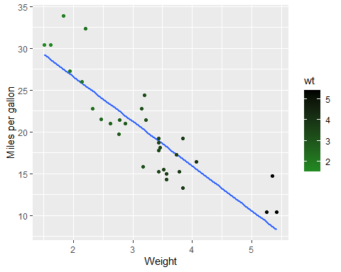

## R markdown fromatting options

# First level header

*this text is italics* **this text is italics** # double asterics for bold

1. one item
2. another item

* one subitem

## Links

[Link to my github](https://github.com/vbs0303/Class-Reports.git)

## Images

|  |
| --- |
| Shrek ggplot |

Shrek ggplot