TEST

1. Dart

Q4)

class Ride

{

double distance;

double ratePerKm;

bool peakHour;

Ride(this.distance, this.ratePerKm, this.peakHour);

double calculateFare()

{

double fare = distance \* ratePerKm;

if (peakHour) {

fare += fare \* 0.20; // 20% surcharge

}

return fare;

}

}

void main() {

List<Ride> rides = [

Ride(9, 15.0, false), // 10 km, normal hours

Ride(10, 20.0, true), // 8 km, peak hours

Ride(20, 12.0, true) // 15 km, peak hours

];

double totalEarnings = 0;

for (int i = 0; i < 3; i++)

{

double fare = rides[i].calculateFare();

totalEarnings += fare;

print("Ride ${i + 1} Fare: Rs.$fare");

}

print("\nTotal Earnings from all rides: Rs.$totalEarnings");

}

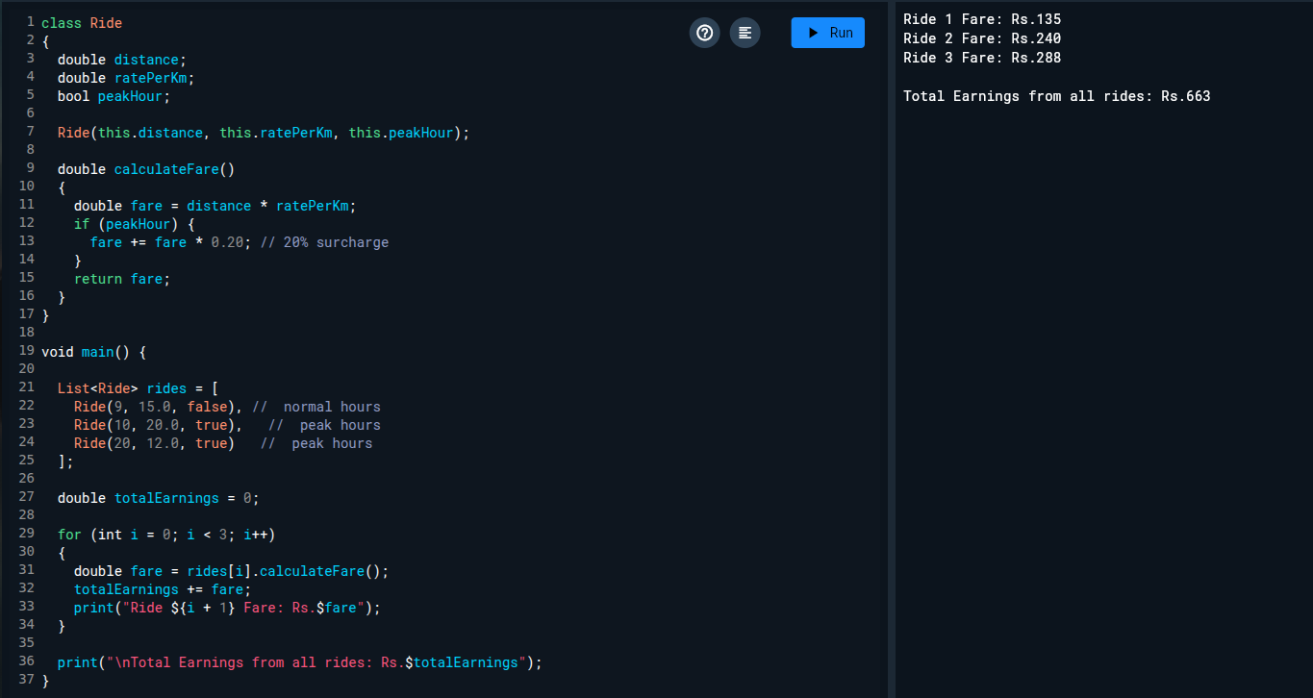

O/P:

Ride 1 Fare: Rs.135

Ride 2 Fare: Rs.240

Ride 3 Fare: Rs.288

Total Earnings from all rides: Rs.663

Q5)

void main()

{

List<Map<String, dynamic>> bookings = [

{"movieName": "MIB", "ticketsBooked": 3, "pricePerTicket": 250.0},

{"movieName": "F1", "ticketsBooked": 4, "pricePerTicket": 300.0},

{"movieName": "Avengers", "ticketsBooked": 5, "pricePerTicket": 400.0}

];

double total = 0;

print("Booking Summary:\n");

for (var booking in bookings)

{

String movieName = booking["movieName"];

int tickets = booking["ticketsBooked"];

double price = booking["pricePerTicket"];

double totalCost = tickets \* price;

total += totalCost;

print("Movie Name: $movieName");

print("Tickets Booked: $tickets");

print("Price per Ticket: Rs.$price");

print("Total Cost: Rs.$totalCost\n");

}

print("Grand Total from all bookings: Rs.$total");

}

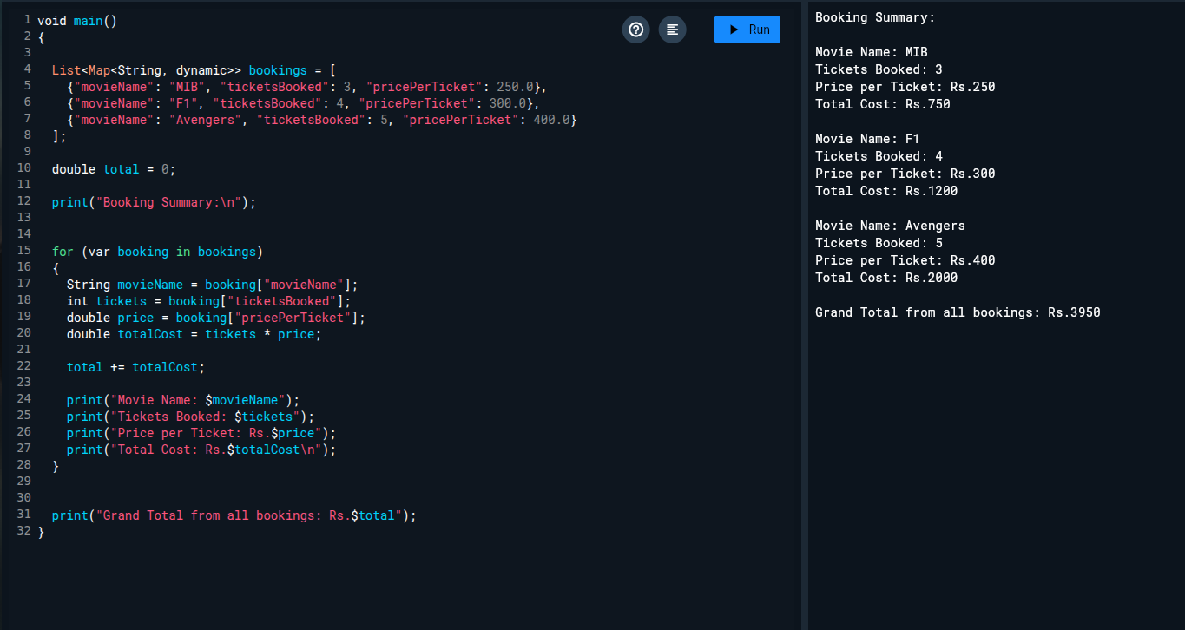O/P:

Booking Summary:

Movie Name: MIB

Tickets Booked: 3

Price per Ticket: Rs.250

Total Cost: Rs.750

Movie Name: F1

Tickets Booked: 4

Price per Ticket: Rs.300

Total Cost: Rs.1200

Movie Name: Avengers

Tickets Booked: 5

Price per Ticket: Rs.400

Total Cost: Rs.2000

Grand Total from all bookings: Rs.3950