Highlights the differences between customers who did and did not accept the coupons.

**Age and Gender Analysis of customers coupon acceptance –**

**Below age 21 show greater tendency to accept the coupons.**

**It decreases by age and suddenly goes back up at 50plus.**

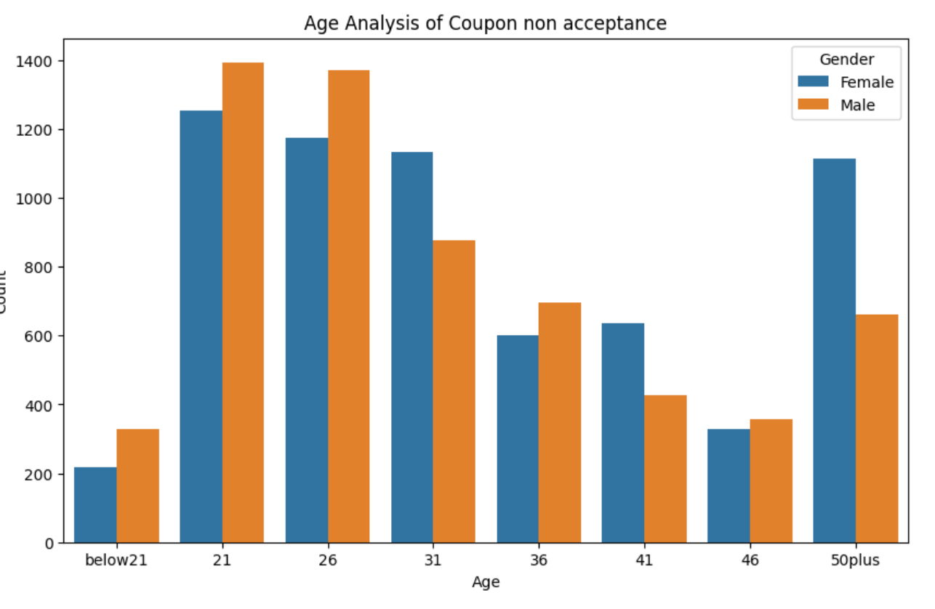

**Marital Status Analysis of customers coupon acceptance –**

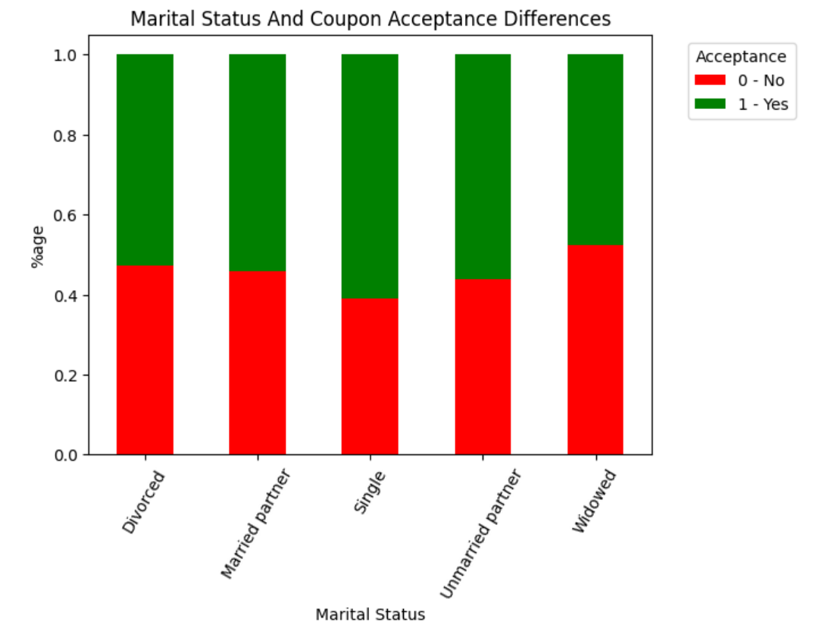

**Single customers have the highest acceptance rate 60%. Widows are less likely to accept coupons at about 47%.**

**Occupation Analysis of customers coupon acceptance –**

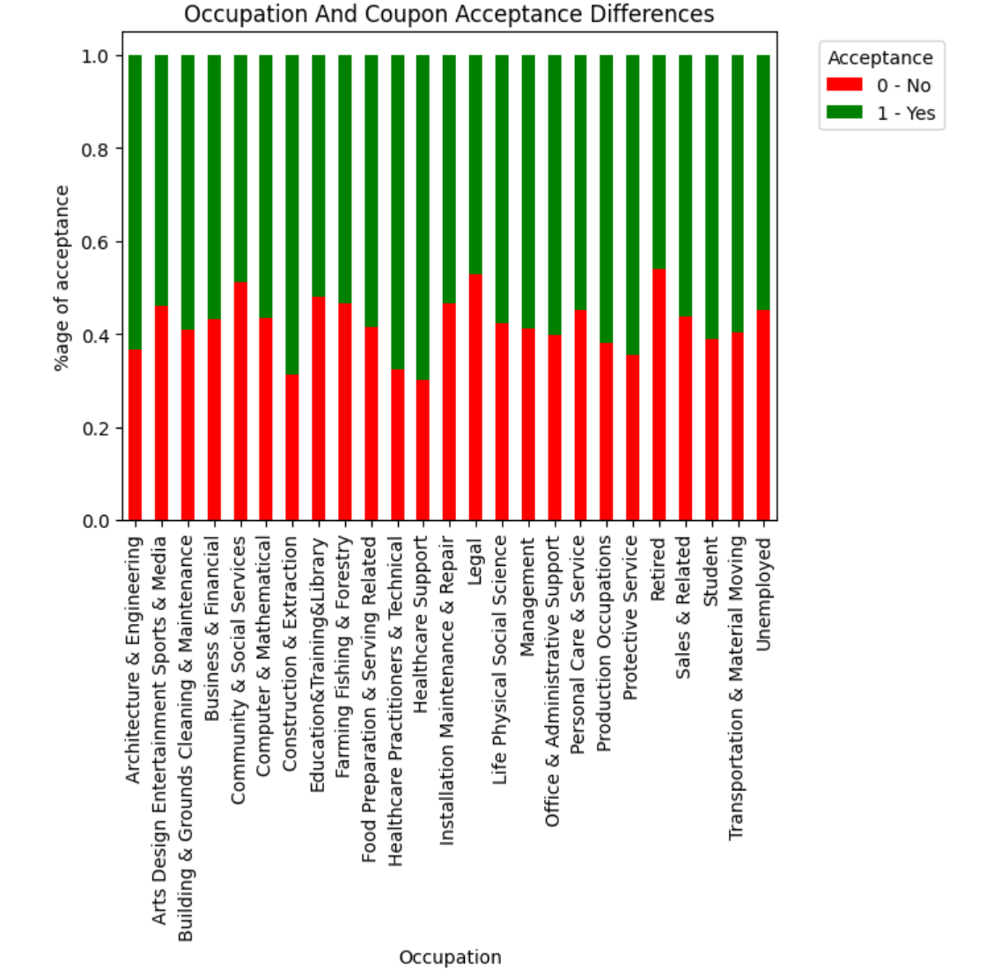

### Healthcare Support occupation has the highest acceptance rate 69%. Retired customers accepts the least 54%.