**Security and business opportunities in Minas Gerais.**

by Victor

1. Introduction:

Minas Gerais is a state that has had a relative increase in its indexes of theft to establishments. That is why it is important when analyzing new businesses to take this important variable into account.

2. Problem:

Data can help bring new business opportunities to safer neighborhoods. However, few customers analyze these aspects before creating their establishments. Taking this opportunity for analysis seems to be a good investment.

3. Interest:

The interest is justified by the lack of companies that analyze criminality and business opportunities in the region.

**Data acquisition and cleaning:**

4. Data Sources:

Minas Gerais Safety Data:

<http://www.seguranca.mg.gov.br/images/2020/Marco/Banco%20Alvos%20de%20Roubo%20-%20Atualizado%20Janeiro%202020.csv>

Foursquare data.

5. Data Cleaning:

As for the data, a cleaning was done. In the security data we take filters for cases of theft to establishments and focus on those neighborhoods that have only a maximum of 2 cases of theft. Then we filter the longitude and latitude of these neighborhoods in order to assess which types of establishments are most nearby in order to assess business opportunities.

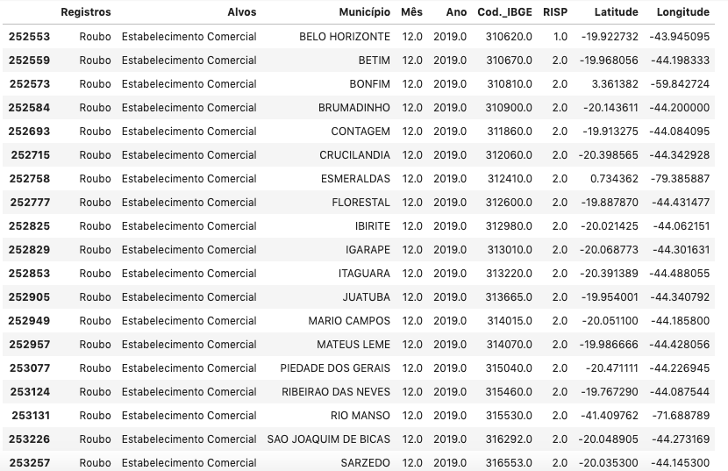

6. Conclusion:

We can see the following results:

1 - Belo Horizonte is the safest place.

2 - Bar is the worst business option, followed by restaurant and gym.

We can conclude that food options are not a good deal in this area.