Program: Password Management Program

Author: Visente Carlos

GitHub: <https://github.com/vcarlos007/CIS480Project.git>



Made several important security-focused changes made to the user management system since the previous submission:

1. A login page has been implemented, requiring username and password authentication before accessing the system. This adds a crucial layer of access control. With the .js code review the user needs to use the credentials of the code to access the program.

1. The user management interface now includes functionality to add new users and change passwords. This allows for proper credential management. Changing from current password to the new password as a two-stage verification. By selecting the view Users Table it would allow a view of very input that was inputted in.

1. Passwords do display in plaintext on the user’s table. To suggest that they appear some form of encryption or hashing is now being used to protect password data.

1. The ability to view the full users table has been restricted behind the authenticated interface, preventing unauthorized access to user information. Also gives the ability to edit or delete user information and password.

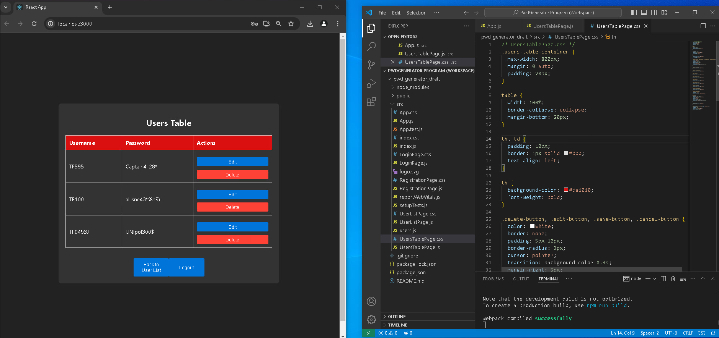

5. Logout functionality has been added, allowing users to securely end their sessions.

These changes significantly improve the security posture of the application by implementing basic authentication, protecting sensitive data, and providing user management capabilities. The system now follows some key security best practices for handling user accounts and access control.