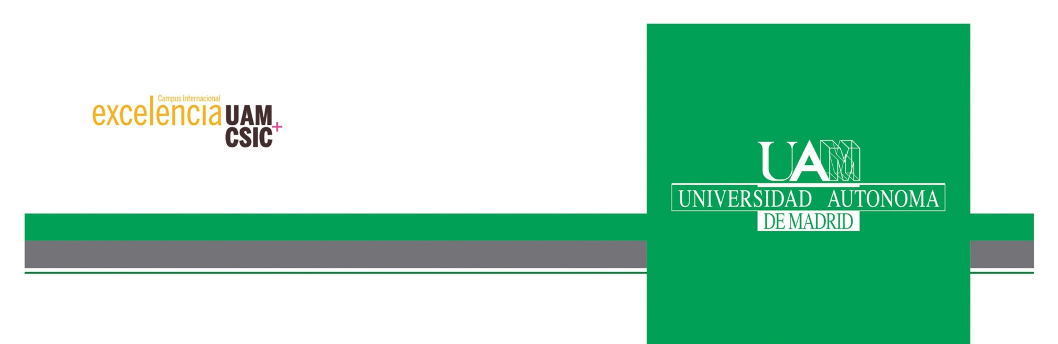

**Master Erasmus Mundus in**

Theoretical Chemistry and Computational Modelling

**Master Thesis. Course 2020-2022**

**Master Erasmus Mundus in**

Theoretical Chemistry and Computational Modelling



**Hydrogen bonds in water clusters from an ELF perspective**

**Director: Dra. Julia Contreras-García**

**Codirector: Dra. M. Merced Montero-Campillo**

**Place where the project was carried out: Laboratoire de Chimie Théorique of Sorbonne Université**

**Victoria Castor Villegas**