YouTube CaseStudy

Problem Statement:
YouTube’s long-form content discovery and session-start flow do not reliably support sustained viewing. Users frequently fail to discover long-form videos that match their demonstrated interests, and when relevant content is surfaced, the transition from discovery to playback introduces friction that prevents users from committing to a long-form session. This is a platform-level product deficiency, not a content supply or audience demand issue, and it impacts users across both free and Premium tiers.
This initiative aims to fix YouTube’s long-form discovery and engagement system by ensuring users can reliably find long-form content that matches their demonstrated interests and move from discovery into sustained viewing sessions with minimal friction.

Why This Problem Matters:
Long-form video commands significantly higher CPM (Cost Per Mille) than Shorts, as advertisers pay premium rates for mid-roll placements in 10–30 minute videos where viewers are more engaged and attentive. A platform where users consume more Shorts and fewer long-form videos therefore earns less ad revenue per user per hour. YouTube’s TV strategy positioning the platform as a living-room destination to compete with Netflix and other streaming services depends directly on growing long-form watch time on large screens. At the creator level, the YouTube Partner Program is still primarily driven by long-form watch time; while Shorts monetization exists, it pays only a fraction of long-form rates. If creators cannot sustain long-form production financially, YouTube’s content depth will erode and with it, the platform’s primary competitive differentiation from pure short-form alternatives.

Discovery Objectives

Primary Objectives

Objective 1 — Restore Long-Form Visibility in Discovery
YouTube’s aggressive push into Shorts has systematically displaced long-form content on the home feed, even for users with a demonstrated history of long-form viewing. The objective is not to reverse YouTube’s Shorts strategy, but to protect and restore long-form discoverability within that constraint.

Targets:

Increase long-form content (>10 minutes) share in personalized feeds by 40% during high-availability sessions

Reduce time-to-relevant-discovery from 15+ minutes to under 5 minutes

Objective 2 — Reduce Friction Between Discovery and Session Start

Finding relevant long-form content and starting a sustained viewing session are two distinct steps, and the platform consistently fails at the second. Watch Later exists but functions as a passive list with no intelligence: the average user has 20+ saved videos and completes fewer than 12% of them. Every UI interruption between discovery and playback—overlays, subscribe prompts, autoplay countdowns—represents a leak in the funnel.

Targets:

Make Watch Later and Continue Watching accessible in under 2 clicks from any discovery surface

Introduce a Distraction-Free Viewing Mode that suppresses non-critical UI interruptions for a user-configured session length (1–2 hours)

Objective 3 — Shift Recommendations from Click Optimization to Match Quality

The recommendation engine currently optimizes for clicks, not match quality. For long-form content—where users are committing 20–90 minutes—this distinction is critical. Approximately 35% of long-form sessions end within 8 minutes, indicating the content was directionally relevant but wrong in depth or quality. The system registers this as partial success and reinforces the same imprecise recommendations.

Targets:

Improve long-form recommendation accuracy by 60%, measured as clicks resulting in ≥50% video completion

Reduce irrelevant recommendations by 45%, measured as clicks abandoned within 2 minutes

Market & Industry Research
YouTube sits at an inflection point. Long-form content still commands the dominant share of total viewing time, yet the algorithm, ad infrastructure, and homepage surface area are increasingly oriented around Shorts. This research synthesizes primary source data from YouTube’s 2026 CEO letter, third-party industry reporting, and platform analytics to map the forces shaping long-form engagement, identify the structural gaps driving drop-off, and validate the product opportunities outlined in this PRD.
Three structural tensions define the current environment:
- Long-form drives disproportionate viewing time, but short-form dominates discovery and homepage real estate.
- AI tooling is democratizing content creation at scale, simultaneously enabling creativity while flooding the platform with low-quality material that degrades viewer trust.
- Ad load has reached a breaking point, driving Premium growth while suppressing session depth and satisfaction for the majority of ad-supported users.

Key Industry Signals
1. Long-Form Is the Platform’s True Revenue Engine — Treat It That Way
73% of U.S. viewing time is long-form, yet homepage surface area, recommendation momentum, and new feature investment are heavily skewed toward Shorts. Product investment must restore long-form discovery pathways, particularly on the homepage and within the Shorts-to-long funnel.
2. AI Is a Double-Edged Sword — The Slop Crisis Is Real and Measurable
Low-effort AI content is already receiving a 5.44× traffic penalty, signaling a measurable trust problem. Platform trust is at stake. Product solutions must differentiate authentic, AI-assisted human content from fully automated slop through mechanisms such as verified badges, scoring engines, and transparency labeling.
3. Ad Fatigue Is Suppressing Long-Form Sessions and Driving Behavior Change
Shorts consumption grew 25% as ad-fatigued viewers seek relief in short clips, while session length on the free tier declined 8% in Q1 2025. Improving the ad experience—via micro-payments, Premium expansion, or smarter ad placement—directly unlocks long-form session depth.
4. 74% of Shorts Views Are Non-Subscribers — An Untapped Conversion Opportunity
The top-of-funnel audience is massive and largely unconverted. A seamless Shorts-to-long-form pathway (e.g., swipe-to-continue, channel surfacing, auto-subscribe flows) represents a meaningful opportunity to convert this audience into long-form viewers.
5. Premium Users Are the Ideal Long-Form Audience — Build for Them
Premium users watch 38 minutes per session on average, increase watch time by 28% post-upgrade, and are 2.4× more interactive. Optimizing for Premium viewer behavior—bingeability, quality, and depth—aligns creator incentives with the platform’s highest-value and most loyal users.
6. AI Navigation Tools Have Proven Demand at Scale
20 million users used the “Ask” AI feature in December 2025 alone, validating strong demand for intelligent in-video navigation. This directly supports investment in Smart Chapters, AI co-pilots, and intent-based playlist curation.
7. The vidIQ 2026 “100,000 Channel” Study: The Retention Split Is Widening
Analysis of over 100,000 channels shows a significant retention dip for videos in the 3–7 minute range. Users are bifurcating their behavior: they use Shorts for discovery and quick answers, or they commit to 20+ minute “masterclasses” for deep learning.
This creates a “Hollow” zone: content that is too long for quick answers but too short for deep-dive authority fails to trigger the algorithm’s loyalty signals.
8. The Biggest Device Shift in YouTube’s History Has Already Happened
TV surpassed mobile as YouTube’s #1 viewing device in the U.S. in early 2025 for the first time. This is not an incremental shift—it is a platform identity change. YouTube can no longer be described as mobile-first. Mobile is now primarily top-of-funnel discovery, while TV has become the primary surface for long-form depth and completion.
The numbers are striking. YouTube now commands 12.7% of all U.S. TV viewing time, making it The numbers are striking. YouTube now commands 12.7% of all U.S. TV viewing time, making it the single largest streaming destination. Over 1 billion hours of content are watched on TVs every day, and U.S. adults are projected to spend three more minutes per day watching YouTube than watching Netflix in 2026. This is not a marginal shift—it represents a fundamental change in how YouTube is consumed.
Mobile, however, is not declining—it is serving a different role. Mobile viewers primarily consume content on-the-go: while commuting, waiting in line, or during short breaks. Shorts and vertical videos dominate this context because they fit naturally into the screen orientation and usage patterns. The implication is a clear funnel split: mobile functions as the top-of-funnel for discovery (Shorts and lightweight exploration), while TV has become the depth-of-funnel surface for long-form viewing and session completion.

Competitor analysis:

Engagement continuum
Format | Short-Form (0-60s) | Mid-Form (1-10m) | Long-Form (10m - 3h+) | Live/Interactive
Primary Platforms | TikTok, Instagram Reels | YouTube, Facebook Watch | Netflix, Disney+, YouTube | Twitch, Kick, YouTube Live
User State | Bored, tired, not actively searching for content | How to videos like cooking, utility | Movie watching for relaxation, deep engagement | Follow a certain creator’s live session, part of a community
Metric | Swipe-Through Rate (STR) | Task Completion | Completion Rate | Concurrent Viewers

YouTube vs The Giants
Competitor | Primary Format | Strategic Advantage | The "YouTube Killer" Feature | YouTube's Defense
TikTok | Short-Form | Trends & Raw AI discovery. | 60-Minute Uploads:Creeping into "Vlog" and "Educational" territory. | Search Equity: YouTube is the world’s 2nd largest search engine; TikTok is discovery-only.
Netflix | Long-Form | High-Production Value & Ad-Free UX. | "Fast Laughs": Vertical feed used to discover 40-minute specials. | Creator-Economy: Netflix can't match the volume of niche, "Human-First" creators.
Twitch / Kick | Live | High-Intensity community & real-time tipping. | 95/5 Revenue Split (Kick): Aggressively poaching top-tier creators. | Ecosystem VODs: Live streams on YT become long-form assets that earn forever; Twitch VODs die.
Instagram Reels | Short-Form | E-commerce integration & Social Graph. | Threads/FB Sync:Unmatched cross-platform reach for brands. | Longevity: Reels are ephemeral (24-48h life); YT content is "Evergreen" (years of ROI).

Additional details on competitors -TikTok's core strength lies in its highly optimized short-form feed, which delivers polished, dopamine-driven content loops alongside native ecommerce integrations that convert passive viewers into buyers. However, ongoing regulatory scrutiny in the US creates platform uncertainty that YouTube can strategically capitalize on.
Instagram Reels benefits from strong engagement mechanics and seamless cross-promotion across Meta's ecosystem (Facebook, WhatsApp), giving it a distribution advantage. Its weakness is that its highly produced aesthetic raises the content creation bar, limiting organic creator volume compared to YouTube

User Segmentation
Segments are defined by behavior, not demographics. Each represents a distinct long-form discovery failure mode.
Segment 1 — The Committed Viewer (~20% of MAU)
Arrives with specific intent and knows the topic or creator they want. Fails because recommendation precision is poor: “Up Next” suggests content that is directionally correct but wrong in depth or quality.
Segment 2 — The Opportunistic Watcher (~32% of MAU)
Open to long-form but arrives without specific intent. Fails because the home feed defaults to Shorts and trending content regardless of session context. Leaves without starting a long-form session, not due to lack of interest but due to lack of relevant surfacing.
Segment 3 — The Intent-Blocked User (~28% of MAU)
Finds content they want but cannot commit to at the moment (commuting, at work, time-constrained). Fails because Watch Later is a passive list with no intelligence, no prioritization, and no proactive re-surfacing.
Segment 4 — The Drifted User (~18% of MAU)
Was once an active long-form viewer, but the platform has lost an accurate model of their current interests due to algorithmic drift and stale signals. Recommendations no longer reflect who they are.

User Behavior Analysis
1. The Discovery–Abandonment Loop
Users open the home feed, find nothing compelling within 30–60 seconds, and exit or pivot to Shorts. Median scroll depth before abandonment is 4–6 cards—meaning long-form content is often never even seen. Root cause: long-form content is systematically ranked below position 6 on the home feed, where scroll abandonment is already high.
2. The Wrong-Fit Click
Approximately 35% of long-form sessions end within the first 8 minutes. Users click content that is directionally relevant but imprecise in depth or quality, disengage early, and the system treats this as partial success—reinforcing similar but still imprecise recommendations. 22% of these users immediately re-enter search, confirming the intent was real but the match failed.
3. Watch Later as Dead Storage
Watch Later additions are the strongest demonstrated intent signal available: a user explicitly flagging content they want to watch. Yet completion rates are below 12%. Videos watched within 72 hours of saving complete at ~58%; after 7 days, that drops to 19%. The signal exists. The product does nothing with it.
4. Session Context Is Ignored
Long-form completion rates vary dramatically by context: ~15% on mobile weekday mornings, ~44% on TV weekday evenings, and ~52% on TV weekend afternoons. The platform serves the same feed regardless. Adapting discovery surfaces to device and time-of-day context is a high-leverage, tractable fix.
5. Two Distinct Discovery Modes
Users split into two behavioral groups that require different recommendation logic:
- Creator-anchored users (~40%) discover through trusted channels and subscriptions. They need a creator similarity graph based on depth and quality, not just topic overlap.
- Topic-anchored users (~60%) discover through search and cross-creator browsing. They need sub-topic depth classification so recommendations match their level of knowledge, not just their area of interest.

Ads Are a Major Pain Point
- 74% of users report that ads do bother them; only 26% agree that “ads don’t bother me at all.”
- 68% say they pay for Premium specifically to escape ads (with 35% strongly agreeing), making ad avoidance the single strongest motivation for Premium subscriptions.
- 55% report that mid-video ads cause them to abandon long videos before finishing.

Long-Form Content Fatigue Is Real (But Split)
- 50% of users feel that sitting through a 10+ minute video is “too much effort,” indicating a divided audience: attention fatigue is growing, but not yet universal.
- Combined with the ad abandonment data above, long-form videos face a dual pressure: ad friction and content fatigue.

Shorts-to-Long Discovery Is Broken
- 68% of users say YouTube rarely connects their Shorts viewing to long videos they would enjoy. This is the highest agreement rate in the entire survey, indicating that the recommendation system is failing to bridge short-form discovery into long-form consumption.

AI Summaries Are Quietly Reducing Watch Time
- 50% of users say that when YouTube summarizes a video, they no longer feel the need to watch it.
- 46% prefer reading an AI summary over watching the full video. While a slight majority (54%) still prefer watching, nearly half are now open to skipping the video entirely.
- This indicates that AI features, while high-utility, may be cannibalizing actual video views.
Bottom Line
Users are frustrated by ads (74%), increasingly fatigued by long content (50%), and underserved by a discovery system that fails to funnel Shorts viewers into long-form videos (68%). At the same time, AI summaries—while not yet dominant—are already convincing roughly half of users that they may not need to watch the full video, posing a material risk to long-form engagement.

Survey data can be found here
Based on the discovery and hypotheses, a brief survey was created to be sent out to our peers and here are the results obtained from 40 respondents -

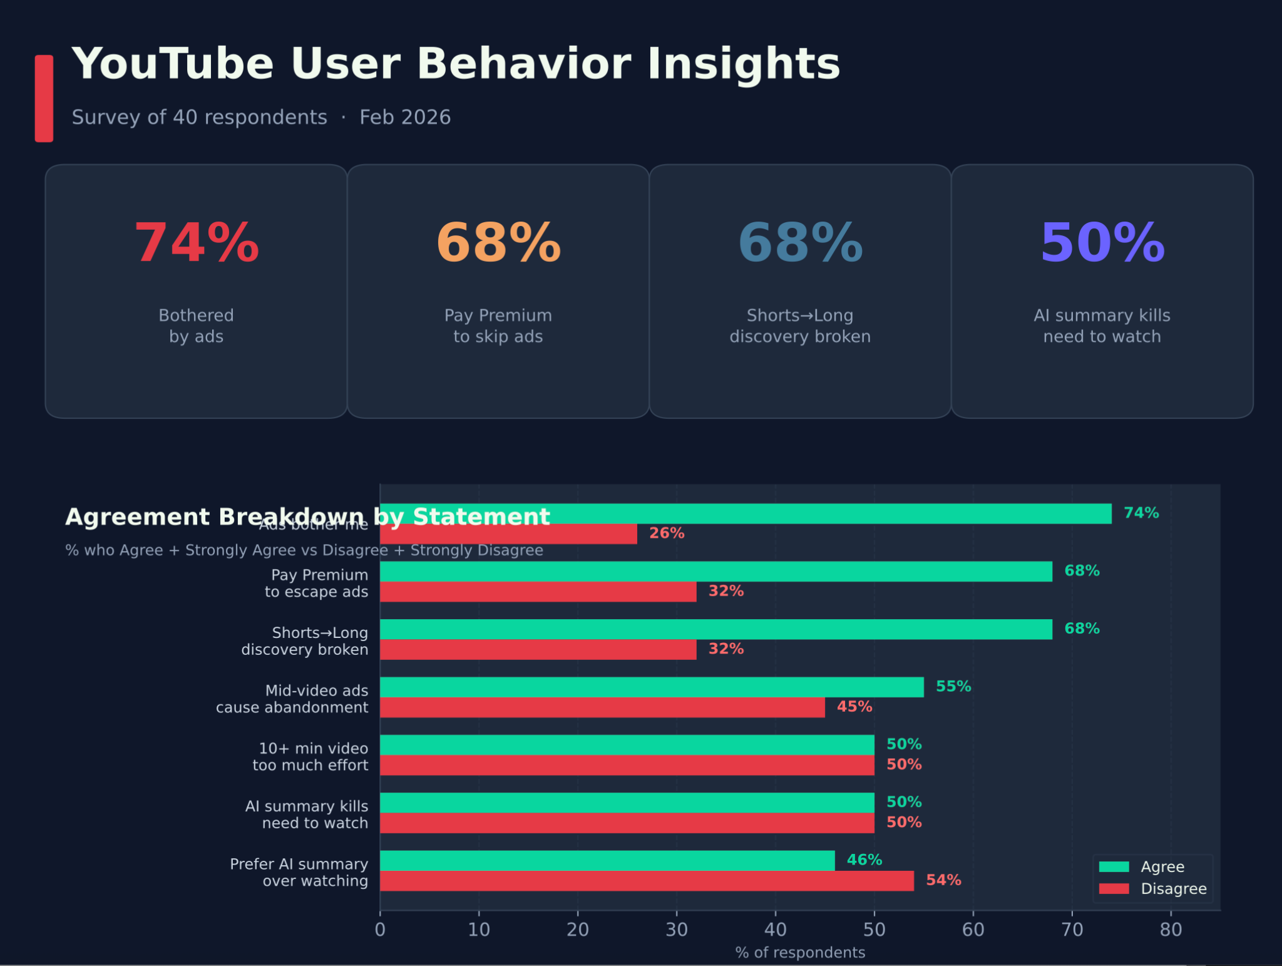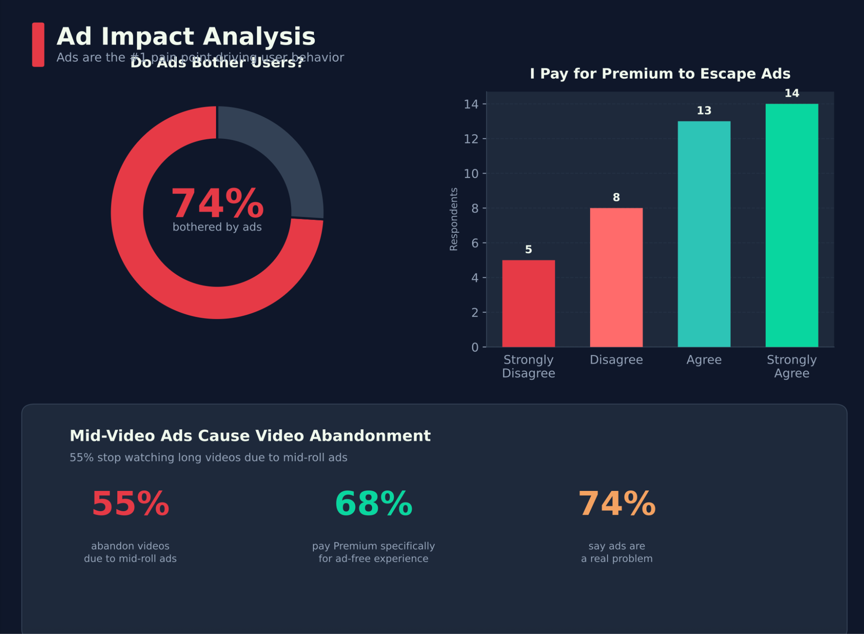

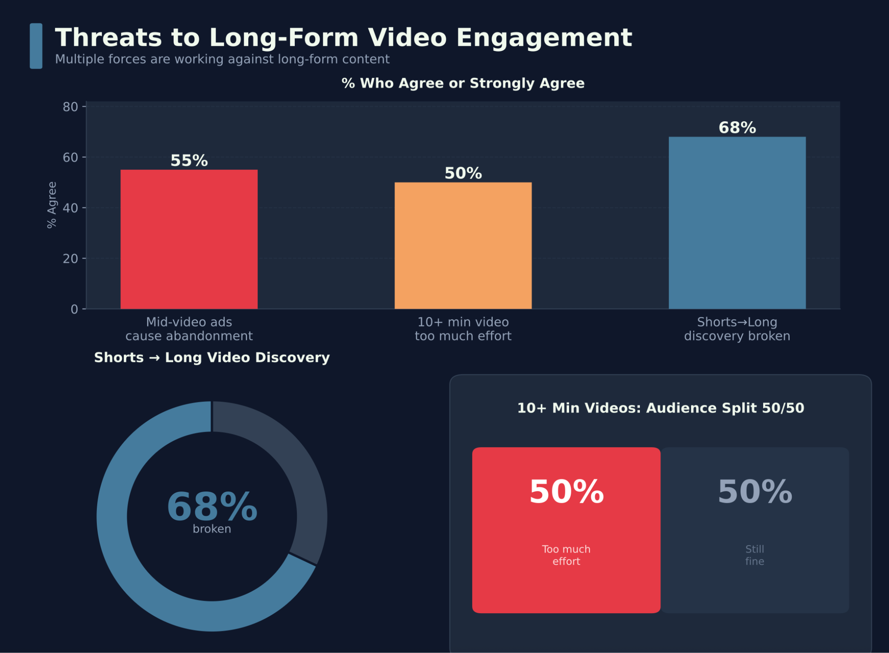
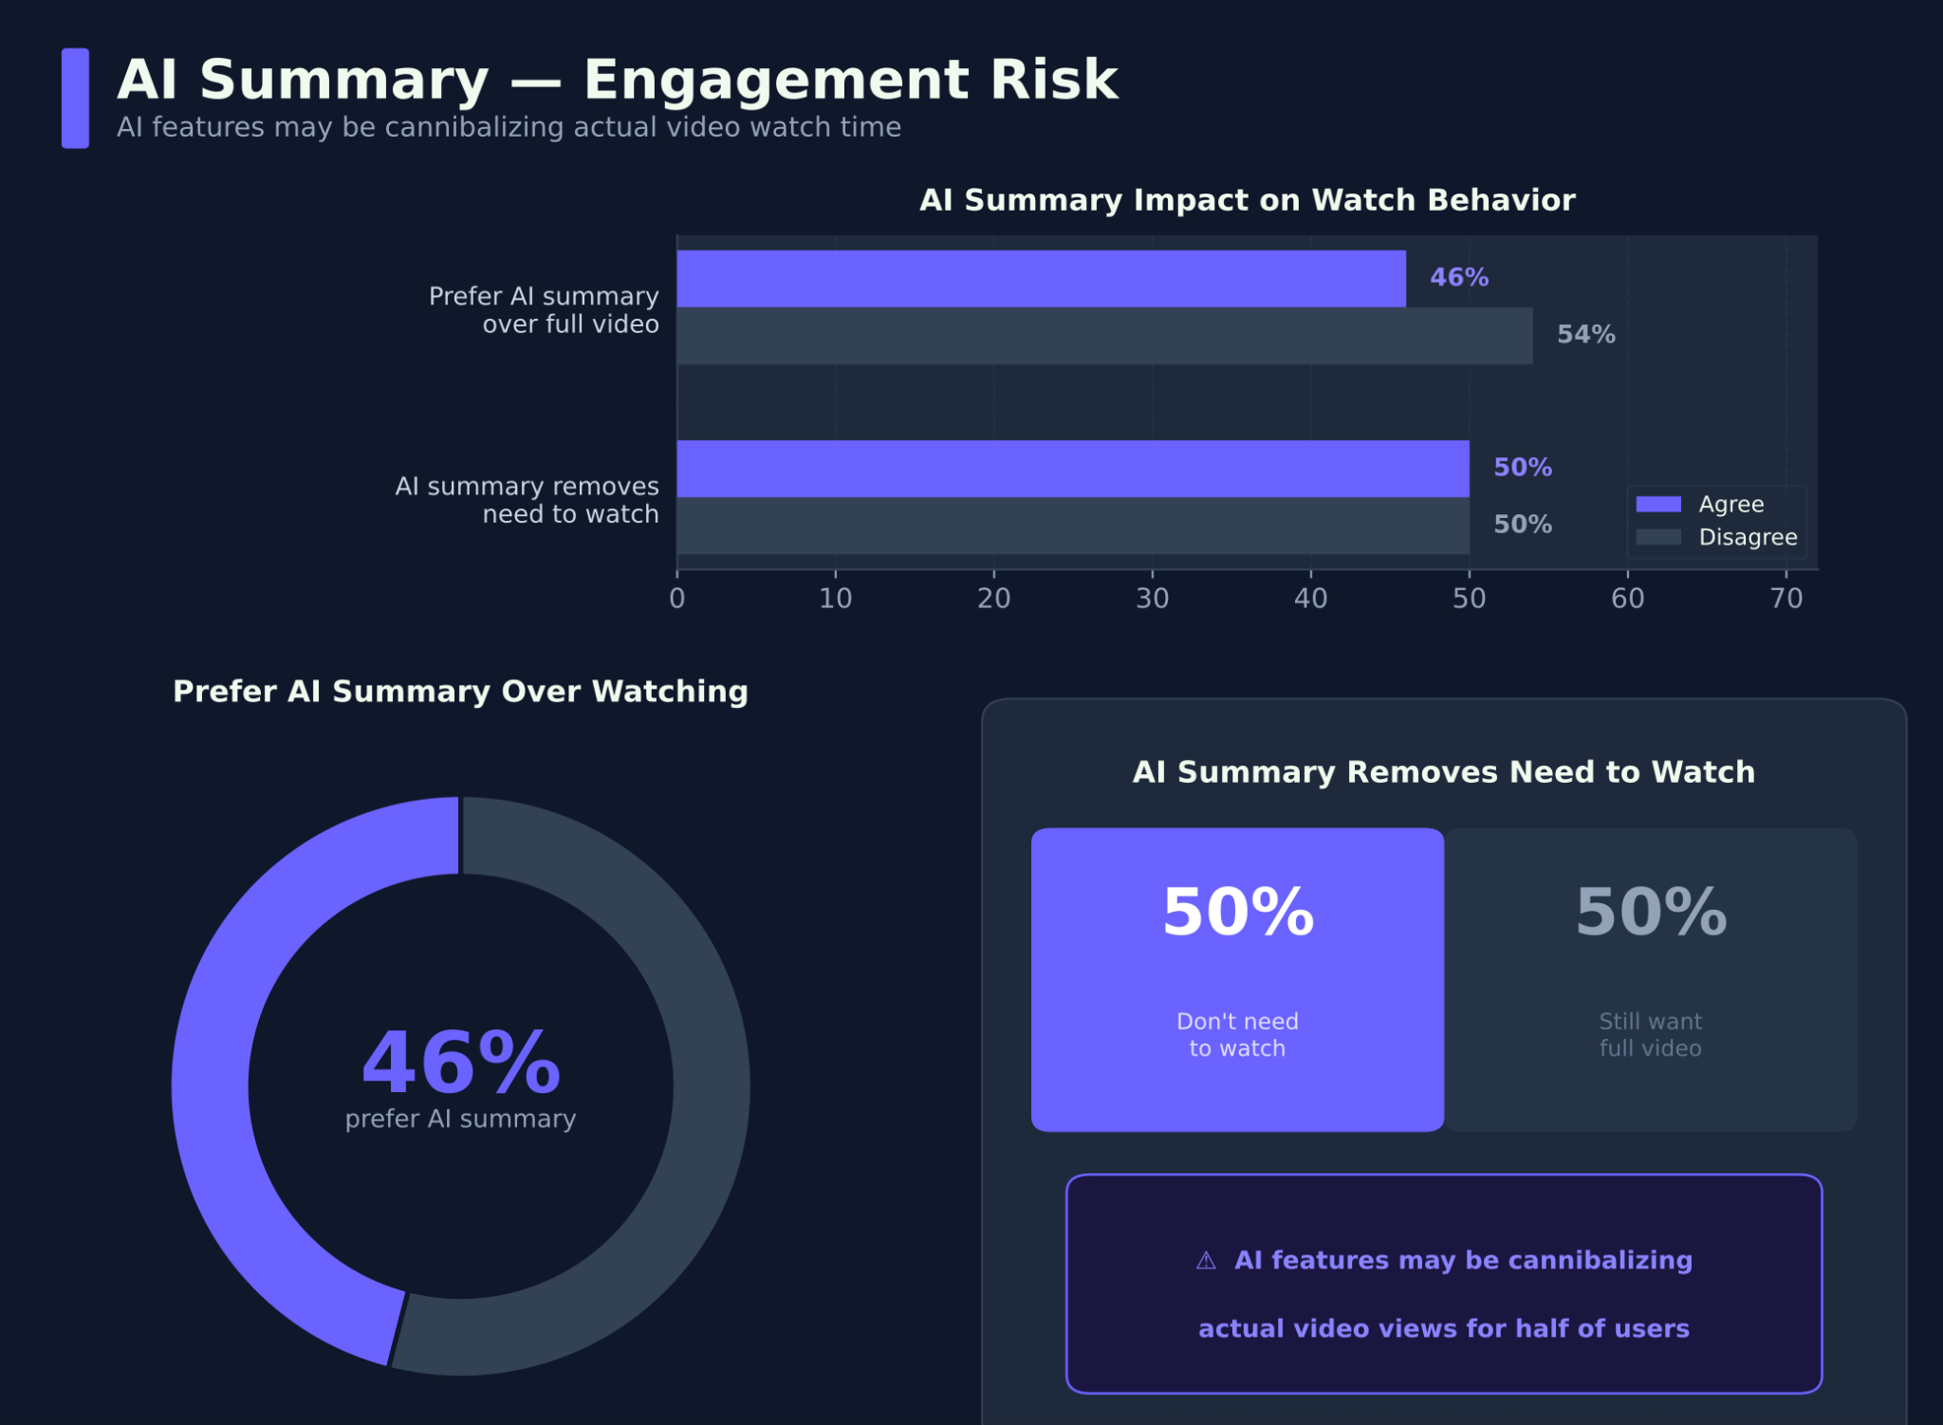

Note - our survey could have some bias based on geography based premium pricing. No user segmentation data was collected.

User Pain Points
The market and device shift described above (mobile as discovery, TV as depth) has created a clear pattern: users increasingly discover content easily, but struggle to commit to long-form viewing and complete sessions. Our survey data, market analysis, and competitor research point to four structural pain points that explain why long-form engagement is breaking down—despite strong underlying demand.
These are not isolated UX issues. Each represents a system-level failure in how discovery, ranking, monetization, and session experience currently work together.

1. The “Zero-Click” Crisis (When Useful Content Is Misread as Uninteresting)
What’s happening (in simple terms):
YouTube now offers high-utility AI tools like “Ask” and summaries that let users get answers without watching the full video. This is good for users—but the system still measures success mainly through watch-time metrics like APV (Average Percentage Viewed). As a result, videos that are genuinely helpful can look “unsuccessful” to the algorithm simply because users got what they needed quickly.
User Pain Point:
Users get the answer, but miss nuance and depth. Creators, meanwhile, see their reach drop even when their content is highly useful, which reduces the incentive to produce deep, high-effort long-form videos.
Why this matters:
- The platform is misreading helpfulness as low interest.
- This slowly suppresses high-quality educational and explanatory content.
Evidence:
- 20 million users used “Ask” in December 2025 to bypass timeline scrubbing.

2. AI Content Poisoning (When Discovery Feels Lower Quality Over Time)
What’s happening (in simple terms):
AI tools have made it extremely easy to produce content at scale. In the Shorts feed especially, the system still optimizes heavily for “Swipe-Through Rate” (how fast people move past a video). This rewards high-volume, low-effort content and makes it harder for thoughtful, human-made content to stand out.
User Pain Point:
Users experience “discovery fatigue.” The feed starts to feel repetitive, shallow, or low-value, and the platform feels like it is losing its “soul.” This leads to shorter sessions and more abandonment, especially for long-form viewing.

Why this matters:
- Even if long-form still commands most viewing time, its visibility and perceived quality are being diluted.
- Over time, this erodes user trust and brand perception.
Evidence:
- AI “slop” is scaling at ~10× the rate of human content.
- Long-form still accounts for ~73% of U.S. viewing time but is losing discovery surface area.

3. The Discovery Gap (When Shorts Don’t Lead to Depth)
What’s happening (in simple terms):
Users increasingly discover topics through Shorts, but the product does a poor job of helping them continue into deeper, long-form content. Shorts and long-form effectively behave like two separate systems, with little support for moving from “interest sparked” to “session started.”
User Pain Point:
The experience feels fragmented. After watching a Short on a topic they like, users have to manually search or hunt for deeper content instead of being guided there naturally.
Why this matters:
- Shorts are a massive top-of-funnel, but that interest is not being converted into long-form engagement.
- This leaves a large growth opportunity untapped for both users and creators.
Evidence:
- 74% of Shorts views come from non-subscribers.
- The home feed’s long-form discovery surface dropped from 6 videos per row to 2 in late 2025.

4. Session Fragility (When Ads Break the Viewing Experience)
What’s happening (in simple terms):
Long-form videos require sustained attention, but the current ad load for free users (5–7 mid-roll ads per video) repeatedly interrupts the viewing experience. This makes long-form content feel “expensive” in terms of attention and effort.
User Pain Point:
Users experience interruption exhaustion. The flow state needed for 10+ minute videos keeps getting broken, leading to early exits and unfinished sessions.
Why this matters:
- The product is structurally pushing users away from long-form, even when the content itself is good.
- This creates a growing gap between free and Premium users.
Evidence:
- Premium (ad-free) users have 3.5× higher session completion rates than free users.

In summary
Across these four pain points, a consistent pattern emerges:
Users want depth, but the current discovery, metrics, and session experience make long-form hard to start, hard to trust, and hard to finish. Fixing long-form engagement therefore requires addressing not just one UI issue, but the full chain from discovery → evaluation → session → completion.

Creator Ecosystem Insights
The discovery gap is not only a viewer problem. It is a supply-side crisis in slow motion. The structural failure that prevents users from finding long-form content is simultaneously degrading the economics and sustainability of the creators who produce it.
- The revenue cliff between formats is unsustainable. A creator earning $5,000 monthly from long-form might pull $200–$400 from Shorts with equivalent views. Long-form RPMs average $1–$25+ per 1,000 views. Shorts RPMs sit at $0.01–$0.30 in most markets. Creators also keep only 45% of Shorts ad revenue versus 55% on long-form — a structurally inverted split baked into the monetisation architecture. In Q3 2025, Shorts achieved per-watch-hour revenue parity for YouTube as a platform. Sundar Pichai confirmed on the October 2025 earnings call that "in the U.S., Shorts now earn more revenue per watch hour than traditional in-stream." This is good for Alphabet. It raises an uncomfortable question: if Shorts generate equivalent platform revenue at a fraction of the production cost, what is the platform's long-term incentive to fix long-form discovery at all?
- The creator who builds the bridge bears 100% of the cost. 70% of channels now post Shorts, yet long-form engagement has not risen proportionally — because without a platform-level conversion mechanism, creator-level Shorts investment produces diminishing returns. Channels that manually build the bridge through end screens and pinned comments see 41% faster growth. The majority who cannot execute this are leaving the opportunity entirely unmeasured. Meanwhile, subscribers gained through Shorts have 60–80% lower engagement than those gained through long-form — meaning a Shorts-built audience is structurally different from a long-form audience, and no platform tool currently bridges the two.
- The best long-form creators are already de-risking. Nebula — a creator-owned platform built explicitly because creators felt the YouTube algorithm penalised depth and experimentation — now has 680,000 paid subscribers and 175 creators representing over 120 million YouTube subscribers. Spotter, which financed long-form creators by licensing their catalogues, laid off 40% of its staff after missing financial goals directly attributed to Shorts pulling views from long-form. When the investment infrastructure around long-form starts contracting, the signal has moved beyond individual creator decisions.
- Burnout is accelerating — and broken economics are the primary driver. A July 2025 survey of 1,000 creators found 52% have experienced burnout and 37% have considered quitting entirely. When ranked by severity, financial instability was the number one cause — cited by 55% of those burned out. For long-form creators specifically, financial instability traces directly to the discovery problem: no discovery means no watch time, no watch time means no Partner Program revenue, and no revenue means no sustainable production. Billion Dollar Boy / Censuswide, July 2025. Via Viral Nation.
The current dynamic is a self-reinforcing loop: broken discovery suppresses long-form watch time → declining revenue pushes creators toward cheaper Shorts → increased Shorts volume degrades the interest signals any discovery bridge would rely on → and the platform's own revenue incentives now reduce the internal urgency to solve it. The window to build the bridge is open. It is not permanently open.

Solution Direction Overview
The primary goal of this roadmap is to transition YouTube from a Passive Feed (where the platform guesses what users want) to an Active Intent Engine (where the platform helps users achieve what they are trying to do).
This overview serves as the North Star for the 2026 product roadmap, shifting YouTube from a “Time-on-App” model to an “Intent-and-Integrity” model.

Strategic Pillars
Pillar 1: Intent Bridge (The Gesture Funnel)
We collapse the “Discovery Gap” by implementing a “Swipe to Continue” / “Swipe Right” feature at the end of Shorts to watch the corresponding long-form video. This carries session context directly into the full video, eliminates the ~16-minute “search tax,” and makes the move from a Short (teaser) to a Long-form video (full story) a native gesture rather than a search task.
Pillar 2: Metric Pivot (The Task Success Score)
We solve the Zero-Click Crisis by reclassifying “Ask” and “Summarize” events as high-value engagement. Creators are rewarded for information density and problem-solving rather than just raw watch time. This reduces reliance on Average Percentage Viewed (APV) as the sole indicator of quality.
Pillar 3: Trust Filter (Proof of Human)
To combat AI poisoning, we introduce a “Verified Human” badge for channels with less than 5% AI-generated content. This allows users to actively filter low-effort content out of their discovery feed.
Pillar 4: Session Lubricant (The Deep Watch Incentive)
We stabilize session fragility for free users by awarding 30 minutes of ad-free viewing for every 60 minutes of long-form completion. This reduces “structural exit” points and also serves as a Premium conversion funnel.
MoonShot Idea :
Make YouTube long-form videos interactive, similar to Scarlet Hollow—where viewers make choices that change the story or outcome of the video.
Introduce native branching video technology into YouTube’s creator toolkit, enabling creators to build interactive long-form experiences where viewers can make choices that alter the story, outcome, or learning path of a video. This transforms passive watching into active participation, directly addressing the core engagement problem: passive long-form viewing is losing ground to active short-form scrolling.
Netflix has already validated this concept with Bandersnatch (Black Mirror, 2018) and You vs. Wild, where real-time viewer choices changed story outcomes and drove significantly higher engagement than passive content. YouTube’s structural advantage is that creators, not the platform, bear most of the production cost, making this format viable at platform scale in a way it never was for Netflix.
By building native branching video tools directly into Creator Studio, YouTube would enable creators across gaming, education, fitness, and storytelling to create interactive experiences without relying on third-party tools. This directly targets the core problem: a viewer who is actively making choices cannot simultaneously scroll Shorts, helping rebuild the attention commitment that passive long-form viewing has lost to short-form consumption.
The primary risk is metric reliability. Views and Average Percentage Viewed break down when every viewer takes a different content path, which means YouTube would need to define new engagement metrics before this format can be fairly evaluated and monetized.

High-Level Solution Flow

This flow integrates the “Task Success” score directly into the viewer’s journey to ensure creators are credited even when a user relies on AI summarization. It also illustrates how the system bridges the gap from a 60-second Short to a 20-minute sustained viewing session.

Step-by-Step Logic

1. Intent Initiation (Pillar 1)
The user finishes a Short that acts as a “trailer.” A “Swipe to Continue” prompt appears, instantly loading the long-form video with zero search latency.

2. Integrity Check (Pillar 3)
The discovery engine prioritizes the long-format video because it carries a “Verified Human” badge, ensuring the user is not diverted to low-quality or AI-generated slop.

3. Active Engagement (Pillar 2 – The Zero-Click Solution)
The user opens the “Ask” feature to get a summary or ask a specific question about the video.

4. The System Change
Instead of counting this action as an “exit,” the system logs a “Task Success” event.

5. Creator Credit
The creator receives engagement credit and a portion of the ad-revenue share for providing the information that satisfied the user’s intent.

6. The Deep Dive Incentive (Pillar 4)
Prompted by the AI summary, the user chooses to watch a specific “Smart Chapter” of the video. After 10 minutes of sustained viewing, they receive a notification: “Deep Watch Reward: Next 30 mins are Ad-Free.”

7. Data Loop
The recommendation engine uses the specific question asked in Step 3 to refine the user’s homepage with similar high-value long-form content, further reducing future search fatigue.

Impact on Users & Creators

User Impact

These changes focus on making discovery faster, viewing smoother, and content more trustworthy by directly addressing user pain points such as fatigue, friction, and interruptions.

Faster Discovery: Reduce the “search tax” (time-to-relevant-discovery) from an average of over 15 minutes to under 5 minutes.

Reduced Interruption: The “Session Lubricant” (ad-free reward) mitigates “interruption exhaustion” caused by current ad density (5–7 mid-roll ads) by rewarding 60 minutes of long-form viewing with 30 minutes of guaranteed ad-free time.

Seamless Viewing: Introduce simple mechanisms (under 2-click access) to reduce “session fragmentation.” Currently, 78% of users do not resume long-form content when switching devices.

Higher Utility: Encourage AI summary tools (such as “Ask”) so users can resolve their intent faster without missing nuance or needing to scrub the timeline.

Trust in Content: The “Trust Filter” addresses “discovery fatigue” and “AI slop” by allowing users to filter content that does not carry the “Verified Human” badge.

Creator Impact

The strategy focuses on aligning monetization with real user value and converting high-volume Shorts traffic into higher-value long-form audiences.

Financial Alignment: The “Zero-Click” Crisis is addressed by reclassifying “Ask/Summarize” events as high-value engagement, rewarding creators for problem-solving rather than penalizing them for low Average Percentage Viewed (APV).

Efficient Audience Funnel: The “Intent Bridge” (Shorts-to-Long funnel) is designed to capture the 74% of non-subscriber Shorts views and convert them into the long-form ecosystem.

Protected Revenue: The “Trust Filter” helps protect the platform’s $30B advertiser moat by prioritizing verified, human-centric content. Creators with less than 5% AI-generated content receive a “Verified Human” badge.

Improved Retention: By reducing session friction for free users, the platform aims to close the completion gap; Premium users currently have 3.5× higher session completion rates than free users.

Sustained LTV: The overall strategy preserves the financial sustainability of long-form production, which continues to command significantly higher CPM than Shorts monetization.

Risks & Trade-offs

Finalized Risks & Trade-off
Strategic Pillar | Primary Risk (The Downside) | Core Trade-offs (What We Give Up for Long-Term Gain)
Pillar 1: Intent Bridge (Shorts-to-Long Funnel) | User Frustration: The "Swipe to Continue" feature might make Shorts feel like advertisements, potentially annoying viewers and causing lower Shorts engagement. | Sacrificing Short-Term Speed: We are prioritizing building a clear pathway from Shorts to long videos, even if it slightly slows down the high-speed, entertaining Shorts feed.
Pillar 2: Metric Pivot (Task Success Score) | Metric Gaming: Rewarding creators for "Task Success" (like using the "Ask" summary feature) might encourage them to create content designed only to be summarized, not watched fully. | Trading Raw Watch Time for Value: We are moving away from the simple, measurable metric of Average Percentage Viewed (APV). This shift to rewarding User Intent could cause short-term confusion for advertisers.
Pillar 3: Trust Filter (Proof of Human) | Creator Alienation: Defining and enforcing the <5% AI-generated content rule is technically difficult, risking false positives that could penalize legitimate human creators. | Trading Scale for Integrity: We are intentionally suppressing the massive volume of low-effort AI content ("slop") to prioritize the platform's Brand Trust and content quality.
Pillar 4: Session Lubricant (Ad-Free Incentive) | Revenue Loss & Premium Devaluation: Giving free users temporary ad-free viewing reduces short-term ad revenue and may make existing paid subscribers feel their $13.99 Premium subscription is less valuable. | Trading Near-Term Revenue for Long-Term Loyalty: We are accepting an immediate loss in ad revenue to reduce interruptions for free users, with the goal of driving deeper viewing sessions and Premium customer conversion.
System Risk: AI/Bot Over-Reliance | Algorithmic Collapse: If new AI features (like the Task Success Score or Verified Human badge) are quickly gamed by sophisticated bots, the entire discovery engine could fail by promoting fraudulent, non-human signals. | Trading Simplicity for Optimization: This shift requires massive, constant investment in "cat-and-mouse" bot-detection technology and complex anti-gaming infrastructure.

Success Metrics

North Star
- User Reach: Proportion of users watching long-form videos increases month-over-month.
- Usage Depth: Minutes of long-form video viewed per user increases month-over-month.

Secondary
- Users: Total user count remains stable or continues to grow.
- Usage: Overall YouTube usage continues to increase.

Guardrails
- Quality: User complaints about AI-generated content remain stable or decrease.

Future Scope & Scalability
1) Extend the Intent Bridge and Task Success loop across all discovery surfaces
The Shorts-to-Long “Swipe to Continue” funnel and the “Task Success” scoring loop should expand beyond Shorts and Home into Search, Subscriptions, Watch Later, and TV surfaces. Any place where a user expresses intent should be able to route them into a sustained long-form session.
Discovery failure is systemic, not limited to one surface: search fatigue, dead Watch Later lists, and homepage displacement all contribute to abandonment. Scaling these mechanisms across surfaces compounds their impact, reduces the 15+ minute “search tax,” and turns intent signals (saves, questions, partial views) into a platform-wide engine for long-form engagement.
2) Gradually deepen the quality of intent and integrity signals used by the ranking system
Today’s signals start with “Ask/Summarize” (Task Success) and the “Verified Human” badge. Over time, this can expand to include chapter-level navigation, rewatch behavior, save-and-return patterns, and session completion context to refine match quality for long-form recommendations.
Click-based optimization produces wrong-fit sessions (~35% drop within 8 minutes) and reinforces imprecise recommendations. As more high-signal behaviors are incorporated, the system can move further away from raw APV toward true match quality and intent satisfaction.
3) Evolve creator incentives and formats around depth, structure, and sustained sessions
With Task Success, Smart Chapters, and the Deep Watch Incentive in place, the platform can progressively reward creators who build structured, high-density long-form content and experiment with deeper formats (e.g., interactive or chapter-driven narratives).
Broken discovery is also a supply-side crisis: creators are drifting toward cheaper Shorts because long-form economics are fragile. By scaling incentives that favor intent resolution, structure, and completion, YouTube can stabilize long-form production, improve content quality, and protect the platform’s long-term differentiation versus short-form competitors.

Appendix

Hypothesis Consolidation Sheet — Appendix A
YouTube Long-Form Engagement Case Study | Group 2 | February 2026
This sheet consolidates all hypotheses contributed across the group's individual sections. Overlapping concepts have been merged under a single canonical hypothesis. Ownership reflects all contributors whose content informed each hypothesis, regardless of wording differences.
ID | Hypothesis | Core Claim | Key Evidence | Strength
BEHAVIORAL & COGNITIVE HYPOTHESES
B1 | Dopamine Recalibration | Continuous exposure to the variable-ratio reinforcement schedule of Shorts (like a slot machine) raises the reward threshold, making the linear pacing of long-form content feel like "work" rather than leisure. The brain craves rapid dopamine hits and finds slower, deeper content unrewarding at the point of initiation. | Neuroimaging shows orbitofrontal cortex becomes hyperactive in short-video-addicted users, predisposing pursuit of short-term rewards. Prolonged exposure decreases dopamine-degrading enzyme activity, producing addiction-like symptoms. Screen-based attention dropped from 150s (2004) to 47s (present). | Moderately Supported — neuroscience is real but correlation ≠ causation. TV long-form is growing, which suggests the effect is context-dependent, not permanent.
B2 | Attention Span Decline | Average human attention spans are measurably decreasing (reportedly ~8 seconds), making users unwilling or unable to engage with content over 10 minutes. The first 15 seconds of any video is now the make-or-break point for retention. | Screen-based attention: 150s (2004) → 47s (present) per Dr. Gloria Mark, UC Irvine. 77% of YouTube views in 2025 are Shorts. However, University of Plymouth & Open University (2025–26) confirm humans are still capable of 2-hour cinema experiences. | Weak Support — widely debunked framing (origin: 2015 Microsoft study measuring selective, not sustained, attention). Counter: Joe Rogan/Lex Fridman 2hr+ podcasts command millions; 4hr Python tutorial has 40M views. Technology reduces tolerance for subpar content, not attention capacity itself.
B3 | Social Currency / FOMO | Users consume Shorts as a social prerequisite to stay in the loop with peer discussions, prioritising breadth of knowledge (Shorts) over depth (long-form). FOMO acts as the primary acquisition trigger for Shorts. | 69% of millennials experience FOMO regularly. 56% worried about missing important social updates. 8 in 10 teenagers say social media makes them feel connected. Large creators see 29 new subs per 10K Shorts views vs 11 per 10K long-form views. | Partially Supported — FOMO phenomenon is real and documented, but "Shorts as social prerequisite" is an inference, not a direct finding. The creator sub-rate gap is correlation, not causation.
B4 | Search Fatigue / Paradox of Choice | The cognitive cost of selecting a long-form video (average 11–16 minute "search tax" per session) has exceeded the perceived reward. Shorts eliminate the burden of choice entirely — users prefer zero-latency gratification over the decision paralysis of browsing a long-form catalogue. | Americans spend 110 hrs/year (16 min/session) just deciding what to watch. 49% would cancel a service if content is too hard to find. Nielsen: only 1/3 of adult streaming users bother browsing; 21% give up watching entirely. Global search time averages 14 minutes per session. | Partial Support — the search tax is real and measurable. However, the hypothesis conflates platform UX failure (poor discovery) with a user cognitive limitation. The fix may be product, not behaviour.
PRODUCT & PLATFORM HYPOTHESES
P1 | The Discovery Gap (Main Hypothesis) | The Shorts and long-form recommendation systems are entirely siloed. Topic interest demonstrated via Shorts behaviour is never surfaced to the long-form recommendation engine for any user — free or Premium. The platform fails to convert 74% of non-subscriber Shorts views into any long-form engagement, leaving a measurable conversion opportunity entirely unmanaged. | 74% of Shorts views from non-subscribers. Home feed dropped from 6 long-form videos per row to 2 in late 2025 (-67%). Shorts use swipe-through rate; long-form uses avg view duration — systems share no data. Creators who manually bridge (end screens, CTAs) see 41% faster channel growth. 12–18 new subs per 10K Shorts views (negligibly small conversion rate). | Strong — the strongest and most actionable hypothesis in the document. Directly measurable, product-solvable, and supported by multiple independent data points. The open question is why YouTube has not built the bridge yet.
P2 | Zero Click Crisis (Metric Failure) | New AI features like YouTube's native "Ask" allow users to summarise long videos in seconds, generating zero views and crushing the Average Percentage Viewed (APV) metric. This incorrectly signals to the algorithm that the content is uninteresting, suppressing high-value educational content from recommendations — even when the content successfully resolved user intent. | 20M users used the "Ask" feature in December 2025 alone (YouTube CEO Neal Mohan, 2026 Annual Letter). Education is the most frequently watched genre: 500M+ educational videos viewed daily. AI summarisation projected to reduce viewing time by 25% by end of 2026. The metric system is at war with the user utility being built. | Strong — points to a genuine systemic metric failure. If the platform measures success by Time on Platform while building tools that Save Time, the North Star is internally contradicted.
P3 | High Friction / Session Fragility | For free users, mid-roll ad density (5–7 per video by 2025) acts as a structural exit prompt, making long-form content costly to sustain. The "Cost of Attention" exceeds the "Value of Content" at each ad break, triggering session abandonment. Premium users, as a natural control group, prove the engagement capacity exists — it is only the friction variable that differs. | Mid-roll completion rates fell from 82% to 57% when ad length exceeded 20 seconds. Premium users watch 32% longer per session and complete long-form videos at 3.5x the rate of free users. 47% of users now use ad blockers (up from 27% in 2020). 36% of Premium conversions driven by desire to escape non-skippable ads. | Medium-Strong — perfect description of user sentiment but risky as a product policy basis. Reducing ads risks Creator Exodus as RPMs decline. Self-selection caveat: Premium users may be inherently more intentional viewers.
P4 | AI Content Poisoning (Brand Equity Erosion) | AI-generated "slop" scales in the Shorts feed at 10x the rate of human content. The algorithm promotes it because it achieves strong swipe-through metrics, but it generates no reliable signal of genuine user interest, degrading the discovery foundation. Users experience "Discovery Fatigue" — the platform is losing its "soul" — and high-value advertisers will exit an ecosystem perceived as low-quality brainrot. | 21% of new-user Shorts feeds are AI-generated slop; 33% are low-value brainrot (Kapwing study, Oct 2025). 42%+ of creators now use AI tools to generate or edit Shorts. Low-effort AI content already receiving 5.44x traffic penalty. Top AI slop channels generate $4–4.25M/yr in ad revenue, creating strong financial incentive to continue. | Strong for brand equity risk. Even if platform metrics appear healthy (users still swiping), the "Soul of YouTube" is being eroded. Loss of the $30B advertiser moat is a credible tail risk.
P5 | Recommendation Metric Misalignment | YouTube's ranking system optimises for clicks and raw watch time rather than match quality or task completion. For long-form content — where users commit 20–90 minutes — this distinction is critical. ~35% of long-form sessions end within 8 minutes because the content is directionally relevant but wrong in depth or quality. The system registers this as a partial success and reinforces the same imprecise recommendations. | 35% of long-form sessions end within 8 minutes. 22% of those users immediately re-enter search, confirming intent was real but match failed. Watch Later completion rate: <12% overall; 58% if watched within 72hrs, dropping to 19% after 7 days. Long-form mobile completion ~15% on weekday mornings vs ~52% on TV weekend afternoons — yet platform serves the same feed regardless. | Strong supporting evidence. The Watch Later "dead storage" signal is particularly compelling — it is the strongest demonstrated intent signal on the platform and is completely ignored.
P6 | Monetisation Model Misalignment (Creator Side) | YouTube's monetisation model for long-form video is a one-size-fits-all approach that fails to account for heterogeneous content types (learning, tutorials, podcasts, storytelling). Combined with the Shorts revenue cliff ($0.01–$0.30 RPM vs $1–$25+ for long-form), creators are structurally incentivised to produce Shorts over long-form, slowly depleting the long-form content supply. | Creator earning $5K/month from long-form might earn $200–$400 from Shorts with same views. Creators keep 45% of Shorts ad revenue vs 55% for long-form. Shorts achieved per-watch-hour revenue parity for YouTube platform (Sundar Pichai, Q3 2025 earnings). Spotter laid off 40% of staff due to Shorts cannibalising long-form views. | Strong supply-side argument. Burnout and financial instability are cited by 55% of creators as the primary burnout driver. If economics don't support long-form production, content supply erodes before the discovery fix arrives.

Hypothesis Strength Key: Strong = Well-supported by multiple independent data points, product-solvable. Moderately Supported = Real phenomenon, causal claim not fully proven. Partial Support = Phenomenon is real but hypothesis framing has gaps. Weak Support = Commonly cited but not well-evidenced in academic/product literature.

Solution Prioritisation Matrix — Appendix B
YouTube Long-Form Engagement Case Study | Group 2 | February 2026
All solutions from tabs: Problem/Hypotheses/Solutions (Cleaned Up), Solution Space, and individual contributor sections. Final solutions map directly to PRD Strategic Pillars. ✅ FINAL = selected for PRD. SHORTLIST = validated for future scope or A/B testing. ❌ REJECTED = removed after VP critique or poor risk/reward.
ID | Hypothesis | Solution | What It Does | Impact | Effort | Key Risk / Trade-off | Verdict
GROUP 1 — DISCOVERY GAP | Hypothesis: The Shorts→Long-Form conversion bridge does not exist
1 | Discovery Gap | Swipe-Right Intent Bridge(PRD: Pillar 1 — Intent Bridge) | Add a 1–2 second end-card on every Short: "For the full video, swipe right." One gesture loads the parent long-form video instantly with zero search latency, carrying AI session context. Eliminates the 16-min search tax. Short = trailer; long-form = full story. | HIGH | MEDIUM | Shorts may feel like forced ads → lower Shorts engagement. Must feel native, not intrusive. UX design is critical. | ✅ FINAL – PRD Pillar 1
2 | Discovery Gap | Mood & Behaviour-Based AI Homepage Playlists | Dynamically generate homepage playlists from Google ecosystem signals (Search, Maps, Assistant), prior viewing history, and optional session-start intent prompt ("Why are you here today?"). Balances Shorts and long-form instead of defaulting to Shorts. | HIGH | HIGH | Privacy concerns around cross-Google signal sharing. Requires data agreements across products. Long build cycle. | SHORTLIST – Future Scope, Phase 2
3 | Discovery Gap | Creator Conversion Tooling(CTA Overlays & Analytics) | Native in-platform templates and CTA overlays for creators to embed in Shorts pointing to long-form. Surfaces conversion analytics (Short viewers → long-form watches) so creators can see and optimise the funnel themselves. | MEDIUM | LOW | Only helps creators already aware of the problem. Doesn't solve platform-level algorithm gap. Best as a complement to S3, not standalone. | SHORTLIST – Creator-side complement to Pillar 1
4 | Discovery Gap | Auto-Subscribe on Short Watch/Like | Automatically subscribe a user to a channel when they watch or like a Short, so the creator's long-form surfaces on the homepage. | LOW | LOW | Engagement inflation. Floods subscriptions feed with noise. Likely causes spike in unsubscribes and damages creator morale. Conflates passive exposure with real interest. | ❌ REJECTED
GROUP 2 — ZERO CLICK CRISIS | Hypothesis: AI summaries are killing APV and burying good content algorithmically
5 | Zero Click Crisis | Task Success Score + AI Smart Chapters(PRD: Pillar 2 — Metric Pivot) | Reclassify "Ask/Summarize" events as high-value engagement (not exits). Creator earns credit for a "Successful Session" when their content resolves user intent. AI-generated semantic chapters give users granular navigation control, keeping them in-video. Queries asked via "Ask" feed back into personalised recommendations. | HIGH | MEDIUM | Creators may game metric by making content designed only to be summarised. Short-term advertiser confusion as raw APV loses primacy. Needs new ad attribution model for zero-watch sessions. | ✅ FINAL – PRD Pillar 2
6 | Zero Click Crisis | Scoring Engine Shift: Watch Time → Task Completion | Broaden the core recommendation signal beyond Average Percentage Viewed (APV) to include task/intent completion signals. Algorithmically flag and suppress sloppy, padded content. Reward creators whose content genuinely resolves user intent with algorithm uplift and badges. | HIGH | HIGH | Requires defining "task completion" in a measurable, ungameable way. Risk of suppressing good-faith long-form content during calibration period. | ✅ FINAL – Core of Pillar 2 (run alongside Task Success Score)
7 | Zero Click Crisis | Usage Limits on "Ask" Feature | Cap free-tier Ask/Summarize uses per session to force more of the video to be watched. | LOW | LOW | Treats symptom, not cause. Degrades product quality to protect a broken metric. Will frustrate users and drive them off-platform rather than into long-form. | ❌ REJECTED
GROUP 3 — AI CONTENT POISONING | Hypothesis: AI "slop" degrades discovery signals and erodes brand trust
8 | AI Content Poisoning | Verified Human Badge + Premium Slop-Free Feed(PRD: Pillar 3 — Trust Filter) | Channels with <5% AI-generated content earn a "Verified Human" badge. Users can filter their discovery feed to show only badged content. Premium subscribers get a dedicated Slop-Free discovery surface. Shifts verification from subscriber-count to content-integrity. Protects the $30B advertiser moat. | HIGH | HIGH | Technically hard to define and enforce <5% AI threshold. Risk of false positives penalising creators who use AI legitimately for captions, editing or translation. Requires robust AI-detection tooling at scale. | ✅ FINAL – PRD Pillar 3
9 | AI Content Poisoning | Community Trust Score & AI View Co-Pilot | Supplement the platform badge with community-driven trust signals: upvotes, quality flags, comment sentiment — with bot-detection filtering. Creates a layered trust system: platform-verified + community-verified. | MEDIUM | HIGH | Community signals are gameable and vulnerable to brigading. Requires heavy investment in bot-detection. Cultural scoring differences across markets could skew results. | SHORTLIST – Phase 2 of Trust Filter
GROUP 4 — SESSION FRAGILITY | Hypothesis: Mid-roll ad density acts as a structural exit prompt for free users
10 | Session Fragility | Deep Watch Ad-Free Incentive(PRD: Pillar 4 — Session Lubricant) | Award 30 minutes of ad-free viewing for every 60 minutes of long-form completion. Turns sustained viewing into a "quest." Doubles as a "try before you buy" funnel for Premium. Reduces structural exit prompts without eliminating ad revenue entirely. | HIGH | MEDIUM | Revenue loss on ad-free periods. Premium subscribers may feel their subscription is devalued if free users get ad-free time too easily. Needs careful ratio calibration. | ✅ FINAL – PRD Pillar 4
11 | Session Fragility | Micro-Payments to Pause Ads | Allow users to pay a small amount (e.g. $0.50) to pause all mid-roll ads for a set window. Lightweight alternative to full Premium for ad-avoidance intent. | MEDIUM | MEDIUM | May train users to pay-to-avoid rather than subscribing, cannibalising Premium LTV. Payment infrastructure complexity. Viable mainly in high-ARPU markets. | SHORTLIST – Revenue experiment, not core roadmap
12 | Session Fragility | Distraction-Free Viewing Mode | User-configurable mode that suppresses non-critical UI elements (overlays, subscribe prompts, autoplay countdowns) for a session window. Reduces cognitive exit triggers without touching ad revenue. | MEDIUM | LOW | Low risk overall. Suppressing subscribe prompts may modestly reduce subscription conversion. Easy to implement and revert. | SHORTLIST – Quick win, Future Scope
12 | Session Fragility | Add More Ads to Shorts to "Push" Users to Long-Form | Deliberately increase Shorts ad density to make long-form feel like the premium experience by comparison. | LOW | LOW | Loser's game. Users leave for TikTok or Reels rather than migrating to long-form. Destroys Shorts business without driving any long-form growth. | ❌ REJECTED
GROUP 5 — SEARCH FATIGUE & ENGAGEMENT | Hypothesis: Cognitive cost of discovery and weak habit loops suppress long-form intent
13 | Search Fatigue / Engagement | Behavioural Incentives: Watch Streaks & Gemini Credits | Watch streaks for videos >10 min (Duolingo model). Gemini AI credits redeemable across Google ecosystem — a differentiator competitors cannot replicate. Personalised progress nudges ("Hey Rahul, you've watched 3 deep-dives this week"). Session-start intent routing. | MEDIUM | MEDIUM | Risk of app bloat — turns YouTube into a productivity gamification app. Hard to verify active vs passive (background) viewing. Paid users may feel cheated if free users earn ad-free time through streaks. | SHORTLIST – Test in limited A/B rollout
14 | Search Fatigue | Intelligent Watch Later Re-Surfacing | Transform Watch Later from a passive dead-storage list into an intelligent priority queue. Re-surface saved videos at contextually optimal moments (TV evening session, weekend). Target: completion rate from 12% → 35%+. | MEDIUM | MEDIUM | Notifications may feel intrusive. Requires a relevance/staleness signal on Watch Later items. Saved videos may have become irrelevant to the user. | SHORTLIST – Quick win, Future Scope
15 | Search Fatigue | Session-Context-Aware Feed (Device + Time of Day) | Serve different recommendation feeds based on device and time-of-day context. Mobile weekday morning → Shorts-dominant. TV weekend evening → long-form dominant. (Long-form completion: 15% mobile morning vs 52% TV weekend, yet the platform serves the same feed regardless.) | HIGH | MEDIUM | Some users deliberately use mobile for long-form (commute, headphones). Needs personalisation layer on top of blanket context rules to avoid over-engineering. | SHORTLIST – Future Scope, scale to all surfaces
MOONSHOT | Long-term bet to rebuild active attention commitment
16 | Attention Decay / Moonshot | 🚀 Native Branching / Interactive Long-Form Video | Build branching video technology into Creator Studio — viewers make choices that alter the story, outcome or learning path (Netflix Bandersnatch model, Scarlet Hollow). Active participation prevents simultaneous Shorts scrolling. YouTube's structural advantage: creators bear the production cost, making it viable at platform scale unlike Netflix. | HIGH(long-term) | HIGH | APV and view metrics break when viewers take different paths — requires entirely new engagement metrics before fair monetisation is possible. High creator production complexity. 18–24 month build timeline minimum. | 🚀 MOONSHOT – Long-term roadmap item

Impact: HIGH = material revenue or platform-scale engagement lift. MEDIUM = measurable improvement in targeted segment. LOW = niche or marginal gain. Effort: HIGH = major infrastructure or algorithm re-architecture (3+ quarters). MEDIUM = moderate feature work (1–2 quarters). LOW = surface-level UX or lightweight change.
PRD Pillars: Pillar 1 = Intent Bridge (S3 Swipe-Right) | Pillar 2 = Metric Pivot / Task Success Score (S4 + S5) | Pillar 3 = Trust Filter / Verified Human Badge (S1 + S5) | Pillar 4 = Session Lubricant / Deep Watch Incentive

References — Appendix C
YouTube Long-Form Engagement Case Study | Group 2 | February 2026
All 46 sources cited across the full case study document, including in-text plain-text URLs and hyperlinks. Sources are grouped by topic area and annotated with a description of how each was used. All URLs were active at the time of research (February 2026).
Ref | Description — What This Source Covers | Category | URL
YOUTUBE OFFICIAL SOURCES
R01 | YouTube CEO Neal Mohan — 2026 Annual Letter to Creators. Primary source cited for the 20M users of the "Ask" feature in December 2025, YouTube's 2026 product roadmap, and AI strategy. | Official / CEO Statement | https://blog.youtube/inside-youtube/the-future-of-youtube-2026/
R02 | Same YouTube CEO letter — anchor-linked to specific section on AI autodubbing and the Ask feature (anchor: text=AI will act as a…10 minutes of autodubbed content). | Official / CEO Statement | https://blog.youtube/inside-youtube/the-future-of-youtube-2026/#:~:text=AI%20will%20act%20as%20a,10%20minutes%20of%20autodubbed%20content
YOUTUBE PLATFORM, ALGORITHM & ENGAGEMENT DATA
R03 | Brisk Tech Solutions — Analysis of YouTube ad worsening trend. Cited for home feed dropping from 6 long-form videos per row to 2 in late 2025 (–67% long-form surface area), and mid-roll ad density increases (5–7 per video). | Industry Analysis | https://brisktechsol.com/youtube-ads-are-getting-worse/
R04 | SEO Sandwitch — YouTube Premium statistics report. Cited for Premium subscriber completion rates (3.5× higher than free users), Premium growth data, and ad-avoidance as primary conversion driver. | Platform Statistics | https://seosandwitch.com/youtube-premium-statistics/
R05 | AIR Media-Tech — YouTube Premium growth analysis and implications for creators. Cited alongside premium statistics for session completion rate comparison between free and Premium users. | Platform Statistics | https://air.io/en/youtube-hacks/youtube-premium-is-growing-heres-what-that-means-for-creators
R06 | Global Media Insight — YouTube user statistics. Cited for educational video consumption figures (500M+ daily views) and broader platform usage data. | Platform Statistics | https://www.globalmediainsight.com/blog/youtube-users-statistics/
R07 | Teleprompter.com — 2025 YouTube statistics. Cited for overall YouTube usage statistics and TV as primary viewing device surpassing mobile. | Platform Statistics | https://www.teleprompter.com/blog/2025-youtube-statistics
R08 | PPC Land — YouTube home feed quietly kills long-form video discovery. Cited for evidence that the platform's home feed algorithmically deprioritises long-form content. | Algorithm / Discovery | https://ppc.land/youtubes-home-feed-quietly-kills-long-form-video-discovery/
R09 | OutlierKit — YouTube algorithm updates. Cited for algorithm mechanics, swipe-through rate (STR) signal weighting in Shorts, and how recommendation systems are siloed between Shorts and long-form. | Algorithm / Discovery | https://outlierkit.com/resources/youtube-algorithm-updates/
R10 | The Measure / Tubular Labs — How YouTube viewing differs by device type (TV vs mobile vs desktop). Cited for long-form completion rate differential: ~15% mobile weekday morning vs ~52% TV weekend evening. | Algorithm / Discovery | https://www.themeasure.net/how-does-youtube-viewing-differ-by-device-type-tv-tubular/
R11 | Hootsuite — How the YouTube recommendation algorithm works. Cited for general algorithm mechanics, ranking factors (clicks, watch time, satisfaction surveys), and how Watch Later signals are underused. | Algorithm / Discovery | https://blog.hootsuite.com/how-the-youtube-algorithm-works/
R12 | Medium / Zentrino Zen — How YouTube's recommendation algorithm actually works (complete creator breakdown). Cited for deep-dive on ranking signals, session-initialisation bias, and how topic interest signals are not shared across formats. | Algorithm / Discovery | https://medium.com/@zentrinozen/how-youtubes-recommendation-algorithm-actually-works-the-complete-breakdown-for-creators-6b395be74db2
YOUTUBE SHORTS — STATISTICS & BEHAVIOUR
R13 | inBeat Agency — YouTube Shorts statistics. Cited for 74% of Shorts views coming from non-subscribers, and subscriber acquisition rates (12–18 new subscribers per 10K Shorts views). | Shorts Statistics | https://inbeat.agency/blog/youtube-shorts-statistics
R14 | AWISEE — YouTube Shorts statistics. Cited for 70 billion Shorts daily views, 1.5 billion Shorts users, and audience overlap data between Shorts and long-form viewers. | Shorts Statistics | https://awisee.com/blog/youtube-shorts-statistics/
R15 | Zebracat — YouTube Shorts statistics. Cited for AI-generated content share in Shorts feed, Shorts engagement metrics, and creator adoption of AI tools for Shorts production. | Shorts Statistics | https://www.zebracat.ai/post/youtube-shorts-statistics
R16 | Voomo — 2025 YouTube Shorts statistics. Cited alongside other Shorts statistics sources for FOMO-driven consumption patterns and Shorts as social prerequisite behaviour. | Shorts Statistics | https://www.voomo.ai/blog/2025-youtube-shorts-statistics-that-will-blow-your-mind/
R17 | LoopexDigital — YouTube Shorts statistics. Cited for engagement patterns, swipe-through behaviour, and audience demographic data. | Shorts Statistics | https://www.loopexdigital.com/blog/youtube-shorts-statistics/
R18 | Adam Connell — YouTube Shorts statistics roundup. Cited for aggregated data on Shorts creator growth, subscriber conversion rates, and format engagement benchmarks. | Shorts Statistics | https://adamconnell.me/youtube-shorts-statistics/
R19 | Affiliate Booster — YouTube Shorts statistics. Cited for Shorts vs long-form comparison data and creator monetisation differential. | Shorts Statistics | https://www.affiliatebooster.com/youtube-shorts-statistics/
R20 | Taja.ai — YouTube Shorts vs Long Videos: The 2025 Guide for Creators. Cited for creator decision-making data on format choice and revenue per view comparisons. | Shorts Statistics | https://www.taja.ai/blog/youtube-shorts-vs-long-videos-the-2025-guide-for-creators
R21 | Falkon Digital — YouTube Long-Form vs Shorts. Cited for US viewing time distribution (73% long-form) and engagement divergence between the two formats. | Shorts Statistics | https://falkondigital.com/youtube-long-form-vs-shorts/
CREATOR ECONOMY, MONETISATION & BURNOUT
R22 | Tubefilter (Oct 2025) — Shorts now make more money for YouTube than long-form. Cited for Q3 2025 Sundar Pichai statement that Shorts achieved per-watch-hour revenue parity with long-form for the platform (though creator RPM is dramatically lower). | Creator / Monetisation | https://www.tubefilter.com/2025/10/29/shorts-now-make-more-money-for-youtube-than-long-form/
R23 | Tubefilter (Jan 2026) — Neal Mohan's 2026 letter to creators: AI, TikTok Shop competitor, and Netflix competition. Secondary reporting on the CEO letter cited for creator context and platform strategy. | Creator / Monetisation | https://www.tubefilter.com/2026/01/21/neal-mohans-2026-letter-to-creators-a-lot-of-ai-a-tiktok-shop-competitor-and-beautifully-produced-tv-to-compete-with-netflix/
R24 | Music Business Worldwide — YouTube ad revenues Q3 2025 ($10.3B, +15% YoY); Shorts revenue per watch hour now exceeds long-form in US. Cited for financial data on Shorts vs long-form revenue split at platform level. | Creator / Monetisation | https://www.musicbusinessworldwide.com/youtube-ad-revenues-reached-10-3b-in-q3-2025-up-15-yoy-as-shorts-now-earn-more-revenue-per-watch-hour-than-long-form-content-in-the-us/
R25 | Digiday — How YouTube Shorts revenue compares to long-form video revenue for creators. Cited for creator-side RPM differential: Shorts $0.01–$0.30 vs long-form $1–$25+, and the 45% vs 55% revenue share split. | Creator / Monetisation | https://digiday.com/media/how-youtube-shorts-revenue-compares-to-long-form-video-revenue-for-creators/
R26 | Lemonlight — YouTube 2025 trends that paid off and what they mean for 2026. Cited for creator ecosystem evolution and long-form production sustainability data. | Creator / Monetisation | https://www.lemonlight.com/blog/which-of-youtubes-2025-trends-paid-off-and-what-it-means-for-2026/
R27 | Viral Nation — The creator burnout crisis: why over half of influencers are at a breaking point. Cited for 52% creator burnout rate, 37% considering quitting, and financial instability as the #1 cause of burnout (55%). | Creator / Monetisation | https://www.viralnation.com/resources/blog/the-creator-burnout-crisis-why-over-half-of-influencers-are-at-a-breaking-point
R28 | Wikipedia — Nebula (streaming service). Cited as evidence of the creator-owned alternative ecosystem emerging in response to YouTube monetisation concerns (680K paid subscribers, 175 creators). | Creator / Monetisation | https://en.wikipedia.org/wiki/Nebula_(streaming_service)
AI CONTENT QUALITY & PLATFORM INTEGRITY
R29 | PPC Land — One third of YouTube Shorts feed now consists of AI-generated slop. Primary source cited for the statistic that 33% of Shorts feed is low-value AI-generated or algorithmic content, and 21% for new users. | AI / Content Quality | https://ppc.land/one-third-of-youtube-shorts-feed-now-consists-of-ai-generated-slop/
R30 | Falkon Digital — YouTube's 2026 strategy to combat AI slop. Cited for YouTube's internal response to AI content proliferation, low-effort AI content receiving algorithm penalty (5.44× traffic reduction), and AI slop revenue data. | AI / Content Quality | https://falkondigital.com/youtubes-2026-strategy-to-combat-ai-slop/
USER BEHAVIOUR, DISCOVERY FRICTION & DECISION FATIGUE
R31 | UserTesting — "Lost in Stream" survey (4,000 US adults, November 2024). Primary survey source cited for: 110 hours/year spent deciding what to watch (16 min/session), 49% would cancel a service if content is too hard to find, 21% give up watching entirely. | User Research | https://www.usertesting.com/company/newsroom/press-releases/lost-stream-survey-finds-americans-waste-nearly-five-days-year-just
R32 | Deadline / Nielsen (2019) — Streaming overload: average viewer takes 7 minutes to pick what to watch. Historical baseline cited for search fatigue and paradox of choice in streaming contexts. | User Research | https://deadline.com/2019/07/streaming-overload-netflix-nielsen-report-average-viewer-takes-7-minutes-to-pick-what-to-watch-1202640213/
R33 | MotionCue — Impact of video length on viewer engagement. Cited for optimal video length data, drop-off curves at different video duration thresholds, and the "50% users find 10+ min too much effort" finding. | User Research | https://motioncue.com/impact-of-video-length/
R34 | HashtagPaid — Short-form video: how influencers are tackling ever-decreasing attention spans. Cited in the context of behavioural adaptation and the Shorts-vs-long-form attention split among creator audiences. | User Research | https://hashtagpaid.com/banknotes/short-form-video-how-influencers-are-tackling-ever-decreasing-attention-spans
FOMO & SOCIAL MEDIA PSYCHOLOGY
R35 | Wisernotify — FOMO statistics. Cited for 69% of millennials experience FOMO regularly, and social media's role in triggering it. | Psychology / FOMO | https://wisernotify.com/blog/fomo-stats/
R36 | OptinMonster — FOMO statistics. Cited for 56% of users worried about missing important news/events if away from social media for too long. | Psychology / FOMO | https://optinmonster.com/fomo-statistics/
R37 | Redfame — Social Media and Communication journal article. Cited for peer-reviewed data on FOMO, social media compulsion, and the relationship between short-form content consumption and social anxiety. | Psychology / FOMO | https://redfame.com/journal/index.php/smc/article/viewFile/7776/7012
R38 | Preprints.org — Manuscript 202405.0824. Cited for pre-print academic research on FOMO and digital content consumption behaviour patterns. | Psychology / FOMO | https://www.preprints.org/manuscript/202405.0824/v1/download
ATTENTION SPAN, COGNITIVE IMPACT & NEUROLOGICAL RESEARCH
R39 | APA — Speaking of Psychology podcast: attention spans (Dr. Gloria Mark, UC Irvine). Cited for the screen-based attention span decline from 150 seconds (2004) to 47 seconds (present), and the research methodology behind the widely-cited figures. | Neuroscience / Attention | https://www.apa.org/news/podcasts/speaking-of-psychology/attention-spans
R40 | PMC / NIH — PubMed Central article PMC12015723. Cited for the meta-analysis of short-form video users scoring lower on attention, inhibitory control, and working memory across 100,000+ participants. | Neuroscience / Attention | https://pmc.ncbi.nlm.nih.gov/articles/PMC12015723/
R41 | Revere Health — Short-form videos and brain rot. Cited for the neurological explanation of dopamine recalibration: variable-ratio reinforcement schedule, orbitofrontal cortex hyperactivity, and the physiological addiction-like response to Shorts. | Neuroscience / Attention | https://reverehealth.com/live-better/short-form-videos-brain-rot/
R42 | ScienceDirect — Computers & Education journal article (2025). Cited for peer-reviewed evidence on attention and cognitive performance in short-form video consumers. | Neuroscience / Attention | https://www.sciencedirect.com/science/article/pii/S0360131525000983
R43 | Psychopedia Journals — IJIAP article on attention and inhibitory control in short-form video users. Peer-reviewed source cited for the cognitive impact hypothesis. | Neuroscience / Attention | https://psychopediajournals.com/index.php/ijiap/article/view/711
R44 | Whitebeard Strategies — Do short-form videos reduce attention span? Industry analysis that presents and scrutinises the attention span decline claim. | Neuroscience / Attention | https://whitebeardstrategies.com/blog/do-short-form-videos-reduce-attention-span/
R45 | arXiv — Paper 2402.18208v2. Cited for peer-reviewed research on human attention and digital media consumption, providing academic backing for the attention span framing. | Neuroscience / Attention | https://arxiv.org/html/2402.18208v2
R46 | SGU Academic — The decline of attention span in the digital era. Cited for the broader narrative on selective attention vs sustained attention and the critique of the 8-second attention span claim. | Neuroscience / Attention | https://sgu.ac.id/the-decline-of-attention-span-in-the-digital-era/

Note: URLs marked with anchor fragments (#:~:text=…) are deep-links to specific paragraphs within longer pages. Where a source was cited multiple times across different sections for different data points, the description above notes all uses. Academic pre-prints and open-access journal articles are cited as-found; final published versions may differ.

