Table1: Length of each bone

|  |  |  |  |  |
| --- | --- | --- | --- | --- |
|  | Bone Name | Bone Index | Index of Two End Joints | Bone Length(cm) |
| Body | RightUpLeg | 1 | 0-1 | 9.76 |
| RightLeg | 2 | 1-2 | 43.12 |
| RightFoot | 3 | 2-3 | 43.12 |
| LeftUpLeg | 4 | 0-4 | 9.76 |
| LeftLeg | 5 | 4-5 | 43.12 |
| LeftFoot | 6 | 5-6 | 43.12 |
| Spine1 | 7 | 0-7 | 14.75 |
| Spine2 | 8 | 7-8 | 10.02 |
| Spine3 | 9 | 8-9 | 10.44 |
| Spine4 | 10 | 9-10 | 10.02 |
| Neck | 11 | 10-11 | 10.71 |
| Head | 12 | 11-12 | 9.72 |
| RightShoulder | 13 | 10-13 | 7.86 |
| RightArm | 14 | 13-14 | 13.10 |
| RightForeArm | 15 | 14-15 | 27.25 |
| RightHand | 16 | 15-16 | 26.75 |
| Fingers | RightHandThumb1 | 17 | 16-17 | 4.11 |
| RightHandThumb2 | 18 | 17-18 | 3.78 |
| RightHandThumb3 | 19 | 18-19 | 2.63 |
| RightInHandIndex | 20 | 16-20 | 3.92 |
| RightHandIndex1 | 21 | 20-21 | 5.46 |
| RightHandIndex2 | 22 | 21-22 | 3.72 |
| RightHandIndex3 | 23 | 22-23 | 2.11 |
| RightInHandMiddle | 24 | 16-24 | 3.60 |
| RightHandMiddle1 | 25 | 24-25 | 5.33 |
| RightHandMiddle2 | 26 | 25-26 | 4.06 |
| RightHandMiddle3 | 27 | 26-27 | 2.55 |
| RightInHandRing | 28 | 16-28 | 3.51 |
| RightHandRing1 | 29 | 28-29 | 4.79 |
| RightHandRing2 | 30 | 29-30 | 3.54 |
| RightHandRing3 | 31 | 30-31 | 2.46 |
| RightInHandPinky | 32 | 16-32 | 3.51 |
| RightHandPinky1 | 33 | 32-33 | 4.40 |
| RightHandPinky2 | 34 | 33-34 | 2.83 |
| RightHandPinky3 | 35 | 34-35 | 1.79 |
| Body | LeftShoulder | 36 | 10-36 | 7.86 |
| LeftArm | 37 | 36-37 | 13.10 |
| LeftForeArm | 38 | 37-38 | 27.25 |
| LeftHand | 39 | 38-39 | 26.75 |
| Fingers | LeftHandThumb1 | 40 | 39-40 | 4.11 |
| LeftHandThumb2 | 41 | 40-41 | 3.78 |
| LeftHandThumb3 | 42 | 41-42 | 2.63 |
| LeftInHandIndex | 43 | 39-43 | 3.92 |
| LeftHandIndex1 | 44 | 43-44 | 5.46 |
| LeftHandIndex2 | 45 | 44-45 | 3.72 |
| LeftHandIndex3 | 46 | 45-46 | 2.11 |
| LeftInHandMiddle | 47 | 39-47 | 3.60 |
| LeftHandMiddle1 | 48 | 47-48 | 5.33 |
| LeftHandMiddle2 | 49 | 48-49 | 4.06 |
| LeftHandMiddle3 | 50 | 49-50 | 2.55 |
| LeftInHandRing | 51 | 39-51 | 3.51 |
| LeftHandRing1 | 52 | 51-52 | 4.79 |
| LeftHandRing2 | 53 | 52-53 | 3.54 |
| LeftHandRing3 | 54 | 53-54 | 2.46 |
| LeftInHandPinky | 55 | 39-55 | 3.51 |
| LeftHandPinky1 | 56 | 55-56 | 4.40 |
| LeftHandPinky2 | 57 | 56-57 | 2.83 |
| LeftHandPinky3 | 58 | 57-58 | 1.79 |

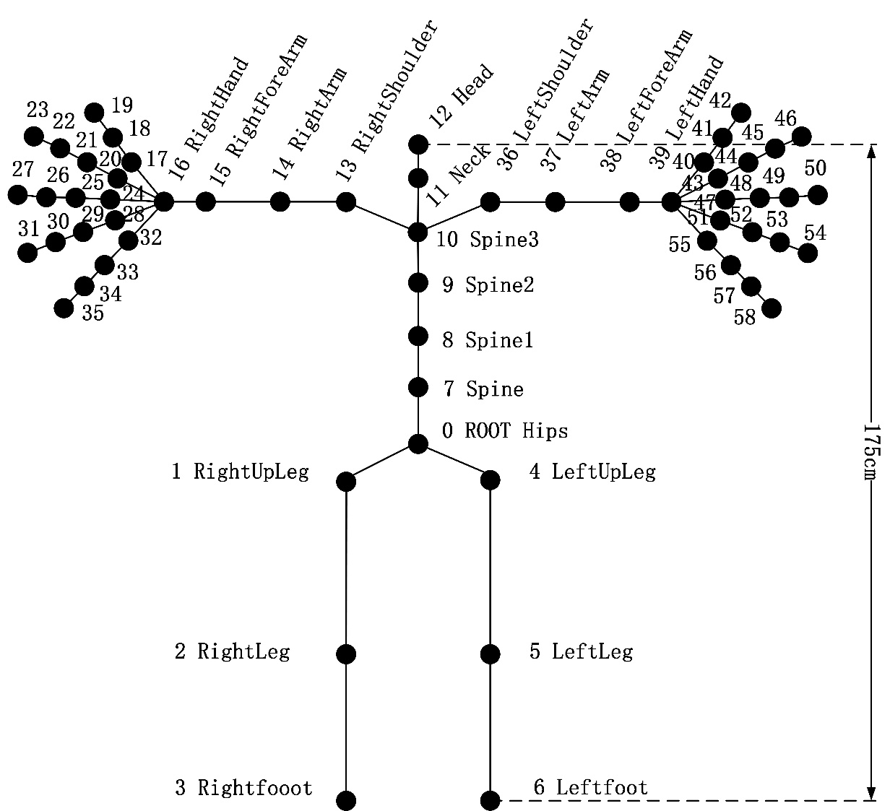

Figure 1. Joint index of NOITOM skeleton