- Convert all images from PDF to PNG
  - Use snipping tool, should be fine since we are downscaling the images
- Open PNG in imageJ
- Split image into channels (red, green, blue), and use the green channel for further image processing
  - The green channel shows the most from the spots and has the least background from other parts of the image - creates a clearer picture
- Select and crop to a rectangular region of the nectar guide that contains the pattern without including other regions that might interfere with thresholding. This process is subjective and can affect the output.
- Resize the image to 200x200 to match the size of the input images
  - Note: This will require the image to be “squished” vertically. However I think this is fine because the pattern forms early during development before the cells elongate. This means that since we don’t include tissue development in our simulations, the “squished” version of the image is likely more similar to how our simulation results should look.
- Add a gaussian blur with radius 1 to smooth the edges of the spots
- Apply a threshold to the image
  - Again subjective, choose a value that best represents the observed pattern
  - Save this image as “Processed”

- To collect parameters from the regular image, do “Measure”, then without clearing the results, do “analyze particles”. Save this combined result as a CSV
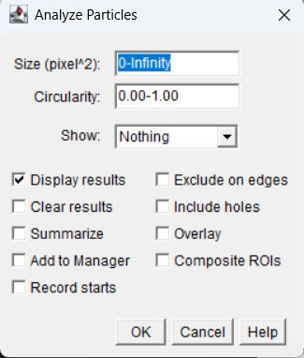
  - This format is what is read by the python code to make a proper input for the model

- Next, clear the results screen, and invert the image (255 -> 0, 0->255)
- Rerun the same “Measure”, “Analyze particles” process on the inverted image and save the resulting CSV separately.
  - These 2 CSVs - regular features and inverted features, will be the inputs to make model predictions
- Use the XGboost trained on simulations to predict parameters based on the ImageJ features we just extracted
  - The code used can be found at https://colab.research.google.com/drive/1HEBa8SlMmmXGMbU2I3WIWNVwyjMDzHVJ
  - The only thing that needs to be changed between each simulation prediction is the paths to the “normal” and “inverted” feats
- After getting the predicted parameters from features obtained from the real image, I input these parameters into VCell in the model 2025_05_10_Kondo_Real_Flower_Testing
  - 200x200 mesh size
  - 'Noise_100_tif2 as field data
  - Run for 5000 seconds
  - The output parameters are in the order: Ua, Ui, Ga, Gi, Da, Di, Ba
- Export the resulting simulations to jpeg
  - Export data for the variable a (activator) at time 5000
  - Make sure the image is in greyscale first to make downstream processing easier
  - Use the settings: Lossless compression, hide volume/membrane outline, no mirroring, and Image size scaling of 5
- To do the final image processing on the output simulation, open the simulation result in imagej
  - Invert LUT to make dark = spot and white = background
  - Do analyze -> measure to find the maximum value
  - Find the maximum value at t=5000 in the VCell simulation
  - To find the threshold value that is equivalent to a VCell simulation value of 3, threshold = 3/Vcell_max_value * imagej_max_value
  - Set a threshold equal to this calculated value
  - The image is now fully processed and ready to be saved and compared to the input image

