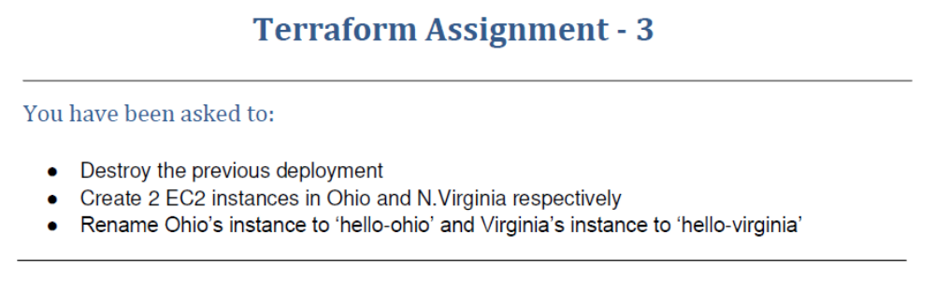
ubuntu@ip-172-31-24-238:~/terraform-ws$ sudo nano assmt3.tf
provider "aws" {
region = "us-east-1"
}

provider "aws" {
region = "us-east-2"
alias = "usa"
}

resource "aws_instance" "Virgenia-server" {
ami = "ami-04ad2567c9e3d7893"
instance_type = "t2.micro"
tags = {
Name = "Hello-Virgenia"
}
}

resource "aws_instance" "Ohio-server" {
ami = "ami-0629230e074c580f2"
instance_type = "t2.micro"
provider = aws.usa
tags = {
Name = "Hello-Ohio"
}
}
ubuntu@ip-172-31-24-238:~/terraform-ws$ terraform validate
Success! The configuration is valid.

ubuntu@ip-172-31-24-238:~/terraform-ws$ terraform init

Initializing the backend...

Initializing provider plugins...
- Reusing previous version of hashicorp/aws from the dependency lock file
- Using previously-installed hashicorp/aws v3.66.0

Terraform has been successfully initialized!

You may now begin working with Terraform. Try running "terraform plan" to see
any changes that are required for your infrastructure. All Terraform commands
should now work.

If you ever set or change modules or backend configuration for Terraform,
rerun this command to reinitialize your working directory. If you forget, other
commands will detect it and remind you to do so if necessary.
ubuntu@ip-172-31-24-238:~/terraform-ws$ terraform plan

Terraform used the selected providers to generate the following execution plan. Resource actions are indicated with the
following symbols:
+ create

Terraform will perform the following actions:

# aws_instance.Ohio-server will be created
+ resource "aws_instance" "Ohio-server" {
+ ami = "ami-0629230e074c580f2"
+ arn = (known after apply)
+ associate_public_ip_address = (known after apply)
+ availability_zone = (known after apply)
+ cpu_core_count = (known after apply)
+ cpu_threads_per_core = (known after apply)
+ disable_api_termination = (known after apply)
+ ebs_optimized = (known after apply)
+ get_password_data = false
+ host_id = (known after apply)
+ id = (known after apply)
+ instance_initiated_shutdown_behavior = (known after apply)
+ instance_state = (known after apply)
+ instance_type = "t2.micro"
+ ipv6_address_count = (known after apply)
+ ipv6_addresses = (known after apply)
+ key_name = (known after apply)
+ monitoring = (known after apply)
+ outpost_arn = (known after apply)
+ password_data = (known after apply)
+ placement_group = (known after apply)
+ placement_partition_number = (known after apply)
+ primary_network_interface_id = (known after apply)
+ private_dns = (known after apply)
+ private_ip = (known after apply)
+ public_dns = (known after apply)
+ public_ip = (known after apply)
+ secondary_private_ips = (known after apply)
+ security_groups = (known after apply)
+ source_dest_check = true
+ subnet_id = (known after apply)
+ tags = {
+ "Name" = "Hello-Ohio"
}
+ tags_all = {
+ "Name" = "Hello-Ohio"
}
+ tenancy = (known after apply)
+ user_data = (known after apply)
+ user_data_base64 = (known after apply)
+ vpc_security_group_ids = (known after apply)

+ capacity_reservation_specification {
+ capacity_reservation_preference = (known after apply)

+ capacity_reservation_target {
+ capacity_reservation_id = (known after apply)
}
}

+ ebs_block_device {
+ delete_on_termination = (known after apply)
+ device_name = (known after apply)
+ encrypted = (known after apply)
+ iops = (known after apply)
+ kms_key_id = (known after apply)
+ snapshot_id = (known after apply)
+ tags = (known after apply)
+ throughput = (known after apply)
+ volume_id = (known after apply)
+ volume_size = (known after apply)
+ volume_type = (known after apply)
}

+ enclave_options {
+ enabled = (known after apply)
}

+ ephemeral_block_device {
+ device_name = (known after apply)
+ no_device = (known after apply)
+ virtual_name = (known after apply)
}

+ metadata_options {
+ http_endpoint = (known after apply)
+ http_put_response_hop_limit = (known after apply)
+ http_tokens = (known after apply)
}

+ network_interface {
+ delete_on_termination = (known after apply)
+ device_index = (known after apply)
+ network_interface_id = (known after apply)
}

+ root_block_device {
+ delete_on_termination = (known after apply)
+ device_name = (known after apply)
+ encrypted = (known after apply)
+ iops = (known after apply)
+ kms_key_id = (known after apply)
+ tags = (known after apply)
+ throughput = (known after apply)
+ volume_id = (known after apply)
+ volume_size = (known after apply)
+ volume_type = (known after apply)
}
}

# aws_instance.Virgenia-server will be created
+ resource "aws_instance" "Virgenia-server" {
+ ami = "ami-04ad2567c9e3d7893"
+ arn = (known after apply)
+ associate_public_ip_address = (known after apply)
+ availability_zone = (known after apply)
+ cpu_core_count = (known after apply)
+ cpu_threads_per_core = (known after apply)
+ disable_api_termination = (known after apply)
+ ebs_optimized = (known after apply)
+ get_password_data = false
+ host_id = (known after apply)
+ id = (known after apply)
+ instance_initiated_shutdown_behavior = (known after apply)
+ instance_state = (known after apply)
+ instance_type = "t2.micro"
+ ipv6_address_count = (known after apply)
+ ipv6_addresses = (known after apply)
+ key_name = (known after apply)
+ monitoring = (known after apply)
+ outpost_arn = (known after apply)
+ password_data = (known after apply)
+ placement_group = (known after apply)
+ placement_partition_number = (known after apply)
+ primary_network_interface_id = (known after apply)
+ private_dns = (known after apply)
+ private_ip = (known after apply)
+ public_dns = (known after apply)
+ public_ip = (known after apply)
+ secondary_private_ips = (known after apply)
+ security_groups = (known after apply)
+ source_dest_check = true
+ subnet_id = (known after apply)
+ tags = {
+ "Name" = "Hello-Virgenia"
}
+ tags_all = {
+ "Name" = "Hello-Virgenia"
}
+ tenancy = (known after apply)
+ user_data = (known after apply)
+ user_data_base64 = (known after apply)
+ vpc_security_group_ids = (known after apply)

+ capacity_reservation_specification {
+ capacity_reservation_preference = (known after apply)

+ capacity_reservation_target {
+ capacity_reservation_id = (known after apply)
}
}

+ ebs_block_device {
+ delete_on_termination = (known after apply)
+ device_name = (known after apply)
+ encrypted = (known after apply)
+ iops = (known after apply)
+ kms_key_id = (known after apply)
+ snapshot_id = (known after apply)
+ tags = (known after apply)
+ throughput = (known after apply)
+ volume_id = (known after apply)
+ volume_size = (known after apply)
+ volume_type = (known after apply)
}

+ enclave_options {
+ enabled = (known after apply)
}

+ ephemeral_block_device {
+ device_name = (known after apply)
+ no_device = (known after apply)
+ virtual_name = (known after apply)
}

+ metadata_options {
+ http_endpoint = (known after apply)
+ http_put_response_hop_limit = (known after apply)
+ http_tokens = (known after apply)
}

+ network_interface {
+ delete_on_termination = (known after apply)
+ device_index = (known after apply)
+ network_interface_id = (known after apply)
}

+ root_block_device {
+ delete_on_termination = (known after apply)
+ device_name = (known after apply)
+ encrypted = (known after apply)
+ iops = (known after apply)
+ kms_key_id = (known after apply)
+ tags = (known after apply)
+ throughput = (known after apply)
+ volume_id = (known after apply)
+ volume_size = (known after apply)
+ volume_type = (known after apply)
}
}

Plan: 2 to add, 0 to change, 0 to destroy.

─────────────────────────────────────────────────────────────────────────────────────────────────────────────────────────

Note: You didn't use the -out option to save this plan, so Terraform can't guarantee to take exactly these actions if you
run "terraform apply" now.
ubuntu@ip-172-31-24-238:~/terraform-ws$ terraform plan -out myplan4

Terraform used the selected providers to generate the following execution plan. Resource actions are indicated with the
following symbols:
+ create

Terraform will perform the following actions:

# aws_instance.Ohio-server will be created
+ resource "aws_instance" "Ohio-server" {
+ ami = "ami-0629230e074c580f2"
+ arn = (known after apply)
+ associate_public_ip_address = (known after apply)
+ availability_zone = (known after apply)
+ cpu_core_count = (known after apply)
+ cpu_threads_per_core = (known after apply)
+ disable_api_termination = (known after apply)
+ ebs_optimized = (known after apply)
+ get_password_data = false
+ host_id = (known after apply)
+ id = (known after apply)
+ instance_initiated_shutdown_behavior = (known after apply)
+ instance_state = (known after apply)
+ instance_type = "t2.micro"
+ ipv6_address_count = (known after apply)
+ ipv6_addresses = (known after apply)
+ key_name = (known after apply)
+ monitoring = (known after apply)
+ outpost_arn = (known after apply)
+ password_data = (known after apply)
+ placement_group = (known after apply)
+ placement_partition_number = (known after apply)
+ primary_network_interface_id = (known after apply)
+ private_dns = (known after apply)
+ private_ip = (known after apply)
+ public_dns = (known after apply)
+ public_ip = (known after apply)
+ secondary_private_ips = (known after apply)
+ security_groups = (known after apply)
+ source_dest_check = true
+ subnet_id = (known after apply)
+ tags = {
+ "Name" = "Hello-Ohio"
}
+ tags_all = {
+ "Name" = "Hello-Ohio"
}
+ tenancy = (known after apply)
+ user_data = (known after apply)
+ user_data_base64 = (known after apply)
+ vpc_security_group_ids = (known after apply)

+ capacity_reservation_specification {
+ capacity_reservation_preference = (known after apply)

+ capacity_reservation_target {
+ capacity_reservation_id = (known after apply)
}
}

+ ebs_block_device {
+ delete_on_termination = (known after apply)
+ device_name = (known after apply)
+ encrypted = (known after apply)
+ iops = (known after apply)
+ kms_key_id = (known after apply)
+ snapshot_id = (known after apply)
+ tags = (known after apply)
+ throughput = (known after apply)
+ volume_id = (known after apply)
+ volume_size = (known after apply)
+ volume_type = (known after apply)
}

+ enclave_options {
+ enabled = (known after apply)
}

+ ephemeral_block_device {
+ device_name = (known after apply)
+ no_device = (known after apply)
+ virtual_name = (known after apply)
}

+ metadata_options {
+ http_endpoint = (known after apply)
+ http_put_response_hop_limit = (known after apply)
+ http_tokens = (known after apply)
}

+ network_interface {
+ delete_on_termination = (known after apply)
+ device_index = (known after apply)
+ network_interface_id = (known after apply)
}

+ root_block_device {
+ delete_on_termination = (known after apply)
+ device_name = (known after apply)
+ encrypted = (known after apply)
+ iops = (known after apply)
+ kms_key_id = (known after apply)
+ tags = (known after apply)
+ throughput = (known after apply)
+ volume_id = (known after apply)
+ volume_size = (known after apply)
+ volume_type = (known after apply)
}
}

# aws_instance.Virgenia-server will be created
+ resource "aws_instance" "Virgenia-server" {
+ ami = "ami-04ad2567c9e3d7893"
+ arn = (known after apply)
+ associate_public_ip_address = (known after apply)
+ availability_zone = (known after apply)
+ cpu_core_count = (known after apply)
+ cpu_threads_per_core = (known after apply)
+ disable_api_termination = (known after apply)
+ ebs_optimized = (known after apply)
+ get_password_data = false
+ host_id = (known after apply)
+ id = (known after apply)
+ instance_initiated_shutdown_behavior = (known after apply)
+ instance_state = (known after apply)
+ instance_type = "t2.micro"
+ ipv6_address_count = (known after apply)
+ ipv6_addresses = (known after apply)
+ key_name = (known after apply)
+ monitoring = (known after apply)
+ outpost_arn = (known after apply)
+ password_data = (known after apply)
+ placement_group = (known after apply)
+ placement_partition_number = (known after apply)
+ primary_network_interface_id = (known after apply)
+ private_dns = (known after apply)
+ private_ip = (known after apply)
+ public_dns = (known after apply)
+ public_ip = (known after apply)
+ secondary_private_ips = (known after apply)
+ security_groups = (known after apply)
+ source_dest_check = true
+ subnet_id = (known after apply)
+ tags = {
+ "Name" = "Hello-Virgenia"
}
+ tags_all = {
+ "Name" = "Hello-Virgenia"
}
+ tenancy = (known after apply)
+ user_data = (known after apply)
+ user_data_base64 = (known after apply)
+ vpc_security_group_ids = (known after apply)

+ capacity_reservation_specification {
+ capacity_reservation_preference = (known after apply)

+ capacity_reservation_target {
+ capacity_reservation_id = (known after apply)
}
}

+ ebs_block_device {
+ delete_on_termination = (known after apply)
+ device_name = (known after apply)
+ encrypted = (known after apply)
+ iops = (known after apply)
+ kms_key_id = (known after apply)
+ snapshot_id = (known after apply)
+ tags = (known after apply)
+ throughput = (known after apply)
+ volume_id = (known after apply)
+ volume_size = (known after apply)
+ volume_type = (known after apply)
}

+ enclave_options {
+ enabled = (known after apply)
}

+ ephemeral_block_device {
+ device_name = (known after apply)
+ no_device = (known after apply)
+ virtual_name = (known after apply)
}

+ metadata_options {
+ http_endpoint = (known after apply)
+ http_put_response_hop_limit = (known after apply)
+ http_tokens = (known after apply)
}

+ network_interface {
+ delete_on_termination = (known after apply)
+ device_index = (known after apply)
+ network_interface_id = (known after apply)
}

+ root_block_device {
+ delete_on_termination = (known after apply)
+ device_name = (known after apply)
+ encrypted = (known after apply)
+ iops = (known after apply)
+ kms_key_id = (known after apply)
+ tags = (known after apply)
+ throughput = (known after apply)
+ volume_id = (known after apply)
+ volume_size = (known after apply)
+ volume_type = (known after apply)
}
}

Plan: 2 to add, 0 to change, 0 to destroy.

─────────────────────────────────────────────────────────────────────────────────────────────────────────────────────────

Saved the plan to: myplan4

To perform exactly these actions, run the following command to apply:
terraform apply "myplan4"
ubuntu@ip-172-31-24-238:~/terraform-ws$ terraform apply "myplan4"
aws_instance.Virgenia-server: Creating...
aws_instance.Ohio-server: Creating...
aws_instance.Virgenia-server: Still creating... [10s elapsed]
aws_instance.Ohio-server: Still creating... [10s elapsed]
aws_instance.Virgenia-server: Still creating... [20s elapsed]
aws_instance.Ohio-server: Still creating... [20s elapsed]
aws_instance.Virgenia-server: Still creating... [30s elapsed]
aws_instance.Ohio-server: Still creating... [30s elapsed]
aws_instance.Ohio-server: Creation complete after 31s [id=i-0802058cbf839c892]
aws_instance.Virgenia-server: Creation complete after 33s [id=i-0daff73089db0c870]

Apply complete! Resources: 2 added, 0 changed, 0 destroyed.

EC-2 instance “Hello-Virginia “created in Virginia region
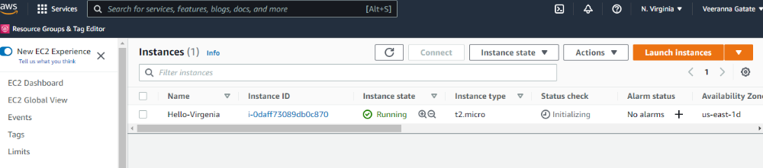

EC-2 instance “Hello-Ohio “created in Ohio region
