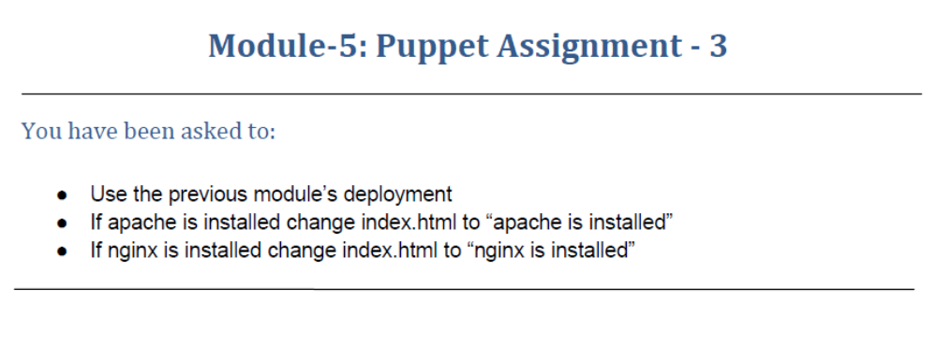
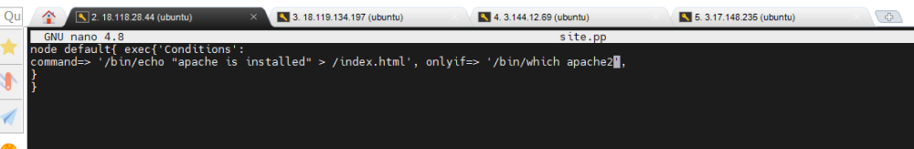
On slave-1
ubuntu@ip-172-31-1-85:~$ sudo puppet agent --test
/usr/lib/ruby/vendor_ruby/puppet/util.rb:461: warning: URI.escape is obsolete
/usr/lib/ruby/vendor_ruby/puppet/util.rb:461: warning: URI.escape is obsolete
/usr/lib/ruby/vendor_ruby/puppet/util.rb:461: warning: URI.escape is obsolete
/usr/lib/ruby/vendor_ruby/puppet/util.rb:461: warning: URI.escape is obsolete
/usr/lib/ruby/vendor_ruby/puppet/util.rb:315: warning: deprecated Object#=~ is called on Puppet::Transaction::Report; it always returns nil
/usr/lib/ruby/vendor_ruby/puppet/util.rb:461: warning: URI.escape is obsolete
/usr/lib/ruby/vendor_ruby/puppet/util.rb:461: warning: URI.escape is obsolete
/usr/lib/ruby/vendor_ruby/puppet/util.rb:461: warning: URI.escape is obsolete
/usr/lib/ruby/vendor_ruby/puppet/util.rb:315: warning: deprecated Object#=~ is called on Puppet::Transaction::Report; it always returns nil
/usr/lib/ruby/vendor_ruby/puppet/util.rb:461: warning: URI.escape is obsolete
Info: Using configured environment 'production'
Info: Retrieving pluginfacts
/usr/lib/ruby/vendor_ruby/puppet/util.rb:461: warning: URI.escape is obsolete
/usr/lib/ruby/vendor_ruby/puppet/util.rb:315: warning: deprecated Object#=~ is called on Puppet::Transaction::Report; it always returns nil
/usr/lib/ruby/vendor_ruby/puppet/util.rb:461: warning: URI.escape is obsolete
/usr/lib/ruby/vendor_ruby/puppet/indirector/request.rb:272: warning: URI.unescape is obsolete
/usr/lib/ruby/vendor_ruby/puppet/util.rb:461: warning: URI.escape is obsolete
Info: Retrieving plugin
/usr/lib/ruby/vendor_ruby/puppet/util.rb:461: warning: URI.escape is obsolete
/usr/lib/ruby/vendor_ruby/puppet/util.rb:315: warning: deprecated Object#=~ is called on Puppet::Transaction::Report; it always returns nil
/usr/lib/ruby/vendor_ruby/puppet/util.rb:461: warning: URI.escape is obsolete
/usr/lib/ruby/vendor_ruby/puppet/indirector/request.rb:272: warning: URI.unescape is obsolete
/usr/lib/ruby/vendor_ruby/puppet/util.rb:461: warning: URI.escape is obsolete
Info: Retrieving locales
/usr/lib/ruby/vendor_ruby/puppet/util.rb:461: warning: URI.escape is obsolete
/usr/lib/ruby/vendor_ruby/puppet/util.rb:315: warning: deprecated Object#=~ is called on Puppet::Transaction::Report; it always returns nil
/usr/lib/ruby/vendor_ruby/puppet/util.rb:461: warning: URI.escape is obsolete
/usr/lib/ruby/vendor_ruby/puppet/indirector/request.rb:272: warning: URI.unescape is obsolete
/usr/lib/ruby/vendor_ruby/puppet/util.rb:461: warning: URI.escape is obsolete
/usr/lib/ruby/vendor_ruby/puppet/util.rb:461: warning: URI.escape is obsolete
Info: Caching catalog for ip-172-31-1-85.us-east-2.compute.internal
/usr/lib/ruby/vendor_ruby/puppet/file_system/uniquefile.rb:126: warning: $SAFE will become a normal global variable in Ruby 3.0
/usr/lib/ruby/vendor_ruby/puppet/util.rb:461: warning: URI.escape is obsolete
/usr/lib/ruby/vendor_ruby/puppet/util.rb:461: warning: URI.escape is obsolete
/usr/lib/ruby/vendor_ruby/puppet/util.rb:461: warning: URI.escape is obsolete
Info: Applying configuration version '1638814897'
Notice: /Stage[main]/Main/Node[default]/Exec[Conditions]/returns: executed successfully
/usr/lib/ruby/vendor_ruby/puppet/file_system/uniquefile.rb:126: warning: $SAFE will become a normal global variable in Ruby 3.0
/usr/lib/ruby/vendor_ruby/puppet/file_system/uniquefile.rb:126: warning: $SAFE will become a normal global variable in Ruby 3.0
Notice: Applied catalog in 0.03 seconds
/usr/lib/ruby/vendor_ruby/puppet/file_system/uniquefile.rb:126: warning: $SAFE will become a normal global variable in Ruby 3.0
/usr/lib/ruby/vendor_ruby/puppet/util.rb:461: warning: URI.escape is obsolete
/usr/lib/ruby/vendor_ruby/puppet/file_system/uniquefile.rb:126: warning: $SAFE will become a normal global variable in Ruby 3.0
ubuntu@ip-172-31-1-85:~$ cd /
ubuntu@ip-172-31-1-85:/$ ls
bin boot dev etc home index.html lib lib32 lib64 libx32 lost+found media mnt opt proc root run sbin snap srv sys tmp usr var
ubuntu@ip-172-31-1-85:/$ cat index.html
Apache is installed
On Slave-2
ubuntu@ip-172-31-15-19:~$ sudo puppet agent --test
/usr/lib/ruby/vendor_ruby/puppet/util.rb:461: warning: URI.escape is obsolete
/usr/lib/ruby/vendor_ruby/puppet/util.rb:461: warning: URI.escape is obsolete
/usr/lib/ruby/vendor_ruby/puppet/util.rb:461: warning: URI.escape is obsolete
/usr/lib/ruby/vendor_ruby/puppet/util.rb:461: warning: URI.escape is obsolete
/usr/lib/ruby/vendor_ruby/puppet/util.rb:315: warning: deprecated Object#=~ is called on Puppet::Transaction::Report; it always returns nil
/usr/lib/ruby/vendor_ruby/puppet/util.rb:461: warning: URI.escape is obsolete
/usr/lib/ruby/vendor_ruby/puppet/util.rb:461: warning: URI.escape is obsolete
/usr/lib/ruby/vendor_ruby/puppet/util.rb:461: warning: URI.escape is obsolete
/usr/lib/ruby/vendor_ruby/puppet/util.rb:315: warning: deprecated Object#=~ is called on Puppet::Transaction::Report; it always returns nil
/usr/lib/ruby/vendor_ruby/puppet/util.rb:461: warning: URI.escape is obsolete
Info: Using configured environment 'production'
Info: Retrieving pluginfacts
/usr/lib/ruby/vendor_ruby/puppet/util.rb:461: warning: URI.escape is obsolete
/usr/lib/ruby/vendor_ruby/puppet/util.rb:315: warning: deprecated Object#=~ is called on Puppet::Transaction::Report; it always returns nil
/usr/lib/ruby/vendor_ruby/puppet/util.rb:461: warning: URI.escape is obsolete
/usr/lib/ruby/vendor_ruby/puppet/indirector/request.rb:272: warning: URI.unescape is obsolete
/usr/lib/ruby/vendor_ruby/puppet/util.rb:461: warning: URI.escape is obsolete
Info: Retrieving plugin
/usr/lib/ruby/vendor_ruby/puppet/util.rb:461: warning: URI.escape is obsolete
/usr/lib/ruby/vendor_ruby/puppet/util.rb:315: warning: deprecated Object#=~ is called on Puppet::Transaction::Report; it always returns nil
/usr/lib/ruby/vendor_ruby/puppet/util.rb:461: warning: URI.escape is obsolete
/usr/lib/ruby/vendor_ruby/puppet/indirector/request.rb:272: warning: URI.unescape is obsolete
/usr/lib/ruby/vendor_ruby/puppet/util.rb:461: warning: URI.escape is obsolete
Info: Retrieving locales
/usr/lib/ruby/vendor_ruby/puppet/util.rb:461: warning: URI.escape is obsolete
/usr/lib/ruby/vendor_ruby/puppet/util.rb:315: warning: deprecated Object#=~ is called on Puppet::Transaction::Report; it always returns nil
/usr/lib/ruby/vendor_ruby/puppet/util.rb:461: warning: URI.escape is obsolete
/usr/lib/ruby/vendor_ruby/puppet/indirector/request.rb:272: warning: URI.unescape is obsolete
/usr/lib/ruby/vendor_ruby/puppet/util.rb:461: warning: URI.escape is obsolete
/usr/lib/ruby/vendor_ruby/puppet/util.rb:461: warning: URI.escape is obsolete
Info: Caching catalog for ip-172-31-15-19.us-east-2.compute.internal
/usr/lib/ruby/vendor_ruby/puppet/file_system/uniquefile.rb:126: warning: $SAFE will become a normal global variable in Ruby 3.0
/usr/lib/ruby/vendor_ruby/puppet/util.rb:461: warning: URI.escape is obsolete
/usr/lib/ruby/vendor_ruby/puppet/util.rb:461: warning: URI.escape is obsolete
/usr/lib/ruby/vendor_ruby/puppet/util.rb:461: warning: URI.escape is obsolete
Info: Applying configuration version '1638814780'
ubuntu@ip-172-31-15-19:~$ cd /
ubuntu@ip-172-31-15-19:/$ ls
bin boot dev etc home index.html lib lib32 lib64 libx32 lost+found media mnt opt proc root run sbin snap srv sys tmp usr var
ubuntu@ip-172-31-15-19:/$ cat index.html
Apache is installed

On Slave-3
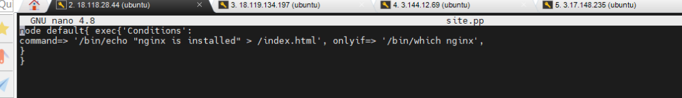
node default{ exec{'Conditions':
command=> '/bin/echo "nginx is installed" > /index.html', onlyif=> '/bin/which nginx',
}
}
ubuntu@ip-172-31-27-231:~$ sudo puppet agent --test
/usr/lib/ruby/vendor_ruby/puppet/util.rb:461: warning: URI.escape is obsolete
/usr/lib/ruby/vendor_ruby/puppet/util.rb:461: warning: URI.escape is obsolete
/usr/lib/ruby/vendor_ruby/puppet/util.rb:461: warning: URI.escape is obsolete
/usr/lib/ruby/vendor_ruby/puppet/util.rb:461: warning: URI.escape is obsolete
/usr/lib/ruby/vendor_ruby/puppet/util.rb:315: warning: deprecated Object#=~ is called on Puppet::Transaction::Report; it always returns nil
/usr/lib/ruby/vendor_ruby/puppet/util.rb:461: warning: URI.escape is obsolete
/usr/lib/ruby/vendor_ruby/puppet/util.rb:461: warning: URI.escape is obsolete
/usr/lib/ruby/vendor_ruby/puppet/util.rb:461: warning: URI.escape is obsolete
/usr/lib/ruby/vendor_ruby/puppet/util.rb:315: warning: deprecated Object#=~ is called on Puppet::Transaction::Report; it always returns nil
/usr/lib/ruby/vendor_ruby/puppet/util.rb:461: warning: URI.escape is obsolete
Info: Using configured environment 'production'
Info: Retrieving pluginfacts
/usr/lib/ruby/vendor_ruby/puppet/util.rb:461: warning: URI.escape is obsolete
/usr/lib/ruby/vendor_ruby/puppet/util.rb:315: warning: deprecated Object#=~ is called on Puppet::Transaction::Report; it always returns nil
/usr/lib/ruby/vendor_ruby/puppet/util.rb:461: warning: URI.escape is obsolete
/usr/lib/ruby/vendor_ruby/puppet/indirector/request.rb:272: warning: URI.unescape is obsolete
/usr/lib/ruby/vendor_ruby/puppet/util.rb:461: warning: URI.escape is obsolete
Info: Retrieving plugin
/usr/lib/ruby/vendor_ruby/puppet/util.rb:461: warning: URI.escape is obsolete
/usr/lib/ruby/vendor_ruby/puppet/util.rb:315: warning: deprecated Object#=~ is called on Puppet::Transaction::Report; it always returns nil
/usr/lib/ruby/vendor_ruby/puppet/util.rb:461: warning: URI.escape is obsolete
/usr/lib/ruby/vendor_ruby/puppet/indirector/request.rb:272: warning: URI.unescape is obsolete
/usr/lib/ruby/vendor_ruby/puppet/util.rb:461: warning: URI.escape is obsolete
Info: Retrieving locales
/usr/lib/ruby/vendor_ruby/puppet/util.rb:461: warning: URI.escape is obsolete
/usr/lib/ruby/vendor_ruby/puppet/util.rb:315: warning: deprecated Object#=~ is called on Puppet::Transaction::Report; it always returns nil
/usr/lib/ruby/vendor_ruby/puppet/util.rb:461: warning: URI.escape is obsolete
/usr/lib/ruby/vendor_ruby/puppet/indirector/request.rb:272: warning: URI.unescape is obsolete
/usr/lib/ruby/vendor_ruby/puppet/util.rb:461: warning: URI.escape is obsolete
/usr/lib/ruby/vendor_ruby/puppet/util.rb:461: warning: URI.escape is obsolete
Info: Caching catalog for ip-172-31-27-231.us-east-2.compute.internal
/usr/lib/ruby/vendor_ruby/puppet/file_system/uniquefile.rb:126: warning: $SAFE will become a normal global variable in Ruby 3.0
/usr/lib/ruby/vendor_ruby/puppet/util.rb:461: warning: URI.escape is obsolete
/usr/lib/ruby/vendor_ruby/puppet/util.rb:461: warning: URI.escape is obsolete
/usr/lib/ruby/vendor_ruby/puppet/util.rb:461: warning: URI.escape is obsolete
Info: Applying configuration version '1638814975'
Notice: /Stage[main]/Main/Node[default]/Exec[Conditions]/returns: executed successfully
/usr/lib/ruby/vendor_ruby/puppet/file_system/uniquefile.rb:126: warning: $SAFE will become a normal global variable in Ruby 3.0
/usr/lib/ruby/vendor_ruby/puppet/file_system/uniquefile.rb:126: warning: $SAFE will become a normal global variable in Ruby 3.0
Notice: Applied catalog in 0.03 seconds
/usr/lib/ruby/vendor_ruby/puppet/file_system/uniquefile.rb:126: warning: $SAFE will become a normal global variable in Ruby 3.0
/usr/lib/ruby/vendor_ruby/puppet/util.rb:461: warning: URI.escape is obsolete
/usr/lib/ruby/vendor_ruby/puppet/file_system/uniquefile.rb:126: warning: $SAFE will become a normal global variable in Ruby 3.0
ubuntu@ip-172-31-27-231:~$ cd /
ubuntu@ip-172-31-27-231:/$ ls
bin boot dev etc home index.html lib lib32 lib64 libx32 lost+found media mnt opt proc root run sbin snap srv sys tmp usr var
ubuntu@ip-172-31-27-231:/$ cat index.html
nginx is installed

