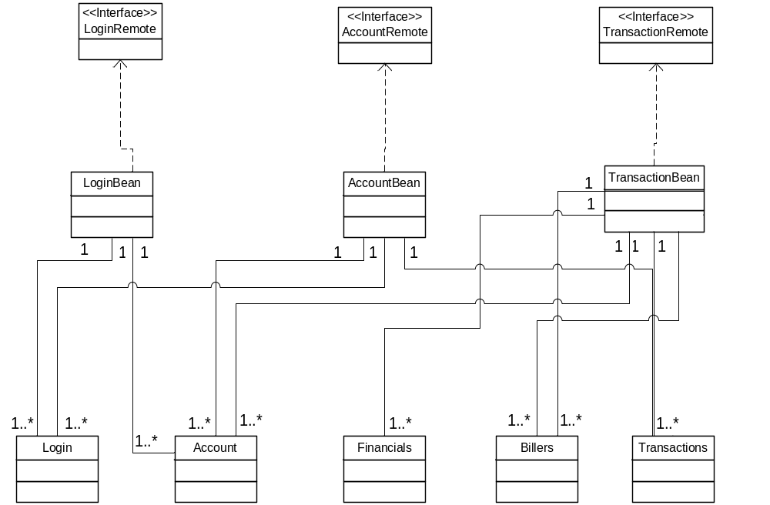
Fig 1.1 Class Diagram
Web Container
JSP
J2EE Server
NetBank Application
EJB Container

Web Browser

SwinBank
Database
Login Entity Class
Account Entity Class
Transaction Entity Class
Financial Entity Class
Biller Entity Class
LoginBean
AccountBean
AtmClient
Java Class
TellerClient Java Class
Servlet
Transaction
Bean
AccountRemote
LoginRemote
Console Applications
Presentation Layer
Data Access Layer
Business Logic Layer
Web Layer
Fig 1.2 Architectural Diagram
TransactionRemote

