Name: Vinay Chandrasekhar Date:

Roll no: 63

**PROGRAM:**

#include <ctype.h>

#include <stdio.h>

#include <stdlib.h>

#include <string.h>

#define MAX_LEN 100

const char *keywords[] = {"if", "else", "while", "return",

"int", "float", "void"};

const int keywordCount = sizeof(keywords) / sizeof(keywords[0]);

int isKeyword(char *lexeme) {

if (lexeme == NULL) return 0;

for (int i = 0; i < keywordCount; i++) if (strcmp(lexeme, keywords[i]) == 0) return 1;

return 0;

}

int isDelimiter(char ch) {

return (ch == ';' || ch == ',' || ch == '(' || ch == ')' || ch == '{' ||

ch == '}' || ch == '[' || ch == ']');

}

int isOperator(char ch) {

return (ch == '+' || ch == '-' || ch == '*' || ch == '/' || ch == '=' ||

ch == '<' || ch == '>' || ch == '!' || ch == '&' || ch == '|' ||

ch == '%' || ch == '^' || ch == '~' || ch == '?' || ch == ':');

}

void skipSingleLineComment(FILE *fp) {

int ch;

while ((ch = fgetc(fp)) != EOF && ch != '\n') {}

if (ch == '\n') ungetc(ch, fp);

}

void skipMultiLineComment(FILE *fp) {

int ch, prev = 0;

while ((ch = fgetc(fp)) != EOF) {

if (prev == '*' && ch == '/') break;

prev = ch;

}

}

void lexer(FILE *fp, FILE *op) {

int c, i,tokenCount = 0;

char buffer[MAX_LEN];

while ((c = fgetc(fp)) != EOF) {

if (isspace(c)) continue;

if (isalpha(c) || c == '_') {

i = 0;

buffer[i++] = c;

while (i < MAX_LEN - 1 && (isalnum(c = fgetc(fp)) || c == '_')) {

buffer[i++] = c;

}

ungetc(c, fp);

buffer[i] = '\0';

if (isKeyword(buffer)) {

fprintf(op, "<KEYWORD, %s>\n", buffer);

} else {

fprintf(op, "<IDENTIFIER, %s>\n", buffer);

}

tokenCount++;

}

else if (isdigit(c)) {

i = 0;

int hasDot = 0;

buffer[i++] = c;

while (i < MAX_LEN - 1 && (c = fgetc(fp)) != EOF) {

if (isdigit(c)) {

buffer[i++] = c;

} else if (c == '.' && !hasDot) {

hasDot = 1;

buffer[i++] = c;

} else {

ungetc(c, fp);

break;

}

}

buffer[i] = '\0';

fprintf(op, "<NUMBER, %s>\n", buffer);

tokenCount++;

}

else if (c == '"') {

i = 0;

buffer[i++] = c;

while (i < MAX_LEN - 1 && (c = fgetc(fp)) != EOF) {

buffer[i++] = c;

if (c == '"')

break;

if (c == '\\') {

if (i < MAX_LEN - 1 && (c = fgetc(fp)) != EOF) {

buffer[i++] = c;

}

}

}

buffer[i] = '\0';

fprintf(op, "<STRING, %s>\n", buffer);

tokenCount++;

}

else if (c == '\'') {

i = 0;

buffer[i++] = c;

while (i < MAX_LEN - 1 && (c = fgetc(fp)) != EOF) {

buffer[i++] = c;

if (c == '\'') break;

if (c == '\\') {

if (i < MAX_LEN - 1 && (c = fgetc(fp)) != EOF) {

buffer[i++] = c;

}

}

}

buffer[i] = '\0';

fprintf(op, "<CHARACTER, %s>\n", buffer);

tokenCount++;

}

else if (isOperator(c)) {

int next = fgetc(fp);

if (next != EOF) {

if ((c == '=' && next == '=') || (c == '!' && next == '=') ||

(c == '<' && next == '=') || (c == '>' && next == '=') ||

(c == '&' && next == '&') || (c == '|' && next == '|') ||

(c == '+' && next == '+') || (c == '-' && next == '-') ||

(c == '+' && next == '=') || (c == '-' && next == '=') ||

(c == '*' && next == '=') || (c == '/' && next == '=') ||

(c == '%' && next == '=') || (c == '<' && next == '<') ||

(c == '>' && next == '>') || (c == '-' && next == '>')) {

fprintf(op, "<OPERATOR, %c%c>\n", c, next);

} else {

ungetc(next, fp);

fprintf(op, "<OPERATOR, %c>\n", c);

}

} else {

fprintf(op, "<OPERATOR, %c>\n", c);

}

tokenCount++;

}

else if (isDelimiter(c)) {

fprintf(op, "<DELIMITER, %c>\n", c);

tokenCount++;

}

else if (c == '#') {

i = 0;

buffer[i++] = c;

while (i < MAX_LEN - 1 && (c = fgetc(fp)) != EOF) {

if (c == '\n') {

ungetc(c, fp);

break;

}

buffer[i++] = c;

}

buffer[i] = '\0';

fprintf(op, "<PREPROCESSOR, %s>\n", buffer);

tokenCount++;

}

}

printf("Total tokens: %d\n", tokenCount);

}

int main() {

FILE *fp = fopen("input.txt", "r");

if (fp == NULL) {

printf("Error opening file\n");

return 1;

}

FILE *op = fopen("output.txt", "w");

lexer(fp, op);

fclose(fp);

fclose(op);

return 0;

}

**INPUT:**

if main(){

int res = 0;

if (res == 0){

res *= 3;

}

return 0;

}

**OUTPUT:**

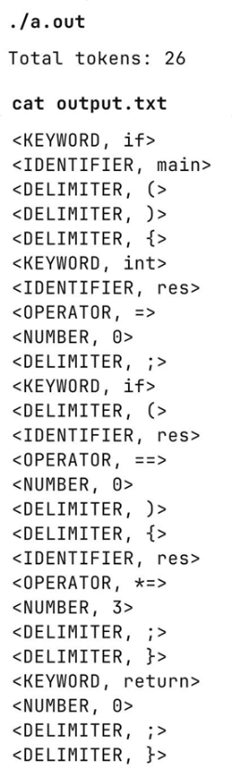

Name: Vinay Chandrasekhar Date:

Roll no: 63

**PROGRAM:**

%{

#include <stdio.h>

%}

%%

.*vina.* {printf("Contains first four characters as substring \n");}

.* {printf("Accepted \n");}

%%

int yywrap(){

return 1;

}

int main(){

yylex();

return 0;

}

**OUTPUT:**

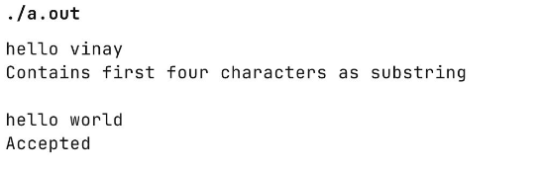

Name: Vinay Chandrasekhar Date:

Roll no: 63

**PROGRAM:**

**program.l**

%{

#include "program.tab.h"

%}

%%

[a-zA-Z_][a-zA-Z_0-9]* return letter;

[0-9] return digit;

. return yytext[0];

\n return 0;

%%

int yywrap() {

return 1;

}

**program.y**

%{

#include <stdio.h>

extern int yylex();

extern int yyerror(const char *);

%}

%token digit letter

%%

start : letter s {printf("Valid variable\n");}

;

s : letter s

| digit s

| /* empty */

;

%%

int yyerror(const char *s) {

printf("\nIt's not an identifier!\n");

return 0;

}

int main() {

printf("\nEnter a name to test if it's a valid identifier: ");

yyparse();

return 0;

}

**OUTPUT:**

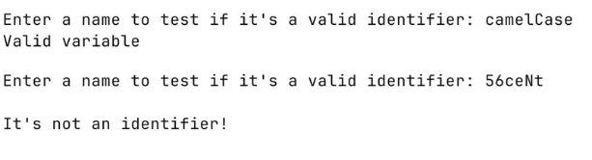

Name: Vinay Chandrasekhar Date:

Roll no: 63

**PROGRAM:**

**calculator.l**

%{

#include "calculator.tab.h"

#include <stdio.h>

%}

%option noyywrap

%%

[0-9]+ {yylval = atoi(yytext); return NUMBER;}

[\t\r]|" " ;

\n {return '\n';}

"+" {return PLUS;}

"-" {return MINUS;}

"*" {return MUL;}

"/" {return DIV;}

"(" {return LPAREN;}

")" {return RPAREN;}

. {printf("Invalid character: %s\n",yytext);}

%%

**calculator.y**

%{

#include <stdio.h>

#include <stdlib.h>

int yylex(void);

void yyerror(const char *s);

%}

%token NUMBER PLUS MINUS MUL DIV LPAREN RPAREN

%left PLUS MINUS

%left MUL DIV

%right UMINUS

%%

input:

//empty

| input expr '\n' { printf("= %d\nEnter the expression: ",$2);}

;

expr:

NUMBER

| expr PLUS expr {$$ = $1 + $3;}

| expr MINUS expr {$$ = $1 - $3;}

| expr MUL expr {$$ = $1 * $3;}

| expr DIV expr {

if ($3 == 0) {

yyerror("Division by zero");

$$ = 0;

} else {

$$ = $1 / $3;

}

}

| LPAREN expr RPAREN {$$ = $2;}

| MINUS expr %prec UMINUS { $$ = -$2; }

;

%%

int main(){

printf("Enter the expression: ");

yyparse();

return 0;

}

void yyerror(const char *s){

fprintf(stderr, "Error: %s\n",s);

}

**OUTPUT:**

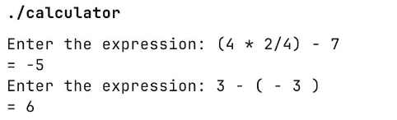

Name: Vinay Chandrasekhar Date:

Roll no: 63

**PROGRAM:**

**bnf.l**

%{

#include "bnf.tab.h"

%}

%%

[0-9]+ { yylval.num = atoi(yytext); return NUMBER; }

[ \t]+ ; /* ignore spaces and tabs */

\n ; /* ignore newlines */

. { return yytext[0]; } /* return single-character operators like + - * / ( ) */

%%

**bnf.y**

%code requires {

typedef struct AST {

char *nodeType;

int value;

struct AST *left, *right;

} AST;

}

%union {

int num;

AST *node;

}

%token <num> NUMBER

%type <node> expr

%left '+' '-'

%left '*' '/'

%left UMINUS

%{

#include <stdio.h>

#include <stdlib.h>

#include <string.h>

int yylex(void);

int yyerror(const char *s);

AST* makeNode(char *type, AST *l, AST *r);

AST* makeNum(int val);

void printAST(AST *root, int lvl);

int evalAST(AST *root);

%}

%%

start: expr {

printf("\nAST:\n");

printAST($1,0);

printf("\nResult: %d\n", evalAST($1));

return 0;

};

expr: expr '+' expr { $$ = makeNode("+",$1,$3); }

| expr '-' expr { $$ = makeNode("-",$1,$3); }

| expr '*' expr { $$ = makeNode("*",$1,$3); }

| expr '/' expr { $$ = makeNode("/",$1,$3); }

| '-' expr %prec UMINUS { $$ = makeNode("NEG",$2,NULL); }

| '(' expr ')' { $$ = $2; }

| NUMBER { $$ = makeNum($1); }

;

%%

AST* makeNode(char *type, AST *l, AST *r) {

AST *n = malloc(sizeof(AST));

n->nodeType = strdup(type);

n->value = 0;

n->left = l;

n->right = r;

return n;

}

AST* makeNum(int val) {

AST *n = malloc(sizeof(AST));

n->nodeType = strdup("NUM");

n->value = val;

n->left = n->right = NULL;

return n;

}

void printAST(AST *root, int lvl) {

if (!root) return;

for (int i = 0; i < lvl; i++) printf(" ");

if (strcmp(root->nodeType, "NUM") == 0)

printf("NUM(%d)\n", root->value);

else

printf("%s\n", root->nodeType);

printAST(root->left, lvl + 1);

printAST(root->right, lvl + 1);

}

int evalAST(AST *root) {

if (!root) return 0;

if (strcmp(root->nodeType, "NUM") == 0) return root->value;

if (strcmp(root->nodeType, "+") == 0) return evalAST(root->left) + evalAST(root->right);

if (strcmp(root->nodeType, "-") == 0) return evalAST(root->left) - evalAST(root->right);

if (strcmp(root->nodeType, "*") == 0) return evalAST(root->left) * evalAST(root->right);

if (strcmp(root->nodeType, "/") == 0) return evalAST(root->left) / evalAST(root->right);

if (strcmp(root->nodeType, "NEG") == 0) return -evalAST(root->left);

return 0;

}

int main() {

printf("Enter arithmetic expression:\n");

yyparse();

return 0;

}

int yyerror(const char *s) {

printf("Error: %s\n", s);

return 0;

}

**OUTPUT:**

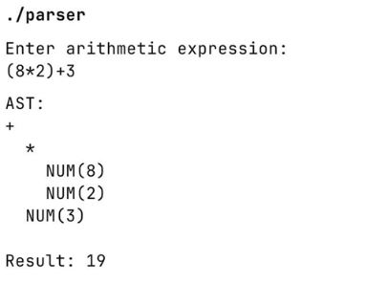

Name: Vinay Chandrasekhar Date:

Roll no: 63

**PROGRAM:**

**for.l**

%{

#include <string.h>

#include "for.tab.h"

char *datatypes[] = {"int","char","float","double"};

int size = sizeof(datatypes)/sizeof(datatypes[0]);

%}

%option noyywrap

%%

"for" { return FOR; }

"(" { return LPAREN; }

")" { return RPAREN; }

";" { return SEMICOLON;}

"=" {return ASSIGN;}

"<"|">"|"<="|">="|"!="|"==" { return COMPARE;}

"+="|"-="|"*="|"/=" { return UPDATE;}

"--"|"++" { return UNARY_OP;}

[0-9]+ { yylval = atoi(yytext); return NUMBER; }

[a-zA-Z_][a-zA-Z0-9_]* { for(int i=0;i<size;i++) {

if(strcmp(yytext,datatypes[i])==0)

return DATATYPE;

}

return IDENTIFIER; }

[ \t\n] ; /* ignore whitespace */

. { return yytext[0]; }

%%

**for.y**

%{

#include <stdio.h>

#include <string.h>

int yylex();

void yyerror(const char *s);

%}

%token FOR RPAREN LPAREN NUMBER IDENTIFIER SEMICOLON DATATYPE UPDATE ASSIGN COMPARE UNARY_OP

%%

start: FOR LPAREN i_expr SEMICOLON c_expr SEMICOLON u_expr RPAREN { printf("Valid for loop\n");return 0; }

;

c_expr: IDENTIFIER COMPARE IDENTIFIER

| IDENTIFIER COMPARE NUMBER

;

u_expr: IDENTIFIER UPDATE NUMBER

| IDENTIFIER UPDATE IDENTIFIER

| IDENTIFIER UNARY_OP

i_expr: variable ASSIGN NUMBER

| variable ASSIGN IDENTIFIER

;

variable: DATATYPE IDENTIFIER

| IDENTIFIER

;

%%

void yyerror(const char *s) {

fprintf(stderr, "Invalid for loop\n");

}

int main(){

printf("Enter the for loop: ");

yyparse();

return 0;

}

**OUTPUT:**

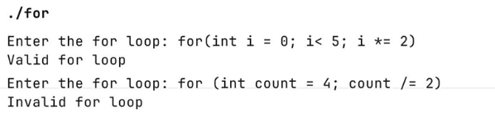

Name: Vinay Chandrasekhar Date:

Roll no: 63

**PROGRAM:**

#include <stdio.h>

#include <string.h>

#include <stdlib.h>

struct States {

char state[5];

int closure_count;

char closures[50][5];

} recorded_states[50];

struct Transition {

char from[5];

char to[5];

} eps_trans[100];

int count = 0;

int eps_count = 0;

int search_state(char *initial) {

for (int i = 0; i < count; i++) if (strcmp(recorded_states[i].state, initial) == 0) return i;

return -1;

}

int add_state(char *initial) {

strcpy(recorded_states[count].state, initial);

recorded_states[count].closure_count = 1;

strcpy(recorded_states[count].closures[0], initial);

return count++;

}

int in_closure(int i, char *state) {

for (int x = 0; x < recorded_states[i].closure_count; x++)

if (strcmp(recorded_states[i].closures[x], state) == 0) return 1;

return 0;

}

void add_closure(char *initial, char *final) {

int i = search_state(initial);

if (i == -1) i = add_state(initial);

if (strcmp(final, "") != 0 && !in_closure(i, final)) strcpy(recorded_states[i].closures[recorded_states[i].closure_count++], final);

}

void expand_closures() {

int changed = 1;

while (changed) {

changed = 0;

for (int i = 0; i < count; i++) {

for (int x = 0; x < recorded_states[i].closure_count; x++) {

char *state = recorded_states[i].closures[x];

// Check epsilon transitions from this state

for (int t = 0; t < eps_count; t++) {

if (strcmp(eps_trans[t].from, state) == 0) {

if (!in_closure(i, eps_trans[t].to)) {

strcpy(recorded_states[i].closures[recorded_states[i].closure_count++],

eps_trans[t].to);

changed = 1;

} } }

} } } }

void find_closures(char *filename) {

FILE *fp = fopen(filename, "r");

if (!fp) {

printf("No such file exists\n");

exit(0);

}

char initial[5], final[5], symbol[5];

while (fscanf(fp, "%s %s %s", initial, symbol, final) == 3) {

if (strcmp(symbol, "e") == 0) {

add_closure(initial, final);

strcpy(eps_trans[eps_count].from, initial);

strcpy(eps_trans[eps_count].to, final);

eps_count++;

}

add_closure(initial, "");

add_closure(final, "");

}

fclose(fp);

expand_closures();

}

int main() {

char filename[50];

printf("Enter the name of the file with state transitions: ");

scanf("%s", filename);

find_closures(filename);

printf("Epsilon Closures of all states:\n");

for (int i = 0; i < count; i++) {

printf("%s: {", recorded_states[i].state);

for (int x = 0; x < recorded_states[i].closure_count; x++) {

printf("%s%s", recorded_states[i].closures[x],

x + 1 == recorded_states[i].closure_count ? "" : ", ");

}

printf("}\n");

}

}

**INPUT:**

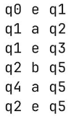

**OUTPUT:**

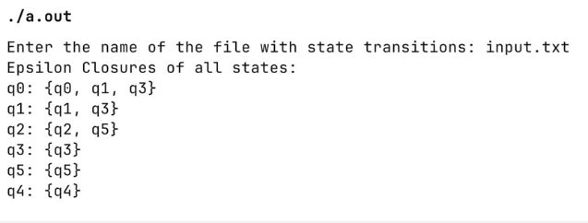

Name: Vinay Chandrasekhar Date:

Roll no: 63

**PROGRAM:**

#include <stdio.h>

#include <stdlib.h>

#include <string.h>

struct States {

char state[5];

int closure_count;

char closures[50][5];

} recorded_states[50];

struct Transition {

char from[5];

char symbol[5];

char to[5];

} trans[100];

struct Transition eps_trans[100]; // Only epsilon

int count = 0, t_count = 0, eps_count = 0;

int search_state(char *initial) {

for (int i = 0; i < count; i++) if (strcmp(recorded_states[i].state, initial) == 0) return i;

return -1;

}

int add_state(char *initial) {

strcpy(recorded_states[count].state, initial);

recorded_states[count].closure_count = 1;

strcpy(recorded_states[count].closures[0], initial);

return count++;

}

int in_closure(int i, char *state) {

for (int x = 0; x < recorded_states[i].closure_count; x++)

if (strcmp(recorded_states[i].closures[x], state) == 0) return 1;

return 0;

}

void add_closure(char *initial, char *final) {

int i = search_state(initial);

if (i == -1) i = add_state(initial);

if (strcmp(final, "") != 0 && !in_closure(i, final)) strcpy(recorded_states[i].closures[recorded_states[i].closure_count++],final);

}

void expand_closures() {

int changed = 1;

while (changed) {

changed = 0;

for (int i = 0; i < count; i++) {

for (int x = 0; x < recorded_states[i].closure_count; x++) {

char *state = recorded_states[i].closures[x];

for (int t = 0; t < eps_count; t++) {

if (strcmp(eps_trans[t].from, state) == 0) {

if (!in_closure(i, eps_trans[t].to)) {

strcpy(recorded_states[i]

.closures[recorded_states[i].closure_count++],

eps_trans[t].to);

changed = 1;

} } } }

} } }

void find_closures(char *filename) {

FILE *fp = fopen(filename, "r");

if (!fp) {

printf("No such file exists\n");

exit(0);

}

char initial[5], final[5], symbol[5];

while (fscanf(fp, "%s %s %s", initial, symbol, final) == 3) {

if (strcmp(symbol, "e") == 0) { // epsilon

add_closure(initial, final);

strcpy(eps_trans[eps_count].from, initial);

strcpy(eps_trans[eps_count].to, final);

eps_count++;

} else {

strcpy(trans[t_count].from, initial);

strcpy(trans[t_count].symbol, symbol);

strcpy(trans[t_count].to, final);

t_count++;

}

add_closure(initial, "");

add_closure(final, "");

}

fclose(fp);

expand_closures();

}

int in_set(char result[50][5], int *rcount, char *s) {

for (int i = 0; i < *rcount; i++) if (strcmp(result[i], s) == 0) return 1;

return 0;

}

void move_closure(int state_index, char *symbol, char result[50][5],

int *rcount) {

*rcount = 0;

for (int i = 0; i < recorded_states[state_index].closure_count; i++) {

char *s = recorded_states[state_index].closures[i];

for (int t = 0; t < t_count; t++) {

if (strcmp(trans[t].from, s) == 0 &&

strcmp(trans[t].symbol, symbol) == 0) {

int idx = search_state(trans[t].to);

if (idx != -1) {

for (int c = 0; c < recorded_states[idx].closure_count; c++) {

if (!in_set(result, rcount, recorded_states[idx].closures[c])) {

strcpy(result[(*rcount)++], recorded_states[idx].closures[c]);

} } } }

} } }

int main() {

char filename[50];

printf("Enter the name of the file with state transitions: ");

scanf("%s", filename);

find_closures(filename);

printf("\nEpsilon Closures of all states:\n");

for (int i = 0; i < count; i++) {

printf("%s: {", recorded_states[i].state);

for (int x = 0; x < recorded_states[i].closure_count; x++) {

printf("%s%s", recorded_states[i].closures[x],

x + 1 == recorded_states[i].closure_count ? "" : ", ");

}

printf("}\n");

}

char all_symbols[20][5];

int all_scount = 0;

for (int t = 0; t < t_count; t++) {

int found = 0;

for (int k = 0; k < all_scount; k++) {

if (strcmp(all_symbols[k], trans[t].symbol) == 0) {

found = 1;

break;

}

}

if (!found) strcpy(all_symbols[all_scount++], trans[t].symbol);

}

printf("\nEquivalent NFA Transitions (without epsilon):\n");

for (int i = 0; i < count; i++) {

for (int k = 0; k < all_scount; k++) {

char result[50][5];

int rcount;

move_closure(i, all_symbols[k], result, &rcount);

printf("%s --%s--> { ", recorded_states[i].state, all_symbols[k]);

for (int r = 0; r < rcount; r++) {

printf("%s%s", result[r], r + 1 == rcount ? "" : ", ");

}

printf(" }\n");

} } }

**INPUT:**

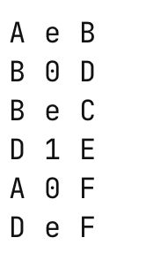

**OUTPUT:**

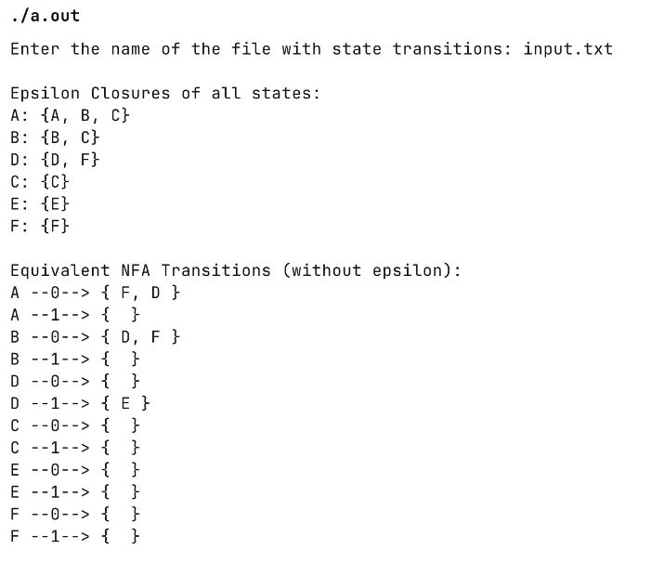

Name: Vinay Chandrasekhar Date:

Roll no: 63

**PROGRAM:**

#include <stdio.h>

#include <stdlib.h>

#include <string.h>

#define MAX_STATES 100

char sym[5], nfastate[5], symbols[100][5];

int curr_state_count, res_count, symbol_count = 0;

char nfa_final_states[MAX_STATES][5];

int nfa_final_count = 0;

struct NFATransition {

char from[5], symbol[5], to[5];

} nfa_trans[100];

int nfa_count = 0;

struct DFATransition {

char from[MAX_STATES][5], symbol[5], to[MAX_STATES][5];

int from_count, to_count;

} dfa_trans[100];

int dfa_count = 0;

struct DFAState {

char state[MAX_STATES][5];

int state_count;

} dfa_states[100];

int dfa_state_count = 0;

int search_state(char *state) for (int i = 0; i < nfa_count; i++) {

if (strcmp(nfa_trans[i].from, state) == 0) return i;

return -1;

}

void add_to_res(char *state, char *symbol, char res[][5], int *res_count) {

for (int i = 0; i < nfa_count; i++)

if (strcmp(nfa_trans[i].from, state) == 0 &&

strcmp(nfa_trans[i].symbol, symbol) == 0) strcpy(res[(*res_count)++], nfa_trans[i].to);

}

int is_dfa_final(struct DFAState dfa_state) {

for (int i = 0; i < dfa_state.state_count; i++)

for (int j = 0; j < nfa_final_count; j++) if (strcmp(dfa_state.state[i], nfa_final_states[j]) == 0) return 1;

return 0;

}

void find_nfa_transitions(char *filename) {

FILE *fp = fopen(filename, "r");

if (!fp) {

printf("No such file exists\n");

exit(0);

}

char initial[5], final[5], symbol[5];

while (fscanf(fp, "%s %s %s", initial, symbol, final) == 3) {

strcpy(nfa_trans[nfa_count].from, initial);

strcpy(nfa_trans[nfa_count].symbol, symbol);

strcpy(nfa_trans[nfa_count++].to, final);

if (symbol_count == 0)

strcpy(symbols[symbol_count++], symbol);

else {

int found = 0;

for (int i = 0; i < symbol_count; i++) {

if (strcmp(symbols[i], symbol) == 0) {

found = 1;

break;

}

}

if (!found)

strcpy(symbols[symbol_count++], symbol);

}

}

fclose(fp);

}

int state_exists(char res[][5], int res_count) {

for (int i = 0; i < dfa_state_count; i++) {

if (dfa_states[i].state_count == res_count) {

int match = 1;

for (int j = 0; j < res_count; j++) {

int found = 0;

for (int k = 0; k < res_count; k++) {

if (strcmp(res[j], dfa_states[i].state[k]) == 0) {

found = 1;

break;

}

}

if (!found) {

match = 0;

break;

}

}

if (match)

return i;

}

}

return -1;

}

void add_dfa_transition(char from[][5], int from_count, char *symbol,

char to[][5], int to_count) {

for (int i = 0; i < from_count; i++)

strcpy(dfa_trans[dfa_count].from[i], from[i]);

for (int i = 0; i < to_count; i++)

strcpy(dfa_trans[dfa_count].to[i], to[i]);

strcpy(dfa_trans[dfa_count].symbol, symbol);

dfa_trans[dfa_count].from_count = from_count;

dfa_trans[dfa_count++].to_count = to_count;

}

void print_transitions() {

printf("\nDFA Transitions:\n");

for (int i = 0; i < dfa_count; i++) {

printf("{ ");

for (int j = 0; j < dfa_trans[i].from_count; j++)

printf("%s ", dfa_trans[i].from[j]);

printf("} --%s--> {", dfa_trans[i].symbol);

for (int j = 0; j < dfa_trans[i].to_count; j++)

printf(" %s", dfa_trans[i].to[j]);

printf(" }\n");

}

}

void find_dfa_transistions(char *start_state) {

strcpy(dfa_states[dfa_state_count++].state[0], start_state);

dfa_states[0].state_count = 1;

for (int curr_state = 0; curr_state < dfa_state_count; curr_state++) {

for (int s = 0; s < symbol_count; s++) {

char res[MAX_STATES][5];

res_count = 0;

strcpy(sym, symbols[s]);

curr_state_count = dfa_states[curr_state].state_count;

for (int st = 0; st < curr_state_count; st++) {

strcpy(nfastate, dfa_states[curr_state].state[st]);

add_to_res(nfastate, sym, res, &res_count);

}

if (state_exists(res, res_count) == -1 && res_count > 0) {

for (int r = 0; r < res_count; r++)

strcpy(dfa_states[dfa_state_count].state[r], res[r]);

dfa_states[dfa_state_count].state_count = res_count;

dfa_state_count++;

}

add_dfa_transition(dfa_states[curr_state].state,

dfa_states[curr_state].state_count, sym, res,

res_count);

}

}

print_transitions();

}

int main() {

char filename[50];

printf("Enter the name of the file with state transitions: ");

scanf("%s", filename);

find_nfa_transitions(filename);

printf("Enter the start state of the NFA: ");

char start_state[5];

char fin_state[5];

scanf("%s", start_state);

// check if start state is valid

if (search_state(start_state) == -1) {

printf("Invalid start state\n");

exit(0);

}

printf("Enter number of final states in NFA: ");

scanf("%d", &nfa_final_count);

printf("Enter the final states: ");

for (int i = 0; i < nfa_final_count; i++) {

scanf("%s", fin_state);

if (search_state(fin_state) == -1) {

printf("Invalid final state: %s\n", fin_state);

exit(0);

} else strcpy(nfa_final_states[i], fin_state);

}

find_dfa_transistions(start_state);

printf("\nDFA Final States:\n");

for (int i = 0; i < dfa_state_count; i++) {

if (is_dfa_final(dfa_states[i])) {

printf("{ ");

for (int j = 0; j < dfa_states[i].state_count; j++) {

printf("%s ", dfa_states[i].state[j]);

}

printf("}\n");

} } }

**INPUT:**

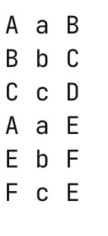

**OUTPUT:**

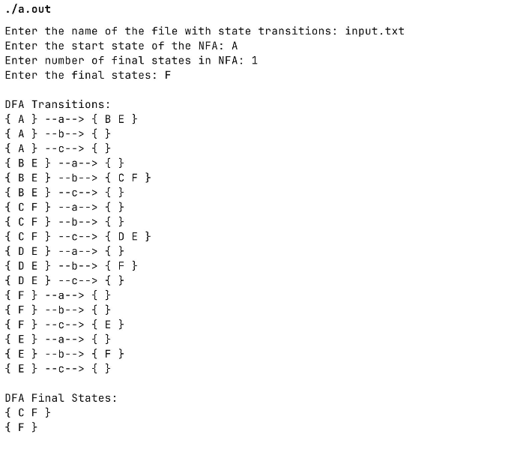

Name: Vinay Chandrasekhar Date:

Roll no: 63

**PROGRAM:**

#include <stdio.h>

#include <stdio.h>

#include <stdlib.h>

#include <string.h>

#define MAX 50

int transition[MAX][MAX];

int states, symbols;

int final_states[MAX], final_count;

int start_state;

int partition[MAX], new_partition[MAX];

int main() {

printf("Enter number of states: ");

scanf("%d", &states);

printf("Enter number of symbols: ");

scanf("%d", &symbols);

printf("Enter transition table (%d x %d):\n", states, symbols);

for (int i = 0; i < states; i++)

for (int j = 0; j < symbols; j++) scanf("%d", &transition[i][j]);

printf("Enter start state: ");

scanf("%d", &start_state);

printf("Enter number of final states: ");

scanf("%d", &final_count);

memset(final_states, 0, sizeof(final_states));

printf("Enter final states: ");

for (int i = 0; i < final_count; i++) {

int f;

scanf("%d", &f);

final_states[f] = 1;

}

for (int i = 0; i < states; i++) partition[i] = final_states[i] ? 1 : 0;

int changed;

do {

changed = 0;

int new_class = 0;

for (int i = 0; i < states; i++)

new_partition[i] = -1;

for (int i = 0; i < states; i++) {

if (new_partition[i] == -1) {

new_partition[i] = new_class;

for (int j = i + 1; j < states; j++) {

if (partition[i] == partition[j]) {

int same = 1;

for (int s = 0; s < symbols; s++) {

if (partition[transition[i][s]] != partition[transition[j][s]]) {

same = 0;

break;

}

}

if (same) new_partition[j] = new_class;

}

}

new_class++;

}

}

for (int i = 0; i < states; i++) {

if (partition[i] != new_partition[i]) {

changed = 1;

break;

} }

for (int i = 0; i < states; i++) partition[i] = new_partition[i];

} while (changed);

int classes = 0;

for (int i = 0; i < states; i++) {

if (partition[i] > classes)

classes = partition[i];

}

classes++;

printf("\nMinimized DFA has %d states:\n", classes);

for (int i = 0; i < classes; i++) {

printf("State %d: {", i);

for (int j = 0; j < states; j++) if (partition[j] == i) printf(" %d ", j);

printf("}\n");

}

printf("\nTransitions in Minimized DFA:\n");

for (int i = 0; i < classes; i++) {

for (int s = 0; s < symbols; s++) {

int old_rep = -1;

for (int j = 0; j < states; j++) {

if (partition[j] == i) {

old_rep = j;

break;

} }

if (old_rep != -1) printf("%d --%d--> %d\n", i, s, partition[transition[old_rep][s]]);

} }

printf("\nStart state: %d\n", partition[start_state]);

printf("Final states: ");

for (int i = 0; i < states; i++) if (final_states[i] && partition[i] != -1)

printf("%d ", partition[i]);

printf("\n");

return 0;

}

**OUTPUT:**

