OUTPUT FOR AREA OF TRIANGLE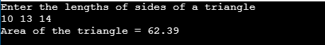

OUTPUT FOR AVERAGE OF THREE NUMBERS

