OUTPUT FOR CONVERTING HOURS INTO MINUTES

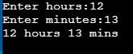

OUTPUT FOR FINDING SUM OF N NATURAL NUMBERS



OUPUT FOR FINDING THE SQUARE OF ANY NUMBER

