CIS 9760 - Big Data Technologies
Project Milestones
Victor Chen
5/16/25

Milestone 1 - Proposal
For my project, I have decided to go with the topic of chess. There are a few reasons for this. Firstly, my main hobby outside of academics/work is chess, and I have a great interest in exploring the intricacies of the royal game. Furthermore, chess games are recorded in a very quantitative style, with moves being written down in a standardized notation of rows and columns and the results of the game being clear-cut, with either the white side winning, black side winning, or a draw. Due to this, I am confident that the topic will be relatively easy to analyze. The most appropriate dataset available that fits all the criteria is from Kaggle:
https://www.kaggle.com/datasets/naddleman/lichess-blitz-subsample
The dataset contains a random subsample of every blitz game played on lichess.org, a very popular online chess playing platform. Within the files, games are stored in the format of PGNs, which can be later converted to something easier to work with such as JSON or CSV. The attributes in the dataset are “Event”, “Site”, “Date”, “Round”, “White”, “Black”, “Result”, “WhiteElo”, “BlackElo”, “ECO”, “Opening”, “TimeControl”, “UTCDate”, “UTCTime”, “Termination”, “WhiteRatingDiff”, and “BlackRatingDiff”. Additionally, the moves of the game for both colors are included. Using this dataset, I intend to predict whether the white player will win based on a few factors, including but not limited to the rating difference and the opening played. A simple way of doing this would be to use a regression model, such as logistic regression, as they are perfect for predicting either 1.0 (a win) or 0.0 (a loss). If possible later, I could implement more complex ML algorithms such as random forest or other classification algorithms.

Milestone 2 - Data Acquisition
To complete project milestone 2, I took a few steps to ensure that the data landed safely in my bucket’s landing folder without ever downloading it onto my laptop. I began by opening the virtual machine instance on Google Cloud with the same method I used for the second homework assignment but changed the storage from 10GB to 50GB to ensure all my files would fit. Then, I went to my Kaggle dataset and downloaded it with curl, copying the command provided. I took out the code section where it said “download”, as I did not want it to go to my downloads folder, and inputted the code into the virtual machine instance. I unzipped the files using the asterisk command and then created a bucket in my project. After creating five folders in the bucket, I checked to ensure the bucket existed and then copied my data files to the landing folder. All of the code I used is visible in Appendix A. Proof of my completion of milestone 2 can be seen with the screenshot below:

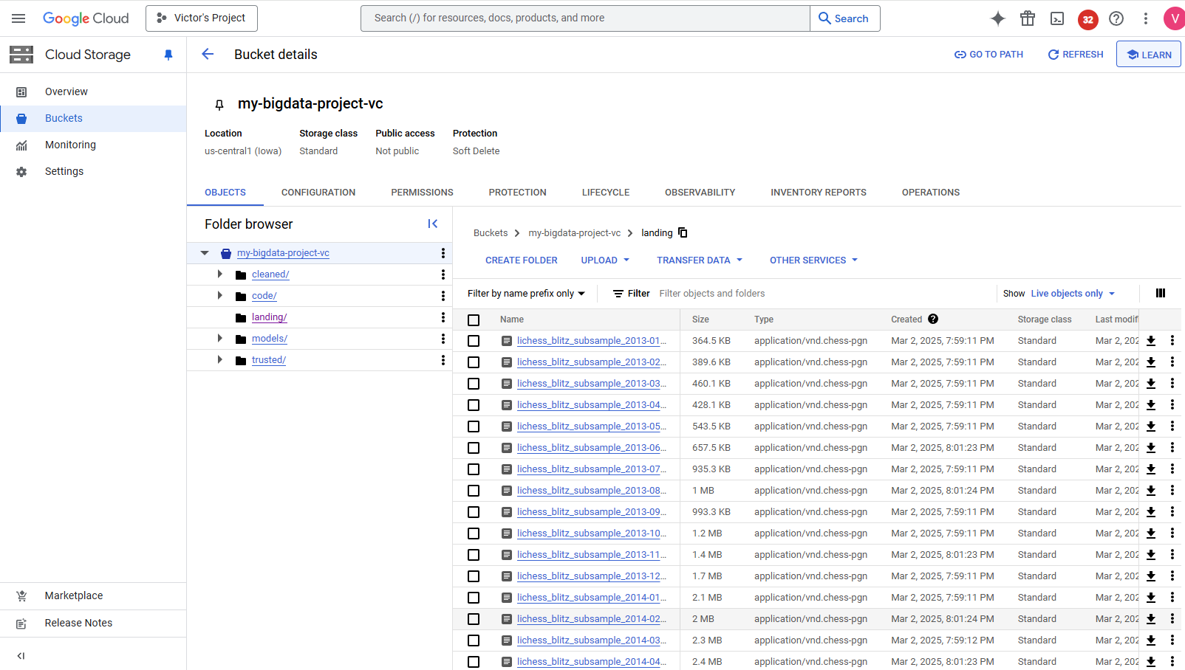
Milestone 3 - Exploratory Data Analysis and Data Cleaning
For this project milestone, I decided on using Python to perform my EDA instead of PySpark. This is because my dataset was broken into several smaller files that were not big enough to require the use of PySpark, so I just used Python. For my EDA code, I referenced a few other samples from the notebook, such as the functions “perform_EDA_numeric()”, and “perform_EDA_categorical().” Additionally, I had to do some data wrangling to change the data format of my dataset from PGN to something easier to work with, and I referenced the code that Professor Holowczak sent in an email. Finally, I created a few visualizations using matplotlib and seaborn to understand the distribution of my data. Below, I’ve provided a few images for one of the files in my dataset.
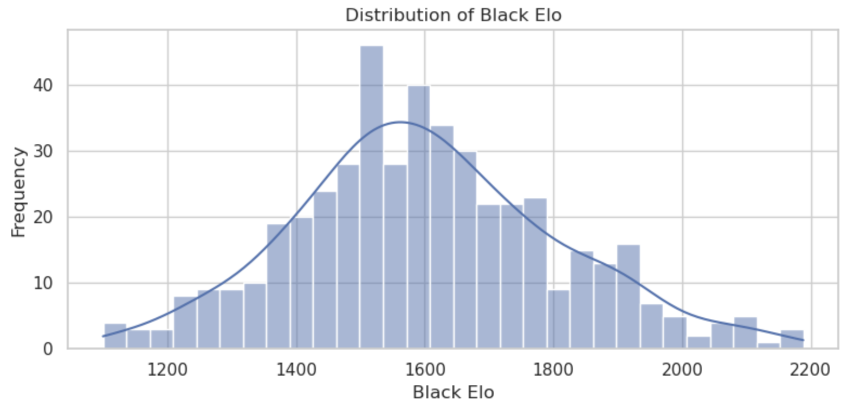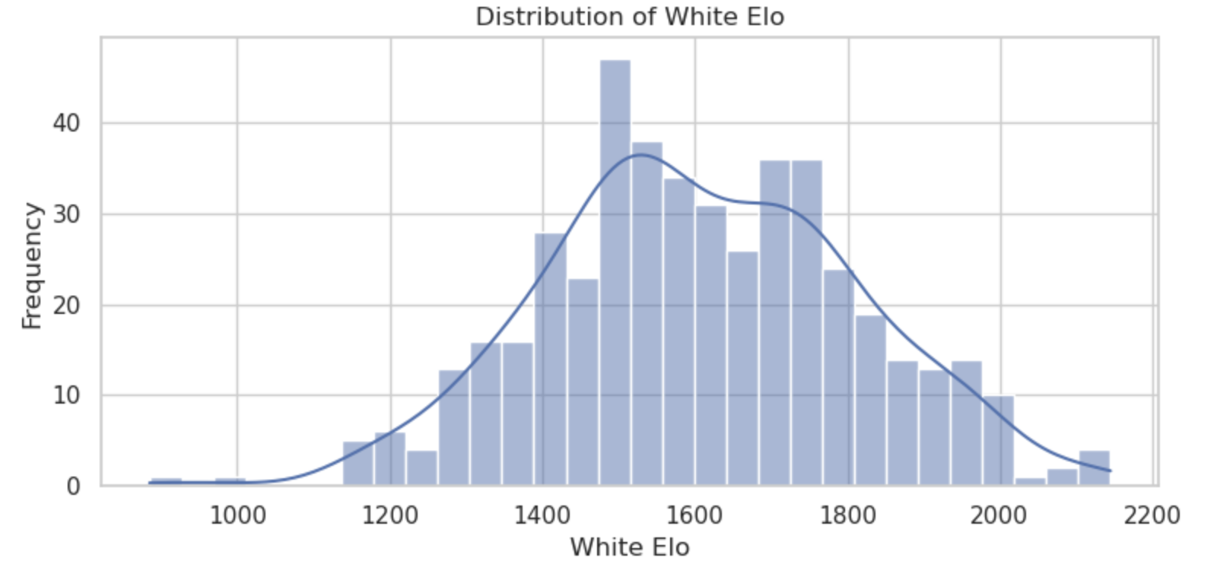
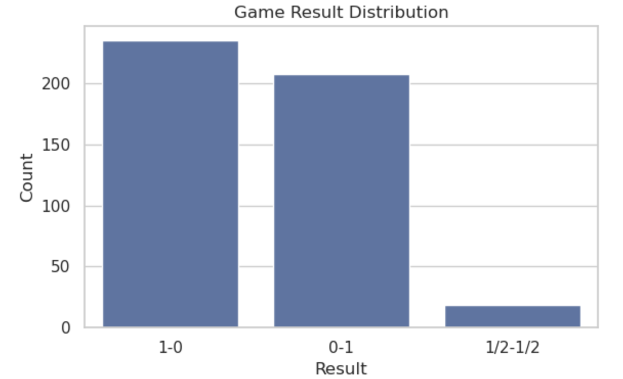
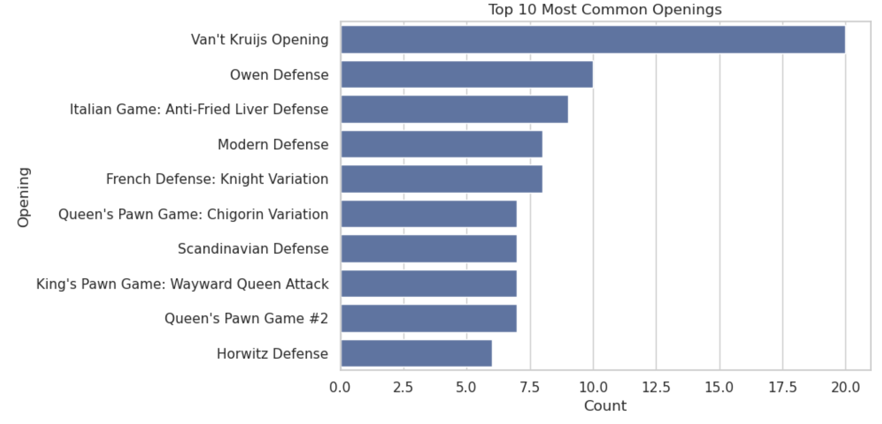
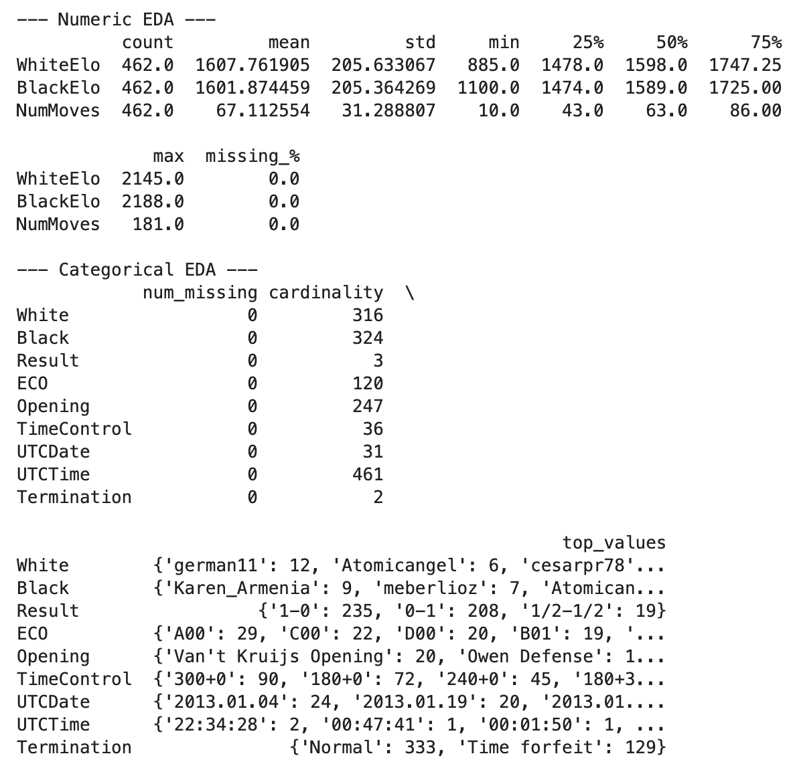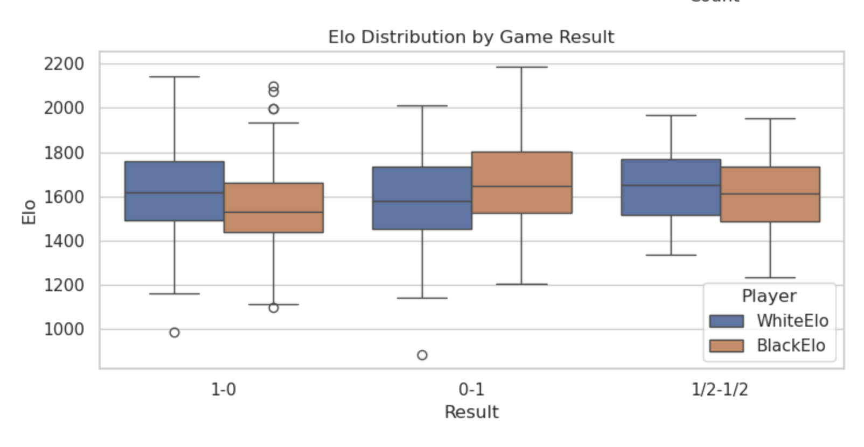

From the EDA, we can see that there are a few unnecessary columns. “UTCTime” and “UTCDate” are irrelevant, as we do not really care about the time and date of the games. Additionally, we drop “White” and “Black”, as we do not care about the usernames of the players, and it is actually better to anonymize them if we are aiming to predict the winner based on a few moves. Then we will clean up columns and drop missing values, and move the data to the cleaned folder. When I tried to do this in a new notebook, I had trouble actually getting the code to work. I know what columns I want to remove, and what else to do to clean, but somehow I could not get the files to save to parquet, and my files ultimately did not end up in the cleaned folder.

In summary, my data consists of WhiteElo, BlackElo, NumMoves, White, Black, Result, ECO, Opening, TimeControl, UTCDate, UTCTime, and Termination. I will drop White, Black, UTCDate, and UTCTime, as they are unnecessary variables for what I am looking to predict. I suspect that a challenge I may face during feature engineering is managing to convert Opening (a categorical type of data) into something that can be expressed through numbers, so the algorithm can understand it.

Milestone 4 - Feature Engineering and Modeling
Model: Predict whether the white player wins (1.0) or not (0.0).
Column | Data Type | Variable Type | Indexer | Encoder | Scaler
whiteelo | numeric | continuous |  |  | StandardScaler
blackelo | numeric | continuous |  |  | StandardScaler
nummoves | numeric | continuous |  |  | StandardScaler
eco | string | categorical | StringIndexer | OneHotEncoder
opening | string | categorical | StringIndexer | OneHotEncoder
timecontrol | string | categorical | StringIndexer | OneHotEncoder
termination | string | categorical | StringIndexer | OneHotEncoder
Result (label) | string | categorical | StringIndexer

For this milestone, I wrote PySpark code to read and process the data using a Dataproc cluster. The main steps of my program include reading the cleaned data from the /cleaned folder, applying feature engineering on categorical columns using StringIndexer, normalizing numeric columns with StandardScaler, and combining features into a single vector using VectorAssembler. The dataset was split into training and testing sets 80/20, and a random forest classifier was trained to predict the result of the game, using accuracy as the metric for evaluation. Data with features was saved to the /trusted folder, while models were saved to the /models folder.
Milestone 5 - Data Visualization
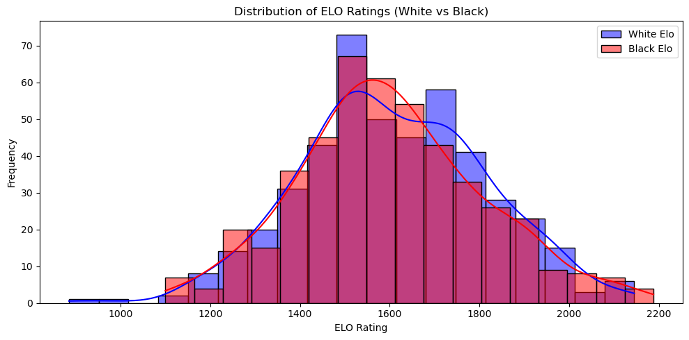
This histogram compares the distributions of white and black player ELO ratings in the dataset. The distributions are bell-shaped and centered around similar rating ranges, though white players tend to have slightly higher ELOs on average. This similarity supports the fairness of the dataset in terms of player skill levels.
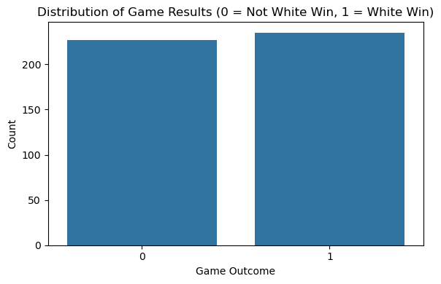
The bar chart shows a near-even split between games won by White (1) and games not won by White (0), which includes both Black wins and draws. This balance suggests that the model was trained on a dataset without severe class imbalance, which helps in fair model learning and evaluation.
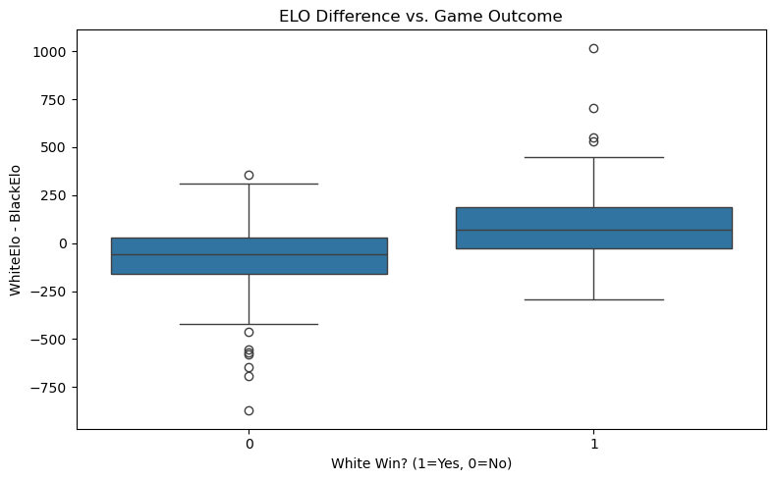
The boxplot visualizes the difference between white and black ELO ratings across game outcomes. Games won by White generally show a positive ELO difference (White rated higher), while losses and draws show a negative or smaller difference. This supports the intuition that a higher-rated player is more likely to win.
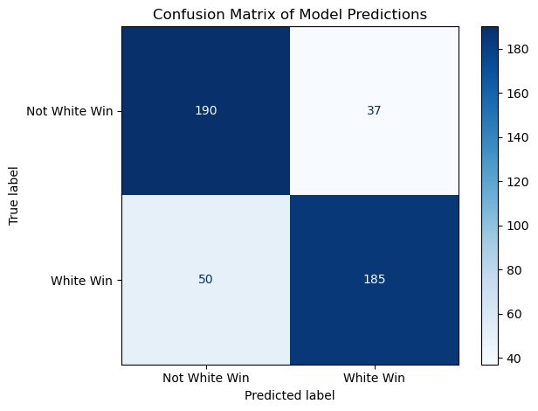
The confusion matrix summarizes the model’s predictive performance. The diagonal values (190 and 185) represent correct predictions for both classes, while the off-diagonal values (37 and 50) represent misclassifications. The model performs reasonably well, though there's some confusion between classes, consistent with the 57.58% accuracy score.
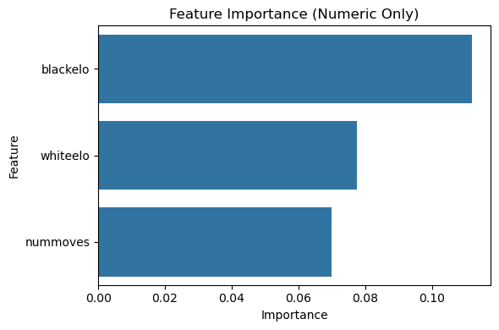
This bar chart ranks the importance of numeric features used in the Random Forest model. blackelo has the highest impact on model predictions, followed closely by whiteelo and nummoves. This indicates the model heavily relies on player skill levels and game length when determining outcomes.

Milestone 6 - Summary and Conclusions
This project set out to explore the factors influencing the outcome of online blitz chess games, with the ultimate goal of predicting whether the white player would win. Using a Kaggle dataset that pulled directly from Lichess.org, we constructed a complete data processing pipeline, from acquisition and cleaning through to modeling and visualization entirely in a cloud-based environment using Google Cloud Platform, Python, and PySpark.
The pipeline began with acquiring PGN files directly into cloud storage. These files were parsed into structured data using Python's chess library and pandas, allowing us to extract meaningful game metadata such as player ratings, results, opening names, and time controls. Exploratory data analysis revealed interesting distribution patterns in ELO ratings and outcomes. Key insights included the dominance of certain openings and a generally balanced outcome distribution, which helped ensure our target variable was not skewed.
In the data cleaning phase, we removed non informative columns like player usernames and timestamps, handled missing values, and ensured all features were appropriately typed. Our modeling focused on transforming categorical data via StringIndexer and OneHotEncoder, scaling continuous variables, and combining them using VectorAssembler. The final dataset was split into training and test sets and used to train a random forest classifier using Spark MLlib.
Model evaluation showed an accuracy of approximately 57.6%, which suggests a moderate signal in the selected features. The confusion matrix highlighted the model's balanced sensitivity across both classes, albeit with room for improvement. Feature importance analysis revealed that BlackElo was the most predictive feature, followed closely by WhiteElo and the number of moves, supporting the intuitive conclusion that player skill and game length are strong indicators of outcomes.
Visualizations supported these findings. ELO distributions showed that white players were marginally higher rated on average, and boxplots confirmed that games with a greater ELO advantage for white were more likely to result in a white win. The confusion matrix and feature importance bar charts further clarified model behavior and reliability.
While the model's performance was modest, the project demonstrates the potential of applying data engineering and machine learning to chess analytics. There is significant room for enhancement, such as incorporating move-level data or time usage patterns, experimenting with deeper models, or using player behavior metrics. This foundational pipeline serves as a strong base for future explorations in predictive modeling within structured game environments.
Code references:
- PGN parsing and EDA adapted from sample notebooks “python_eda_functions_20250331”, “Amazon_Reviews_EDA_Python_20250331”, and chess PGN code shared by Professor Holowczak.
- Feature engineering and modeling adapted from sample notebook “Amazon_Reviews_Feature_Engineering_20250506” shared by Professor Holowczak.

Appendix A
sudo apt update
## Data from Kaggle
#!/bin/bash
curl -L -o lichess-blitz-subsample.zip\
https://www.kaggle.com/api/v1/datasets/download/naddleman/lichess-blitz-subsample
sudo apt install unzip -y
## Unzip files
unzip lichess-blitz-subsample.zip
## Create bucket
gcloud storage buckets create gs://my-bigdata-project-vc --project=victors-project-451221 --default-storage-class=STANDARD --location=us-central1 --uniform-bucket-level-access
## Create folders
gcloud storage cp /dev/null gs://my-bigdata-project-vc/landing
gcloud storage cp /dev/null gs://my-bigdata-project-vc/cleaned
gcloud storage cp /dev/null gs://my-bigdata-project-vc/trusted
gcloud storage cp /dev/null gs://my-bigdata-project-vc/code
gcloud storage cp /dev/null gs://my-bigdata-project-vc/models
## Check if bucket exists
gcloud storage ls -l gs://my-bigdata-project-vc
## Copy files to GCS bucket landing folder
gcloud storage cp lichess_blitz/lichess_blitz_subsample_*.pgn gs://my-bigdata-project-vc/landing/
Appendix B
from google.cloud import storage
from io import StringIO
import pandas as pd
import chess
import chess.pgn
import matplotlib.pyplot as plt
import seaborn as sns
# Set seaborn style
sns.set(style="whitegrid")
def perform_EDA_numeric(df, filename=None):
numeric_df = df.select_dtypes(include='number')
summary_df = numeric_df.describe().T
summary_df['missing_%'] = 100 * numeric_df.isna().sum() / len(numeric_df)
if filename:
summary_df.to_csv(f"numeric_summary_{filename}.csv")
return summary_df
def perform_EDA_categorical(df, filename=None, include_columns=[]):
categorical_df = df.select_dtypes(include='object')
if include_columns:
categorical_df = categorical_df[include_columns]
summary = {}
for col in categorical_df.columns:
value_counts = categorical_df[col].value_counts(dropna=False)
summary[col] = {
"num_missing": categorical_df[col].isna().sum(),
"cardinality": categorical_df[col].nunique(),
"top_values": value_counts.head(5).to_dict()
}
summary_df = pd.DataFrame(summary).T
if filename:
summary_df.to_csv(f"categorical_summary_{filename}.csv")
return summary_df
def games_to_dataframe(games):
data = []
for game in games:
headers = game.headers
data.append({
"White": headers.get("White"),
"Black": headers.get("Black"),
"WhiteElo": int(headers.get("WhiteElo", 0)) if headers.get("WhiteElo") else None,
"BlackElo": int(headers.get("BlackElo", 0)) if headers.get("BlackElo") else None,
"Result": headers.get("Result"),
"ECO": headers.get("ECO"),
"Opening": headers.get("Opening"),
"TimeControl": headers.get("TimeControl"),
"UTCDate": headers.get("UTCDate"),
"UTCTime": headers.get("UTCTime"),
"Termination": headers.get("Termination"),
"NumMoves": len(list(game.mainline_moves()))
})
return pd.DataFrame(data)
# Visualization functions
def plot_distributions(df):
# WhiteElo histogram
plt.figure(figsize=(8, 4))
sns.histplot(df['WhiteElo'].dropna(), bins=30, kde=True)
plt.title("Distribution of White Elo")
plt.xlabel("White Elo")
plt.ylabel("Frequency")
plt.tight_layout()
plt.show()
# BlackElo histogram
plt.figure(figsize=(8, 4))
sns.histplot(df['BlackElo'].dropna(), bins=30, kde=True)
plt.title("Distribution of Black Elo")
plt.xlabel("Black Elo")
plt.ylabel("Frequency")
plt.tight_layout()
plt.show()
# Result count
plt.figure(figsize=(6, 4))
sns.countplot(x='Result', data=df, order=df['Result'].value_counts().index)
plt.title("Game Result Distribution")
plt.xlabel("Result")
plt.ylabel("Count")
plt.tight_layout()
plt.show()
# Top10 openings
plt.figure(figsize=(10, 5))
top_openings = df['Opening'].value_counts().head(10)
sns.barplot(x=top_openings.values, y=top_openings.index)
plt.title("Top 10 Most Common Openings")
plt.xlabel("Count")
plt.ylabel("Opening")
plt.tight_layout()
plt.show()
# Elo boxplot by result
plt.figure(figsize=(8, 4))
df_melted = df.melt(id_vars='Result', value_vars=['WhiteElo', 'BlackElo'], var_name='Player', value_name='Elo')
sns.boxplot(x='Result', y='Elo', hue='Player', data=df_melted)
plt.title("Elo Distribution by Game Result")
plt.tight_layout()
plt.show()
def main_chess():
bucket_name = 'my-bigdata-project-vc'
storage_client = storage.Client()
blobs = storage_client.list_blobs(bucket_name, prefix="landing/lichess_blitz_subsample_2013-01")
pgn_blobs = [blob for blob in blobs if blob.name.endswith('.pgn')]
for blob in pgn_blobs:
print(f"File: {blob.name} | Size: {blob.size} bytes | Created: {blob.time_created}")
pgn_content = blob.download_as_string()
pgn_text = pgn_content.decode('utf-8')
games = []
pgn_io = StringIO(pgn_text)
while True:
game = chess.pgn.read_game(pgn_io)
if game is None:
break
games.append(game)
print(f"Parsed {len(games)} games from this file.")
df = games_to_dataframe(games)
print("\n--- Numeric EDA ---")
numeric_summary_df = perform_EDA_numeric(df, filename=blob.name.replace("/", "_"))
print(numeric_summary_df)
print("\n--- Categorical EDA ---")
categorical_summary_df = perform_EDA_categorical(df, filename=blob.name.replace("/", "_"))
print(categorical_summary_df)
print("\n--- Generating Visualizations ---")
plot_distributions(df)
break # Remove to process all files
main_chess()

Appendix C
df.columns = (
df.columns
.str.strip()
.str.replace(" ", "_")
.str.replace("-", "_")
.str.lower()
)
columns_to_drop = ['utcdate', 'utctime', 'white', 'black']
df.drop(columns=columns_to_drop, inplace=True, errors='ignore')
df_cleaned = df.dropna()
df_cleaned['whiteelo'] = df_cleaned['whiteelo'].astype(int)
df_cleaned['blackelo'] = df_cleaned['blackelo'].astype(int)
df_cleaned['nummoves'] = df_cleaned['nummoves'].astype(int)
for col in ['result', 'eco', 'opening', 'timecontrol', 'termination']:
df_cleaned[col] = df_cleaned[col].astype('category')
df_cleaned.to_parquet('./cleaned/chess_cleaned_data.parquet', index=False)
Equivalent command line for dataproc cluster
gcloud dataproc clusters create cluster-e006 --enable-component-gateway --region us-central1 --master-machine-type n4-standard-4 --master-boot-disk-type hyperdisk-balanced --master-boot-disk-size 100 --num-workers 2 --worker-machine-type n4-standard-2 --worker-boot-disk-size 500 --image-version 2.2-debian12 --optional-components JUPYTER --project victors-project-451221
Appendix D
from pyspark.sql import SparkSession
from pyspark.sql.functions import when
from pyspark.ml import Pipeline
from pyspark.ml.feature import (
StringIndexer, OneHotEncoder, VectorAssembler, StandardScaler
)
from pyspark.ml.classification import RandomForestClassifier
from pyspark.ml.evaluation import MulticlassClassificationEvaluator
from pyspark.ml.tuning import ParamGridBuilder, CrossValidator
# Initialize Spark Session
spark = SparkSession.builder \
.appName("ChessFeatureEngineeringModeling") \
.getOrCreate()
# Load cleaned data
input_path = "gs://my-bigdata-project-vc/cleaned/lichess_blitz_2013_01_combined_cleaned.parquet"
df = spark.read.parquet(input_path)
# Label: 1 if White won, 0 otherwise
df = df.withColumn("label", when(df["result"] == "1-0", 1).otherwise(0))
# Feature Engineering
# Categorical features
categorical_cols = ["eco", "opening", "timecontrol", "termination"]
indexers = [
StringIndexer(inputCol=col, outputCol=f"{col}_idx", handleInvalid="keep")
for col in categorical_cols
]
encoders = [
OneHotEncoder(inputCol=f"{col}_idx", outputCol=f"{col}_vec")
for col in categorical_cols
]
# Numeric features
numeric_cols = ["whiteelo", "blackelo", "nummoves"]
# Assemble all features
assembler_inputs = [f"{col}_vec" for col in categorical_cols] + numeric_cols
assembler = VectorAssembler(inputCols=assembler_inputs, outputCol="assembled_features")
# Standardize
scaler = StandardScaler(inputCol="assembled_features", outputCol="features")
# Model Setup
rf = RandomForestClassifier(
labelCol="label",
featuresCol="features",
seed=42
)
param_grid = ParamGridBuilder() \
.addGrid(rf.numTrees, [20, 50]) \
.addGrid(rf.maxDepth, [5, 10]) \
.build()
evaluator = MulticlassClassificationEvaluator(
labelCol="label",
predictionCol="prediction",
metricName="accuracy"
)
# CrossValidator setup
cv = CrossValidator(
estimator=rf,
estimatorParamMaps=param_grid,
evaluator=evaluator,
numFolds=3
)
# Full pipeline
pipeline = Pipeline(stages=indexers + encoders + [assembler, scaler, cv])
# Train/Test Split
train_df, test_df = df.randomSplit([0.8, 0.2], seed=42)
# Fit pipeline
model = pipeline.fit(train_df)
# Evaluation
predictions = model.transform(test_df)
accuracy = evaluator.evaluate(predictions)
print(f"Model Accuracy: {accuracy:.4f}")
# Save Outputs
with open("/tmp/evaluation_results.txt", "w") as f:
f.write(f"Model Accuracy: {accuracy:.4f}\n")
# Save engineered data to trusted zone
trusted_path = "gs://my-bigdata-project-vc/trusted/chess_trusted_data.parquet"
transformed_df = model.transform(df)
transformed_df.write.mode("overwrite").parquet(trusted_path)
# overwrite previous files and save the model
import subprocess
subprocess.run([
"gsutil", "-m", "rm", "-r", "gs://my-bigdata-project-vc/models/chess_rf_model"
])
model_path = "gs://my-bigdata-project-vc/models/chess_rf_model"
model.save(model_path)
# Upload evaluation result to GCS
import subprocess
subprocess.run([
"gsutil", "cp", "/tmp/evaluation_results.txt", "gs://my-bigdata-project-vc/models/evaluation_results.txt"
])
spark.stop()

Appendix E
from pyspark.sql import SparkSession
spark = SparkSession.builder \
.appName("ChessDataVisualization") \
.getOrCreate()
trusted_path = "gs://my-bigdata-project-vc/trusted/chess_trusted_data.parquet"
df = spark.read.parquet(trusted_path)
# If label/prediction are not present, rerun model.transform(df), but assume it's already there
predictions = df.select("whiteelo", "blackelo", "label", "prediction")
# Convert to Pandas
predictions_pd = predictions.toPandas()
# ELO Distribution Plot
import matplotlib.pyplot as plt
import seaborn as sns
import pandas as pd
plt.figure(figsize=(10, 5))
sns.histplot(predictions_pd["whiteelo"], color="blue", label="White Elo", kde=True)
sns.histplot(predictions_pd["blackelo"], color="red", label="Black Elo", kde=True)
plt.title("Distribution of ELO Ratings (White vs Black)")
plt.legend()
plt.xlabel("ELO Rating")
plt.ylabel("Frequency")
plt.tight_layout()
plt.savefig("/tmp/viz1_elo_distribution.png")
# Result Distribution Plot
plt.figure(figsize=(6, 4))
sns.countplot(x="label", data=predictions_pd)
plt.title("Distribution of Game Results (0 = Not White Win, 1 = White Win)")
plt.xlabel("Game Outcome")
plt.ylabel("Count")
plt.tight_layout()
plt.savefig("/tmp/viz2_result_distribution.png")
# Elo Difference vs. Outcome Plot
predictions_pd["elo_diff"] = predictions_pd["whiteelo"] - predictions_pd["blackelo"]
plt.figure(figsize=(8, 5))
sns.boxplot(x="label", y="elo_diff", data=predictions_pd)
plt.title("ELO Difference vs. Game Outcome")
plt.xlabel("White Win? (1=Yes, 0=No)")
plt.ylabel("WhiteElo - BlackElo")
plt.tight_layout()
plt.savefig("/tmp/viz3_elo_diff_vs_outcome.png")
# Confusion Matrix Plot
from sklearn.metrics import confusion_matrix, ConfusionMatrixDisplay
cm = confusion_matrix(predictions_pd["label"], predictions_pd["prediction"])
disp = ConfusionMatrixDisplay(confusion_matrix=cm, display_labels=["Not White Win", "White Win"])
disp.plot(cmap="Blues")
plt.title("Confusion Matrix of Model Predictions")
plt.tight_layout()
plt.savefig("/tmp/viz4_confusion_matrix.png")
# Load your model if needed
from pyspark.ml import PipelineModel
model = PipelineModel.load("gs://my-bigdata-project-vc/models/chess_rf_model")
# Extract the best RandomForest model
rf_model = model.stages[-1].bestModel
# Get feature importances (last 3 numeric features: whiteelo, blackelo, nummoves)
importances = rf_model.featureImportances.toArray()
numeric_feats = ["whiteelo", "blackelo", "nummoves"]
feat_df = pd.DataFrame({
"Feature": numeric_feats,
"Importance": importances[-3:]
}).sort_values("Importance", ascending=False)
# Plot feature importances
plt.figure(figsize=(6, 4))
sns.barplot(x="Importance", y="Feature", data=feat_df)
plt.title("Feature Importance (Numeric Only)")
plt.tight_layout()
plt.savefig("/tmp/viz5_feature_importance.png")

