Installtion of Kubernetes via kubeadm( 1 master and 2 worker node):

----------------------------------------------------------------------

Step1:

------

Stepup the kubernetes and Docker Repo on all Server :

curl -fsSL https://download.docker.com/linux/ubuntu/gpg | sudo apt-key add -

sudo add-apt-repository "deb [arch=amd64] https://download.docker.com/linux/ubuntu \

$(lsb_release -cs) \

stable"

curl -s https://packages.cloud.google.com/apt/doc/apt-key.gpg | sudo apt-key add -

cat << EOF | sudo tee /etc/apt/sources.list.d/kubernetes.list

deb https://apt.kubernetes.io/ kubernetes-xenial main

EOF

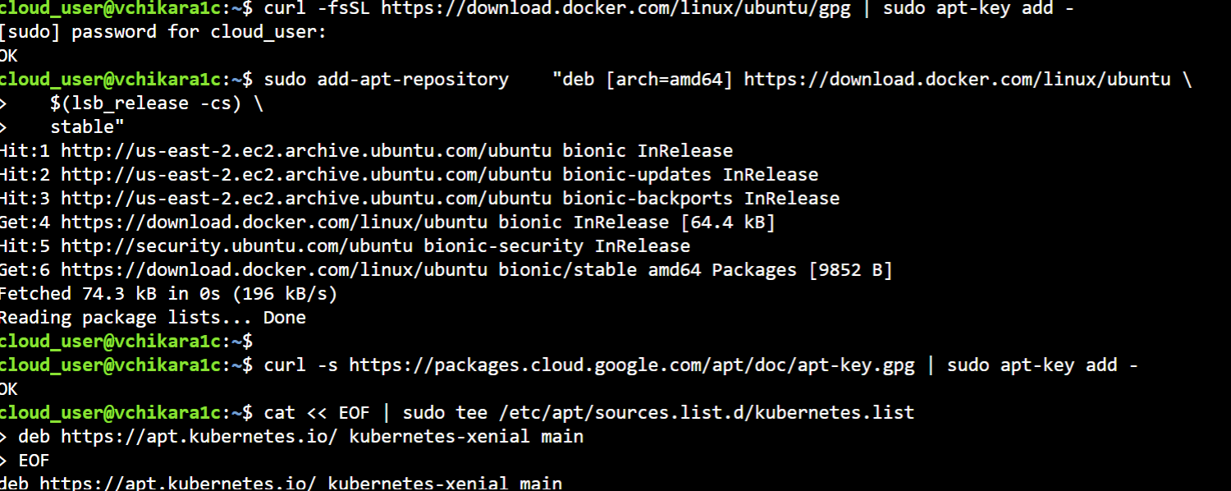

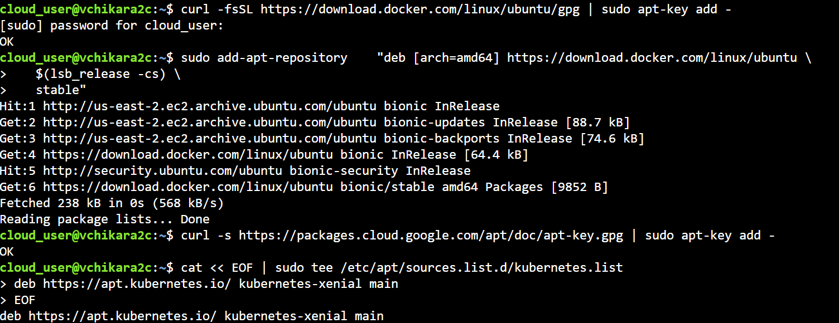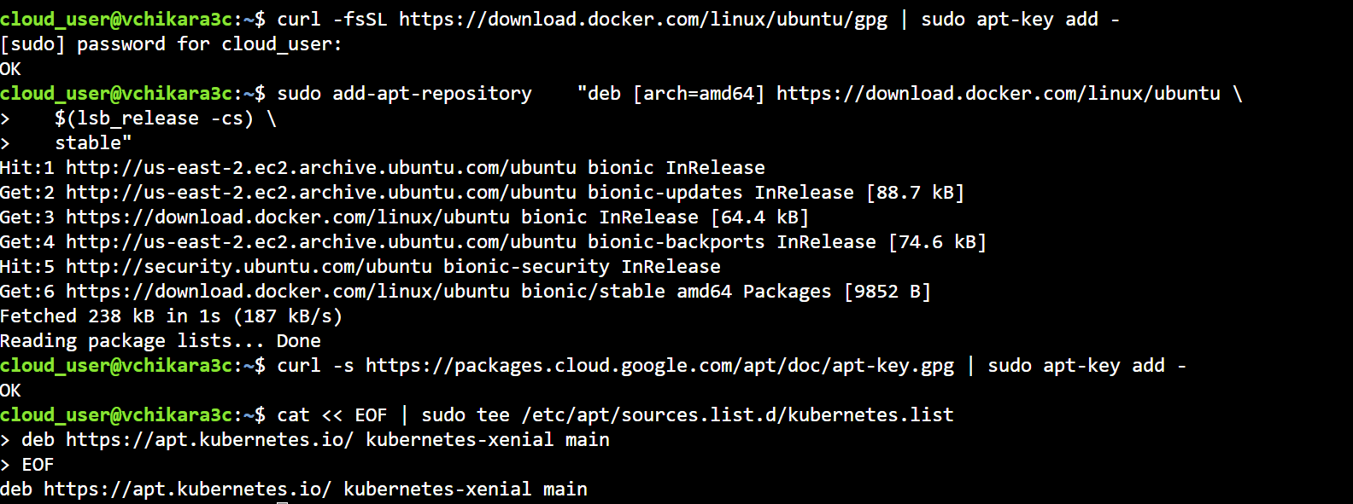

Step2:

-------

Install Docker and Kubernetes packages:

sudo apt-get update

sudo apt-get install -y docker-ce=18.06.1~ce~3-0~ubuntu kubelet=1.13.5-00 kubeadm=1.13.5-00 kubectl=1.13.5-00

sudo apt-mark hold docker-ce kubelet kubeadm kubectl

Enable IP tables bridge call:

echo "net.bridge.bridge-nf-call-iptables=1" | sudo tee -a /etc/sysctl.conf

sudo sysctl -p

Step3:

On kube master server

Initialize the cluster :

sudo kubeadm init --pod-network-cidr=10.244.0.0/16

Setup local kube conf

mkdir -p $HOME/.kube

sudo cp -i /etc/kubernetes/admin.conf $HOME/.kube/config

sudo chown $(id -u):$(id -g) $HOME/.kube/config

Install Flannel networking:

kubectl apply -f https://raw.githubusercontent.com/coreos/flannel/bc79dd1505b0c8681ece4de4c0d86c5cd2643275/Documentation/kube-flannel.yml



Step4 :

On each kuberntes worker node run this :

kubeadm join 172.31.123.84:6443 --token e7mrgk.7b6sjpubudfkkogd --discovery-token-ca-cert-hash sha256:717137d8054f137858c5f596cec4019e7a855bb4142a5eee5ba416ce77a04cab

Step5 :

On each master node:

Kubectl get nodes

