**Kubernetes Rolling updates and Rollbacks :**

Rolling updates provide a way to update a deployment to a new container version by gradually updating replicas so that there is no downtime.

The –record flag records information about the update so that it can be rolled back.

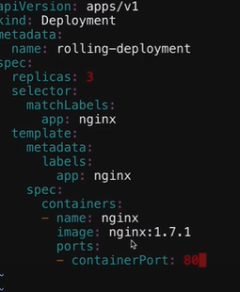

Perform rolling update



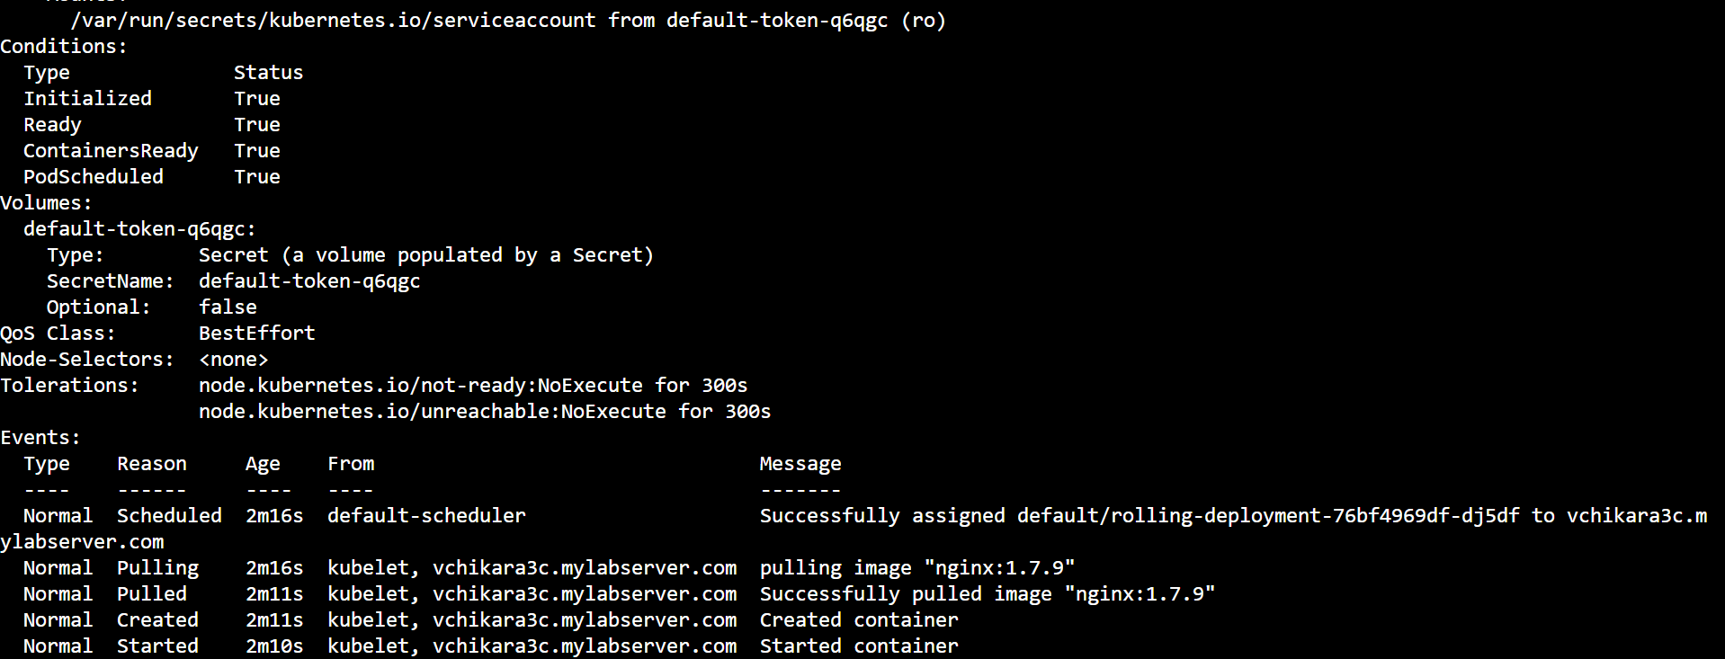

Explore the rollback to the previous version: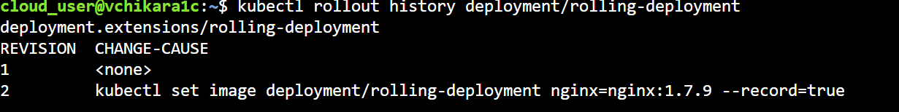

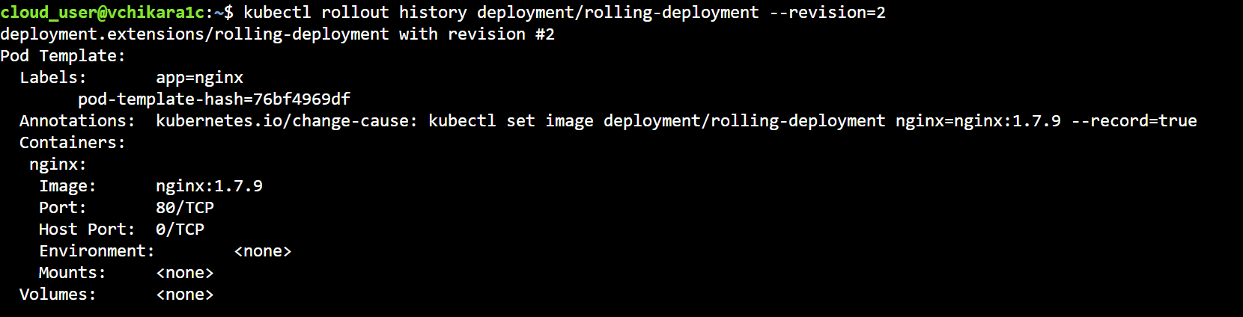

Rollback to previous version:



Rollingback are performed by setting maxsurge and maxunavailable

apiVersion: apps/v1

kind: Deployment

metadata:

name: rolling-deployment

spec:

strategy:

rollingUpdate:

maxSurge: 3

maxUnavailable: 2

replicas: 3

selector:

matchLabels:

app: nginx

template:

metadata:

labels:

app: nginx

spec:

containers:

- name: nginx

image: nginx:1.7.1

ports:

- containerPort: 80

JOBS and CRONJOBS :

Jobs can be used to reliably execute a workload until it complete. When the job is finished the container will exit and the pods enter the completed state.

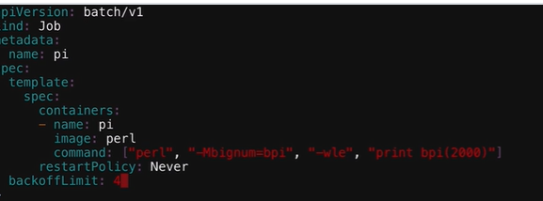

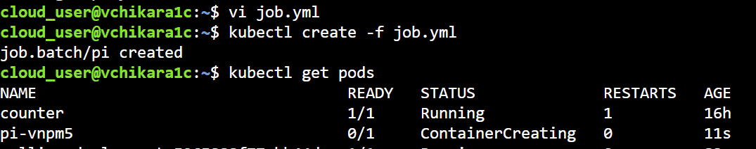

Kubectl logs pi-vnpm5

