**Services and networking in the Kubernetes**

Services create an abstract layer which provides network access to a dynamic set of pods.

Service uses selector to determine which pods will receive traffic through out the service.

Create the deployment :

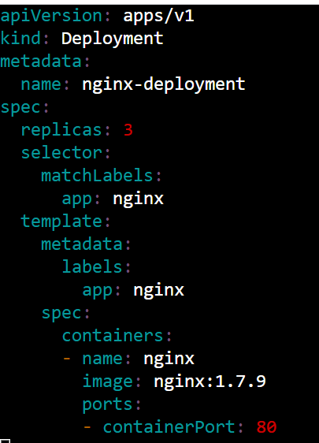



Expose the service with the deployment:

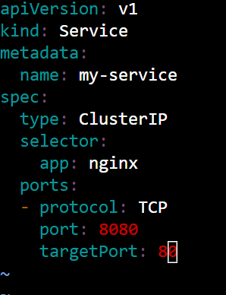



kubectl get svc

kubectl get endpoints my-service



Network Policies:

podSelector : determine which pods the networkpolicy applies to.

policyTypes: sets whether the policy governs the incoming traffic(ingress), outgoing(egress) or both.

Rules : both ingress and egress rule are while listbased.

* Ports: specifiy the ports and protocol that matches rule.
* From/to: selectors specifies the source and destination of network traffic that matches the rule.

