**Bootstrap worker node**

Install packages on both workwer node



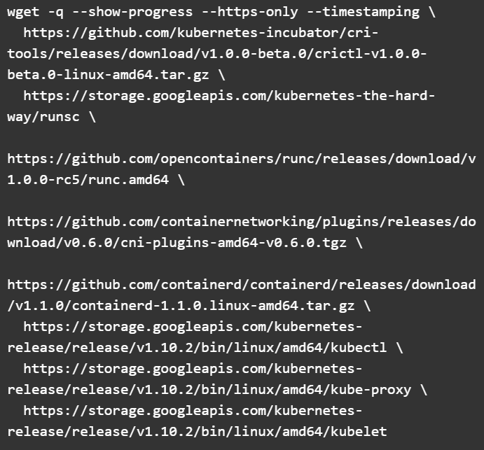

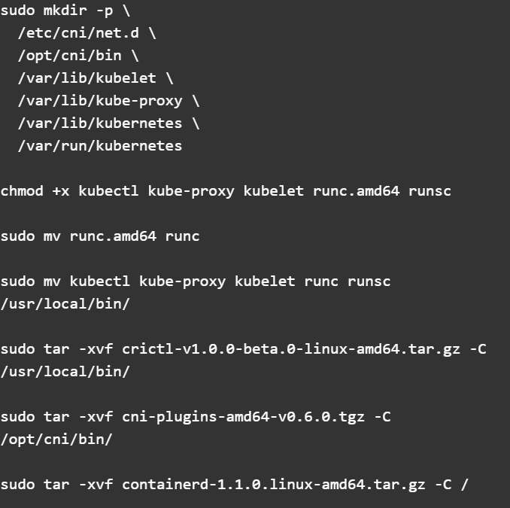

Configure the containerd service



Create the containerd config.toml

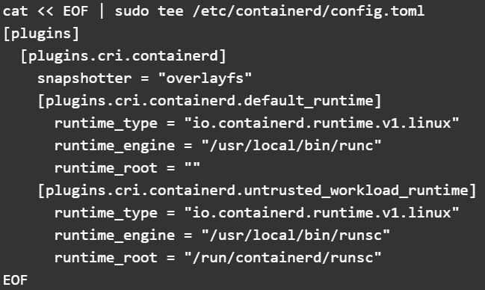

Create the containerd unit file

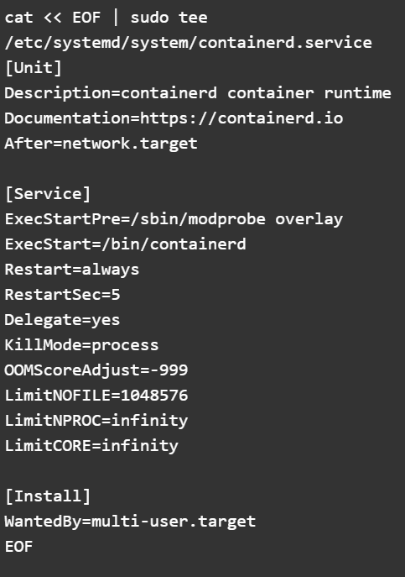

Configure the kubelet service

You can set the HOSTNAME to worker0 on the first worker node and worker1 on the second.

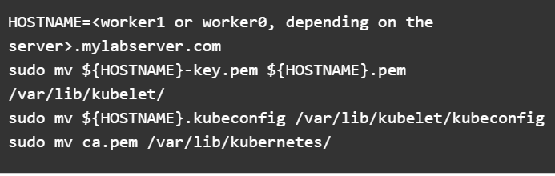

Create the kubelet config

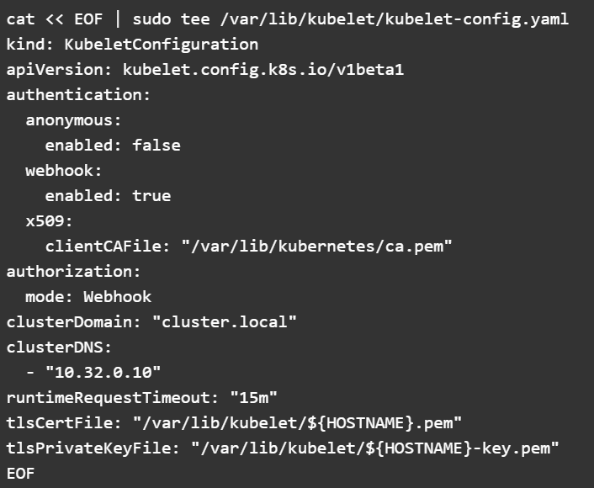

Create the kubelet unit file

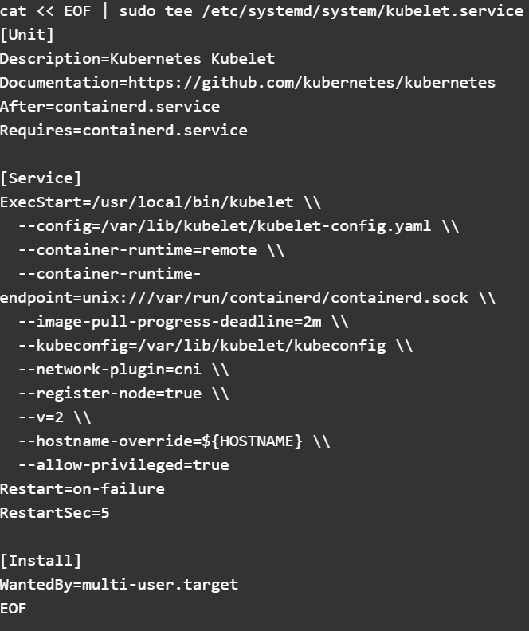

Configure the kube-proxy file

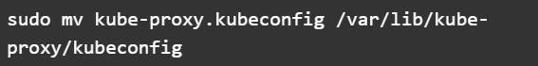

Kube-proxy config file

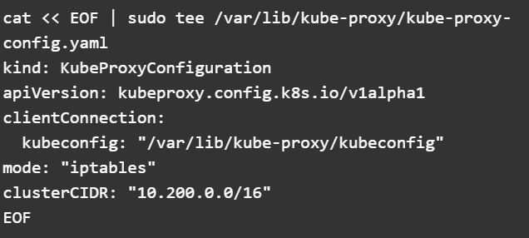

Kube-proxy unit file

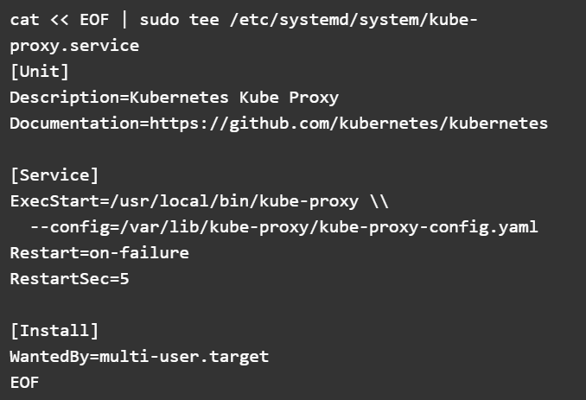

Successfully start all the service:

Enable and start all the service

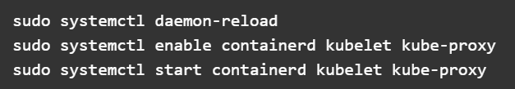

Verify service up and running



Make sure two nodes are in READY state.

Make sure node are registering with cluster

