**Bootstrapping the control plane**

Download and install the binaries for kube-apiserver,kube-controller-manager, kube-scheduler, kubectl

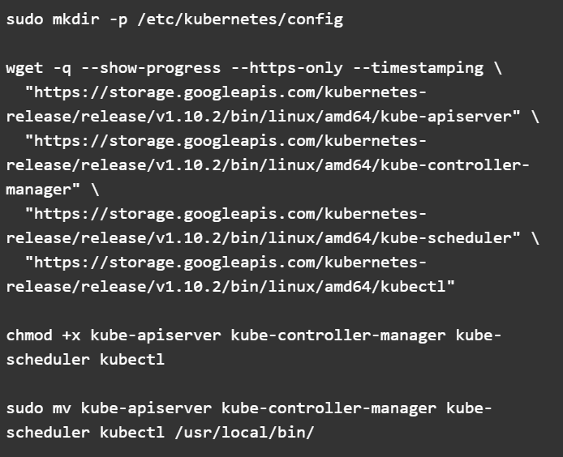

Configure the kube-apiserver service

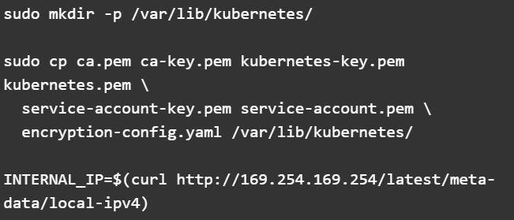

Set the environmental to contain the private ip.

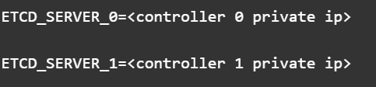

Create the system unit file

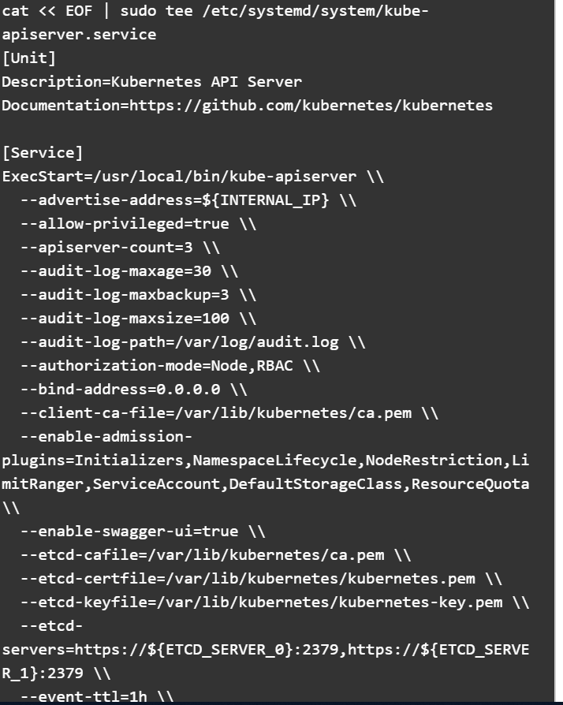

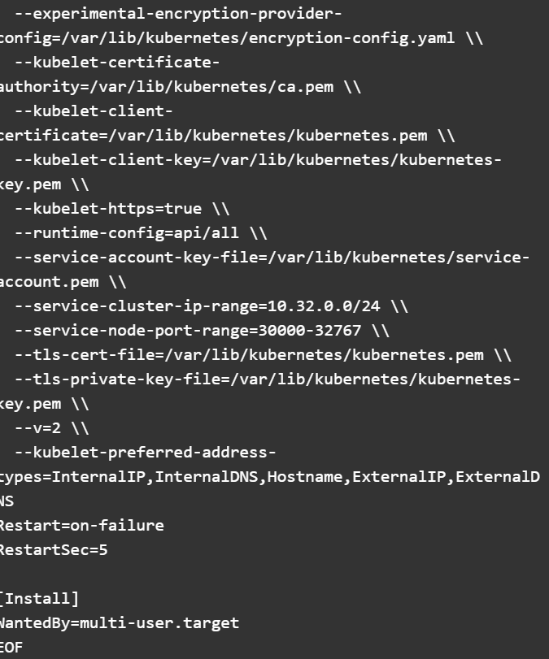

Configure kube-controller manager service

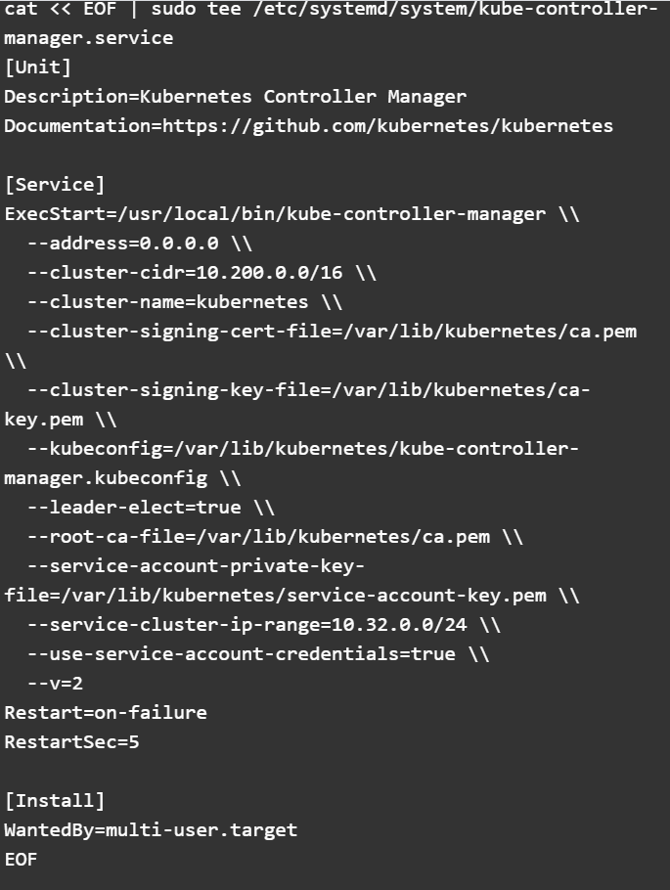

Successfully start all service

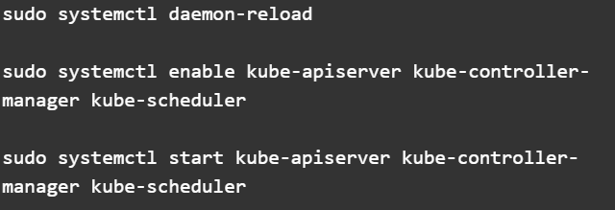

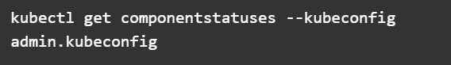

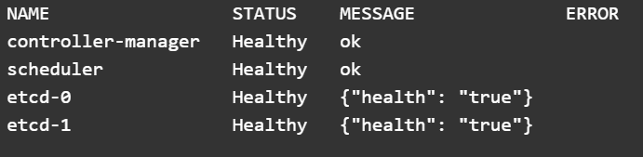

Set up RBAC for kubelet authorization:

