**Data Encryption for Kubernetes**

Encryption key and include it in Kubernetes data encryption conf file

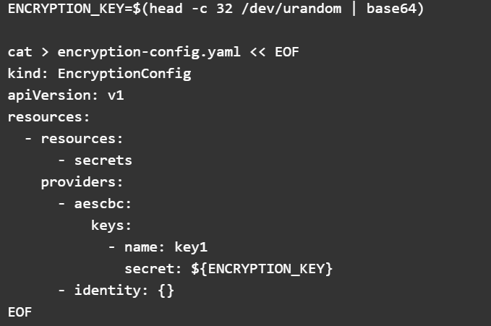

**Copy the file to the Kubernetes controller server**

