**Kubeconfig:**

Generate kubelet kubeconfig for each worker node

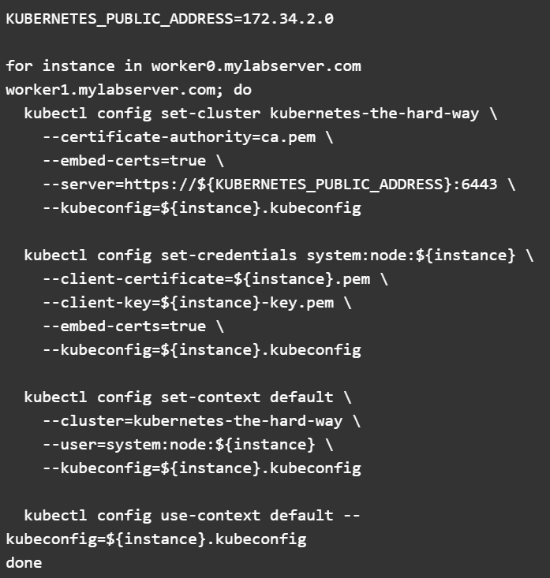

Kubeconfig kube-proxy:

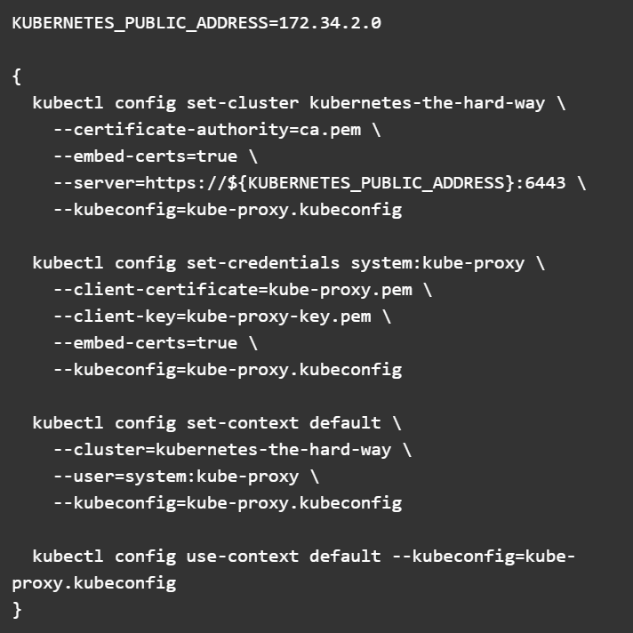

Kube-controller manager kubeconfig:

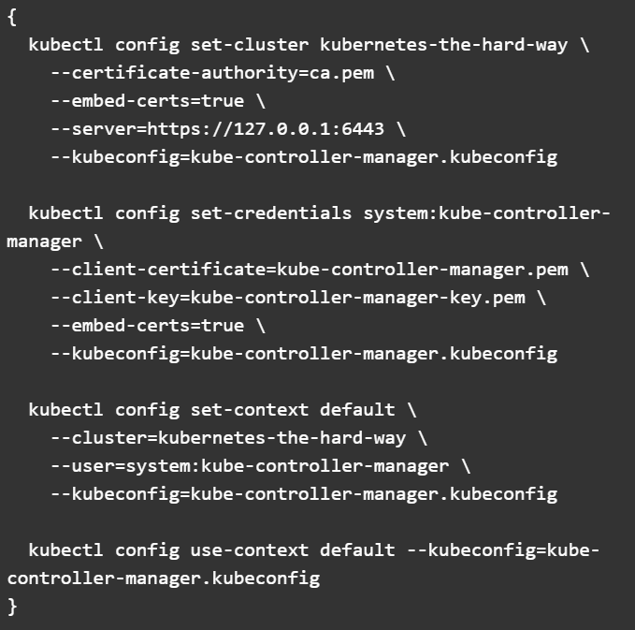

Kube-scheduler:

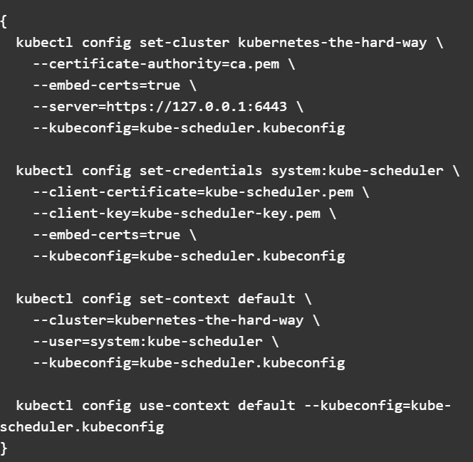

Kube-admin:

