**Kubernetes the hard way :**

1. **Create a certificate authority and TLS certificate for Kubernetes.**

* **Provision the certificate authority**

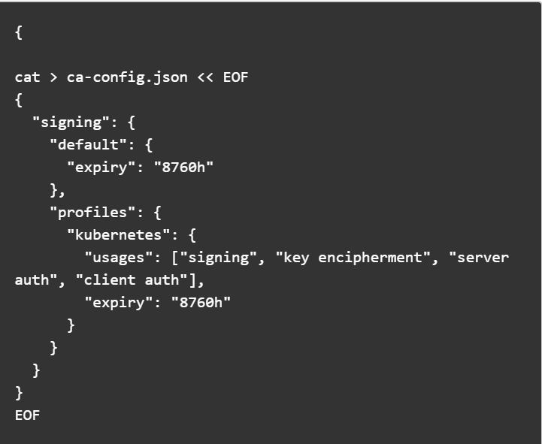

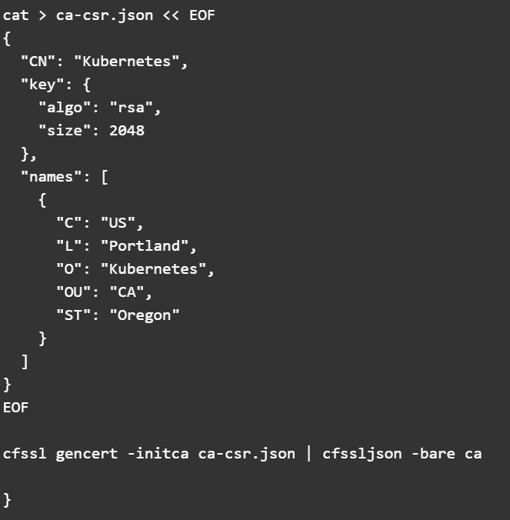

**Generate the necessary client certs and client certs for two worker node.**

**AdminClient cert:**

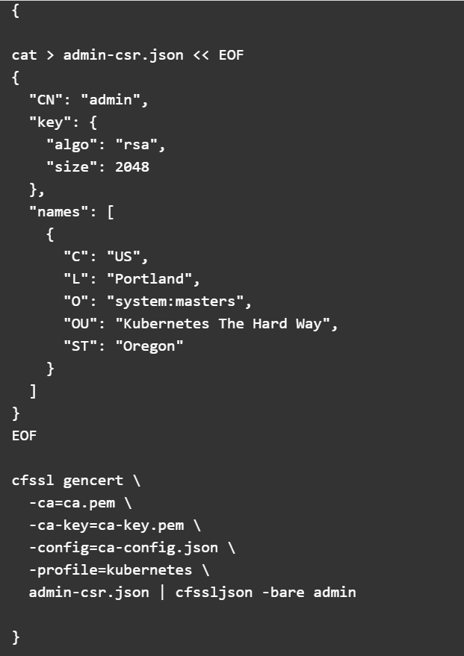

**Clientcerts:**

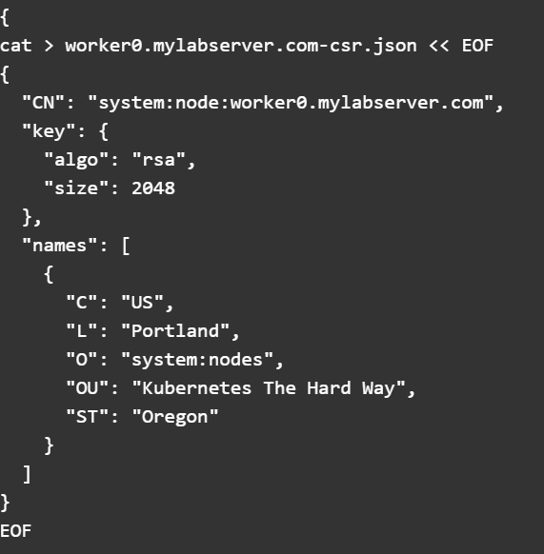

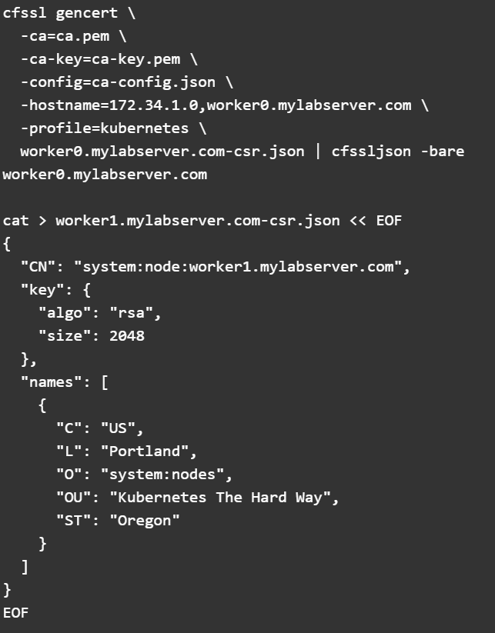

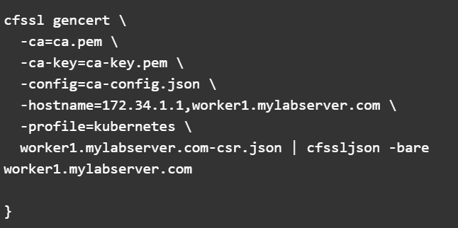

**Kubecontroller manger:**

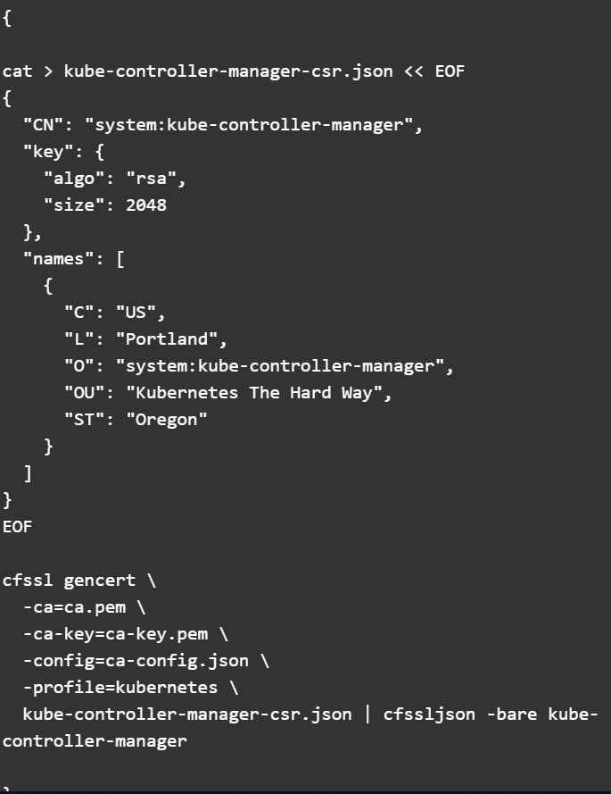

**Kubeproxyclient:**

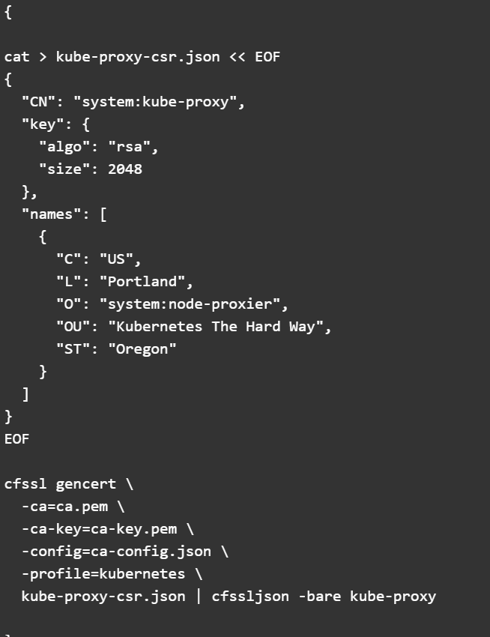

**Kubeschedulerclient:**

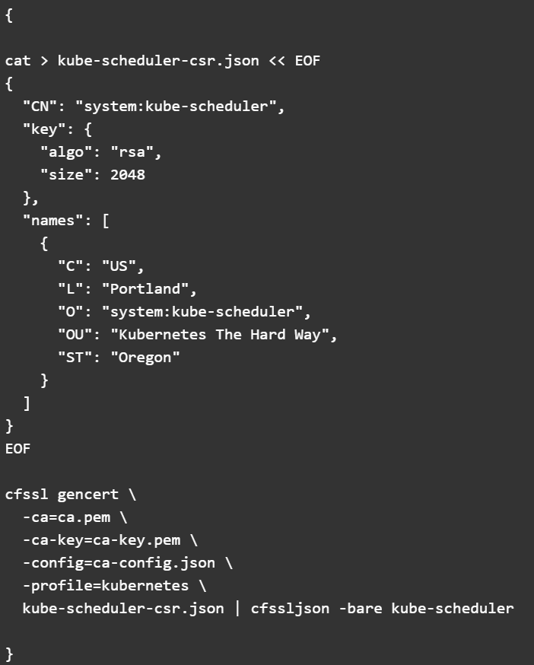

**Kuberapiservercertificate:**

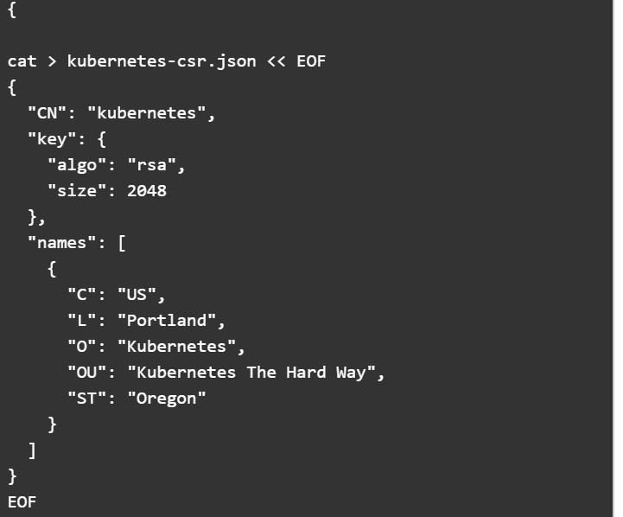

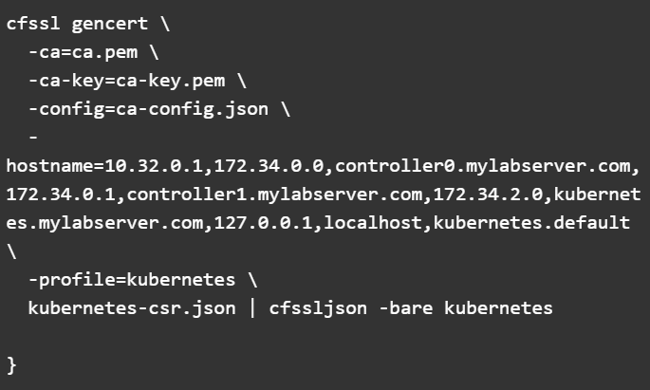

**Service AccountKeyPair:**

