1).Clone the project from below git link,

<https://github.com/vchiranjeevi/shoppingcart>

2).Run the application main class(ShoppingCartAppliation) as RunAsApplication.

3).Add the products into DB by using the below url’s,

<http://localhost:8080/addBookProducts>

PostCall

[

{

"productName" : "Book",

"productPrice" : 123.4,

"genre" : "history",

"author" : "abc",

"publications" : "abc"

},

{

"productName" : "Book",

"productPrice" : 200.4,

"genre" : "comedy",

"author" : "charli",

"publications" : "chapan"

},

{

"productName" : "Book",

"productPrice" : 300.4,

"genre" : "social",

"author" : "def",

"publications" : "one"

}

]

<http://localhost:8080/addApparalProducts>

Postcall

[

{

"productName" : "Apparal",

"productPrice" : 2000.9,

"type" : "shirt",

"brand" : "raymond",

"design" : "curve"

},

{

"productName" : "Apparal",

"productPrice" : 1200.4,

"type" : "paint",

"brand" : "abc",

"design" : "strightlines"

},

{

"productName" : "Apparal",

"productPrice" : 3200.4,

"type" : "tea-shirt",

"brand" : "abc",

"design" : "abc"

}

]

Check the DB products are saved or not

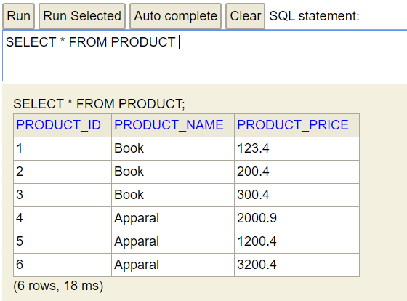

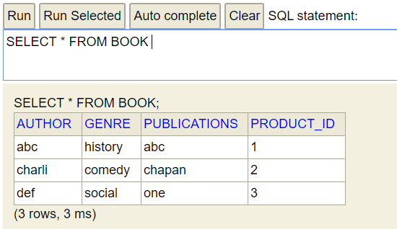

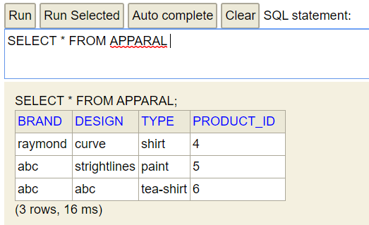

4) Add the User and Products to the Cart using the below url,

<http://localhost:8080/addUser>

PostCall

{

"userName" : "Chiran",

"cart" : {

"quantity" : 1,

"productId" : 1

}

}

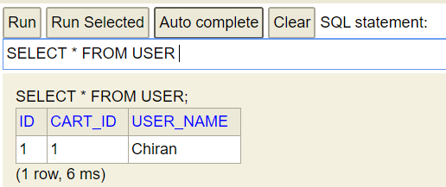

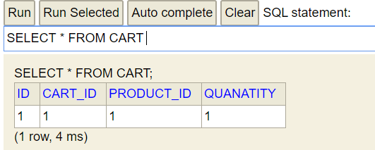

5) Add one more product to the same user it will increase the quantity

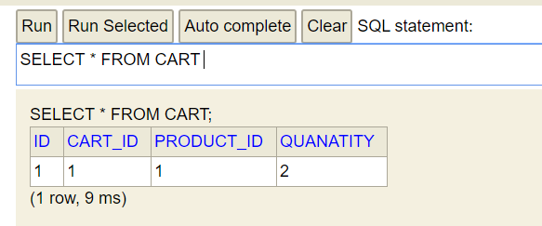

Quantity should not be negative value,

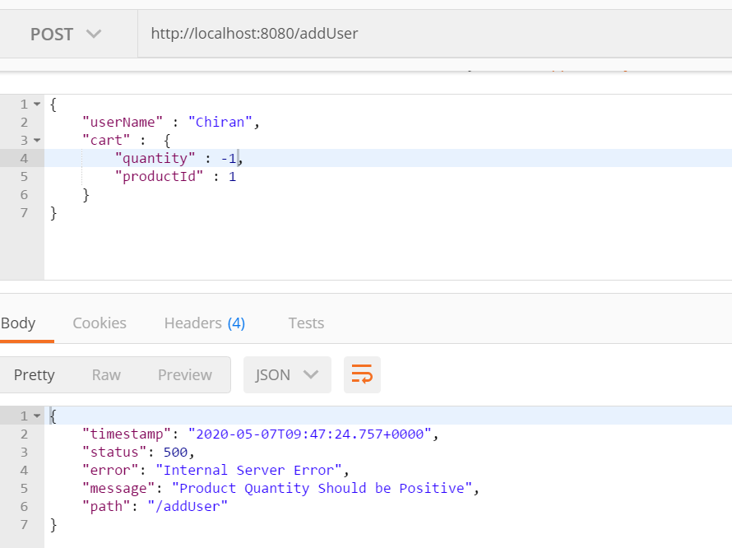

Add another product to the cart for same user,

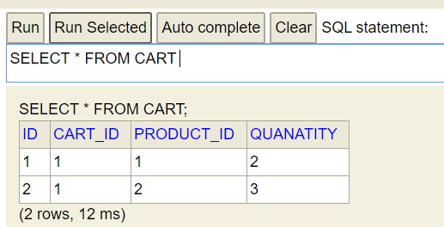

6) Delete product from the cart by productId, making the quantity as zero for deleted products,

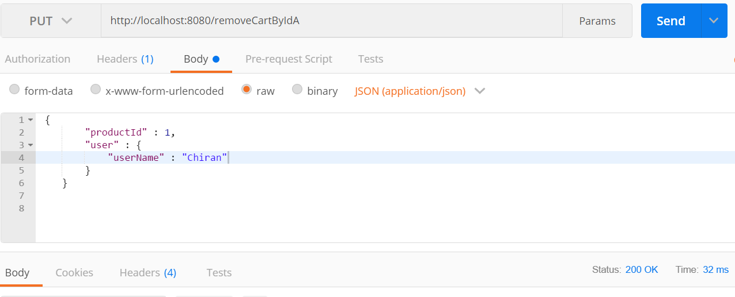

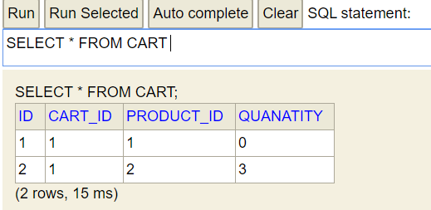

Delete all products for user from cart making all deleted products quantity as zero,

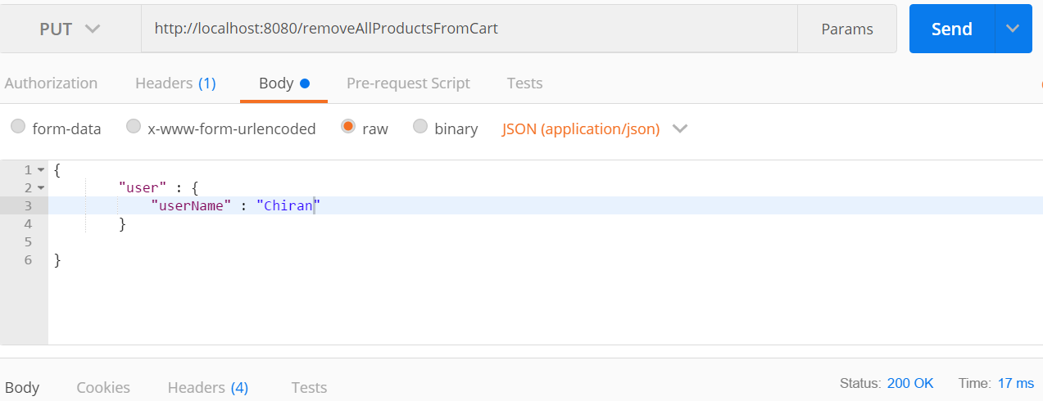

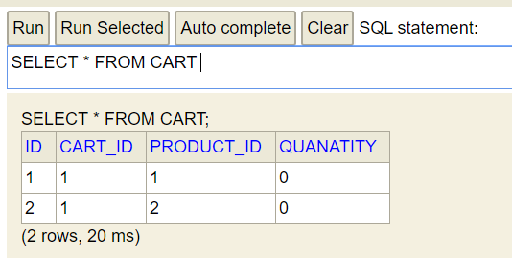

7). Update the quantity for the products 1 and 2 of the user,

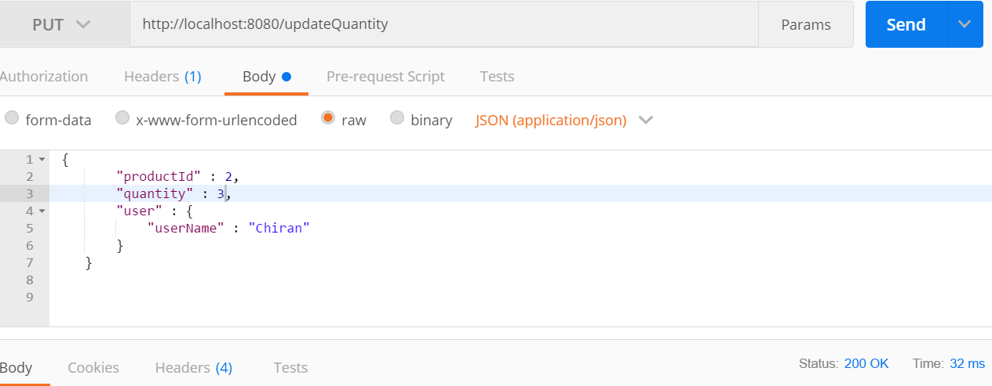

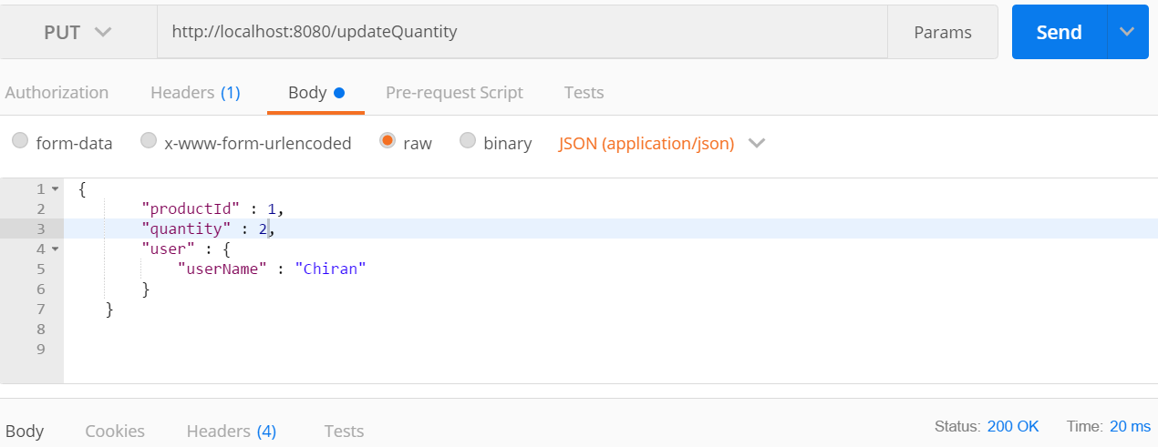

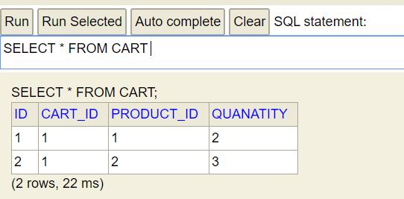

8). Search the Product by id,

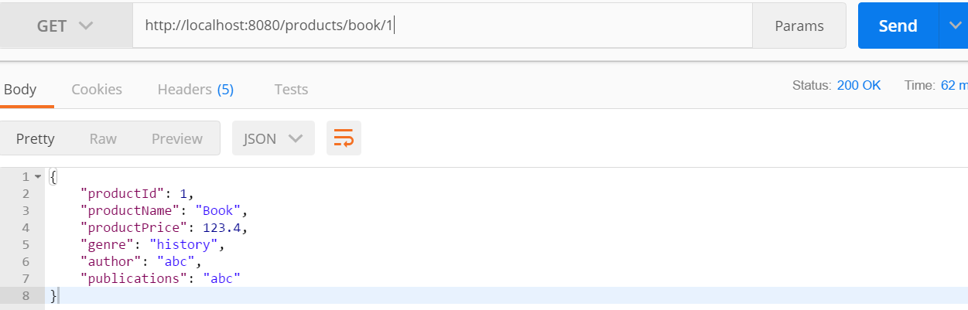

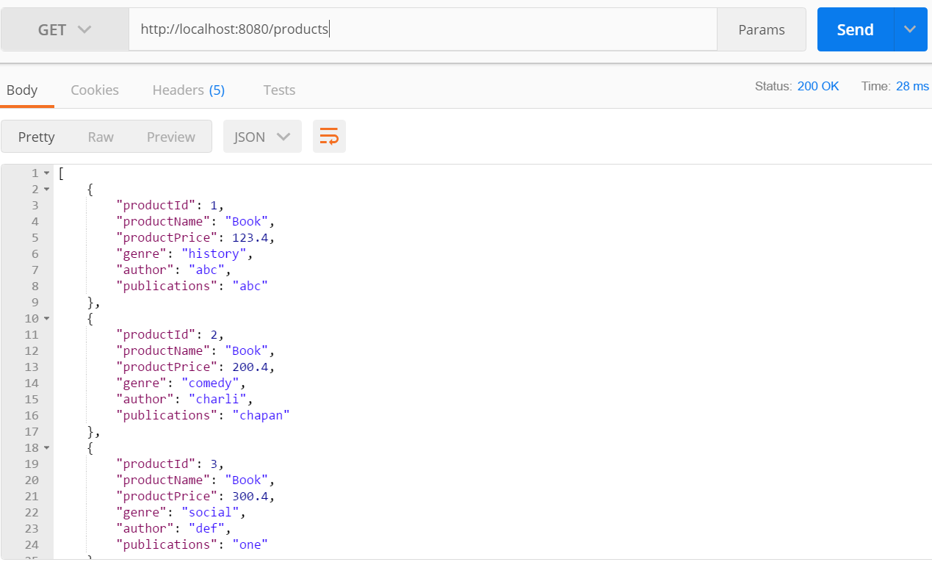

9).Get the Total amount of the products brought by the user and details,

