* Download and install Node.JS (JavaScript Runtime Framework)
  + <https://nodejs.org/en>
* Clone the application repository using below link.
  + <https://github.com/vcl-lms/VCL-Kubernetes-Demo-Application.git>
* Go to the cloned folder.
* Go to **./frontend** and open terminal or CMD
  + Run **npm install**
* Go to **./backend** and open terminal or CMD
  + Run **npm install**
* This is a full stack **school management** application which is built using **MERN** stack.
* It has
  + Front-end
  + Back-end
  + Database (MongoDB)
* The application is containerized into **front-end, back-end & database.**
* Front-end container is created using a **Dockerfile** inside **./frontend/Dockerfile** folder.
* Back-end container is created using a **Dockerfile** inside **./backend/Dockerfile** folder.
* Database is created using **official** docker image.

**HOW TO RUN THE APPLICATION USING DOCKER**

* Download **Docker** application from the internet.
  + <https://www.docker.com/products/docker-desktop/>
* Once the docker is installed and if your not able to run the docker, open terminal or cmd and run this command **wsl --update**
* Go to the path where **docker-compose.yml** file is present.
* Open terminal or cmd in that location.
* Run **docker-compose up --build** command. (takes 10 to 20 mins depending on your hardware configuration)
* Once the docker-compose is finished open docker application.
* You can see the **Images & Containers** created using **docker-compose** file.

**IMAGES**

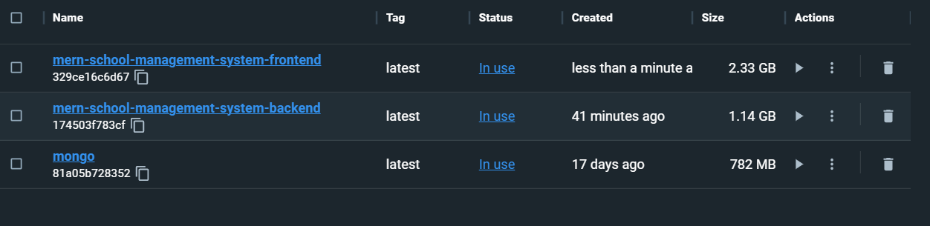

**CONTAINER**

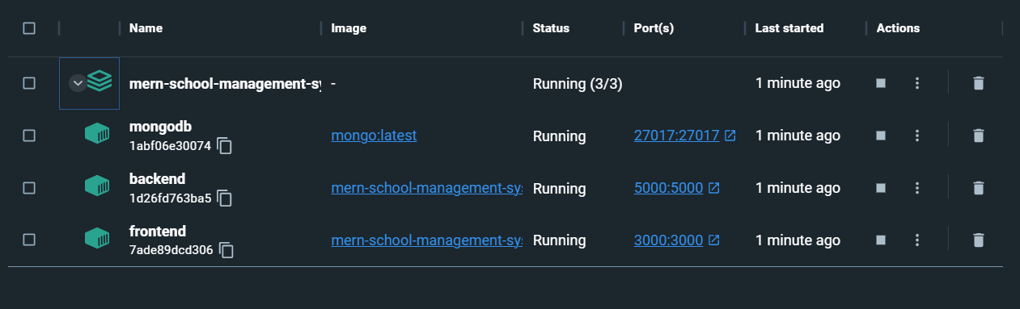

* Environment variables for the application is directly included in **docker-compose.yml** file.

**HOW TO UPDATE THE APPLICATION AND PUSH THE CHANGES**

* Go to **./frontend/src/pages/Homepage.js**
* Go to **Line number 36**
* **Uncomment** from line number **36**  to **40**
* Save the file, commit the changes with the message “**added guest login”.**
* Push the changes and observe the pipeline.