Development of containerized code using visual studio code, follow these steps:
Install Required tools
- Docker Desktop: Download & Install
- VS Code: Download & Install
- VS Code Extensions:
  - Install Docker Extension from the VS Code Marketplace
Install Docker Desktop on Windows:
- Download Docker Desktop: https://desktop.docker.com/win/main/amd64/Docker%20Desktop%20Installer.exe?utm_source=docker&utm_medium=webreferral&utm_campaign=dd-smartbutton&utm_location=module
- Run the installer (Docker Desktop Installer.exe)
- Follow setup instructions and ensure WSL 2 Backend is enabled.
- Restart your PC after installation.
- Launch Docker Desktop and ensure it’s running.

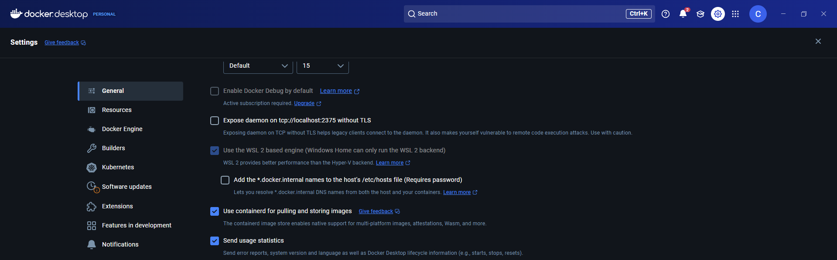

Verify Installation:
- Open Command Prompt (CMD) or PowerShell and run:
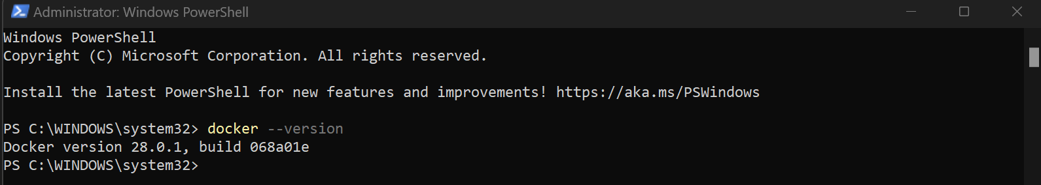
Test Docker
- Run a test container to verify Docker is working:
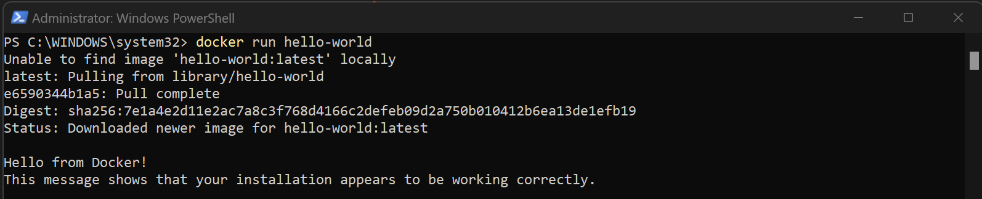

Installing Docker Extension on Visual studio code
The Docker extension makes it easy to build, manage, and deploy containerized applications in Visual Studio Code.
Install Docker on your machine and add it to the system path.
To install the extension, open the Extensions view (Ctrl+Shift+X), search for docker to filter results and select Docker extension authored by Microsoft.

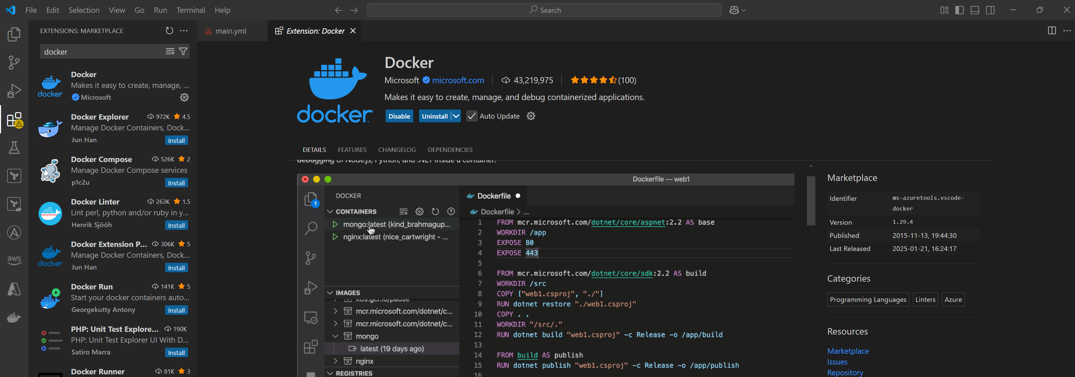

Create a Github Project
- Go to GitHub: Visit GitHub and log in.
- Create a New Repository:
- Click the "+" icon in the top-right corner.
- Select "New repository".
- Enter a repository name and description.
- Choose public or private visibility.
- Initialize with a README (optional).
- Click "Create repository".
- Set Up Your Local Project: Set Up Your Local Project:
- Clone the repo:

