# Thames River Anglers Association

# Created on January 19 2019 by Renata Cunha

# Table of Contents

1.0. Home

2.0. About us

3.0. Events

4.0. Projects

5.0. Newsletters

6.0. Contact

# 1.0. Home

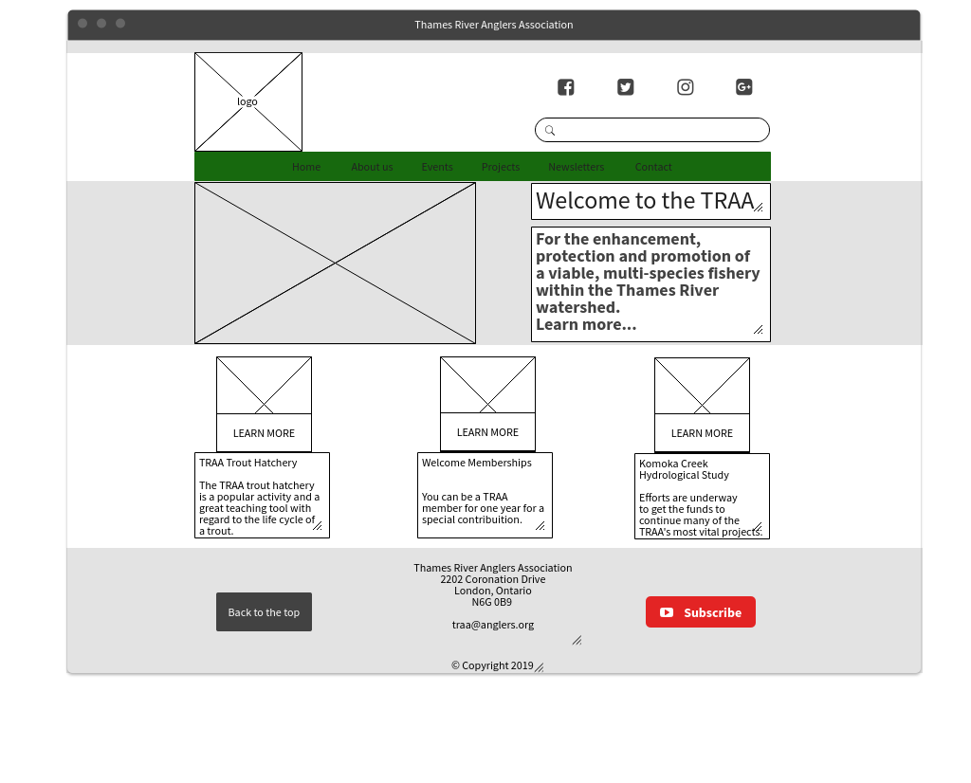

# 2.0. About us

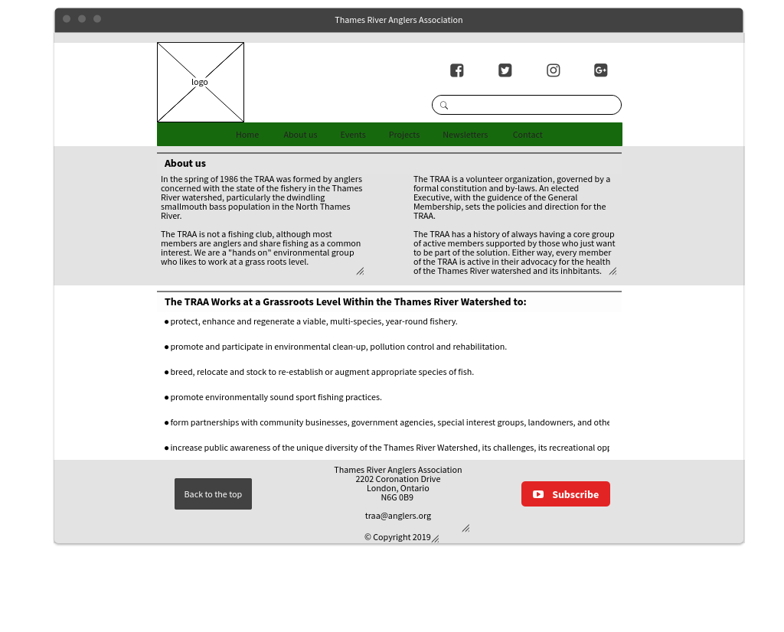

# 3.0. Events

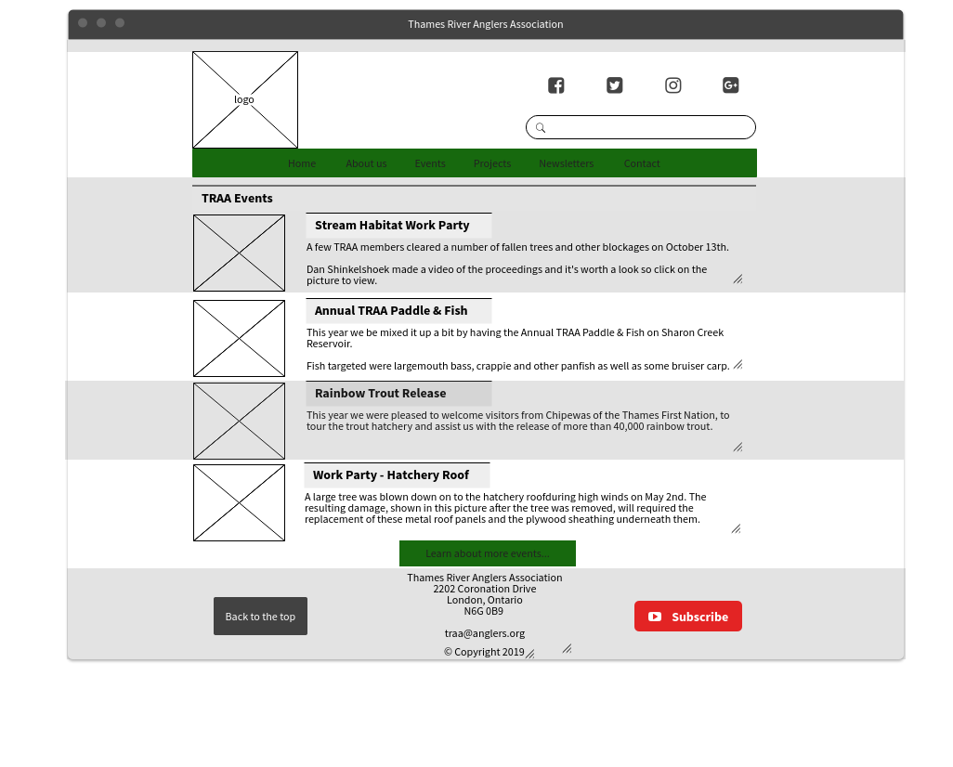

# 4.0. Projects

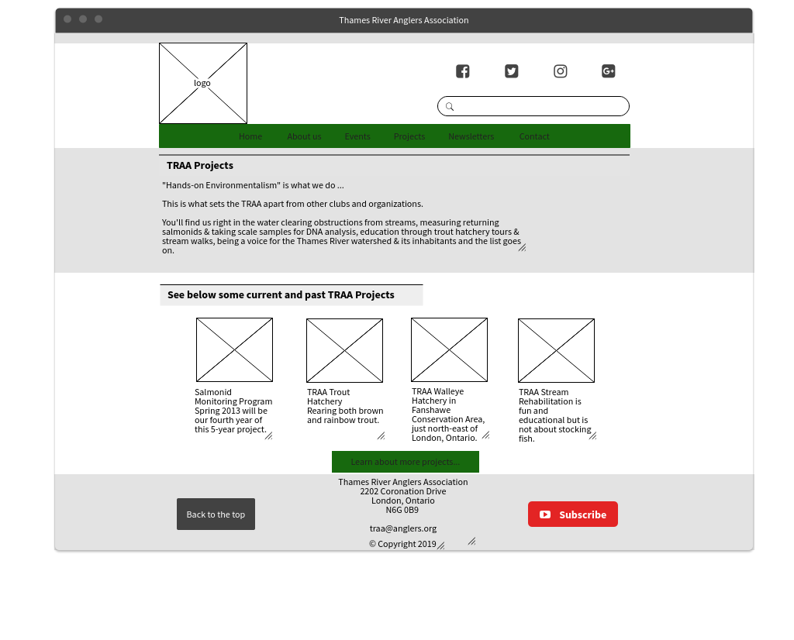

**5.0. Newsletters**

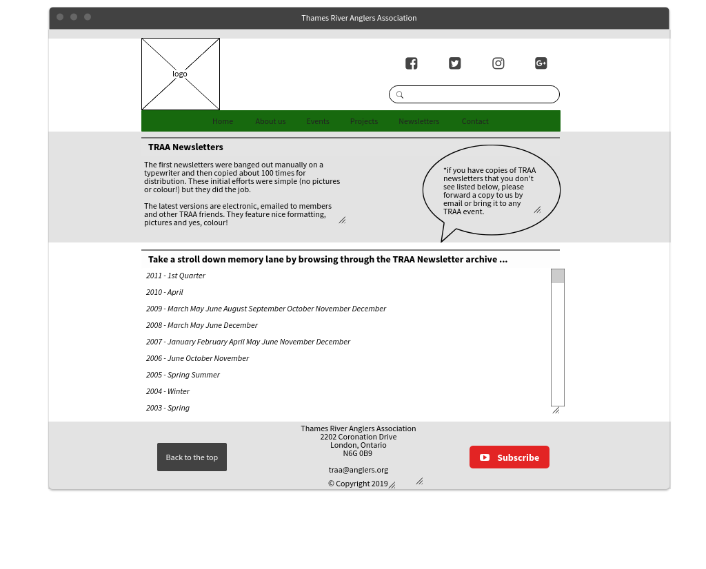

# 6.0. Contact

