- App application mapping
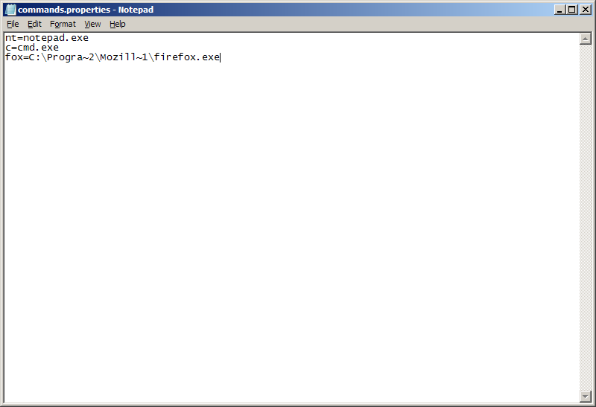
Note:
- The file or folder names should be in 8 character DOS format. This can be obtained using dir /X command.
- Application should be restarted on each modification.

- Execute AppRunner.exe to start the program. 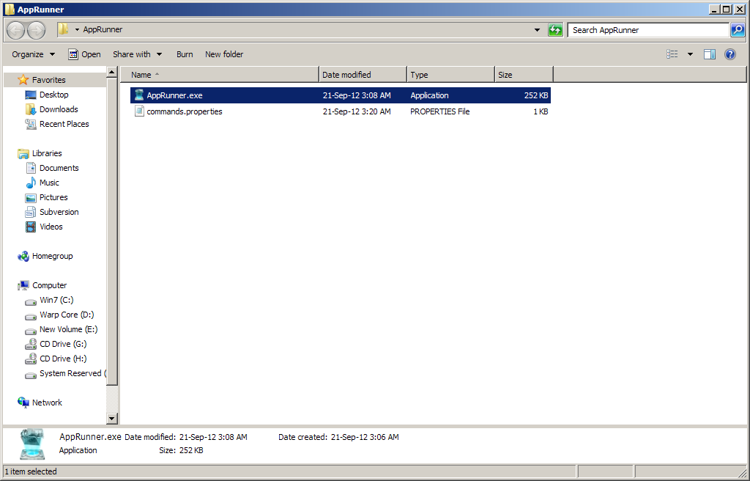
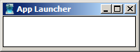
- Enter the configured command or system command and press enter to launch.
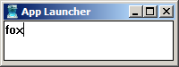
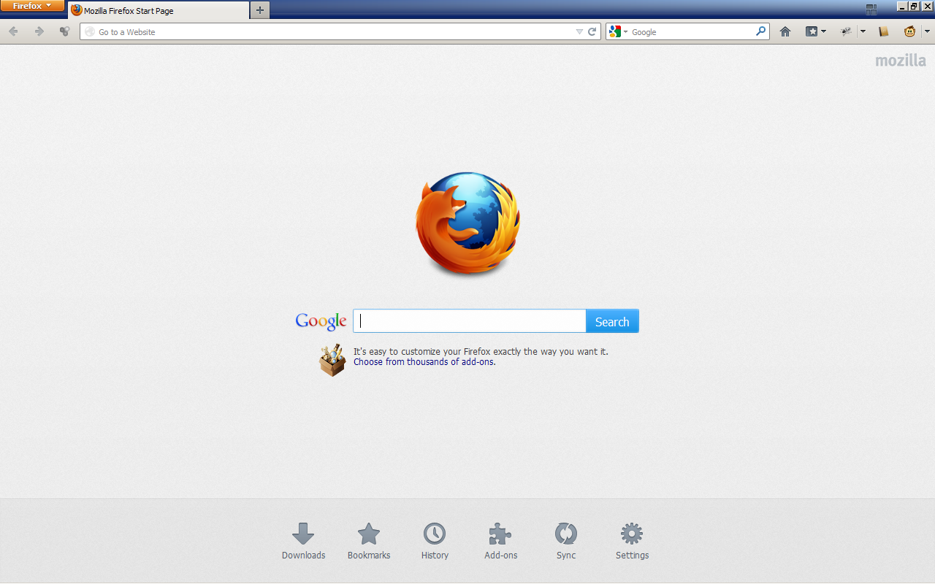
- The application will be running in the taskbar and can be expanded by pressing Alt+F12
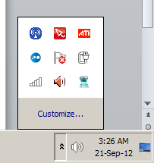
- Click on the icon to launch it.
Note:
- Folders can be opened using command explorer.exe c:\.

