TASK 8 – SALES TRACKER IN GOOGLE SHEETS

1. Objective
The objective of this task was to build a lightweight sales tracker in Google Sheets that separates raw transactional data from the summary layer and automatically calculates daily, weekly, and monthly sales and units sold. The tracker also includes data validation, formula verification, manual verification, and a dynamic product-category chart.

2. Dataset
A retail sales transaction dataset containing 1,000 records was used. The core fields include Transaction ID, Date, Customer ID, Gender, Age, Product Category, Quantity, Price per Unit, and Total Amount. The dataset was imported into Google Sheets as the Raw Data sheet.
Dataset source: GitHub – Retail Sales Dashboard / retail_sales_dataset.csv

3. Tools Used
- Google Sheets
- SUMIFS and SUMIF formulas
- Data validation and dropdown rules
- Conditional formatting
- Google Sheets charts

4. Workbook Structure
Sheet | Purpose | Main Contents
Raw Data | Stores source transactions | Transaction, date, customer, product, quantity, price, total amount, calculated amount, amount check
Summary | Automated sales tracker | Daily, weekly and monthly sales/units, verification, category table and chart

5. Raw Data Preparation and Data Quality
- Imported the retail sales CSV into Google Sheets and renamed the sheet Raw Data.
- Formatted the Date field as DD/MM/YYYY.
- Formatted Price per Unit and Total Amount as Indian Rupee currency.
- Added a Calculated Amount column using Quantity × Price per Unit.
- Added an Amount Check column using an IF comparison to verify Total Amount against the calculated amount.
- Checked Transaction ID uniqueness and reviewed missing values in key fields.
- Applied data validation to Gender, Product Category, Quantity, and Price per Unit to reduce invalid entries.

6. Key Formulas Used
Metric | Formula
Calculated Amount | =G2*H2
Amount Check | =IF(ROUND(I2,2)=ROUND(J2,2),"PASS","CHECK")
Daily Sales | =SUMIFS('Raw Data'!$I$2:$I$1001,'Raw Data'!$B$2:$B$1001,B3)
Daily Units | =SUMIFS('Raw Data'!$G$2:$G$1001,'Raw Data'!$B$2:$B$1001,B3)
Week Start | =B3-WEEKDAY(B3,2)+1
Weekly Sales | =SUMIFS('Raw Data'!$I$2:$I$1001,'Raw Data'!$B$2:$B$1001,">="&$B$6,'Raw Data'!$B$2:$B$1001,"<"&$B$6+7)
Weekly Units | =SUMIFS('Raw Data'!$G$2:$G$1001,'Raw Data'!$B$2:$B$1001,">="&$B$6,'Raw Data'!$B$2:$B$1001,"<"&$B$6+7)
Month Start | =EOMONTH(B3,-1)+1
Monthly Sales | =SUMIFS('Raw Data'!$I$2:$I$1001,'Raw Data'!$B$2:$B$1001,">="&$B$9,'Raw Data'!$B$2:$B$1001,"<"&EDATE($B$9,1))
Monthly Units | =SUMIFS('Raw Data'!$G$2:$G$1001,'Raw Data'!$B$2:$B$1001,">="&$B$9,'Raw Data'!$B$2:$B$1001,"<"&EDATE($B$9,1))
Category Sales for Selected Date | =SUMIFS('Raw Data'!$I$2:$I$1001,'Raw Data'!$F$2:$F$1001,D2,'Raw Data'!$B$2:$B$1001,$B$3)

7. Summary Results
For the selected date of 24/11/2023, the completed tracker produced the following results:
Metric | Result
Selected Date | 24/11/2023
Daily Sales | ₹1,110
Daily Units Sold | 8
Week Start | 20/11/2023
Weekly Sales | ₹7,760
Weekly Units Sold | 48
Month Start | 01/11/2023
Monthly Sales | ₹34,920
Monthly Units Sold | 205

8. Dynamic Category Analysis
The Product Category table and column chart were linked to the Selected Date input. For 24/11/2023, the category-level sales were:
Product Category | Sales on 24/11/2023
Beauty | ₹150
Clothing | ₹960
Electronics | ₹0
The category totals reconcile to the daily sales total: ₹150 + ₹960 + ₹0 = ₹1,110.

9. Manual Verification
To verify the daily sales calculation, the transactions for 24/11/2023 were checked independently from the Raw Data sheet. The manually checked daily total was ₹1,110, while the Summary formula also returned ₹1,110. The verification cell therefore returned PASS.

10. Business/Analytical Insights
- The tracker provides a single selected-date input that drives daily, weekly, monthly and category-level metrics.
- SUMIFS makes the weekly and monthly rollups repeatable and reduces manual calculation effort.
- Separating Raw Data from Summary reduces the risk of accidentally overwriting formulas.
- Data validation helps maintain consistent categorical values and positive numeric entries.
- The dynamic category chart provides a quick visual comparison of sales composition for the selected date.

11. Interview Questions and Practical Answers
Q: How would you design a spreadsheet so non-technical staff can enter data safely?
A: Separate raw data from summary formulas, use dropdown validation for categorical fields, apply numeric validation to quantity and price, and protect formula areas where possible.
Q: What is the risk of mixing raw data and formulas on the same tab?
A: Users may overwrite formulas, create inconsistent data, and make the workbook harder to maintain and audit. Separating input and summary areas reduces these risks.
Q: Why did you use SUMIFS for weekly and monthly totals?
A: SUMIFS can aggregate sales using multiple date criteria, making it suitable for date-range rollups such as Monday–Sunday and the first-to-last day of a month.

13. Final Dashboard Screenshot
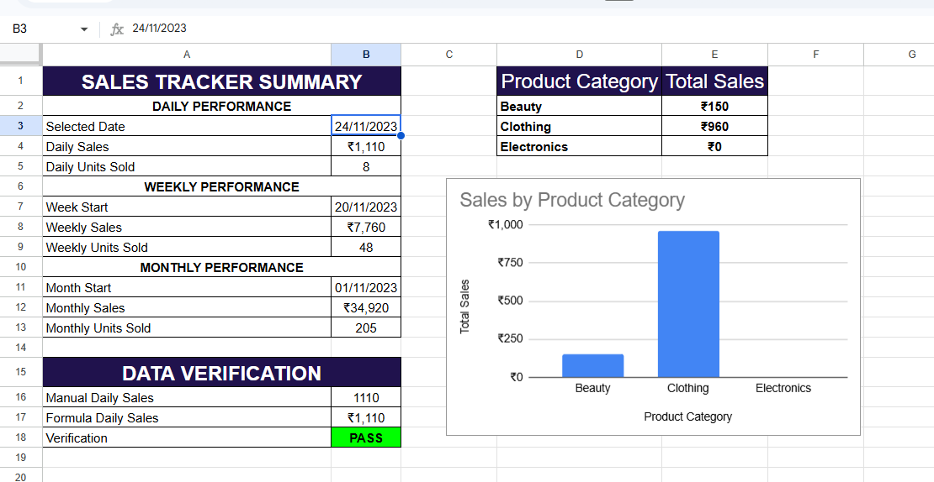
Sales Tracker

