TASK 7 – FIRST CHART STORY
Turning Numbers into a Narrative
Data Analytics Internship Project
Dataset: Iris Dataset | Tools: Python, Pandas, Matplotlib, Scikit-learn

1. Introduction
Data visualization is an important part of data analysis because it helps transform numerical information into clear and meaningful insights. The purpose of this task is to understand how to select an appropriate basic chart for a specific analytical question and communicate the findings through a short data story.
For this task, the Iris dataset was analyzed using Python, Pandas, Matplotlib, and Scikit-learn. Four visualizations were created to compare measurements across the three Iris species: Setosa, Versicolor, and Virginica.

2. Objective
- Understand the structure of a small dataset.
- Perform basic aggregation and analysis using Pandas.
- Select an appropriate chart type for a given analytical question.
- Create clear and labeled visualizations using Matplotlib.
- Identify important patterns from the charts.
- Convert numerical findings into a meaningful data narrative.

3. Tools and Technologies Used
Tool | Purpose
Python | Programming and analysis
Scikit-learn | Loading the Iris dataset
Pandas | Data manipulation and aggregation
Matplotlib | Data visualization
Jupyter Notebook | Analysis environment

4. Dataset Description
The Iris dataset is a commonly used dataset in data science and machine learning. It contains 150 observations, four numerical features, and three species: Setosa, Versicolor, and Virginica.
Features: Sepal Length, Sepal Width, Petal Length, and Petal Width. Each species contains 50 observations, making the dataset balanced.

5. Loading the Dataset
from sklearn.datasets import load_iris
iris = load_iris()
The dataset was converted into a Pandas DataFrame for analysis using the four feature columns and a species column.

6. Dataset Inspection
The dataset contains 150 rows and 5 columns. The species distribution is:
Species | Number of Observations
Setosa | 50
Versicolor | 50
Virginica | 50
Total | 150

7. Chart 1 – Average Sepal Length by Species
Question: Which species has the highest average sepal length?
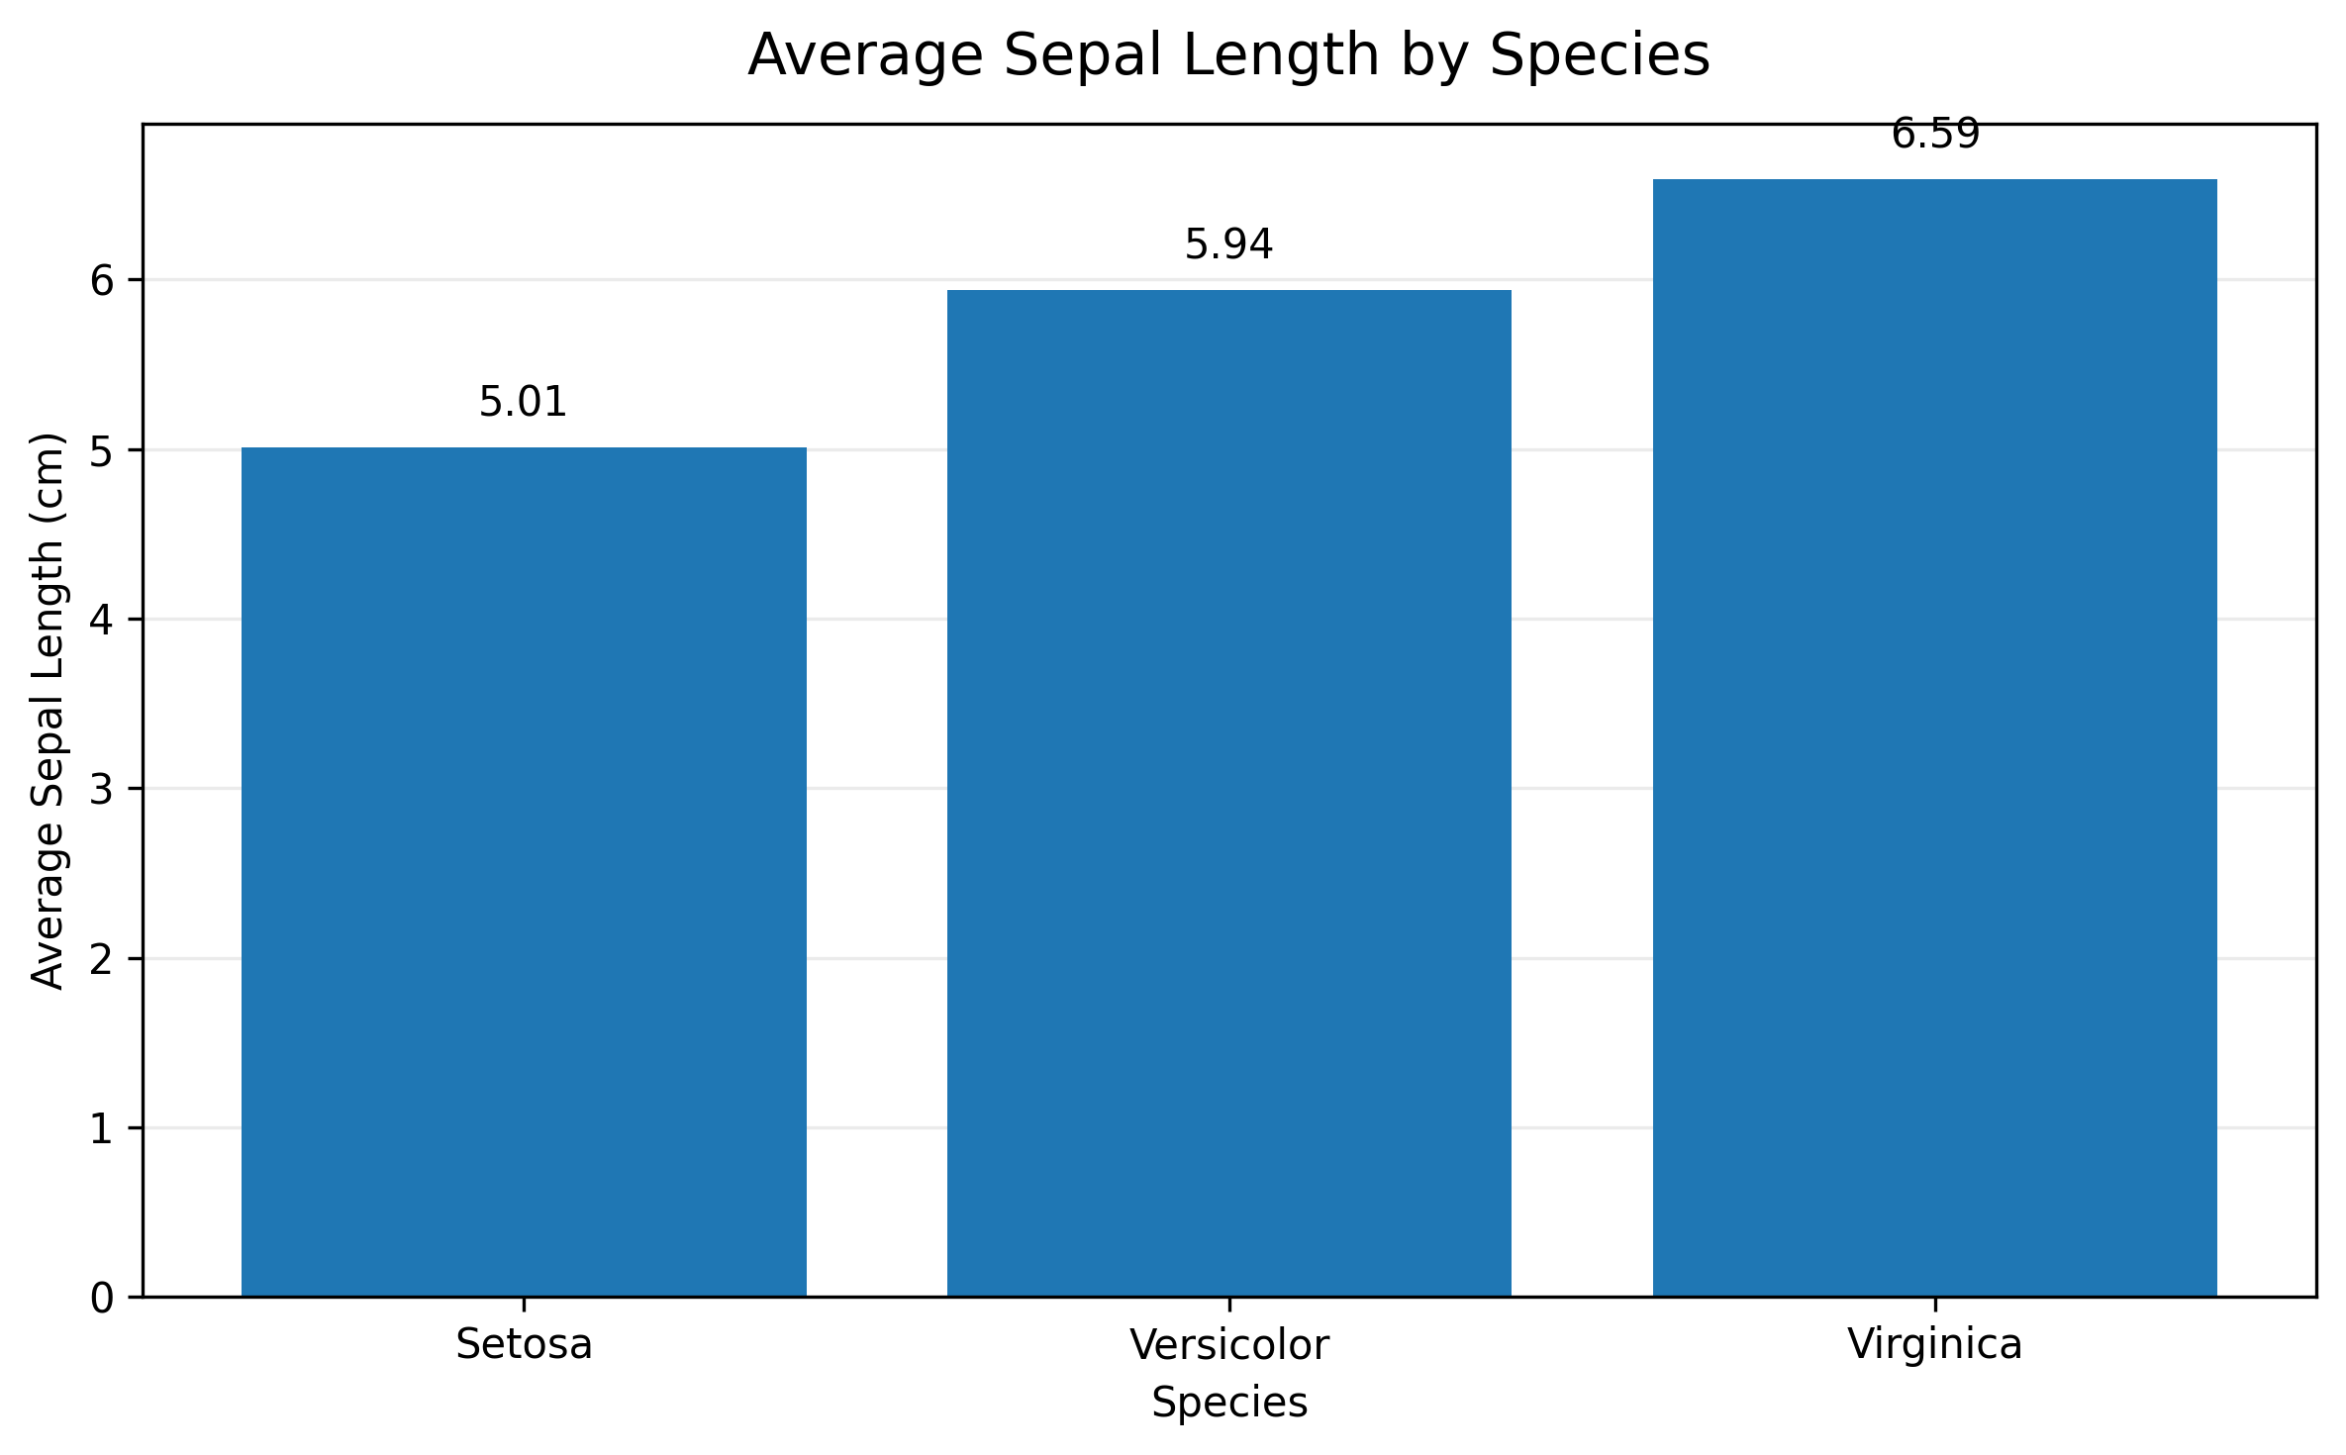
Insight: Virginica has the highest average sepal length at approximately 6.59 cm, while Setosa has the lowest at approximately 5.01 cm.

Chart 1 – Calculation
The average sepal length was calculated using a group-by aggregation in Pandas:
avg_sepal = df.groupby('species')['sepal length (cm)'].mean()

8. Chart 2 – Average Petal Length by Species
Question: Which species has the longest average petal length?
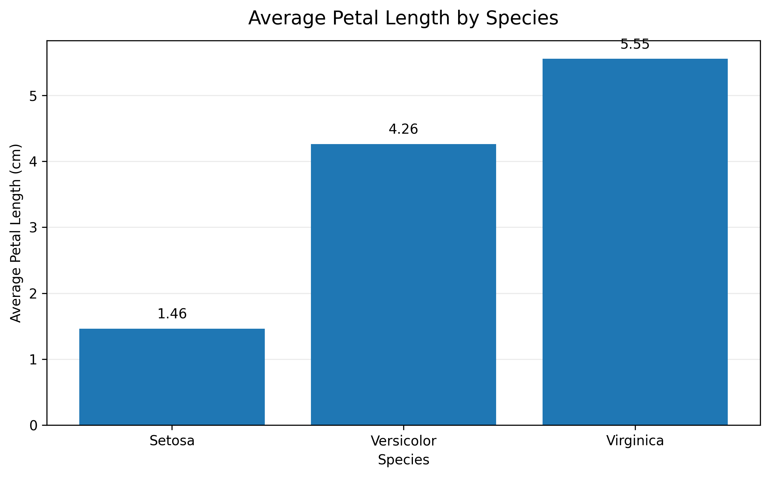
Insight: Virginica has the longest average petal length at approximately 5.55 cm, while Setosa has substantially shorter petals at approximately 1.46 cm.

9. Chart 3 – Average Sepal and Petal Length by Species
Question: How do average sepal and petal lengths vary across the three species?
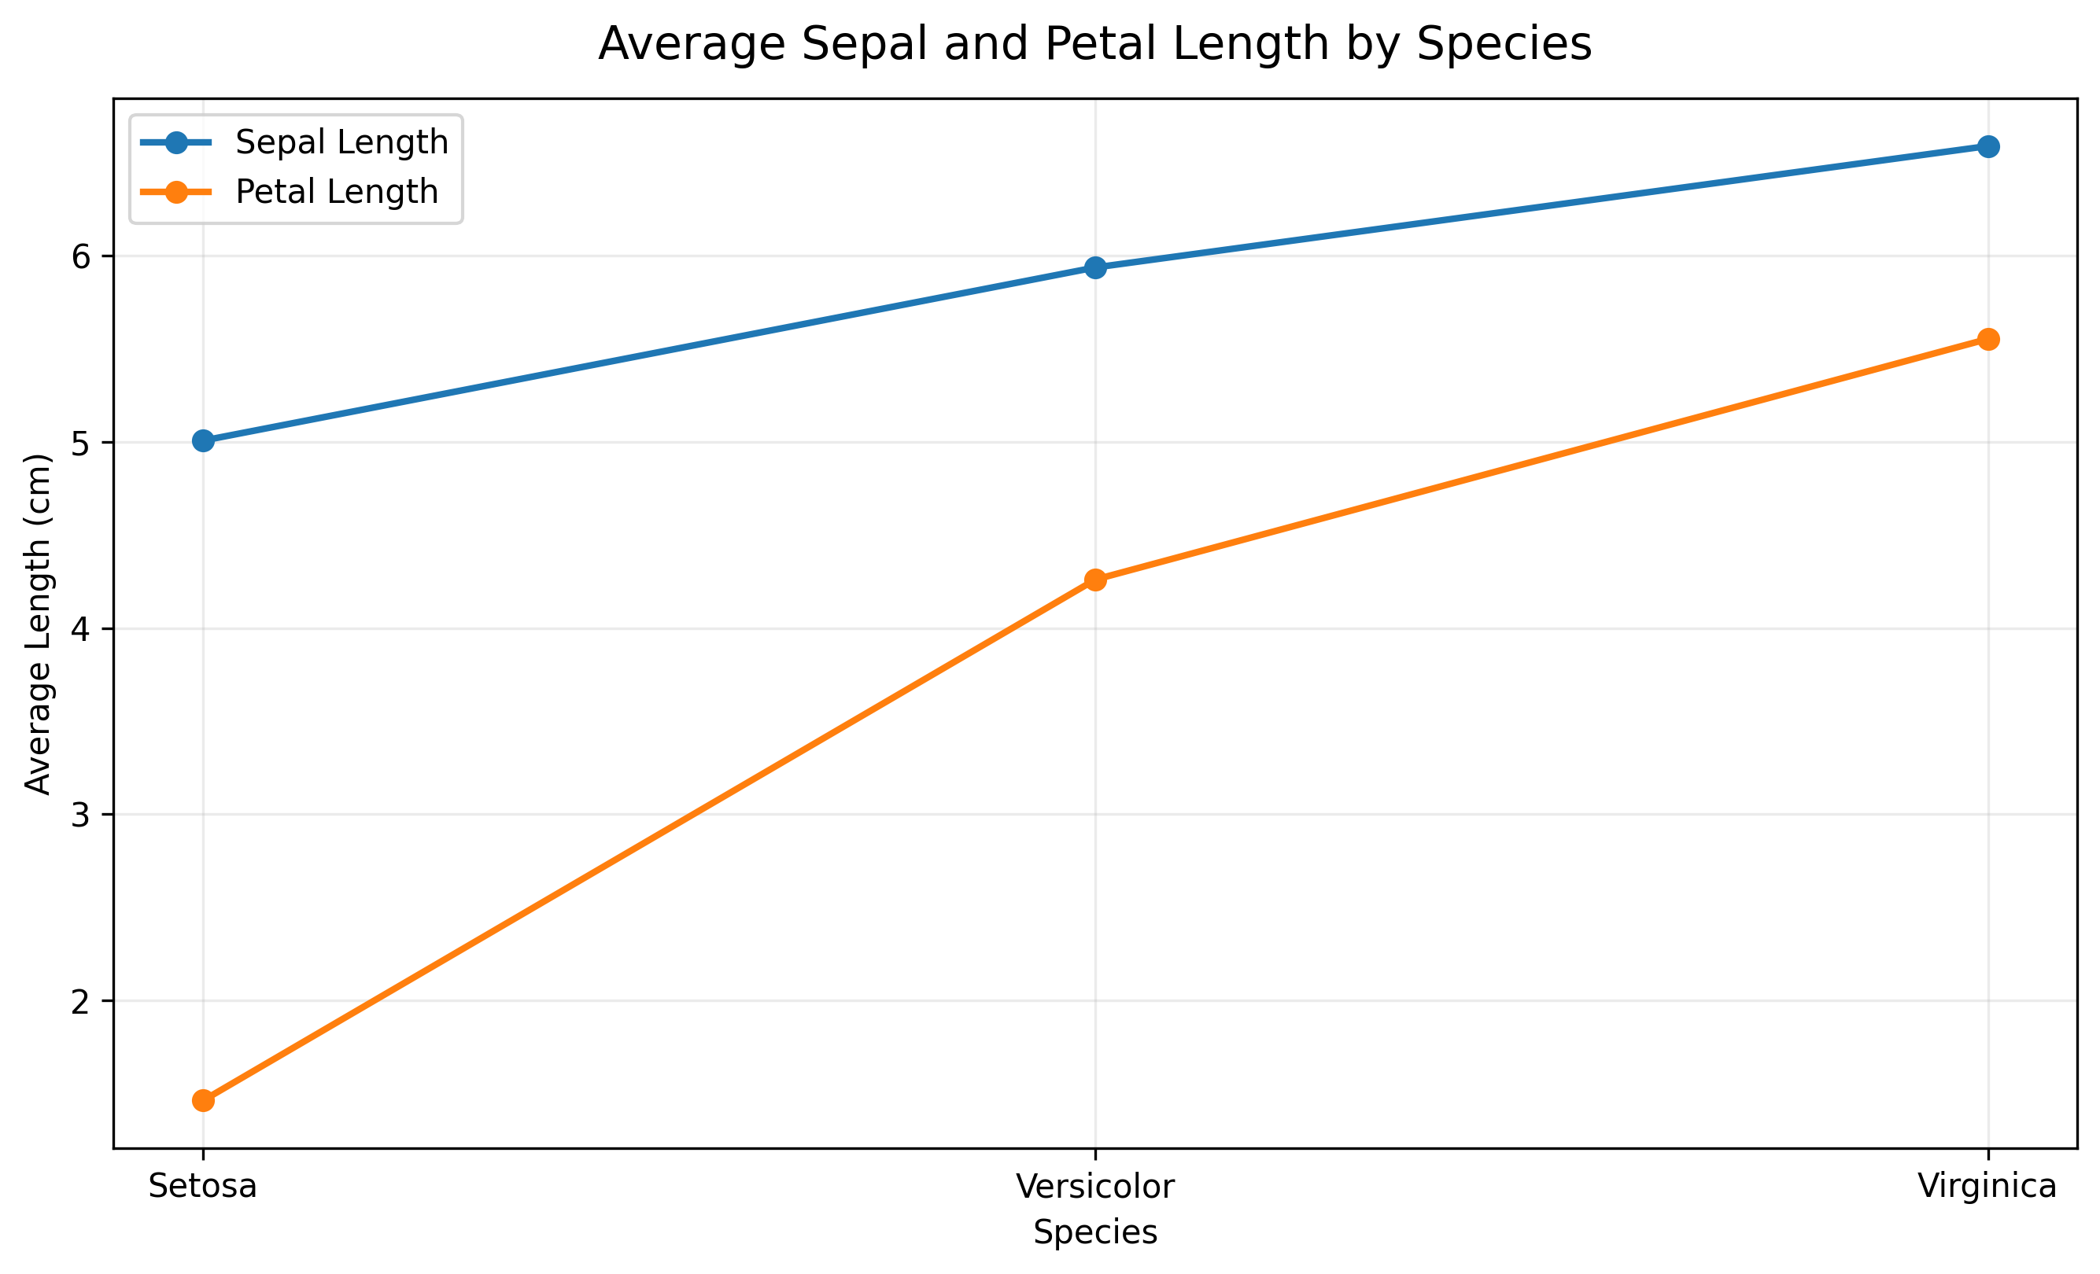
Insight: Both average sepal and petal lengths increase from Setosa to Virginica, with petal length showing a particularly strong difference between the species.
Analyst note: Species are categorical rather than time-series data, so a bar chart would normally be preferred for direct comparison. The line chart was included here to demonstrate the requested chart type and its interpretation.

10. Chart 4 – Distribution of Iris Species
Question: Is the dataset balanced across the three species?
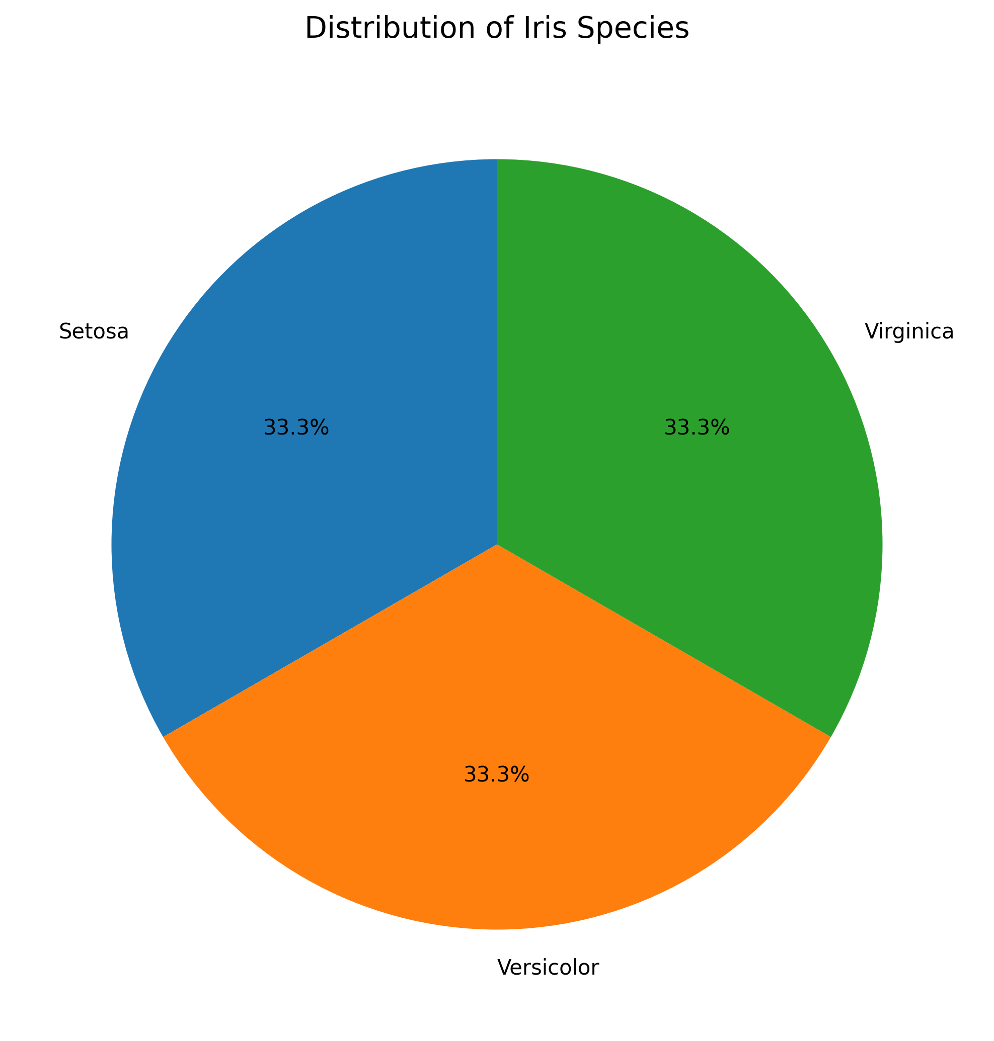
Insight: The Iris dataset is perfectly balanced, with each species representing approximately one-third (33.3%) of the observations.

11. Summary Analysis
Species | Sepal Length | Sepal Width | Petal Length | Petal Width
Setosa | 5.01 | 3.43 | 1.46 | 0.25
Versicolor | 5.94 | 2.77 | 4.26 | 1.33
Virginica | 6.59 | 2.97 | 5.55 | 2.03
The results show that Virginica generally has the largest measurements, while Setosa has the smallest measurements, particularly for petal dimensions.

12. Key Insights
- Virginica has the highest average sepal length at approximately 6.59 cm.
- Virginica has the highest average petal length at approximately 5.55 cm.
- Setosa has the smallest petal measurements.
- Petal length shows a strong difference between the three species.
- The dataset is perfectly balanced, with 50 records for each species.
- Simple visualizations make these differences easier to understand than looking at raw numbers alone.

13. Data Story – Turning Numbers into a Narrative
The Iris dataset contains three equally represented species: Setosa, Versicolor, and Virginica. The analysis reveals clear differences in their physical measurements.
Virginica has the largest average sepal and petal measurements, whereas Setosa has the smallest. The difference is particularly noticeable in petal length, where Virginica averages approximately 5.55 cm compared with only 1.46 cm for Setosa.
The visualizations also show that the average measurements generally increase from Setosa to Virginica. At the same time, the dataset itself is balanced because each species contributes exactly 50 observations.
Therefore, the charts transform the raw numerical measurements into a simple story: the three species have distinct physical characteristics, with Virginica generally being the largest and Setosa the smallest in terms of the measured dimensions.

14. Interview Questions
Q1. When would you choose a bar chart over a line chart?
A bar chart is preferred when comparing values across discrete categories, such as product categories, departments, or species. A line chart is generally better for showing trends or changes across an ordered sequence, especially over time.
Q2. Why are pie charts often discouraged in professional reporting?
Pie charts can make it difficult to accurately compare similar-sized segments, especially when there are many categories. Bar charts are usually easier to read and provide more precise comparisons. Pie charts are most useful when there are only a few categories and they represent meaningful parts of a whole.

