SGIWEBSRV WEB API
Programmers Manual

SDK version 0.9
(DRAFT)



SecuGen India Pvt. Ltd.
C-605, Solaris, Saki Vihar Road,
Andheri, Mumbai 400057
(INDIA)
www.secugenindia.com

Copyright 2015 SecuGen India Pvt. Ltd.
Disclaimer
Contents of this document are subject to change without notice, SecuGen India does not warranty correctness of the material herein or fitness for any purpose. This document is supplied without any expressed or implied warranties.

- License Agreement
- Introduction

SecuGen WEB API supports JavaScript access to SecuGen fingerprint readers, enabling browser based applications to access SecuGen fingerprint sensors. JavaScript access permits cross browser functioning and extremely fast capturing of fingerprint data in a browser based application.

SecuGen WEB API makes it very simple to incorporate fingerprint capturing functionality in your browser based application through JavaScript. Applications written using WEB API work on almost all modern browsers. Using WEB API eliminates need for JAVA runtime or browser plug-in on the client machine as well as applet signing and deployment issues related to different JRE versions and browser versions. This document describes the RESTFUL web service calls supported by WEB API SDK.

WEB API provides simple call to capture fingerprint data and template in one method. It also provides UIDAI specific calls to capture PID block for single or multiple fingers, UIDAI BFD (Best Finger Detection) support provides RBD block with local duplicate check. Applications such as AADHAAR authentication, E-KYC based on AADHAAR and BFD are extremely easy to develop and deploy as web based applications using SecuGen WEB API.

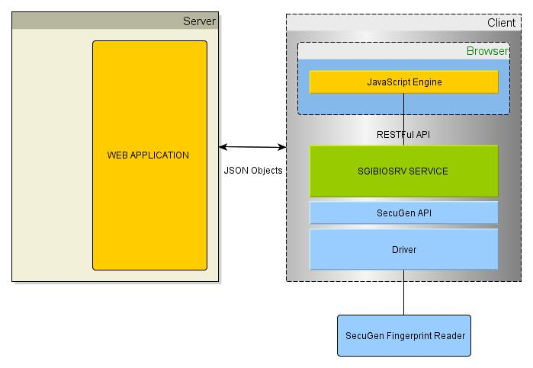
- Installation and pre-requisites

<< TO COMPLETE >>
- SGIFPCapture

This service returns fingerprint data, details of sensor and extracted template to the caller as JSON object. In case of HTTP request this service can be called as URI http://localhost:8000/SGIFPCature. The port number may change depending on the way the service is configured, 8000 is default port for the service.

Parameters
Following table describes the parameters and their permissible values that can be passed to the service. All the parameters are optional and their defaults are described below.

Name | Type | Description
Licstr | STRING | This is the license key provided for the domain, when not used the WEB server will work only for limited period (usually 90 days)
Timeout | INTEGER | Specifies the timeout in milliseconds to wait for the sensing operation to complete. If fingerprint image is not captured within this time (user does not place the finger on the sensor) then an error is generated. Defaults to 10000.
Quality | INTEGER | Specifies the quality of the image desired value is from 1 to 100. Higher value implies better image. Default value is 50.
TemplateFormat | STRING | Extractor template format is specified in this parameter, currently supported values are “ISO” and “ANSI”. Defaults to “ISO”.

JSON Object Returned
Web service returns JSON formatted object, that contains following fields.

Name | Type | Description
ErrorCode | INTEGER | Integer value, describes error if any, value of 0 indicates no error other wise the error code or non-zero indicates various errors described in this document elsewhere. You must check of this value before accessing other fields of JSON object, if this is not 0 then other fields are NULL or undefined.
Manufacturer | STRING | Currently “SecuGen” .
Model | STRING | Currently “HU20” indicating SecuGen Hamster Pro-20
SerialNumber | STRING | String containing the unique serial number of the connected device.
ImageWidth | INTEGER | Integer value indicating the width of the fingerprint image in pixels.
ImageHeight | INTEGER | Integer value indicating the height of the fingerprint image in pixels.
ImageDPI | INTEGER | Integer value indicating resolution of the fingerprint image in dots per inch.
ImageQuality | INTEGER | Integer value indicating the quality of the image actually captured it will always be equal to or higher than the quality parameter passed as argument.
NFIQ | INTEGER | Integer value, NIST Finger Image Quality number from 1 – 5 . 1 is best and 5 is worst.
ImageDataBase64 | STRING | String containing actual Image data (raw) encoded as base64 string.
BMPBase64 | STRING | String value fingerprint image in .BMP format encoded as base 64 string, useful for display in browser using data element in image tag.
TemplateBase64 | STRING | String value containing Template encoded as base 64 format. This value is encrypted if called with session key parameter.

Notes
- SGIEnrollCapture
This web service is useful for capturing multiple fingerprints from the fingerprint reader. Parameters required are same as SGIFPCapture and can be used to capture one fingerprint as well. Call this service once for each capture along with the same server handle to accumulate fingerprints. The service also ensures that one fingerprint is present only once in the array i.e. local duplicate check is performed on the client end. JSON object returned contains array of templates

Notes
Error Codes

ERROR CODE | DESCRIPTION
0 | No Error
1 | Creation failed (fingerprint device not installed correctly driver files error)
2 | Function failed (wrong type of sensor or not correctly installed)
3 | Internal (invalid parameters to sensor API)
5 | DLL load failed
6 | DLL load failed for driver
7 | DLL load failed for Algorithm
51 | System file load failure
52 | Sensor chip initialization failed
53 | Sensor line dropped
54 | Timeout
55 | Device not found
56 | Driver load failed
57 | Wrong image
58 | Lack of bandwidth
59 | Device busy
60 | Can not get serial number of the device
61 | Unsupported device
101 | Very low minutiae count
102 | Wrong template type
103 | Invalid template
104 | Invalid template
105 | Could not extract features
106 | Match failed
1000 | No memory
4000 | Invalid parameter passed to service
2000 | Internal Error
3000 | Internal error extended
6000 | Certificate error can not decode
10001 | License error
10002 | Invalid domain
10003 | License expired

