**REF:** VCQRU/OCT/2021 **Quotation Oct 10th, 2021**

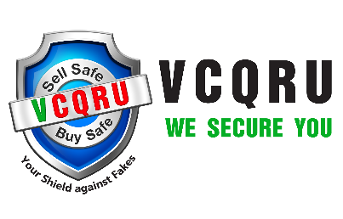

**VCQRU (We Secure You) Head Office**

Owned by Accomplish Trades Solutions Pvt. Ltd. 1101 A, 11th Floor, Unitech Arcadia

**Address**: 1101 A, 11th Floor, Unitech Arcadia South City II, Sector 49,

South City II, Sector 49, Gurugram, Gurugram, Haryana - 122018

Haryana - 122018

To,

Mr. Harsh

FB Nutrition

**Subject:** Quotation for printed labels and Loyalty services

|  |  |  |  |  |
| --- | --- | --- | --- | --- |
| **Description of Goods** | **Specification** | **Quantity** | **Development Cost  One Time** | **Cost / Label** |
| Printed QR Code Labels | 78mm*22mm | 50,000 | 15000 | Rs 0.75 +GST |
|  |  |  |  |  |

**Cost Calculated services including:**

1. Printing and designing of the labels
2. 2-3 colors would be there
3. Multiple Modes of verification covering all the community standards: 13digit Code via Web, Message, IVR and APP
4. Vendor dashboard for your company.
5. We will provide you complete backend support, where you can customize the scheme at any point of time.
6. Weekly & monthly customer verification reports will be provided to strengthen the branding and marketing strategies.
7. PAN India Multilingual support for solving queries coming for end customers.

**Account Detail:**

|  |  |  |  |  |  |  |
| --- | --- | --- | --- | --- | --- | --- |
| **Name** | **PAN** | **GSTIN** | **Bank Name** | **Account No** | **IFSC** | **Branch** |
| ACCOMPLISH TRADES SOLUTIONS PVT. LTD. | AAQCA3749P | 06AAQCA3749P1ZX | INDUSIND BANK | 201003920092 | INDB0000599 | CBD Belapur |