ILOCOS SUR POLYTECHNIC STATE COLLEGE
Candon Campus

NARRATIVE REPORT
3 Day (IT Seminar)

VINCE MARC JUSTINE O. RUBANG
Bachelor of Science in Information Technology

2nd Semester, A.Y. 2025–2026

I. INTRODUCTION
The BSIT Department of Ilocos Sur Polytechnic State College (ISPSC), Candon Campus conducted a three-day IT Seminar focused on Artificial Intelligence and Application Development from January 6 to 8, 2026. The activity was organized to expose students and faculty to the latest advancements in artificial intelligence, including generative AI, conversational AI, and agentic systems, as well as practical frameworks for building AI-powered applications.
The seminar served as both an academic enrichment activity and a career development opportunity, aligning with the department's commitment to producing graduates equipped with relevant, industry-ready technology competencies. It featured a resource speaker from the private sector and was coordinated through the leadership of the BSIT Program Chair and a dedicated subject instructor.

II. OBJECTIVES
The seminar aimed to achieve the following objectives:
1. To introduce students and faculty to foundational and advanced concepts in Artificial Intelligence, including generative, conversational, and agentic AI.
2. To expose participants to AI-powered application development methodologies, including PRD-driven and PRP-driven workflows.
3. To provide hands-on experience in building practical AI applications as part of team-based learning.
4. To connect participants with industry practitioners and thought leaders in the technology sector.
5. To inspire students to integrate AI tools and platforms into their professional and academic work.

III. PARTICIPANTS AND KEY PERSONNEL
The seminar was attended by students and faculty of the BSIT Department of ISPSC-Candon Campus. The event was organized under the supervision of the following key personnel:
Program Chair, BSIT Department: Ariel A. Dela Cruz, MIT
Campus Director, ISPSC-Candon Campus: Annie D. Dorada, Ed.D.
Subject Instructor / Seminar Coordinator: Clariza G. Valdez, MIT
Facilitator / Instructor: Fe Airam R. Dakig, MIT
Resource Speaker: Emil Capino, CEO & Founder, iAlchemy, Inc.

Special messages were also delivered by distinguished guests from the private sector, namely: Francis Xavier Hernandez, Co-Founder & Vice President of Audentes Technologies Inc.; Jeffrey Yu, CEO of High6 Corp; and Glo Anne DM Marfori, CEO of GMAC Business Developers, Inc. Their presence underscored the strong industry support and collaboration extended to the academic community.

IV. PROCEEDINGS
Day 1 – January 6, 2026: Opening Program and Introduction to Artificial Intelligence
The first day began at 7:45 AM with the assembly and gathering of participants at the venue. The formal program commenced at 8:00 AM with an opening prayer and welcome remarks delivered by Ariel A. Dela Cruz, MIT, Program Chair of the BSIT Department.
Messages were subsequently delivered by Annie D. Dorada, Ed.D., Campus Director of ISPSC-Candon Campus; Francis Xavier Hernandez, Co-Founder and Vice President of Audentes Technologies Inc.; Jeffrey Yu, CEO of High6 Corp; and Glo Anne DM Marfori, CEO of GMAC Business Developers, Inc. These messages highlighted the significance of AI literacy in the contemporary workplace and encouraged the participants to embrace innovation and continuous learning.
Following a morning snack break, Clariza G. Valdez, MIT, presented the rationale and purpose of the IT Seminar, after which Fe Airam R. Dakig, MIT, introduced the resource speaker. The seminar proper commenced at 10:00 AM, led by Emil Capino, CEO and Founder of iAlchemy, Inc.
The morning session centered on an Introduction to Artificial Intelligence, providing participants with a comprehensive overview of AI principles and their real-world applications. After a lunch break at 12:00 noon, the afternoon sessions resumed at 1:00 PM with discussions on Generative AI and Conversational AI — two of the most transformative subfields in modern artificial intelligence. Following a short snack break at 2:45 PM, the session on Agentic AI was conducted at 3:00 PM, exploring autonomous AI systems capable of goal-directed behavior. The first day concluded at 5:00 PM.

Day 2 – January 7, 2026: AI-Powered Application Development
The second day commenced at 8:00 AM under the continued facilitation of Emil Capino. The morning opened with a session on AI-Powered Application Development, equipping participants with conceptual and practical knowledge on how artificial intelligence can be integrated into software systems. This was followed by a session on PRD-Driven Development Workflow — a methodology that leverages product requirement documents to streamline AI application development processes.
After the noon break, afternoon sessions at 1:00 PM featured the PRP-Driven Context Engineering Workflow, introducing participants to a structured approach for managing context and prompts in AI-driven development. The day's final session covered AI Tools and Platforms for Application Development, where participants were introduced to widely used tools and frameworks in the AI industry. The second day ended at 5:00 PM.

Day 3 – January 8, 2026: Hands-On Application and Awarding
The culminating day of the seminar began at 8:00 AM and was dedicated to hands-on, team-based activities. Participants worked in groups to build practical AI-powered applications, applying the skills and knowledge they had acquired over the preceding two days. The collaborative exercise allowed teams to demonstrate creativity, problem-solving, and technical competence in a real-world development context.
Following a noon break, teams presented their outputs from 1:00 PM to 3:00 PM, with each group showcasing their developed applications before the facilitators and fellow participants. The presentations highlighted the practical potential of AI in everyday applications and affirmed the participants' capacity to innovate within a short development cycle.
The event concluded from 3:00 PM to 5:00 PM with the Awarding of Certificates and Closing Ceremony, recognizing the participation and accomplishments of all attendees. The closing rites marked a successful conclusion to the three-day learning event.
V. SUMMARY AND OBSERVATIONS
The three-day IT Seminar on Artificial Intelligence and Application Development was a resounding success in terms of content depth, participant engagement, and practical outcomes. The program was logistically well-structured, transitioning seamlessly from theoretical foundations on Day 1 to development methodologies on Day 2 and culminating in applied, team-based work on Day 3.
The resource speaker, Mr. Emil Capino, delivered highly relevant and industry-grounded content that resonated with both students and faculty. The participation of industry leaders as message senders further elevated the seminar's significance and bridged the gap between academic learning and professional practice.
Participants demonstrated enthusiasm and active engagement throughout all sessions. The team-based output presentations on the final day were particularly noteworthy, as they showcased the participants' ability to translate new knowledge into tangible, functional applications within a compressed timeframe.
VI. RECOMMENDATIONS
Based on the outcomes of this seminar, the following recommendations are proposed:
1. The BSIT Department may consider incorporating AI-related topics as a regular component of the curriculum, given the increasing relevance of AI in the technology industry.
2. Future seminars may allot more time for hands-on activities and mentorship from industry practitioners to further strengthen participants' applied skills.
3. Collaboration with iAlchemy, Inc. and other industry partners may be sustained to provide continuing education opportunities for both students and faculty.
4. A follow-up activity or capstone showcase may be organized to allow participants to further develop and present the applications initiated during the seminar.
VII. FEATURED PROJECT: HR MANAGEMENT SYSTEM
As part of the hands-on application development activities on Day 3 of the seminar, one of the featured outputs developed by the participating team is an HR Management System — a web-based platform designed to streamline and digitize core human resource functions within an organization. Built using modern web technologies and incorporating AI-powered capabilities, the system demonstrates the practical application of the concepts and workflows discussed throughout the three-day seminar.
System Modules and Features
1. Login / Authentication
The system features a clean, secure login interface where HR administrators and staff can sign in using their credentials. The authentication screen includes username and password fields with a show/hide password toggle, ensuring both usability and security. Access is role-based, with designated privileges for HR admins and other system users.
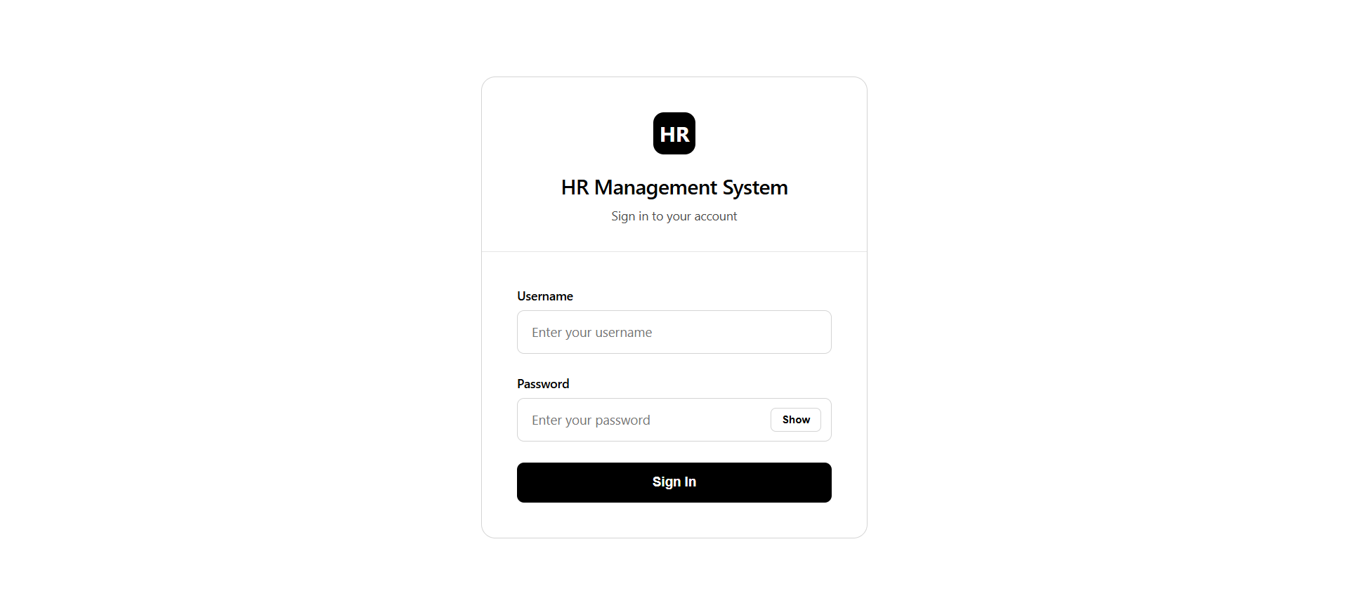
2. Employee Management
The Employee Management module serves as the central hub for managing all employee records. HR administrators can view, add, edit, and delete employee profiles. Each record displays key details including employee number, full name, position, department, employment type (Regular or Contractual), status (Active/Inactive), and date hired. The module also supports search, filtering by department and status, and options to export or print the employee list.
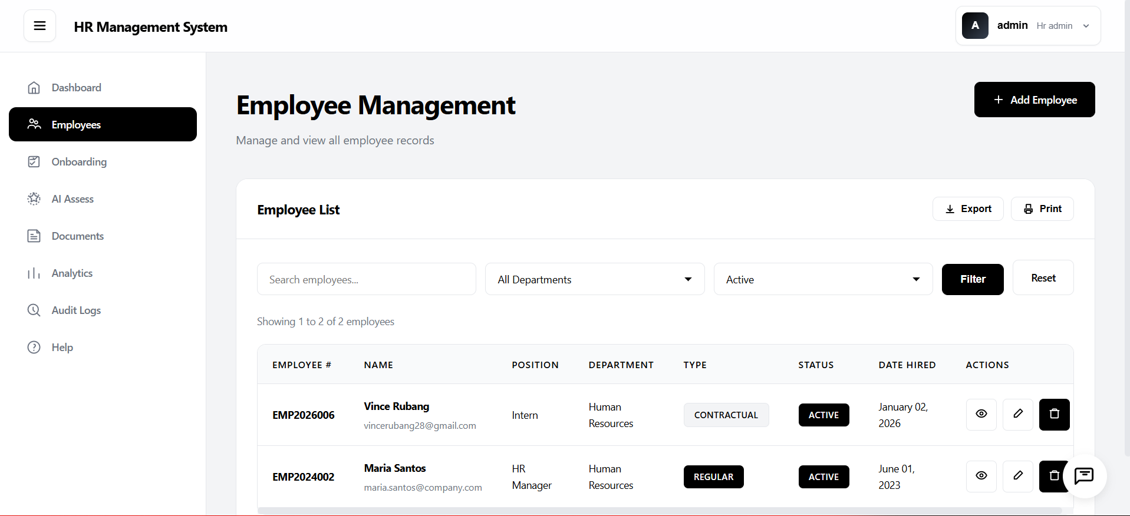

3. Onboarding
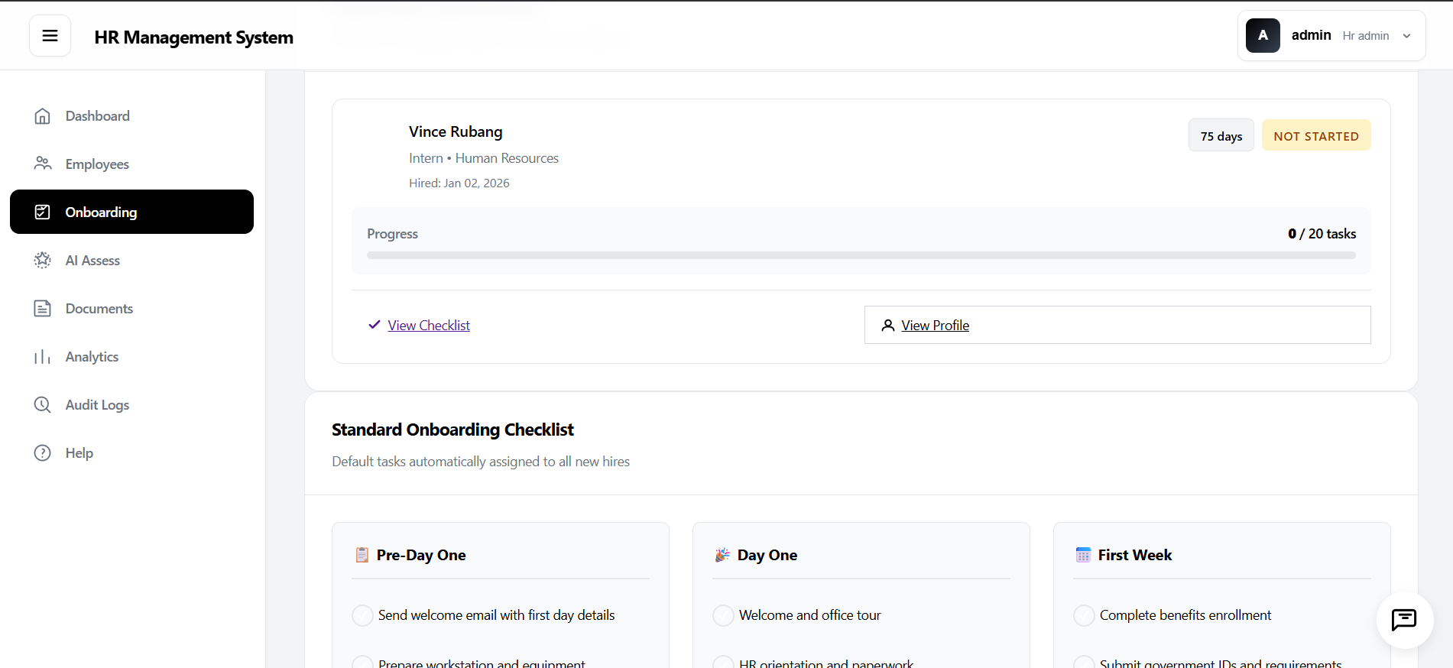
The Onboarding module automates the new hire integration process through a structured Standard Onboarding Checklist. Tasks are organized into three phases — Pre-Day One, Day One, and First Week — and are automatically assigned to each new employee upon hiring. The module tracks individual onboarding progress, displays task completion counts, and provides quick access to the employee’s checklist and profile. This feature ensures a consistent and organized onboarding experience across all new hires.

4. AI-Powered Assessment (AI Assess)
One of the most distinctive features of the system is the AI Assess module, powered by Groq AI (Llama 3.1). This module leverages artificial intelligence to evaluate each employee’s onboarding progress, predict hire success, and generate actionable insights to guide HR decision-making. The module displays aggregate statistics such as the number of employees in onboarding, total assessments conducted, and pending assessments. AI assessment results are accessible per employee and help HR teams proactively identify and address potential onboarding concerns.
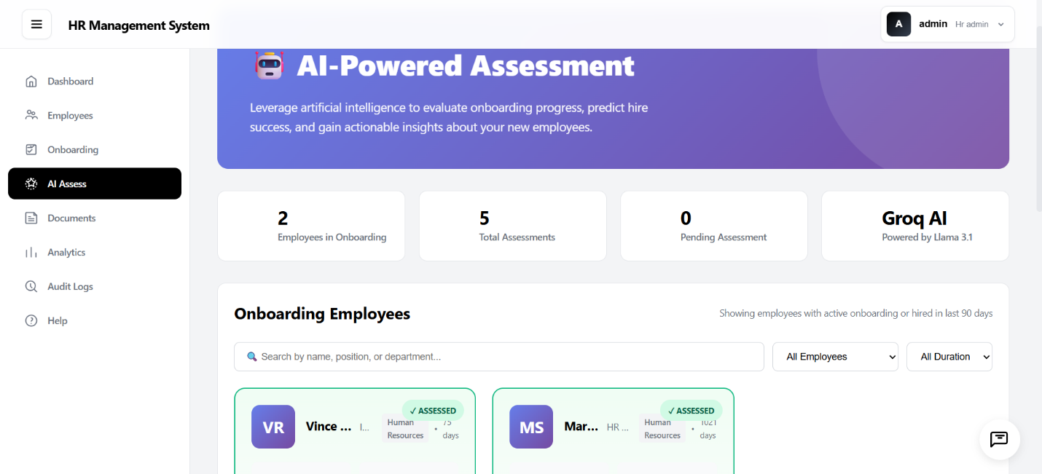
5. Documents
The Documents module provides a centralized repository for all employee-related files. Documents are categorized into four types — Contracts, Compliance, Personal, and Other — allowing HR staff to quickly locate and manage records. Users can upload files and click to download them directly from the system. The module supports both grid and list view modes for flexible document browsing.
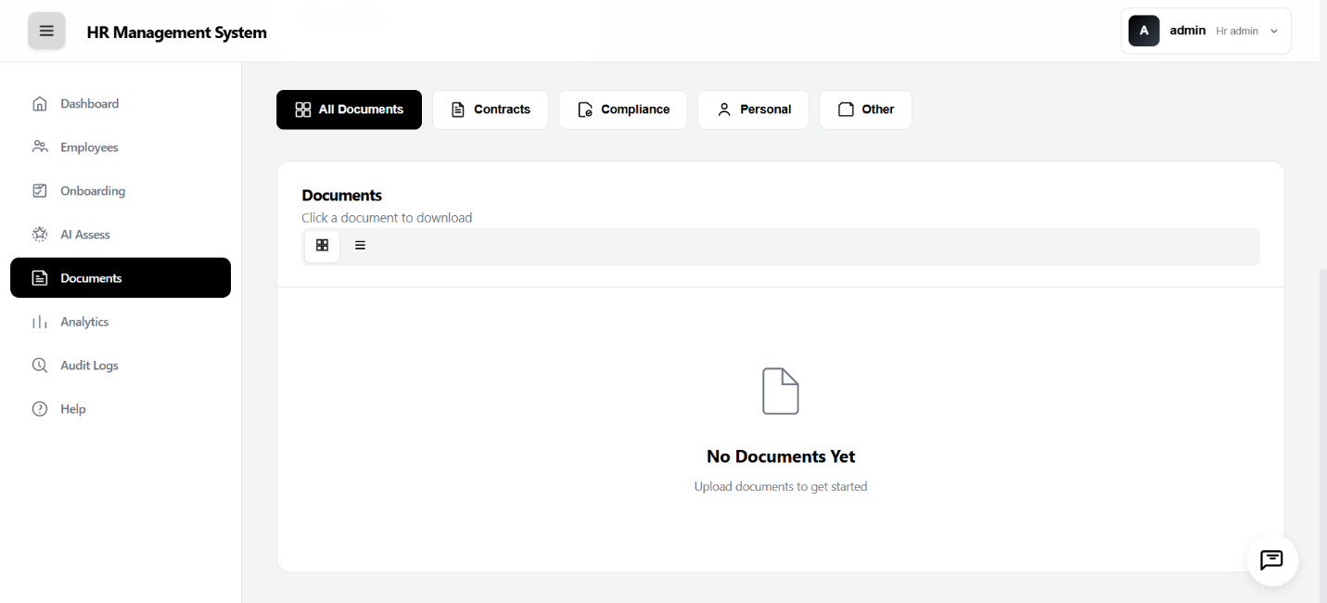
6. Audit Logs
The Audit Logs module provides a comprehensive trail of all system activities and data changes. Each log entry captures the date and time, the user who performed the action, the type of action (e.g., View, Create, Update, Delete), the affected database table, the record ID, and the IP address of the user. Administrators can filter logs by action type, table, and user for targeted auditing. This feature promotes transparency, data accountability, and system integrity.
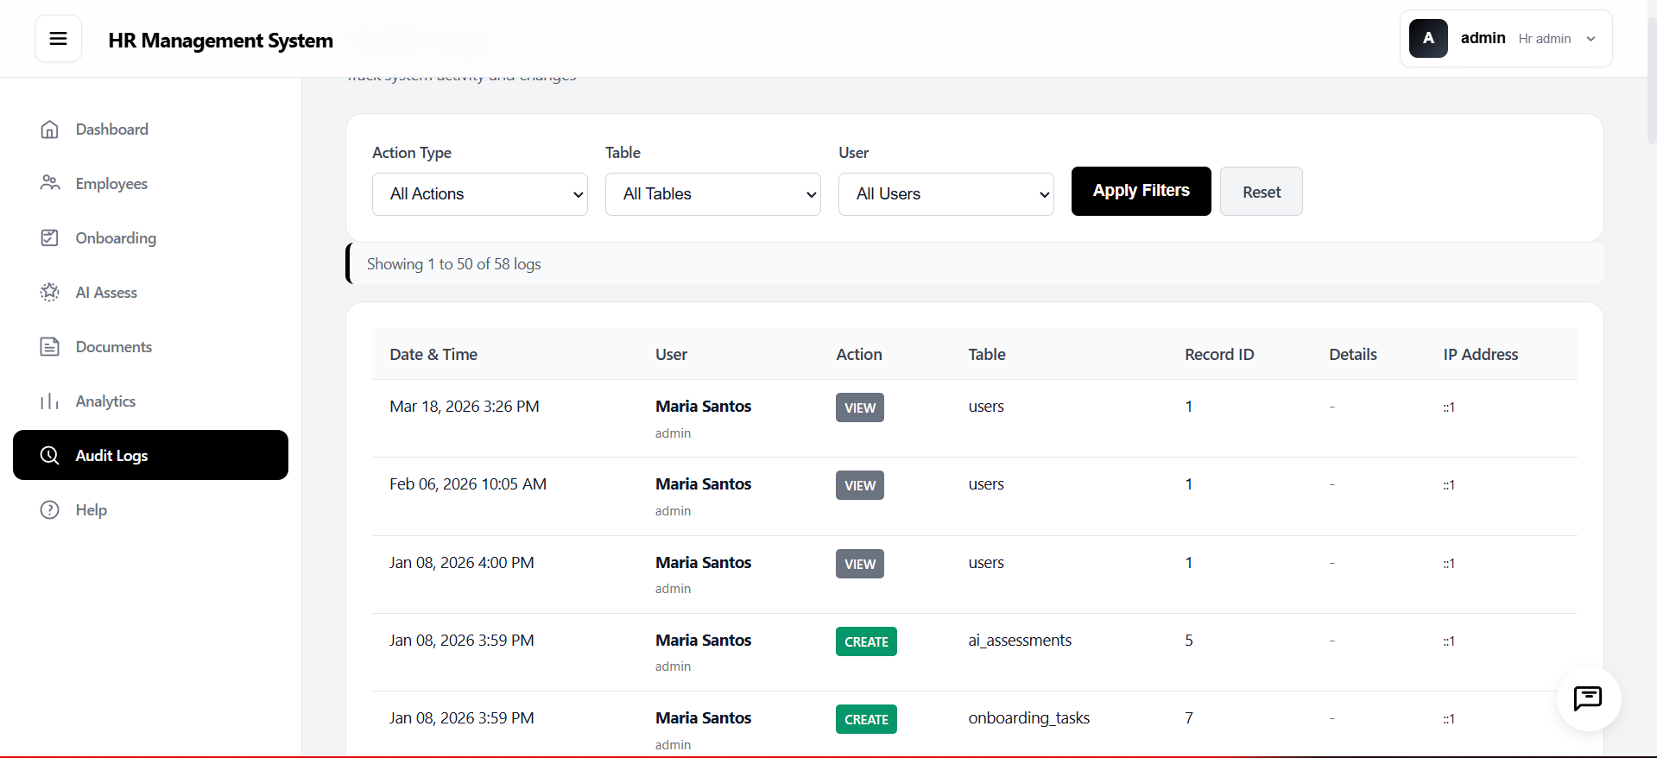
7. Help & Support
The Help & Support module offers in-system guidance for all types of users. It features a searchable knowledge base, quick-access cards for Getting Started, FAQs, Contact Support, and Video Tutorials, as well as organized help content segmented for HR Administrators, Managers, and Employees. This ensures that users at all levels can efficiently resolve questions and maximize their use of the system without requiring external assistance.
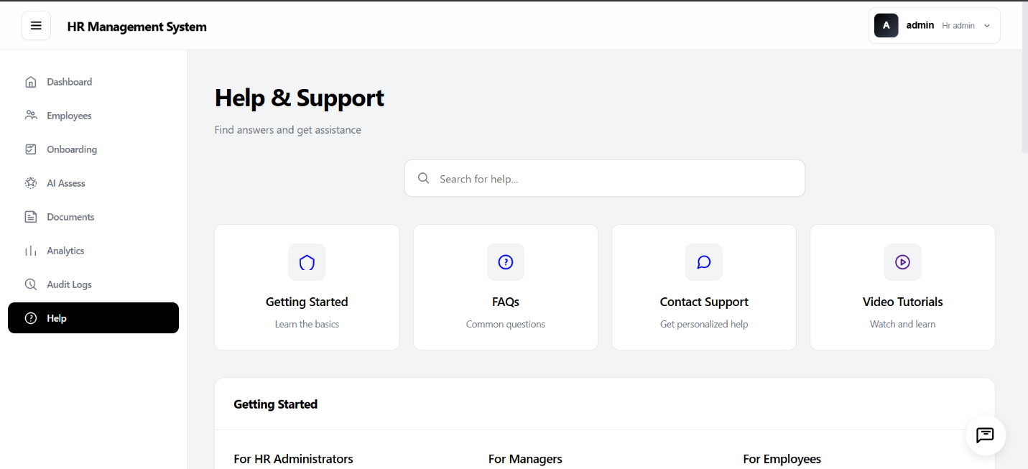
The HR Management System stands as a testament to the participants’ capacity to develop functional, AI-integrated software solutions within a structured and time-bound environment. It effectively embodies the seminar’s core themes of AI-powered application development, PRD- and PRP-driven workflows, and the use of modern AI tools and platforms.
VII. CONCLUSION
The IT Seminar on Artificial Intelligence and Application Development held on January 6 to 8, 2026, at ISPSC-Candon Campus was a meaningful and impactful academic endeavor. It successfully fulfilled its objectives of equipping participants with knowledge and practical skills in artificial intelligence and modern application development practices.
The event affirmed the BSIT Department's commitment to academic excellence and industry relevance, and demonstrated the power of collaboration between educational institutions and the private sector. The BSIT Department expresses its sincere gratitude to all speakers, guests, organizers, and participants who contributed to the success of this activity.

