ILOCOS SUR POLYTECHNIC STATE COLLEGE
Candon Campus

OJT REPORT
ERovoutika Electronics Robotics Automation
703 Parc House 2, Guadalupe Nuevo, Makati City

VINCE MARC JUSTINE O. RUBANG
Bachelor of Science in Information Technology

2nd Semester, A.Y. 2025–2026

Table of Contents
Chapter I Company Profile
Introduction | 3
Duration and Time | 5
Purpose / Role in the Company | 6
Chapter II Immersion Documentation
Background of the Action Plan | 7
Program of Activities – per day | 8
Evaluation of Results | 32
Chapter III Conclusion and Recommendation
Conclusion | 33
Recommendation | 34
Appendices
Endorsement Letter | 35
Screenshot of the Project | 36
Certificates | 37
Performance Evaluation Form | 37
Daily Time Record (DTR) | 39
Photo Documentation | 42

Chapter I
Company Profile

Introduction

Erovoutika Ph, Inc. is a Philippine-based robotics and technology education company that specializes in providing STEM and robotics learning programs for schools, organizations, and communities. Operating as an education enabler, Erovoutika develops comprehensive robotics kits, curriculum materials, and technology platforms designed to make hands-on STEM education accessible and practical across diverse academic environments.
The company was established by a team of engineers, educators, and technology advocates who recognized the growing demand for applied robotics and STEM skills among Filipino learners. The name "Erovoutika" reflects a commitment to bringing the excitement of engineering and robotics into Philippine classrooms from basic education through higher institutions.
Beyond robotics education, Erovoutika develops IoT-based solutions and e-commerce platforms, working alongside schools, universities, and government partners to build products suited to local educational requirements. Its Erovoutika Shop serves as an online marketplace offering robotics kits and technology products to schools and individual learners nationwide.

Company Milestones
Year | Milestone
2018 | Founded as a robotics and STEM education company in the Philippines, initially offering robotics kits and training programs for schools in Metro Manila.
2019 | Expanded product line to include IoT-based educational kits; began academic institution partnerships across Luzon.
2020 | Developed digital STEM modules and online robotics training programs in response to COVID-19 pandemic remote learning demands.
2021 | Launched the Erovoutika Shop — an e-commerce platform for robotics and technology kits targeting schools and individual learners.
2022 | Established partnerships with universities and higher education institutions for robotics internship programs and curriculum collaboration.
Present | Continues to grow as one of the leading robotics and STEM education companies in the Philippines, with active projects in IoT Smart Farming, web platform development, and robotics competition systems.

Duration and Time
Company Name | Erovoutika Ph, Inc.
Company Address | 703 Parc House 2, Guadalupe Nuevo, Makati City, Metro Manila
OJT Supervisor | Edarlyn Deplomo
Designation | HIP Supervisor / Administrator
Trainee Name | Vince Marc Justine O. Rubang
Beginning Date | January 28, 2026
End Date | March 3, 2026
Total Training Hours | 220 Hours
Schedule | Tuesday – Sunday (On-site / Hybrid)
Daily Hours | 9:00 AM – 6:00 PM (8 hrs/day)

Purpose / Role in the Company
As a Junior Developer Intern at Erovoutika Ph, Inc., my primary responsibility was to contribute to the development and improvement of the Erovoutika website revamp a full redesign of the company's web presence, internally designated as the Erovoutka Revamp project. This was an active, output-driven role embedded in the development workflow from the very first week, with assigned tasks carrying direct technical accountability and measurable deliverables.
My role spanned multiple areas of web development and technology: wireframing and mockup construction, frontend implementation, backend system development, UI/UX design, IoT hardware integration testing, and project finalization. I reported directly to Ms. Edarlyn Deplomo, HIP Supervisor/Administrator, and submitted progress updates on assigned tasks throughout the internship period.
The internship fulfilled the required on-the-job training component of the Bachelor of Science in Information Technology program at Ilocos Sur Polytechnic State College, Candon Campus, under the supervision of the OJT Coordinator of the Department of Information Technology. The 220 hours logged exceeded the minimum 200-hour requirement.

Chapter II
Immersion Documentation
Background of the Action Plan
The internship at Erovoutika Ph, Inc. commenced on January 28, 2026, with an OJT orientation, and concluded on March 3, 2026, with the submission of all final project requirements and the completion of an Entry Level Robotics Certification Examination. Deployed as the intern from ISPSC Candon Campus assigned to this company, the engagement demanded consistent self-directed output, independent problem-solving, and reliable delivery across a broad range of concurrent project tracks.
The work plan covered several parallel workstreams: website revamp development, covering the full frontend and backend implementation of the company's redesigned web presence; content creation for cloud computing and networking modules; IoT Smart Farming system testing involving soil moisture sensors, relay modules, and water pump automation; and supplementary tasks including poster design, video editing, webinar preparation, and robotics exam answer key preparation.
The internship was primarily conducted on-site at the company's Makati City office, with a hybrid arrangement on select days. Over twenty-nine recorded working days and six weeks, a total of 220 training hours was completed exceeding the required 200-hour minimum.

Program of Activities
Week / Dates | Hours | Tasks / Activities
Week 1 Jan. 28 – Feb. 1 | 40 hrs | - OJT Orientation  - Helped construct the Mockup for Erovoutika Revamp Website (EIRA/ROBOLUTION)  - Made a Module/Presentation about Cloud Storage and Networking  - Drafted tentative Diagrams for Erovoutika Revamp Website  - Compiled list of global schools offering robotics (with Dean/President names and emails)  - Edited short video clip about DLSMHSI ROBOSPORTS TOURNAMENT
Week 2 Feb. 4 – 8 | 40 hrs | - Compiled PPT modules/presentations on Cloud Computing and Networking  - Prepared and proposed webinar titles and outlines  - Deployed a sample website using GitHub and Vercel  - Acquired foundational knowledge of GitHub functions and version control  - Attended webinar: "Let's Git Started: An Introduction to GitHub and Git Essentials"  - Prepared answer keys for Fibonacci exam (60 questions, validated from reliable sources)  - Continued progress on Erovoutika Revamp Mockup
Week 3 Feb. 11 – 15 | 40 hrs | - Made a poster about Erovoutika Shop Grand Opening  - Sprint 1: Landing Page Completed  - Landing Page Mobile View implementation  - Admin Dashboard Core System Implementation  - News & Updates CRUD with Scheduled Publishing
Week 4 Feb. 18 – 22 | 40 hrs | - Awards Management System Integration  - Partners Management (Industry & Academe) System  - Contact Form with Database Integration  - Multi-Language System (50+ Languages) with Language Toggle  - Google Cloud Translation API Integration for Dynamic Content
Week 5 Feb. 23 – 27 | 40 hrs | - IoT Smart Farming: Soil Moisture Sensor Testing  - IoT Smart Farming: Sensor, Relay, and Pump Testing  - IoT Smart Farming: Final Testing  - Erovoutika Revamp: Organized Card Placements  - Dark Mode Implementation  - ROBOcrabs Bug Finding  - Applying Changes (Transitions)  - Finalizing Front End Design; Fixed Mobile Responsiveness
Week 6 Mar. 2 – 3 | 15 hrs | - Passed final requirements for Erovoutika Revamp  - Taken and passed Certification Exam (Entry Level Robotics)
TOTAL TRAINING HOURS | 220 HOURS

Narrative of Activities
Week 1 — January 28–February 1: Orientation and Initial Development
January 28, 2026 (Wednesday)
The internship formally commenced at Erovoutika Ph, Inc., located at 703 Parc House 2, Guadalupe Nuevo, Makati City, Metro Manila. Due to travel arrangements from Ilocos Sur, the first day began at 3:03 PM and concluded at 6:00 PM — a shortened but purposeful introduction to the company and its working environment. The OJT orientation covered the company’s organizational structure, its active project portfolio, internal communication protocols, and a high-level briefing of the tasks to be assigned in the coming weeks. The supervisor, Ms. Edarlyn Deplomo, introduced the internship expectations, outlined the scope of deliverables, and provided access to the tools and platforms used by the development team. The immediate impression of the office environment was one of a lean, technically driven team managing multiple simultaneous projects — robotics education kits, IoT systems, an active e-commerce platform, and a full website redesign. This orientation established not just the logistical context of the internship but also its professional tone: output-driven, technically demanding, and structured around real project accountability from day one. The breadth of concurrent undertakings made clear that the internship would require more than passive observation — it would demand direct contribution from the outset.
January 29, 2026 (Thursday)
The first full working day began promptly at 9:01 AM and extended to 6:01 PM. Work commenced immediately on the Erovoutika Revamp project — specifically, contributing to the construction of the wireframe mockup for EIRA/ROBOLUTION, the internal project designation for the company’s complete website overhaul. The mockup work involved translating conceptual design goals into structured visual layouts, mapping out page hierarchies, defining component placements, and identifying the key user flows that the revamped platform would need to support. This was not merely a decorative exercise — the mockup served as the architectural blueprint that the entire sprint-based development process would follow, making precision and thoroughness in the planning phase critically important. Alongside the mockup, a module and presentation on Cloud Storage and Networking was prepared and submitted. This deliverable required researching foundational concepts in cloud infrastructure — including storage types, networking models, and cloud service categories — and organizing them into a structured, instructional format suitable for Erovoutika’s educational content library. The combination of technical development work and knowledge content creation on the very first full day established the dual-track nature of the internship role: a role that would consistently operate across both practical implementation and educational output throughout the engagement.
January 30, 2026 (Friday)
Development of the Erovoutika Revamp mockup continued, with focused progress on the EIRA and ROBOLUTION sections. In parallel, tentative structural diagrams for the revamped website were drafted — formalizing the navigation flow, defining the information hierarchy across pages, and identifying the relationships between site sections and their underlying content. These diagrams served as the logical architecture layer beneath the visual mockup: while the mockup communicated layout and aesthetics, the structural diagrams mapped the functional and informational backbone of the platform. Drafting both in tandem during the first week ensured that design decisions were grounded in a coherent content and user-flow strategy from the beginning. The deliberate front-loading of planning and architecture work in the earliest days of the internship reflected a professional approach to project management — avoiding the costly rework that typically results from beginning implementation before foundational decisions are resolved. By the end of the day, the directional framework for the Erovoutika Revamp had been significantly advanced, setting a clear trajectory for the sprint work scheduled to begin in Week 3.

January 31, 2026 (Saturday)
The EIRA/ROBOLUTION mockup continued to advance with further refinements incorporating feedback and emerging design decisions from the preceding days. Alongside mockup progress, a separate research task was undertaken: the compilation of a comprehensive list of schools globally that offer robotics programs, including the names of their respective deans or presidents and official contact email addresses. This task required systematic sourcing from academic directories, institutional websites, and publicly available faculty listings — demanding both research discipline and attention to accuracy, as the data would be used directly for the company’s partnership outreach activities. The scope of schools included both international and Philippine-based institutions, requiring the ability to navigate a wide variety of website formats and directory structures to locate the correct contact information. An additional deliverable was completed before the end of the day: a short video clip for the DLSMHSI ROBOSPORTS TOURNAMENT was edited and submitted. The video editing task required working with raw footage, applying basic post-production refinements, and producing a polished output suitable for event documentation or promotional use. This third deliverable within a single workday reflected the pace and breadth of output that characterized the internship from its earliest days.
February 1, 2026 (Sunday)
The final day of Week 1 was devoted to continued refinement of the EIRA/ROBOLUTION mockup, consolidating all design decisions made across the preceding four days into a coherent and submission-ready visual document. Page-by-page components were reviewed for consistency in spacing, typography, and layout logic. Navigation structures were cross-checked against the structural diagrams produced on January 30 to ensure alignment between the architectural intent and the visual execution. By the close of the day, the mockup had reached a level of completeness that provided a reliable and actionable foundation for the development sprints planned to begin in Week 3. The first week as a whole established the working rhythms and expectations of the internship: a fast-paced environment requiring consistent multi-task delivery, strong independent judgment, and a capacity to produce quality output without close supervision. With the planning and design groundwork now firmly laid, the remaining weeks of the internship would shift progressively toward implementation, integration, testing, and finalization.

Week 2 — February 4–8: Content Development and Technical Foundations
February 4, 2026 (Wednesday)
The second week opened with the compilation of PowerPoint modules and presentations on Cloud Computing and Networking, building substantively on the documentation groundwork initiated in Week 1. This task required translating complex technical concepts into structured, learner-friendly instructional content — covering topics such as cloud service models (IaaS, PaaS, SaaS), network topologies, data storage paradigms, and cloud security considerations. The modules were designed for an audience of students and educators participating in Erovoutika’s STEM education programs, requiring careful calibration of technical depth and clarity of presentation. In parallel, webinar titles and proposed outlines for an upcoming company-organized event were developed and submitted to the team for review. The webinar planning task demanded a broader perspective — identifying themes of relevance to the target audience, structuring content for a live instructional format, and framing topics in a way that would both educate and engage participants. These content development responsibilities ran concurrently with continued monitoring and refinement of the Erovoutika Revamp mockup, reflecting the standard multi-track workload of the internship.
February 5, 2026 (Thursday)
A sample website was designed, built, and successfully deployed using GitHub and Vercel — a hands-on technical exercise that produced practical, working knowledge of the full modern deployment pipeline. The exercise involved creating a repository on GitHub, committing project files, configuring the repository for deployment, and linking it to a Vercel project for automated build and hosting. Through this process, a solid foundational understanding of GitHub’s core features was developed: repository creation and management, branch-based version control, commit history and rollback capability, and the integration between GitHub and cloud deployment platforms. Vercel’s build system, environment variable configuration, and deployment preview features were also explored. This hands-on deployment exercise was directly applicable to the Erovoutika Revamp project, which relied on the same GitHub-based version control workflow and a similar deployment pipeline. The knowledge gained on this day significantly reduced the onboarding friction for contributing to the live development codebase in the weeks ahead, enabling faster and more confident participation in the team’s collaborative development environment.
February 6, 2026 (Friday)
Continued progress was made on the Erovoutika Revamp mockup, with refinements applied to several sections based on the evolving design direction. The primary structured activity of the day was attendance at the company-organized webinar: “Let’s Git Started: An Introduction to GitHub and Git Essentials.” The webinar covered Git’s core concepts — commits, branches, merges, pull requests, and conflict resolution — and demonstrated best practices for collaborative version control in a team development environment. Attending the webinar the day after completing the independent deployment exercise on February 5 created a highly effective learning sequence: the practical experience provided concrete context for the theoretical content delivered in the webinar, and the webinar in turn clarified and formalized the concepts encountered during the hands-on exercise. This reinforced understanding not only of the mechanics of Git and GitHub but also of the professional norms and team workflows that version control systems are designed to support. The combined learning from the two days established a solid working foundation in version control that would be applied directly and consistently throughout the remainder of the Erovoutika Revamp development work.
February 7, 2026 (Saturday)
Progress on the Erovoutika Revamp mockup continued, with additional design refinements applied to pending sections. The other major deliverable of the day was the preparation of a complete answer key for a Fibonacci sequence examination — a task involving 60 questions that required rigorous validation of every answer against reliable and authoritative academic sources before submission. The Fibonacci examination was part of Erovoutika’s robotics and computational thinking educational programs, and the accuracy of the answer key was non-negotiable: errors in an answer key used for student evaluation would directly compromise the integrity of the assessment. Each question was carefully cross-referenced — not simply accepted at face value — before being included in the final document. This validation process demanded sustained analytical attention and methodical organization across all 60 items. The completed answer key was submitted before the end of the working day, meeting the delivery expectation within the standard 9:00 AM to 6:00 PM schedule.
February 8, 2026 (Sunday)
The final day of Week 2 was dedicated to continued progress on the Erovoutika Revamp mockup, consolidating and refining the work accumulated across the preceding days. Design decisions from the week were reviewed for internal consistency, and any outstanding layout questions were resolved to ensure the mockup remained a reliable and current reference for the development work ahead. By the close of Week 2, the mockup had reached a near-final state of completeness — with both the EIRA and ROBOLUTION sections sufficiently developed to guide sprint-based implementation. The codebase preparation for the revamp was also progressing in the background: the technical environment, project structure, and repository configuration for the development phase had been set up and validated during the week’s deployment exercises. The successful completion of both the mockup and the technical preparation work by the end of Week 2 meant that Week 3 could open with full-speed implementation, moving from planning and prototyping directly into front-end and back-end development without delay.

Week 3 — February 11–15: Sprint Development and Core Implementation
February 11, 2026 (Wednesday)
The third week marked the transition from design and planning into active sprint-based development. Alongside continued refinements to the Erovoutika Revamp mockup, a promotional poster for the Erovoutika Shop Grand Opening was designed and completed as a separate deliverable. The poster required balancing visual hierarchy, brand alignment, and marketing clarity within a single-page design asset — communicating the event’s key information while maintaining the visual tone and identity appropriate for Erovoutika’s audience. The design process involved selecting typography, composing layout, choosing color schemes consistent with the company’s brand, and producing a final output suitable for both digital sharing (social media, email) and physical printing. The completed poster was submitted for use in the company’s promotional campaign for the shop’s launch event.
February 12, 2026 (Thursday)
Sprint 1 of the Erovoutika Revamp was completed and delivered: the Landing Page was finalized and submitted for review. This milestone represented the culmination of two weeks of planning, mockup construction, design iteration, and technical preparation. The landing page was implemented using Next.js and React, structured according to the approved mockup, and developed to meet both desktop and performance standards. The completed page incorporated all major sections defined in the mockup — hero banner, featured programs, company highlights, navigation, and footer — with full visual fidelity to the approved design. Beyond its content, the landing page served as the visual and structural template for the entire revamped platform: the component architecture, styling conventions, and layout patterns established here would be replicated and extended across all subsequent pages. Delivering Sprint 1 on schedule on the first full implementation day of Week 3 confirmed that the planning investment of the first two weeks had translated directly into efficient and confident execution.
February 13, 2026 (Friday)
With the desktop landing page delivered, attention shifted immediately to mobile responsiveness — implementing the landing page’s responsive design for smaller screen sizes. This task involved adapting the desktop layout to function correctly across a range of standard mobile breakpoints, adjusting CSS media queries, reworking component arrangements that did not translate directly from wide to narrow viewports, and ensuring that touch-friendly interaction patterns were preserved throughout. Navigation elements, hero sections, image scaling, and typography were all reviewed and adapted to ensure readability and usability on mobile devices. Modern web standards demand that a platform function correctly across all device types — not just desktop — and any responsiveness failure on a public-facing site directly affects user experience and brand perception. The mobile implementation was validated across standard breakpoints before being committed, ensuring the landing page met professional quality standards in both desktop and mobile environments before the project advanced to subsequent modules.
February 14, 2026 (Saturday)
With the public-facing landing page completed, development shifted to the administrative backend — the core system through which all website content would be managed. The Admin Dashboard Core System was built from the ground up, establishing the foundational architecture that all subsequent content management modules would plug into. This involved implementing a secure authentication layer with session management to protect the dashboard from unauthorized access, designing the primary navigation structure that would organize all administrative functions, and defining the database schema conventions and API routing patterns that would standardize how all future CRUD modules communicated with the backend. The dashboard’s layout was built with scalability in mind — each new module added in the subsequent days would integrate into the same navigational framework without requiring structural rework. Careful attention was paid to user experience within the admin interface: clear labeling, logical grouping of functions, and consistent component patterns were applied throughout to ensure the dashboard would be intuitive to use for non-technical content administrators. Completing the core system on this day created the stable platform upon which all remaining administrative features would be built.
February 15, 2026 (Sunday)
The News & Updates module was developed and integrated into the admin dashboard as the first fully operational content management feature of the Erovoutika Revamp. The module was built with complete CRUD functionality — Create, Read, Update, Delete — giving administrators the ability to author new announcements, edit existing entries, manage visibility, and remove outdated content. A particularly significant feature implemented alongside the core CRUD operations was a scheduled publishing system: administrators could draft content, set a specific publication date and time, and allow the system to automatically make the content publicly visible at the designated moment without requiring manual intervention. This scheduling capability was designed to support the company’s content calendar workflows — enabling the team to prepare announcements and updates in advance, queue them against planned dates, and ensure timely publication without the need for someone to be present at the exact moment of release. The module included validation logic to prevent incomplete drafts from being published prematurely, and the public-facing rendering of news items was implemented in parallel to ensure content created through the dashboard appeared correctly on the live website in the appropriate format and layout.
Week 4 — February 18–22: Advanced Systems and API Integration
February 18, 2026 (Wednesday)
The Awards Management System was designed, built, and integrated into the admin dashboard as the first feature of Week 4. The module enabled the company to systematically manage and publicly display its portfolio of awards, competition victories, recognitions, and institutional distinctions. The development process involved designing the database schema to store award records — including fields for award title, awarding body, date received, category, and supporting media — and building the full CRUD interface within the dashboard for administrators to add, edit, and remove award entries. On the public-facing side, a rendering component was implemented to display the awards collection in a visually organized format appropriate for the website’s design language. For a company like Erovoutika — whose credibility in the education and robotics sector is directly supported by its competitive track record — the accurate and professional presentation of its awards portfolio on the company website carries tangible reputational and commercial weight. The module was completed and integrated within the working day, consistent with the delivery pace established in Week 3.
February 19, 2026 (Thursday)
The Partners Management System was developed and integrated into the admin dashboard, covering two distinct partner categories: Industry partners and Academe partners. Each category required its own data structure, display logic, and management interface, as the nature of industry collaborations differs meaningfully from academic institutional partnerships in how they are described, categorized, and presented to visitors. The module allowed administrators to add, edit, reorder, and remove partner entries — including partner name, logo, category designation, and a brief description or collaboration note. The public-facing implementation rendered partner logos and names in an organized, visually cohesive section of the website, presenting Erovoutika’s institutional network in a manner that reinforces its credibility with prospective partners, schools, and clients. For a company whose business model is deeply reliant on institutional relationships — with universities, government agencies, and private sector organizations — having a professionally maintained and easily updatable partner directory on its public website is a direct contributor to trust and outreach effectiveness.
February 20, 2026 (Friday)
A fully functional Contact Form with Database Integration was implemented and deployed on the Erovoutika Revamp website. The contact form serves as the primary structured communication channel between website visitors — prospective partners, schools, clients, and individuals — and the Erovoutika team. The implementation covered both the front-end form interface and the complete backend processing pipeline: form submission triggers server-side validation to ensure all required fields are populated correctly, the validated data is written to a dedicated database table with a timestamp and submission metadata, and the entry is made available for review through the admin dashboard. Appropriate error handling was implemented for failed submissions, and user-facing confirmation messages were added to acknowledge successful form completion. The contact form replaced any prior static placeholder or external redirect, making it a live, operational feature from the day of deployment. From a business perspective, this feature directly affects lead capture and institutional inquiry management — two functions that have tangible commercial implications for a company actively seeking school partnerships and product sales.
February 21, 2026 (Saturday)
A Multi-Language System supporting over 50 languages was architected, developed, and integrated into the Erovoutika Revamp website — one of the most technically ambitious features of the entire project. The system included a user-controlled language toggle, allowing any visitor to switch the website’s display language from the interface without reloading the page. The implementation required building a language state management layer that persisted the user’s language selection across page navigation, ensuring a consistent experience throughout the site visit. Text content throughout the site was structured to be dynamically replaced based on the active language selection, rather than hardcoded into static page components. The scope of 50+ supported languages required a translation infrastructure capable of scaling beyond manual entry — which set the stage for the Google Cloud Translation API integration that would follow on February 22. The language toggle itself was designed to be intuitive and accessible, with a clean UI component that allowed users to identify and select their preferred language quickly. For a company whose school partnership outreach spans institutions globally — as evidenced by the partner contact compilation work in Week 1 — a multi-language website represents a meaningful capability that directly supports international engagement objectives.
February 22, 2026 (Sunday)
The Google Cloud Translation API was integrated into the Erovoutika Revamp website to power the multi-language system developed on February 21. This integration transformed the language switching feature from a static translation lookup into a fully dynamic, real-time content translation system. When a user selects a language through the toggle, the API is called with the relevant content strings, and translated text is returned and rendered in place — all without requiring manually maintained translation files for each of the 50+ supported languages. The integration involved setting up a Google Cloud project, configuring API credentials and access controls, building a server-side translation service layer to handle API calls securely (ensuring that API keys were never exposed to the client), and implementing caching logic to minimize redundant API calls for frequently translated content and reduce operational costs. Error handling and fallback behavior were implemented to ensure the site defaulted gracefully to English if a translation request failed. This technical integration significantly elevated the sophistication and scalability of the multi-language feature — making it maintainable and extendable without requiring manual intervention for every content change or language addition in the future.

Week 5 — February 23–27: IoT Testing and Final Refinements
February 23, 2026 (Monday)
The fifth week opened with a significant shift in technical domain — moving from web platform development into IoT hardware work on the Smart Farming project. The first day of IoT testing focused on the soil moisture sensor: the primary input device of the automated farming system. Testing involved physically connecting the sensor to the microcontroller, writing and executing test code to read raw sensor output values, and then calibrating those readings to correspond accurately to real-world moisture conditions across a defined range — from dry soil through to saturated levels. Baseline behavior was documented across multiple moisture conditions to establish the thresholds that would govern the automation logic: at what sensor reading value the system should interpret the soil as too dry to trigger pump activation, and at what level the soil should be considered sufficiently moist for the pump to remain inactive. The data gathered and documented on this day provided the quantitative foundation for the relay and pump automation logic that would be tested in the following days. This work required careful methodical attention to hardware behavior — understanding how the sensor responded to different physical conditions and how to translate analog readings into meaningful control signals.
February 24, 2026 (Tuesday)
IoT Smart Farming testing expanded on the second day to encompass the relay module and the water pump system — bringing together all hardware components into a full end-to-end integration test for the first time. The relay module serves as the electrical switching mechanism between the low-power microcontroller and the higher-power water pump: when triggered by a signal from the microcontroller, it closes the circuit to the pump, causing it to activate and deliver water. Testing on this day validated the complete automation chain: the soil moisture sensor took a reading, the microcontroller evaluated the reading against the calibrated moisture thresholds, and when the threshold indicated dry conditions, a control signal was sent to the relay, which activated the pump. Each step of the chain was tested in sequence before the full end-to-end run was executed. Timing behavior, signal reliability, and the physical response of the pump were all observed and documented. Edge cases — such as the sensor reading borderline threshold values — were also tested to confirm the system behaved deterministically under marginal conditions. This integration test was a critical validation checkpoint that confirmed the individual components worked correctly as a coordinated automated system.
February 25, 2026 (Wednesday)
The third day of IoT Smart Farming work was dedicated to final system testing and documentation. With the individual components validated and the integration chain confirmed on February 24, this session focused on comprehensive end-to-end testing under a broader range of conditions to ensure robustness and reliability. Multiple test runs were conducted across different moisture levels, with the system’s automated response — sensor reading, relay activation, pump behavior — verified consistently at each condition. Failure recovery was also examined: testing what occurred when the sensor was disconnected mid-operation, when threshold values were at their boundary, and whether the system recovered gracefully without requiring a manual restart. All test results were compiled into structured documentation, capturing the test conditions, observed outputs, and pass/fail outcomes for each scenario. The documentation was prepared in a format suitable for submission to the company and for inclusion in the project’s technical records. The successful completion of all IoT Smart Farming testing on this day closed out the hardware work component of the internship, marking the conclusion of what had been a technically distinct and physically engaging three-day engagement with embedded systems and IoT hardware.

February 26, 2026 (Thursday)
Development returned to the Erovoutika Revamp following the completion of the IoT testing track. The focus of the day was the organization and refinement of card placements across multiple pages of the website. Cards are a fundamental UI pattern used throughout the platform to display products, programs, news items, partner profiles, and award entries — making their consistent and visually coherent placement a prerequisite for a polished final product. The work involved systematically reviewing each page of the revamped site to assess how card components were arranged within their containing sections: checking for alignment consistency, ensuring appropriate spacing between cards and surrounding content, verifying that card grids responded correctly at different screen sizes, and confirming that visual hierarchy within each card — title, description, image, and call-to-action — was legible and appropriately weighted. Where inconsistencies were identified, adjustments were made to CSS layout properties, grid configurations, and padding values to bring all card implementations into visual alignment across the platform. This kind of cross-page polish pass is essential in the late stages of web development — it is the difference between a platform that functions correctly and one that also looks professionally finished.
February 27, 2026 (Friday)
Dark Mode was implemented across the Erovoutika Revamp website — a user experience feature that has become a standard expectation on modern web platforms and a meaningful accessibility consideration for users who prefer or require lower-brightness display environments. The implementation involved refactoring the site’s entire color system to use CSS custom properties (variables) rather than hardcoded color values, enabling a single toggle to swap the entire site’s color palette between light and dark themes without requiring duplicate stylesheets or component-level conditionals. Each color token was paired: every light-mode value had a corresponding dark-mode equivalent that maintained appropriate contrast ratios for readability and accessibility compliance. Component by component, the rendered output in dark mode was reviewed — checking backgrounds, text colors, border colors, icon fills, button states, hover effects, and modal overlays — to identify and correct any elements that did not translate cleanly from the light theme. Particular care was taken with images and branded elements, where dark-mode adjustments can introduce unintended visual artifacts. The user’s theme preference was persisted using local state and system preference detection, so the site would automatically honor a user’s operating system dark mode setting on first visit while still allowing manual override through the interface toggle.

Week 6 — February 28–March 3: Final Week and Completion
February 28, 2026 (Saturday)
The final week of the internship opened with a quality assurance task on ROBOcrabs — a separate platform project within Erovoutika’s portfolio, distinct from the Erovoutika Revamp that had been the primary focus of the preceding weeks. Bug identification was conducted across the ROBOcrabs platform: systematically navigating through its features and user flows, testing interactions and edge cases, and identifying functional defects, UI inconsistencies, and behavioral anomalies that deviated from expected behavior. Each issue found was documented in a structured bug report format — capturing the steps to reproduce the issue, the expected versus actual behavior, the severity level, and where applicable, screenshots or descriptions of the visual symptoms. The completed bug report was submitted to the development team for triage and resolution. Bug finding is a discipline that requires a specific mindset — the deliberate attempt to break or stress a system rather than simply use it as intended — and contributing a thorough bug report on an unfamiliar platform within a single working day demonstrated both technical attentiveness and the ability to onboard quickly to a new project context.
March 1, 2026 (Sunday)
With the core features of the Erovoutika Revamp complete and the platform entering its final polish phase, the focus of the day was the application of transition effects and animations across the website. CSS transitions and keyframe animations were applied to a range of interactive and page-load elements — including navigation hover states, button interactions, card reveals on scroll, hero section entrance animations, and page element fade-ins. The goal was not visual spectacle but refined subtlety: transitions were calibrated to feel responsive without being distracting, with duration and easing values chosen to complement the platform’s professional aesthetic rather than overpower it. Each transition was tested across multiple browsers — including Chrome, Firefox, and Safari — to confirm consistent rendering behavior, as animation properties occasionally differ in their implementation or performance characteristics across browser engines. Device-level performance was also considered, ensuring that animations did not cause perceptible lag or jank on lower-powered mobile devices. Where performance issues were identified, animations were either optimized using GPU-compositable properties (such as `transform` and `opacity`) or conditionally reduced for devices that had indicated a preference for reduced motion through system accessibility settings.
March 2, 2026 (Monday)
The penultimate day of the internship was devoted to the comprehensive finalization of the Erovoutika Revamp’s front-end design and a thorough mobile responsiveness review across all completed pages of the platform. A page-by-page audit was conducted: each section of the website was reviewed in both desktop and mobile viewports, with particular attention to layout breakpoints, text scaling, image rendering, navigation behavior, and the performance of interactive components across screen sizes. Mobile responsiveness issues that surfaced during this final review pass — including layout overflow on certain screen widths, inconsistent spacing on smaller devices, and navigation edge cases on tablets — were identified, diagnosed, and resolved. CSS adjustments, flexbox and grid refinements, and viewport-conditional styling were applied to correct each issue before re-testing to confirm resolution. Cross-device visual checks were completed to validate that the platform presented a consistently polished and professional experience at all standard breakpoints — from large desktop displays down to compact mobile screens. By the close of the day, the front-end of the Erovoutika Revamp had been brought to a fully finalized state, ready for submission on the following and final day of the internship.
March 3, 2026 (Tuesday) — Final Day
The final day of the internship began at 9:30 AM and carried the weight of six weeks of accumulated work toward its conclusion. The morning was dedicated to completing and submitting all final requirements for the Erovoutika Revamp — the culminating deliverable of the internship and the project that had defined the majority of its technical work. Final submission involved packaging all project files, verifying that the deployed build reflected the latest finalized version, confirming that all modules — the landing page, admin dashboard, news system, awards and partners management, contact form, multi-language system with Google Cloud Translation API integration, dark mode, and mobile responsiveness — were fully functional and correctly integrated. The submission was delivered to Ms. Edarlyn Deplomo and the development team, closing out the Erovoutika Revamp contribution. In the afternoon of the same day, the Entry Level Robotics Certification Examination — administered by Erovoutika as part of its educational certification program — was taken and passed. The examination covered foundational robotics concepts and validated the theoretical understanding developed throughout the internship alongside the practical technical work. The internship formally concluded upon the completion of the certification exam. All 220 training hours had been logged across twenty-nine working days spanning six weeks — exceeding the required 200-hour OJT minimum by twenty hours. Every deliverable had been submitted, every development milestone had been met, and a formal certification had been earned. The internship at Erovoutika Ph, Inc. was complete.

Internship Summary
Intern Profile
VINCE MARC JUSTINE O. RUBANG | "VINCE"
ROLE: JUNIOR DEVELOPER INTERN
DEPARTMENT: WEB DEVELOPMENT TEAM
SCHOOL: ILOCOS SUR POLYTECHNIC STATE COLLEGE
Challenges Encountered
- Broad Task Scope - Being assigned deliverables across multiple concurrent tracks web development, content creation, IoT hardware testing, and design required constant context-switching and rapid skill adaptation throughout the internship period.
- Technical Learning Curve - Several assigned technologies, including Google Cloud Translation API, IoT sensor-relay-pump integration, and multi-language web systems, required significant self-directed research and learning to implement correctly within expected timelines.
- Workload Intensity - The volume and variety of deliverables, combined with consistent daily working hours across six weeks, created sustained pressure that demanded careful prioritization and follow-through.

Key Learnings
Soft Skills | Technical Skills
Time Management & Prioritization | Web Development (NEXTJS/REACT/JS)
Adaptability | Admin Dashboard Development
Resilience | IoT Hardware Testing & Integration
Initiative | Google Cloud Translation API
Collaboration | GitHub & Version Control

Internship Impression
- The Erovoutika team provided a technically challenging and professionally enriching internship that pushed both my technical capabilities and work discipline across the entire OJT period.
- The breadth of assignments from web development and API integration to IoT hardware testing and content creation — offered a genuinely comprehensive technology experience that I could not have received in any single academic course.
- I gained concrete, applicable technical skills across multiple domains and developed a clearer sense of the type of developer and technologist I am working toward becoming.
- The experience strengthened my ability to work independently under ambiguity, deliver results under pressure, and adapt quickly to unfamiliar tools and technology stacks.
Evaluation of Results
The internship at Erovoutika Ph, Inc. produced measurable, concrete output across multiple concurrent tracks: a substantially complete website revamp (EIRA/ROBOLUTION) encompassing the landing page, admin dashboard, awards management module, partners management module, contact form, multi-language system with Google Cloud Translation API integration, dark mode, and mobile responsiveness; a functional IoT Smart Farming system validated through end-to-end hardware testing of sensor, relay, and pump components; content modules on Cloud Computing and Networking; webinar preparation materials; event support outputs; and a completed Entry Level Robotics Certification Examination.
Beyond the technical deliverables, the internship provided a rigorous real-world environment that tested not only technical skill but also professional character: the capacity for independent work, the ability to manage multiple workstreams simultaneously, and the discipline to deliver consistent output under sustained time pressure.
The completion of 220 training hours 20 in excess of the required minimum and the passing of the Entry Level Robotics Certification Exam on the final day of the internship stand as the most direct and verifiable measures of performance and commitment over the six-week period.

Chapter III
Conclusion and Recommendation
Conclusion
The On-the-Job Training at Erovoutika Ph, Inc. from January 28 to March 3, 2026, was a demanding and multidimensional professional experience that fulfilled and, in several respects, exceeded its academic purpose. Over the course of 220 hours spanning six weeks and twenty-nine working days, direct contributions were made to the development of the Erovoutika website revamp, IoT Smart Farming system testing, knowledge content creation, promotional design, and a robotics certification examination.
The experience confirmed that professional technology work operates across a range of skills, tools, and contexts that no single course can fully prepare a student for. Web development, API integration, hardware testing, content creation, and design were required concurrently often within the same week. Delivering consistently across these demands required adaptability, initiative, and the discipline to sustain output under conditions of ambiguity and pressure.
The exposure to a live, operating technology company with real projects, real timelines, and real stakeholders provided a concrete benchmark for what professional readiness actually means. The skills developed, the work delivered, and the certification earned at the close of the internship collectively mark a substantive step forward in both technical capability and professional identity.

Recommendation
To Future Interns. Approach the internship prepared for breadth, not just depth. Erovoutika's projects span web development, IoT, content creation, and design often simultaneously. The ability to shift between tracks and deliver on multiple fronts is not optional; it is expected. Invest time before the internship in foundational web development, basic Git workflows, and familiarity with cloud APIs. Arrive ready to learn independently, ask targeted questions, and show initiative beyond your assigned task list. The internship rewards proactive engagement far more than passive compliance.
To ISPSC - Department of Information Technology. The department is encouraged to strengthen pre-deployment exposure to modern web development frameworks, REST and cloud-based API integration, and IoT fundamentals all areas directly applied during this internship. Closer institutional coordination with host companies and earlier provision of endorsement and deployment documents would also meaningfully reduce the administrative friction interns face in the opening days of their placements.
To Erovoutika - The company's internship program is technically rigorous and practically valuable. The breadth of exposure offered to interns is a genuine differentiator. To further strengthen the program, a more structured onboarding process including a written task brief, defined milestones per week, and a clear escalation path for technical blockers would help interns ramp up more efficiently and reduce time lost to ambiguity in the early weeks. Regular supervisor check-ins would also reinforce alignment between intern progress and company expectations throughout the engagement.

Appendices
Appendix A
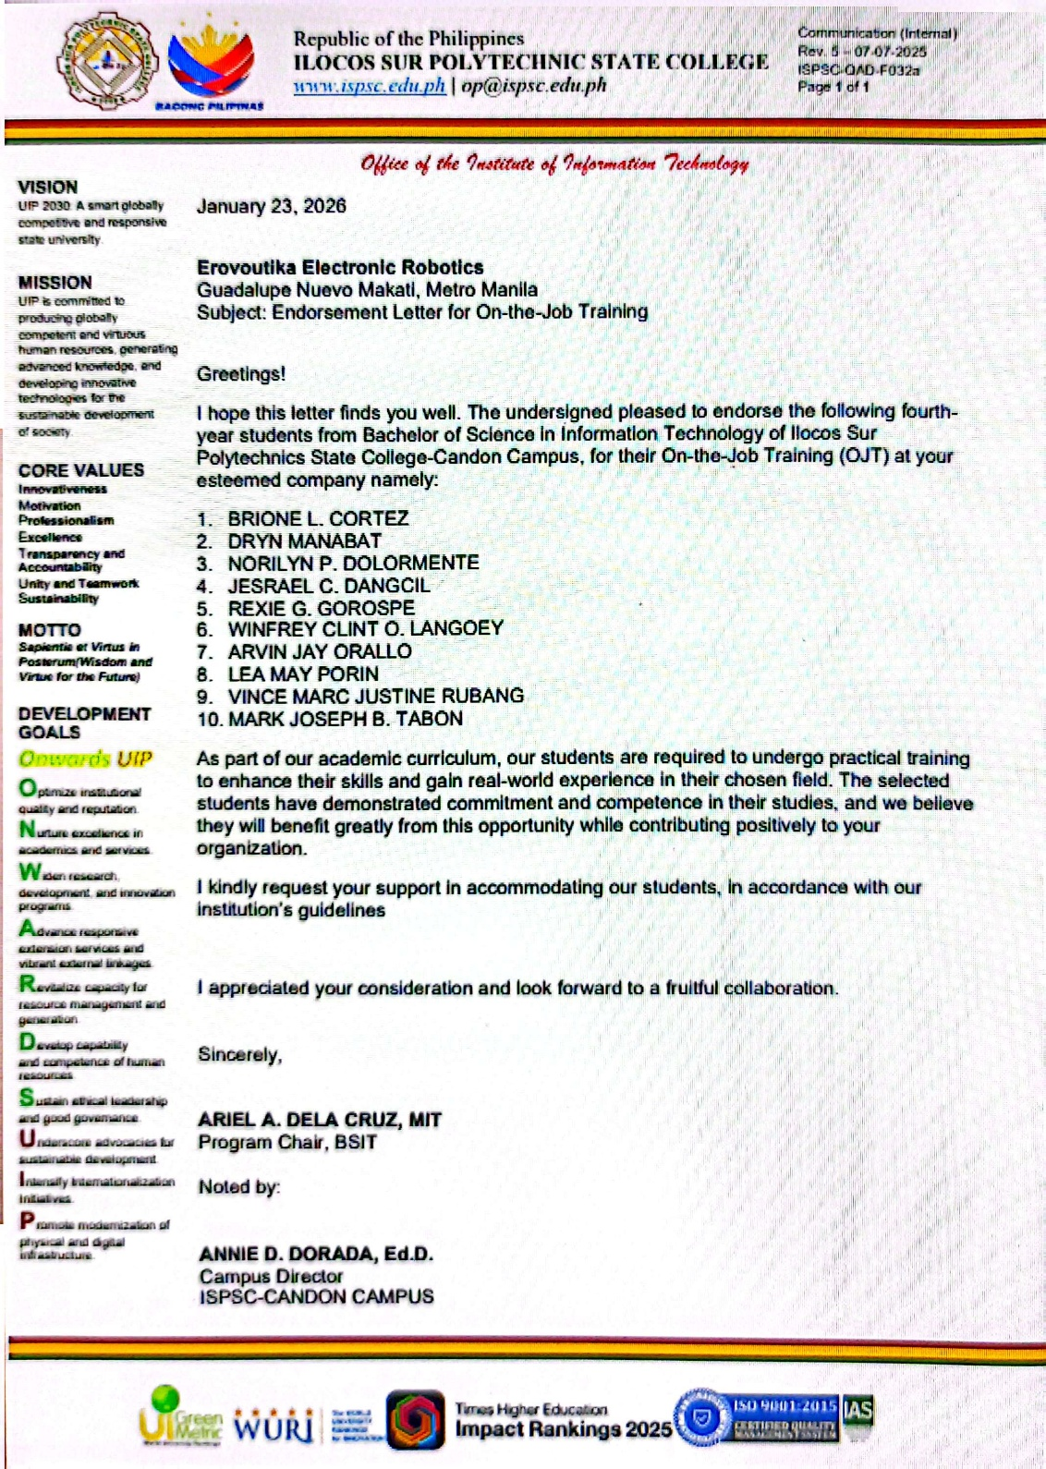
Endorsement Letter

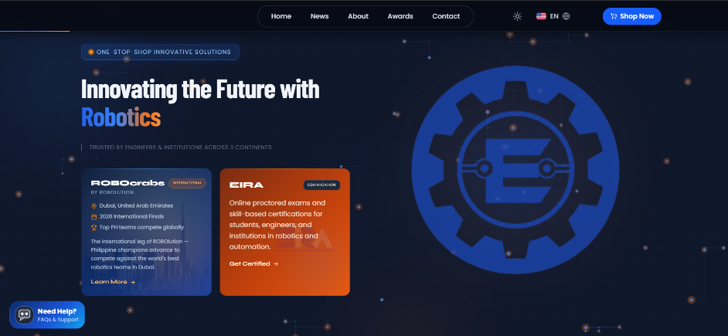
Appendix B

Screenshot of the Project

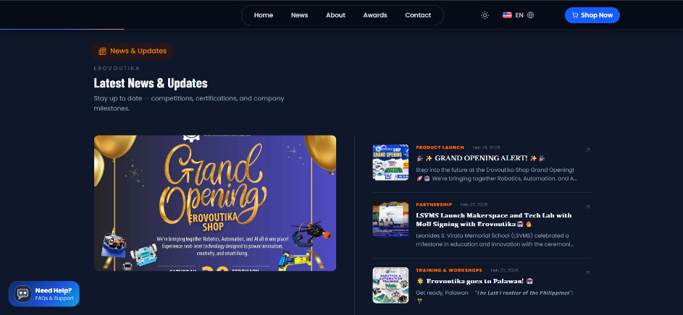

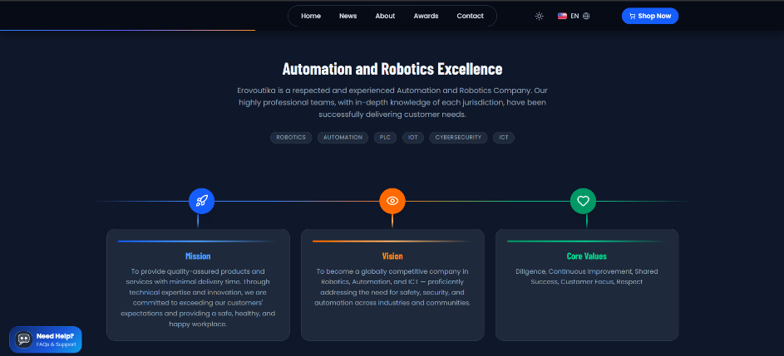

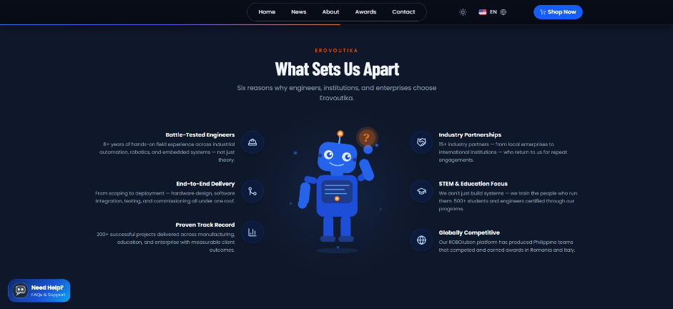

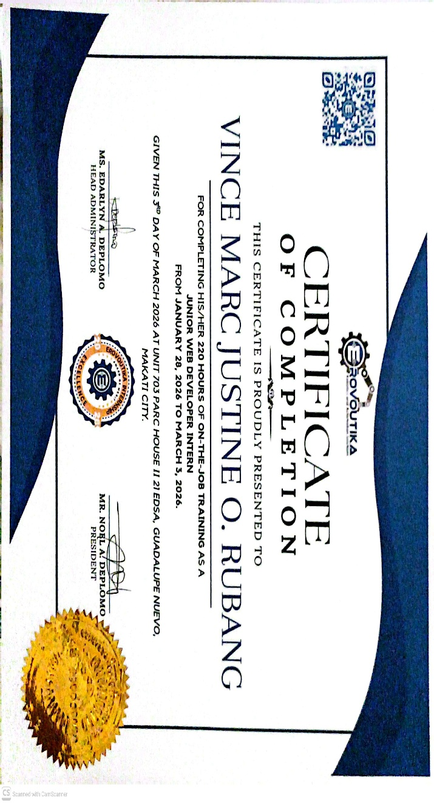
Appendix C
Certificates
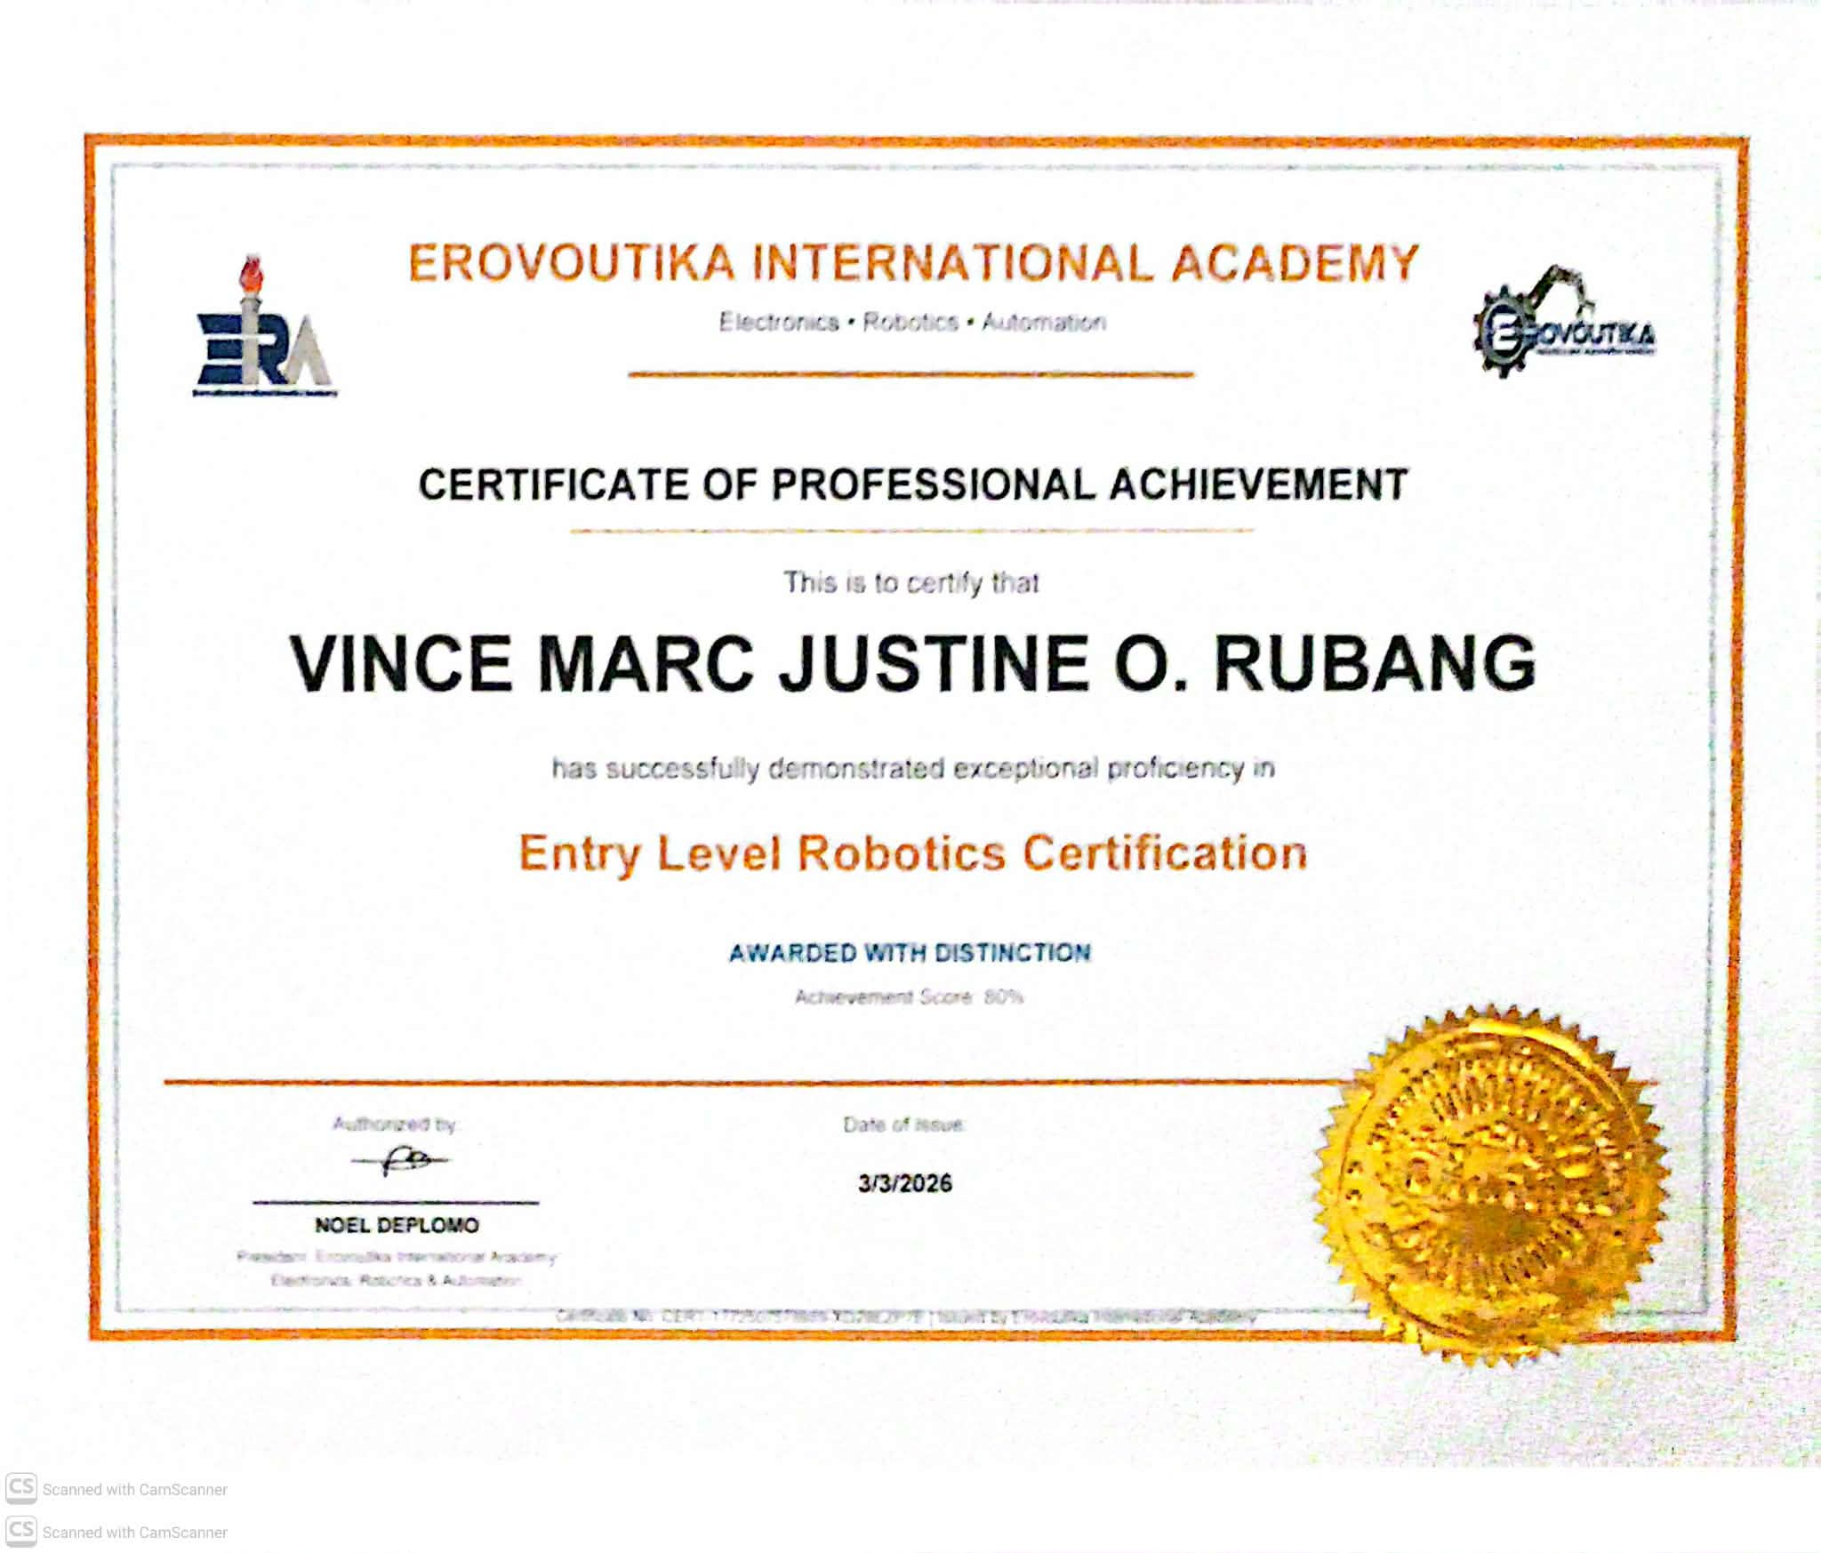
Certificate of Completion - Erovoutika Ph, Inc. Internship Program
Certificate of Completion — Entry Level Robotics Certification Examination (March 3, 2026)

Appendix D
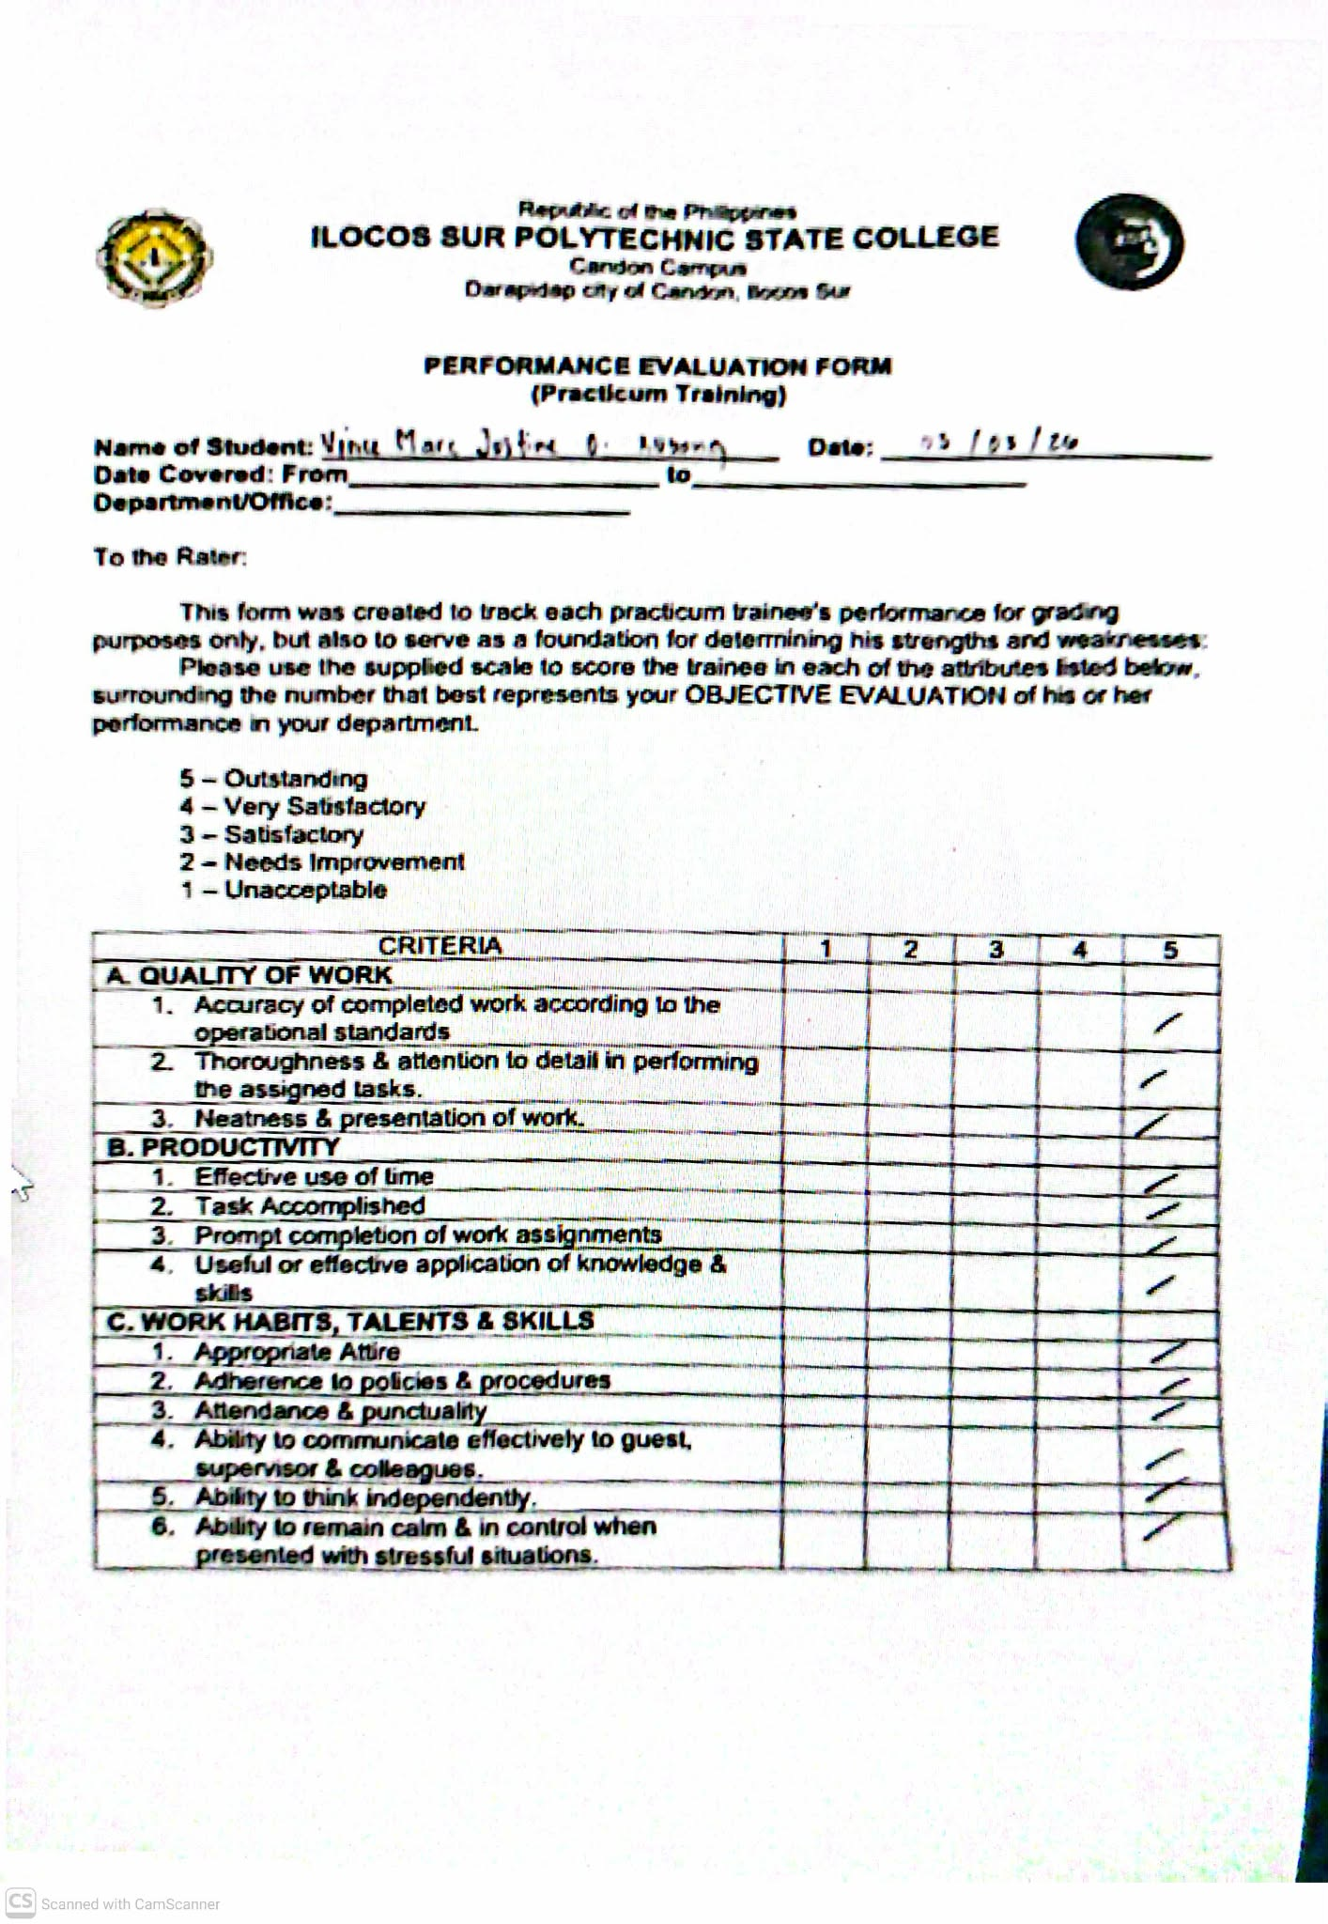
Performance Evaluation Form

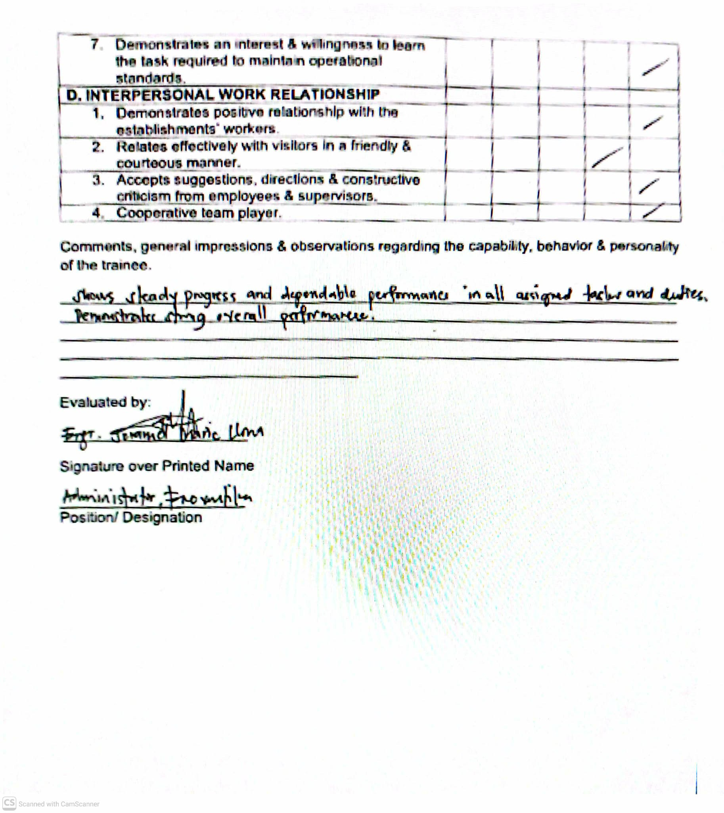

Appendix E
Daily Time Record (DTR)
Data recorded from company DTR system — Erovoutika Ph, Inc. Program: BSIT. Checked by: Edarlyn Deplomo, HIP Supervisor/Administrator.
Date | Time IN | Time OUT | Hours | Activity
January 28, 2026 | 3:03 PM | 6:00 PM | 3 | OJT Orientation
January 29, 2026 | 9:01 AM | 6:01 PM | 8 | Mockup – Erovoutika Revamp; Cloud Storage & Networking Module
January 30, 2026 | 9:01 AM | 6:01 PM | 8 | Mockup Progress; Tentative Diagrams for Revamp
January 31, 2026 | 9:01 AM | 6:01 PM | 8 | EIRA/ROBOLUTION Mockup; Robotics Schools Compilation; Video Editing
February 1, 2026 | 9:00 AM | 6:01 PM | 8 | EIRA/ROBOLUTION Mockup Progress
February 4, 2026 | 9:00 AM | 6:01 PM | 8 | Cloud Computing PPT Modules; Webinar Outline Proposals
February 5, 2026 | 9:00 AM | 6:01 PM | 8 | Sample Website Deployment (GitHub/Vercel); Git Essentials
February 6, 2026 | 9:00 AM | 6:01 PM | 8 | Mockup Progress; Git Started Webinar Attendance
February 7, 2026 | 9:00 AM | 6:00 PM | 8 | Mockup Progress; Fibonacci Exam Answer Keys (60 items)
February 8, 2026 | 9:00 AM | 6:01 PM | 8 | Erovoutika Revamp Mockup Progress
February 11, 2026 | 9:00 AM | 6:01 PM | 8 | Mockup Progress; Erovoutika Shop Grand Opening Poster
February 12, 2026 | 9:00 AM | 6:01 PM | 8 | Sprint 1: Landing Page Completed
February 13, 2026 | 9:00 AM | 6:05 PM | 8 | Landing Page Mobile View
February 14, 2026 | 9:00 AM | 6:05 PM | 8 | Admin Dashboard Core System Implementation
February 15, 2026 | 9:00 AM | 6:05 PM | 8 | News & Updates CRUD with Scheduled Publishing
February 18, 2026 | 9:00 AM | 6:05 PM | 8 | Awards Management System Integration
February 19, 2026 | 9:26 AM | 6:26 PM | 8 | Partners Management (Industry & Academe) System
February 20, 2026 | 9:00 AM | 6:00 PM | 8 | Contact Form with Database Integration
February 21, 2026 | 9:00 AM | 6:00 PM | 8 | Multi-Language System (50+ Languages) with Toggle
February 22, 2026 | 9:00 AM | 6:00 PM | 8 | Google Cloud Translation API Integration
February 23, 2026 | 9:00 AM | 6:00 PM | 8 | IoT Smart Farming: Soil Moisture Sensor Testing
February 24, 2026 | 9:00 AM | 6:00 PM | 8 | IoT Smart Farming: Sensor, Relay, and Pump Testing
February 25, 2026 | 9:00 AM | 6:00 PM | 8 | IoT Smart Farming: Final Testing
February 26, 2026 | 9:00 AM | 6:00 PM | 8 | Erovoutika Revamp: Card Placements
February 27, 2026 | 9:01 AM | 6:02 PM | 8 | Dark Mode Implementation
February 28, 2026 | 9:03 AM | 6:26 PM | 8 | ROBOcrabs Bug Finding
March 1, 2026 | 9:02 AM | 6:01 PM | 8 | Applying Transitions
March 2, 2026 | 9:02 AM | 6:01 PM | 8 | Finalizing Front End; Fixed Mobile Responsiveness
March 3, 2026 | 9:30 AM | 5:00 PM | 7 | Final Requirements Submitted; Passed Robotics Certification Exam
GRAND TOTAL |  |  | 220 hrs

Appendix F
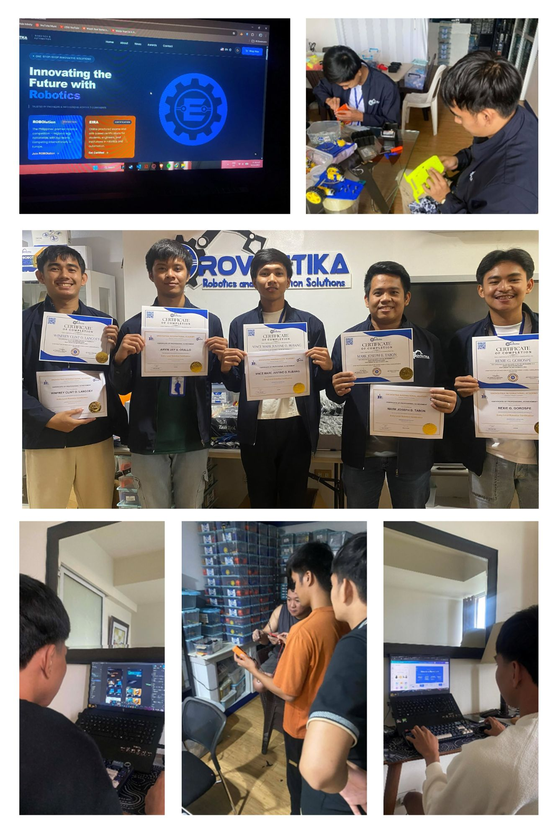
Photo Documentation

