**SQL LIBRARY PROJECT DESIGN DOCUMENT**

1. **Design Decisions:**

* For this project, the decisions were taken carefully reviewing the document given for the SQL Library project
* There are 6 Database table created
* The tables used are as follows:
  + Booktable (isbn10 as primary key)
  + Authors (author_id as primary key)
  + Book_authors (author_id and isbn as primary key)
  + Book_loans (loan_id as primary key)
  + Borrower (card_id as primary key)
  + Fines (loan_id as primary key)
* The database was created using MySQL and data were imported using import statements in MySQL to import data from CSV given. For example:

LOAD DATA LOCAL INFILE 'C:\\Users\\avinash\\Documents\\2SemTexts\\DBDesign\\Project1\\books.csv' INTO TABLE booktable FIELDS TERMINATED BY '\t' OPTIONALLY ENCLOSED BY '"' LINES TERMINATED BY '\n';

* The fields card_id, loan_id, author_id are auto incremented
* Apart from the schema given in the document, following were the columns added for additional designs
  + Deleted in book_loans table as int
  + Availability in booktable as int
* For UI, the code is written in HTML, CSS, JQUERY and PHP Languages.
* Decided to use PHP as server side language and HTML, AJAX and JQuery for Client side
* Using Apache server locally for connection
* An extra feature has been added where one can check in multiple books at the same time
* Similarly one can pay fines for multiple books at the same time

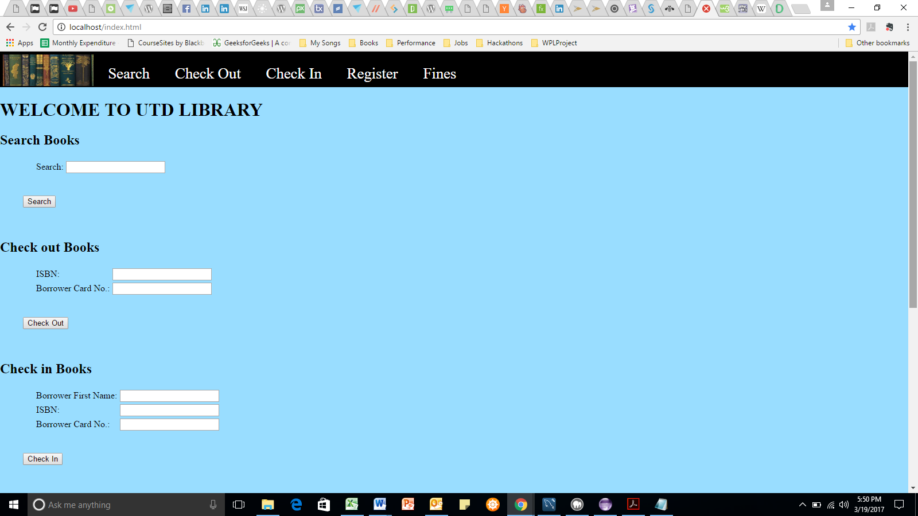

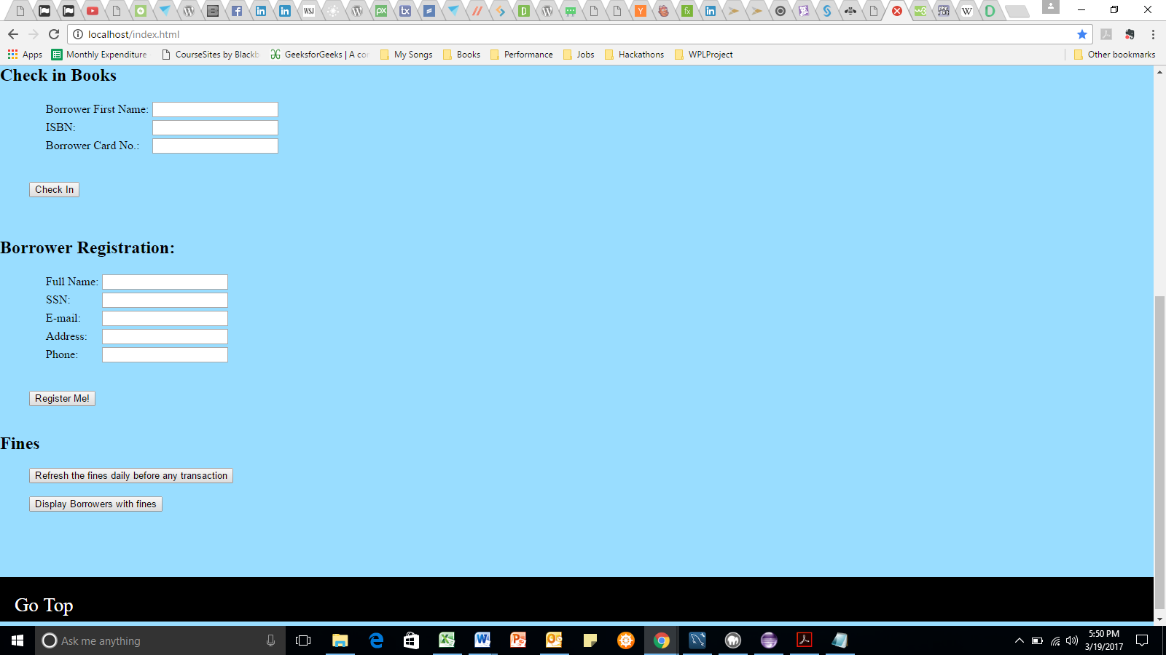

1. **Assumptions:**

* The refresh button for fines has to be pressed before any transaction takes place for the day
* For Borrower registration, all fields are required and hence all should be entered
* For field’s isbn10, isbn the value should be entered like ‘1234567890’ of 10 digits only can be entered.
* For field ssn the value entered should be as ‘123-45-6789’ of 9 digits with dashes in between as shown
* For field Full name in registration, first and last name to be entered
* For field phone, the value entered should be as ‘123-456-7890’
* For field e-mail, the value entered should be as ‘abc@gmail.com’ or ‘abc@hmail.in’
* For check in, any one of fields like any part of borrower name, card id or isbn can be entered to know the books that are to be checked in
* User has to enter some value for getting the results