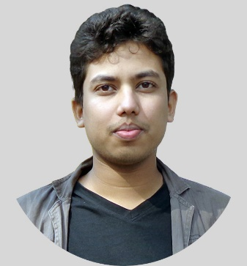

Raghib Shahriyer

**Web Designer & Developer**

Phone: +8801638414864| Email: vcshahriyer@gmail.com | Website: https://vcshahriyer.github.io/Portfolio/

Address: DIT-10, House-24, Dhaka.

|  |  |  |
| --- | --- | --- |
|  | Experience |  |
|  |  |
| Fiverr • Level 1 seller • 2017 – Present  Web designer and developer at fiverr. Experienced with different types of clients, maintaining the good communication with the clients. ( https://www.fiverr.com/vcshahriyer)  Front-end Development • 2016 – Present  Learning through various online courses and online documentation. Several projects have been done for the practice and for the experience. (https://github.com/vcshahriyer)  Repositories (Custom_Omnifood, BrandLy.me , Wego-chem …)  Back-end Development • 2017 – Present  I have very clear understanding of programming structure and various language like structured C programming, OOP C++, basic PYTHON 3, PHP 6-7, OOP PHP. I can customize CMS like WordPress and WordPress theme. Clear understanding of Relational Database. (https://github.com/vcshahriyer) | | |

Repositories (bootstrap-to-wordpress, BasicCRUD , …)

|  |  |  |
| --- | --- | --- |
|  | Education |  |
|  |  |
| SSC  Sherpur govt. victoria academy  2012 | HSC  Sherpur govt. college  2014 | BSC (CSE)  East West University  2019 |

|  |  |  |
| --- | --- | --- |
|  | Key Skills |  |
|  |  |
| Professional  HTML5  CSS  PHP  JavaScript  Bootstrap | Related  Team work  Communication  Problem Solving | Personal  Ambition  Creative  Confidence  Dedication |