EE-193 Special Topics: Thread-Based Device Fabrication
Student: Victor Dinh
Supervisors: Dr. Sameer Sonkusale, Dr. Hojat Rezaei

Introduction
This study is conducted in order to find a solution to the mass-production of thread-based sensors. Assembly line manufacturing processes, feedback control systems, and ovenmaking methods are the three subtopics of study. By the end of this study, a low-cost thread-based sensor fabrication machine will be completed and ready for use.

Background and Significance
As the medical field becomes more dependent on big data-driven solutions, doctors have increasingly demanded for more patient data. Having more data allows doctors to continuously monitor a patient’s health – even when the patient leaves the hospital. The extra information helps the doctor more accurately prescribe prevention strategies and treatment for physical maladies. Data can come in the form of glucose, pH, stress, strain, pressure, and temperature levels inside the body. For example, if doctors wanted to monitor the tissue health of a soldier’s flesh wound, they would depend on information about the tissue’s stress and strain levels. But how can such data be collected?

Thread-based sensors are an emerging data collection solution. These sensors are made by dipping an ordinary piece of thread into a special ink that can detect chemical and physical variables (such as pH and pressure). These coated threads, which can be woven into bandages and wraps, can then be integrated into electronic circuits that send the data to a computer.

The current method of producing these sensors involves a strictly handmade process; a short piece of thread is dipped into the ink, homogenized, and dried with a heat gun. While effective for fine-tuning and tweaking the sensors, this method takes a relatively long time to execute. Due to the intricacy of bandage weaves and electronic circuitry, a great length of these thread-based sensors will be needed. Thus, it is necessary to easily develop many of these threads in a relatively short period of time. This study is focused on building and implementing a solution to achieve such a goal.

Sources
http://now.tufts.edu/news-releases/researchers-invent-smart-thread-collects-diagnostic-data-when-sutured-tissue

Product Overview
The thread factory contains four primary subsections: the inker, heater/dryer, collector, and Arduino control. These subsections allow the factory to take a spool of cotton thread and turn it into an electrochemical sensor.
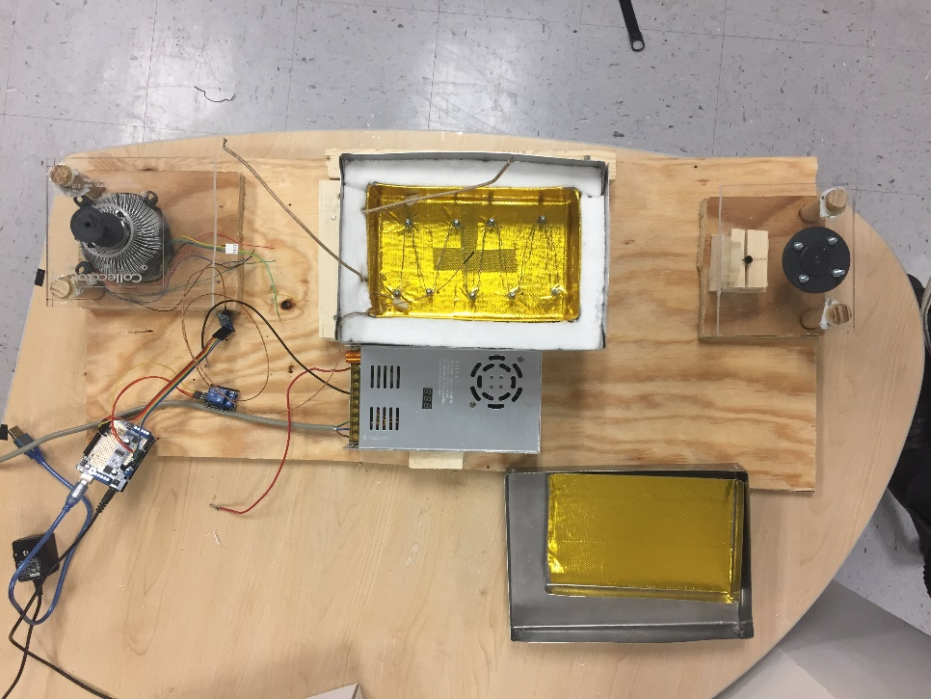
Functional Requirements
The thread factory should be able to take an ordinary spool of thread and turn it into a spool of sensing thread. The inker should be able to uniformly coat the thread with ink as well as store the ink when the machine is not in use. The heater should dry the thread and ensure that no liquid dye is left over. Finally, the collector should collect all the thread around an empty spool.

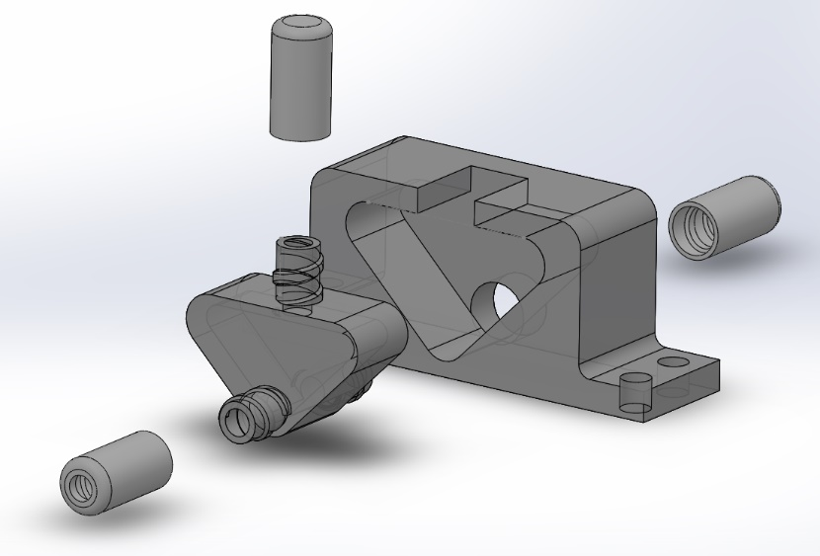
- The inker:
  - Holds about 25mL of ink
  - Thread passes through bottom channel to be coated in ink
  - Thread passes through PDMS layer as it leaves the cartridge
    - Layer squeezes out excessive ink
  - Cartridge can be capped to retain and prevent evaporation of ink
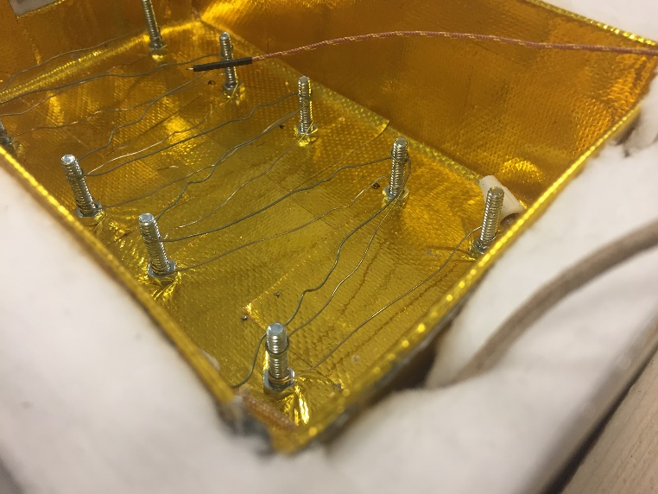
- The heater/dryer:
  - The heater is an oven that dries the ink on the thread.
    - The thread is passed through a hole on one side of the oven and comes out the other
    - The thread is dried by convection. The heat coming from the nichrome wires placed at the bottom of the oven rises and warms the thread
  - A thermocouple measures the temperature inside the oven and relays the information to an Arduino, which maintains the temperature inside the oven by controlling the amount of time that current can pass through the nichrome wires

- The collector:
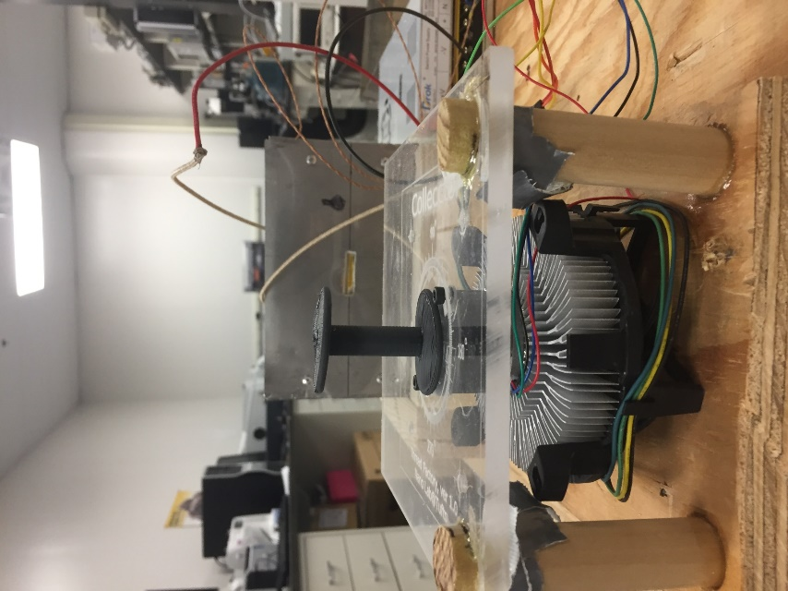
  - The collector is a stepper motor connected to a spool that pulls the thread through the factory
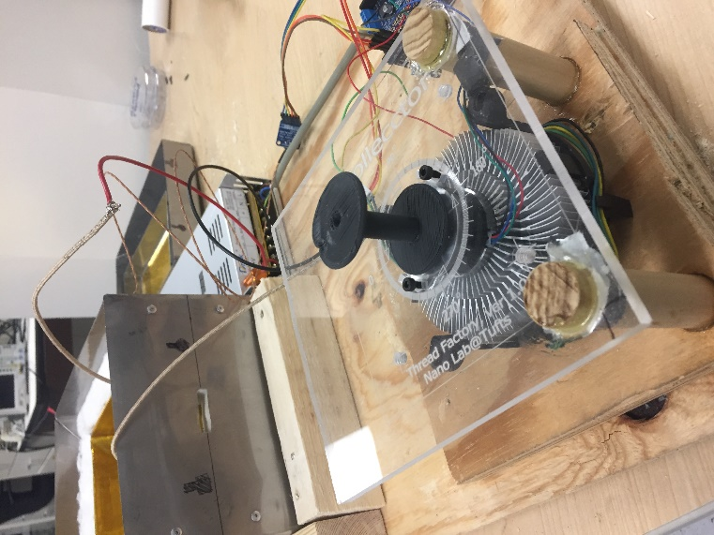
  - The electrochemical sensing thread is also collected around the spool
  - The stepper motor speed is set by the Arduino
  - A CPU heatsink and cooling fan are attached to the bottom of the motor to cool it down and maintain optimum stepper motor performance
- Arduino control:
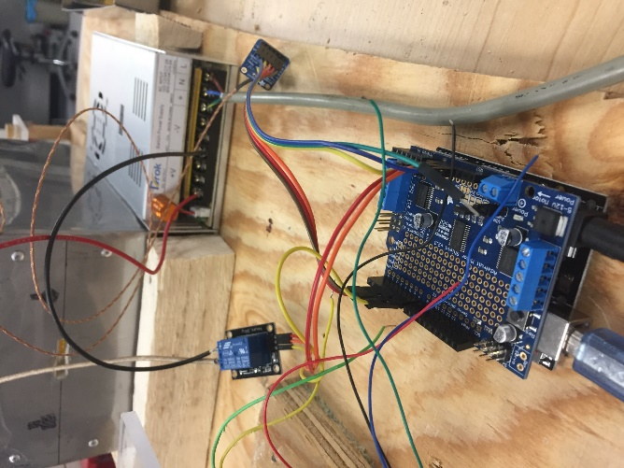
  - Controls the speed of the collector (and subsequently the speed of the entire process)
  - Processes input from the thermocouple
  - Maintains a set temperature inside the oven by regulating the duration of current flow through the nichrome wires
  - Code can be altered to change the temperature of the oven as well as the speed of the motor

Instructions
- Place spool of thread onto the spool holder.
- Thread a needle
- Pass the needle through the inker by pushing it through the PDMS layers
- Remove the lids of the oven
- Pull the needle through the input and output of the oven (slits in the sides)
- Remove the needle and secure the end of the thread to the collector
- Inject ink into the inker
- Initiate the machine by plugging in all power cables (Arduino, power supply)

