SSIP Hackathon 2022

Gram/Taluka Panchayat Website

Team Registration Number:- TM001323

Problem ID:- PID 419

By

**Team Member’s Name Enrollment No.**

Thakar Krutarth B. 210830131507

Vaja Manav P. 210830131508

Dave Vandan M. 210830131512

Under The Guidance of

Prof. Punit K. Mendpara

Computer Science & Engineering

(Dr. Subhash Technical Campus,Junagadh.)



# ABSTRACT

A Website Where DDO Office & Gram/Taluka Panchayat Staff Connect with Public and Share Some Relevant Information to Public Via this website. The information includes Latest Updates, DDO & Gram/Taluka Panchayat Staff Details, Services and Public can share their Opinion to DDO Office & Gram/Taluka Panchayat.

**Index**

|  |  |  |
| --- | --- | --- |
| **Sr.**  **No.** | **Content** | **Page**  **No.** |
| 1 | Abstract | 2 |
| 2 | Chapter-1 Introduction | 5 |
| 3 | Chapter-2 Module | 7 |
| 4 | Chapter-3 Flow Diagrams | 8 |
| 5 | Chapter-4 Screenshot of Solutions | 11 |
| 6 | Chapter-5 Conclusion | 13 |
|  |  |  |

**Table Of Content**

**Chapter No Topic Name Page No.**

**Chapter-1 Introduction 5**

1.1 Definition & Title 6

1.2 Aim & Purpose 6

1.3 Domain Selection 6

& Observation

**Chapter-2 Module** **7**

**Chapter-3 Flow Diagrams 8**  3.1 Flow Diagram-1 9

3.2 Flow Diagram-2 10

**Chapter-4 Screenshot of Solution 11**

**Chapter-5 Conclusion 13**

**Chapter-1**

**Introduction**

* 1. Definition & Title
  2. Aim & Purpose
  3. Domain Selection and Observation
  4. **Definition & Title**

A Website Where DDO Office & Gram/Taluka Panchayat Staff Connect with Public and Share Some Relevant Information to Public Via this website. The information includes Latest Updates, DDO & Gram/Taluka Panchayat Staff Details, Services and Public can share their Opinion to DDO Office & Gram/Taluka Panchayat.

**Project Title:** Gram/Taluka Panchayat Website

* 1. **Aim & Purpose of Project**

**Aim:** This system has main aim is to Provide Information about Gram/Taluka Panchayat’s Details of Staff, Services and Related Information.

**Purpose:** People can Easily Gate Information about Gram/Taluka Panchayat Office and Services

**1.3 Domain Selection and Observation**

* + - It is powerful enough to be at the core of biggest blogging system on the web.
    - PHP file can contain TEXT, HTML, CSS,JAVA SCRIPT and PHP code.
    - PHP code are executed on the server and the result is returned to the browser as plain HTML.
    - PHP file have extension “.PHP”.**Platform**

**Chapter-2**

**Module**

Module -1: - A website where DDO office & gram/taluka panchayat staff connect with public and share some relevant information to public via this website. The information includes “Jahannam”, DDO & gram/taluka panchayat staff details, services and public can share their opinion to DDO office & gram/taluka panchayat.

Module – 2: - There is panchayat, rural housing & Rural Development Department Website which represent overall panchayat and state government schemes and Information for panchayat and public but it is Represent overall state

We can Develop website which can the only particular DDO Office & gram/taluka panchayat to more easily aware the public and all access DDO office.

Module – 3: - We are analyzing overall system of DDO & gram/taluka panchayat and resolve their problems they facing

**Chapter-3**

**Flow Diagrams**

3.1 Flow Diagram - 1

3.2 Flow Diagram - 2

**3.1 Flow Diagram-1**

* **Brainstorming Session:** A group problem-solving technique that involves the spontaneous contribution of ideas from all members of the group. conducted several brainstorming sessions. also: the mulling over of ideas by one or more individuals to devise or find a solution to a problem.
* **Analyzing System:** The process of studying a procedure or [business](https://en.wikipedia.org/wiki/Business) to identify its goal and purposes and create [systems](https://en.wikipedia.org/wiki/System) and procedures that will efficiently achieve them".
* **Research:** Research is defined as the creation of new knowledge and/or the use of existing knowledge in a new and creative way to generate new concepts, methodologies, and understandings.
* **Prototyping Model:** The prototyping model is a systems development method in which a prototype is built, tested, and then reworked as necessary until an acceptable outcome is achieved from which the complete system or product can be developed.

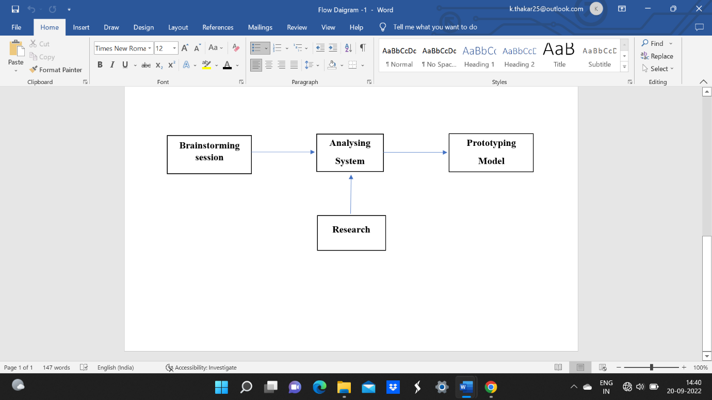

**3.2 Flow Diagram-2**

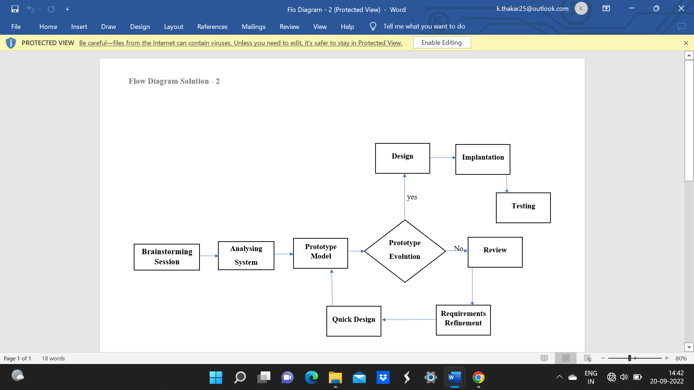

**Chapter-4**

**Screenshot of Solutions**

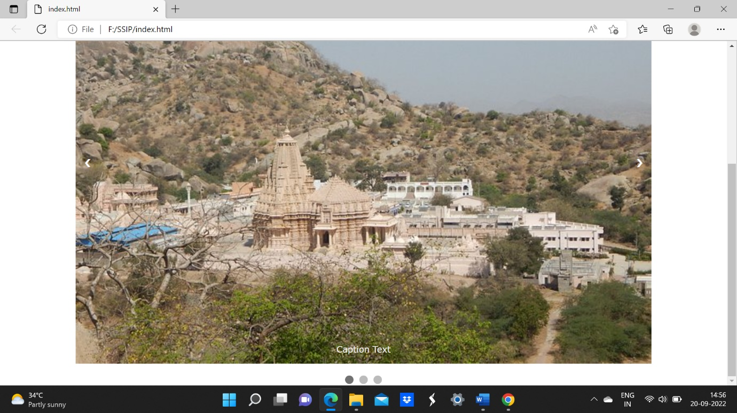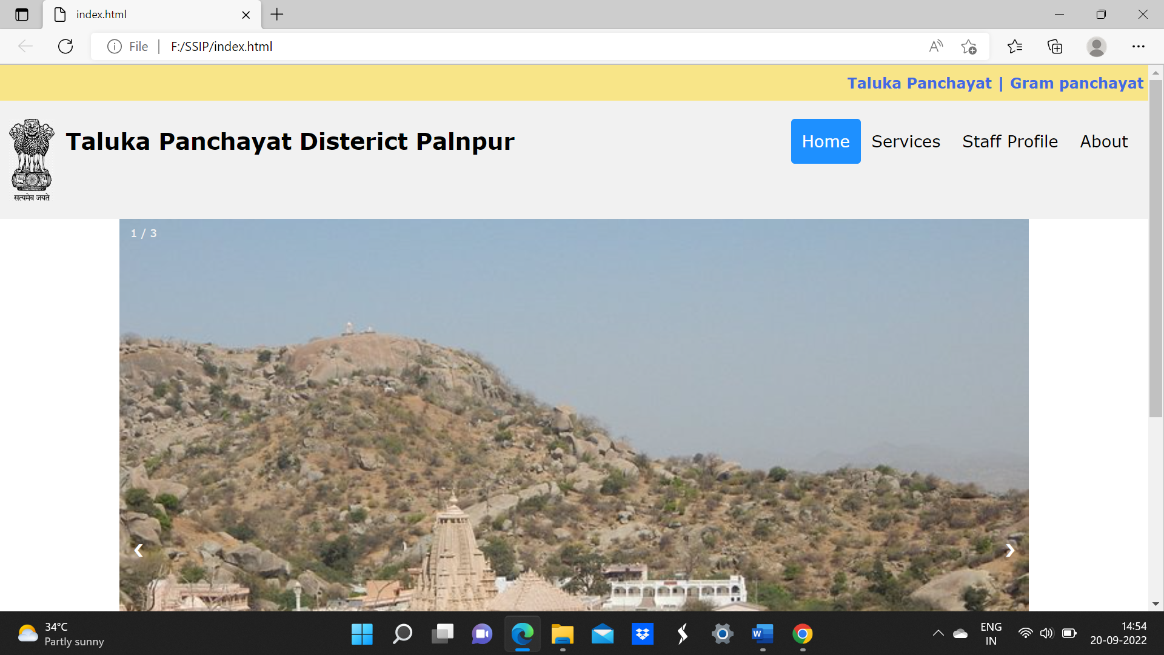

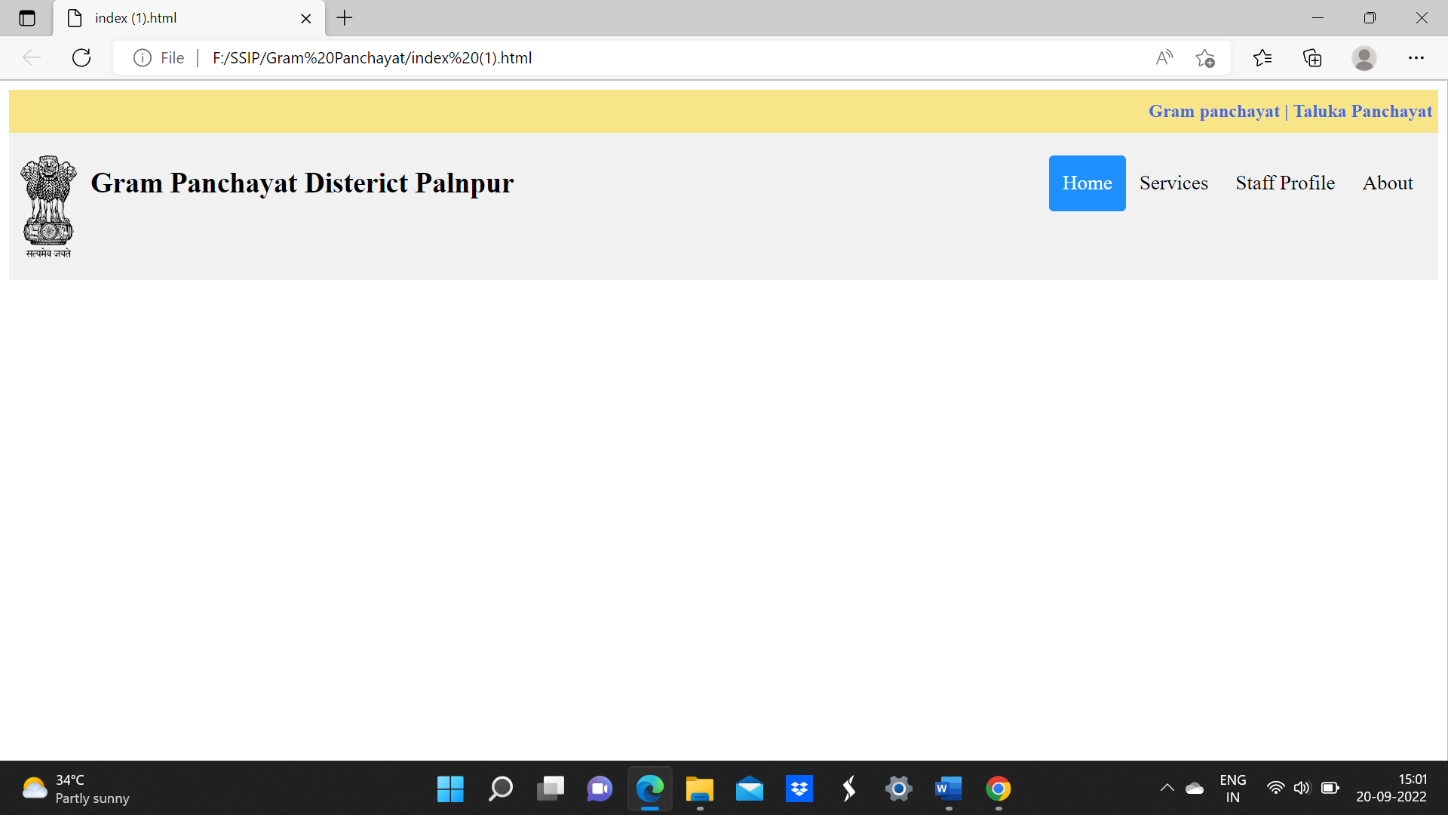

**Chapter-5**

**Conclusion**

Our Main Aim is to Provide An e-portal or Website for Gram/Taluka Panchayat for People, DDO Office Staff, Gram Panchayat Office staff.

With help of Website People See the Information and Services about Gram/Taluka Panchayat.