E-Commerce Order Fulfilment Dashboard

Problem Statement -: An e-commerce company wants to monitor order delivery performance and reduce delays.

Objective -: The main objectives of this dashboard is to analyze Delays and order trends . This project helps to understand order trends and Delay analysis.

Purpose / Client requirements - :
The client requirements are as follows:
Create Delivery Time (Days) column
- On-time vs Delayed orders
- Region-wise delay analysis
- KPI cards:
  - Total Orders
  - On-time Delivery %
  - Avg Delivery Time
- Line chart for order trend
- Slicers: Region, Category
Dashboard-:
- “Region wise delay analysis” Chart is Stacked Bar Chart which is created using Region column and Delay column. The Delay column is created using DAX query. This chart shows the region wise delays. The West region having more Delays as campare to other.

- “On time Region” Chart is a Donut Chart is created using Region column as legend and On-time column as values. This chart is used to show the on-time delivery regions.
- “Order trend” Chart is Line Chart is created using OrderDate column at X-axis and Order id column at Y-axis . This Chart shows the Count of Orders by month. It help to understand in which month how many Orders are delivered.
- “Amount by Category” Chart is Stacked Column Chart is Created using Product category as X-axis and Sales amount Column at Y-axis. This chart shows category wise Revenue. Fashion Category having highest Sales amount.
- There are some card on dashboard which are used to various data in short. Card are used to give quick overview of data. Total Amount: 2M, Total Orders: 200 On-Time Delivery Percentage: 54%, Average Delivery Time: 5m.
- This dashboard includes Two Slicer For Product Category and Another one is for Region. Slicer are helps to show dashboard as per the filter. Slicer makes reports more interactive and user-friendly.

Solved Problems -:
- Calculated On-Time vs Delayed Orders to understand Delay analysis.
- Analysed delay count by region to identify which region having more delayes.
- Created Amount by Category Analysis to track Category wise earnings.
- Designed KPI Cards to show important metrics like Total Amount, Total Orders, On-Time Delivery Percentage, Average Delivery Time.
- Applied Filters (Category and Region) to make the report interactive and easy to analyze.

Conclusion -:
The report helps in better understanding of E-Commerce Orders Data q in an easy and visual way. It shows important insights like Orders Delay, On-Time Delivery and revenue clearly. The dashboard helps to identify which category are performing well and which need improvement.

Dashboard Photos -:
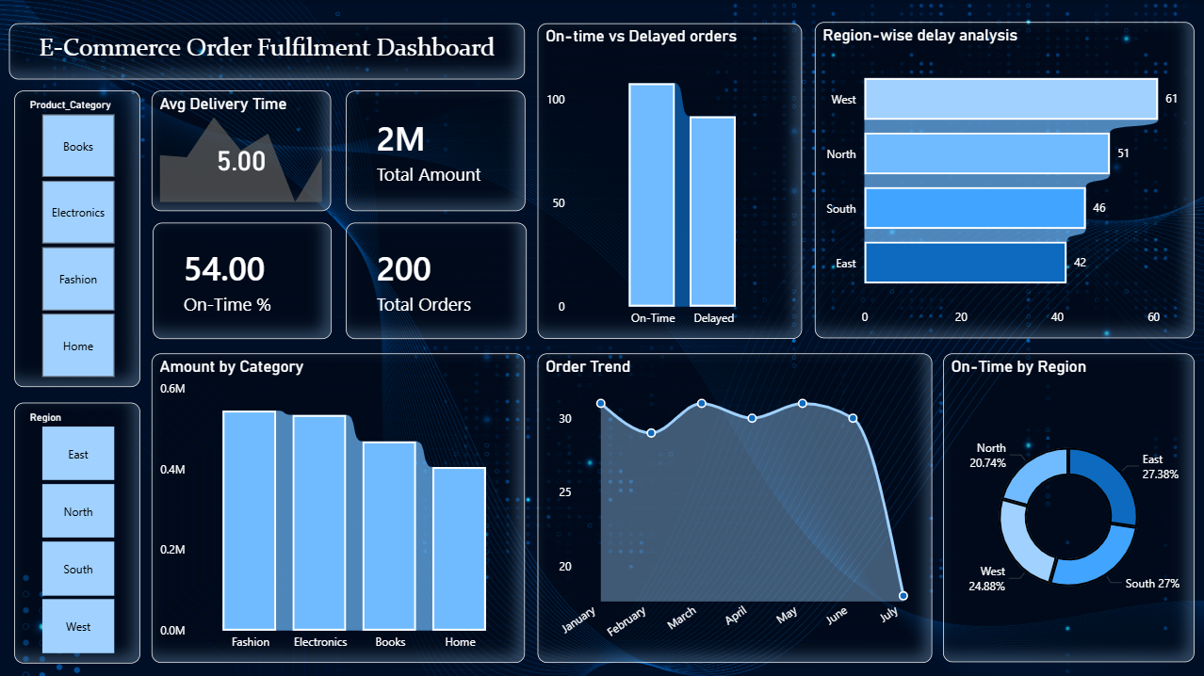

Name -: Vishal Vishwas Desai

