Dataset: ape.tre
Tools: d3.js and R Studio
The data consists of a collection of 101 phylogenetic trees including branch length, in NEXUS format. There are 10 different branch length per state and tip label of 6 species.
- Design

The first design I thought of was a punch-card visualization. I wanted to
represent together species per edge length across the different states of the tree.
The circles would represent each specie and moving the mouse through a dot the specific
number (bootstrap value) of the state could be seen. Each quality would have a
different color to make it more visual. When trying this design out two basic
difficulties were found: first, the struggles to implement the code and second, it did
not seem the appropriate and effective visualization that allowed realizing the
disparities between the categories or the different species.

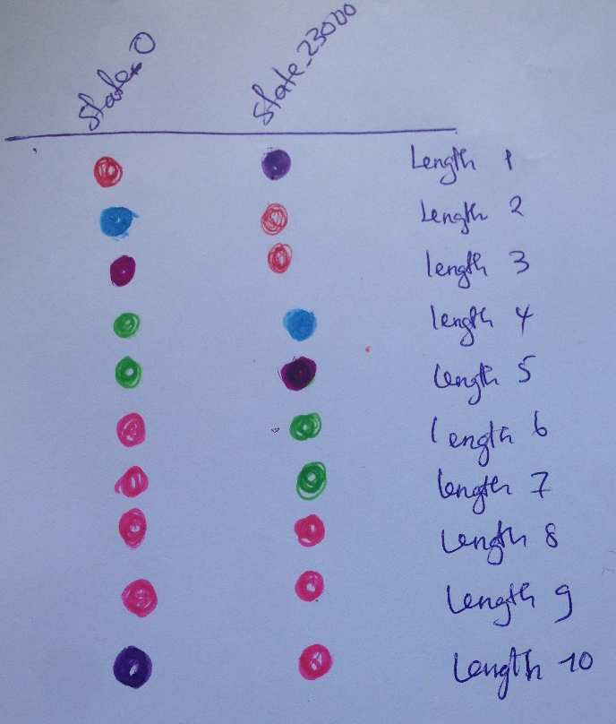
Here we can see that at some length along the tree state_0 and state_23000 belong to the same specie

Specie colors
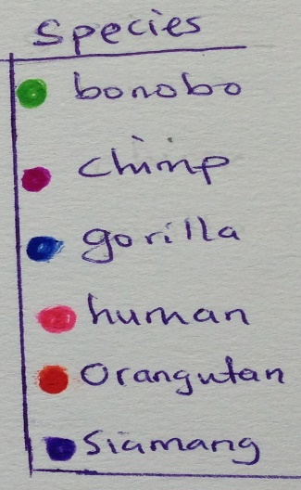

Figure 1: Graph showing difference and similarity between state_0 and state_23000

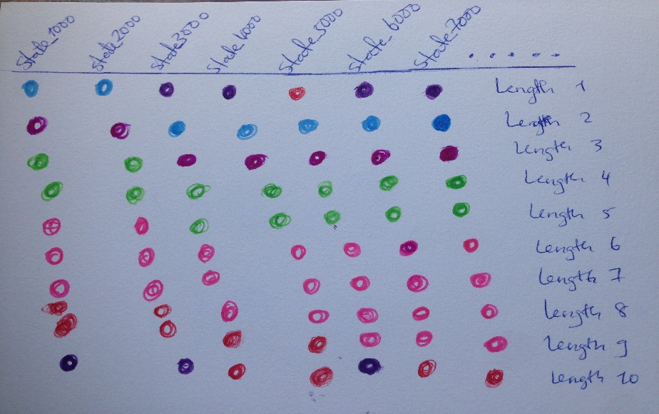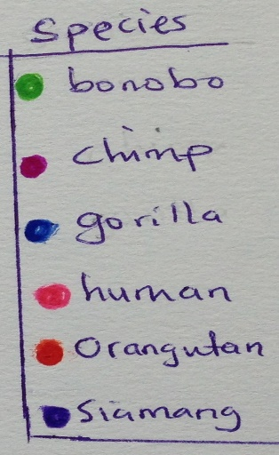

Figure 2: showing the similarities and differences between each state

The second design I tried out was a multiple pie chart representation. In this case I
was thinking about a static illustration of the data. The principal idea was to represent each state per chart. Each pie chart would be divided into different specie region denoted by different colors and the portion sizes, according to the edge length of the specie tree(branch). Once again, it looked like the visualization did not clearly permit the contrast between the species. It seemed more a suitable method to show the species categories individually. I would consider it a nice approach if the idea was designing a poster or advertising panel of the species.

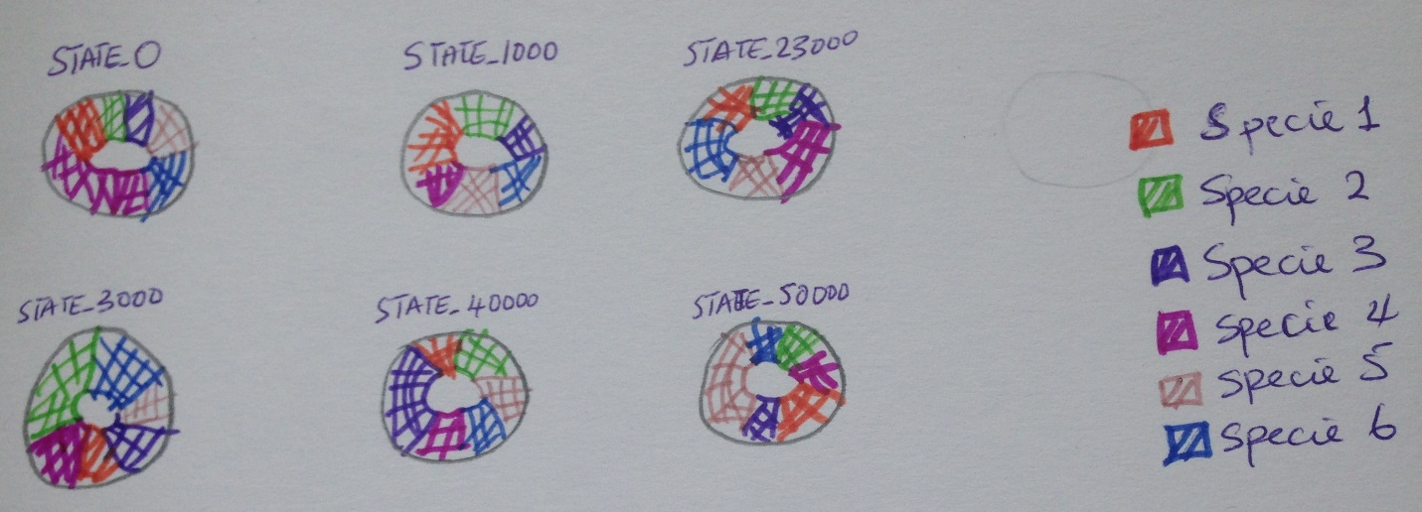

Figure 3: Multiple pie chart of different states

2. Implementation

My final design was parallel Coordinates. Parallel coordinates are a visualization technique used to plot individual data elements across many dimensions. Each of the dimensions corresponds to a vertical axis and each data element is displayed as a series of connected points along the dimensions/axes. The motivation for using this design was such that each state can be visualized across all the different lengths and compared. The different colors of the lines represent the species to which the state belong. The plot of figure 3 showing the difference between state_0 and state_2330 clearly represent the data in such a way that we can see that they don’t belong to the same cluster.

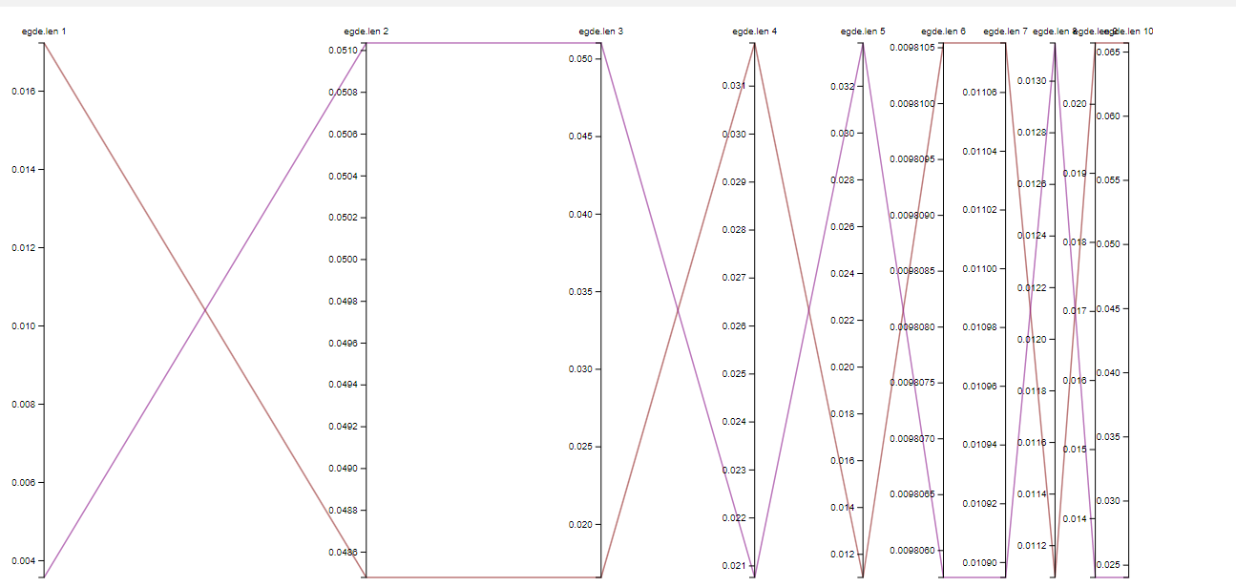

Figure 4: Parallel coordinates of state_0 and state_23000

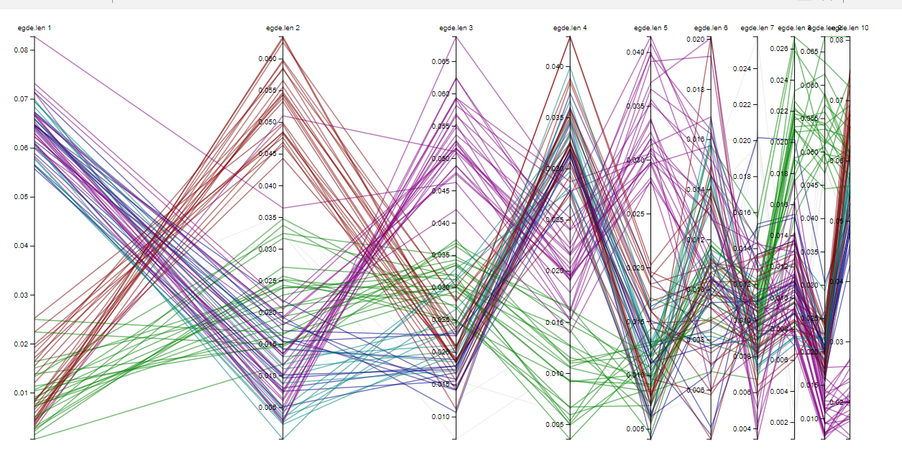
Figure 4: Parallel coordinates of all states
- Insights

The patterns that can be developed from this design is that each line connects all the values (edge length) and defines an area for the same category. Thus, each area represents in this design a single state position whose shape and dimension are determined by the values of the variables plotted in the axes. Each state has a color to permit an easy, fast and clear differentiation of the diverse states in the tree. The dynamical qualities of the design let change the opacity of the different areas when moving the mouse over them, hence we can compare the different state across all length and visualize the different clusters presented with different colors to tell how many clusters are there. In this case for example, it can be observed that there are 6 colors which implies the 6 species and the number of states in each cluster varies between clusters but is the same across the different length. These features allow a clear and visual mode of understanding the data.

- Screencast
https://www.youtube.com/watch?v=SYObymqEgW4

