Colton Gowan
R0643868
Data-Omics
Part 1: Comparing all 101 trees
Design 1.1 : Proportional Terminal Graphs
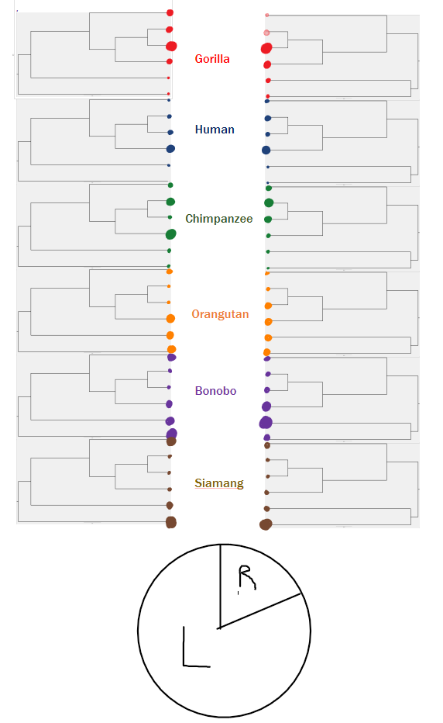
This design visualizes the two most prominent tree structures found in the 101 trees. It imparts knowledge of the proportions each organism occupies a specific leaflet. For instance, you can easily see how often each organism occupies the outer branches compared to the inner, connected branches. This graph requires a separate representation of each organism, so the total number of graphs is (# of organisms * # of tree structures). In this dataset, only two structures were especially prominent so it is rather simple to view each of them. Additionally, with two structures, you can easily compare the differences in spots and how the structure is likely to change the proportions. The prominence of each structure in this case is represented by a pie chart to show how many of the trees in the total dataset are of the left form compared to the right form. The main drawbacks of this method is that you lose information about branch distances.

Design 1.2 : Forest topography graph

This visualization aims to show the distribution of the 6 factorial potential trees ( each organism can potentially occupy 1 of 6 spots ). This results in a theoretical 720 trees per structure. Each square would represent a specific ordering of organisms on leaflets and each dot would represent an occurrence of tht order. The main difficulty would be to decide how to order these potential trees in a meaningful way. Assuming a system to order these potential trees, a visualization like this may be produced. Here, both structures are shown in one of two colors (red and black). The idea is that we can simultaneously visualize the quantity and density of each structure. Ideally, we can see that the different structures have trees that occupy different squares with varying densities and different clustering patterns. Which may allow us to infer that depending on the relationships/structure that organisms are likely to be related in qualitatively and quantitatively different ways. So the left structure (as in the previous design explanation) has a higher density in the 7th square, whereas the right(red) structure has a shifted clustering pattern and square with the highest number of matches.

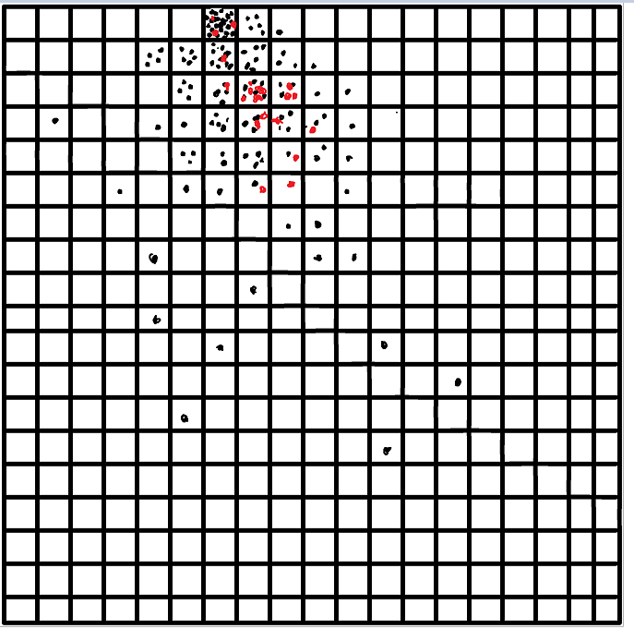

Design 3 : Planetary Tree Graph

This design implements concepts from both the previous designs and has an interactive component. It condenses the first design into a single tree for each structure and aligns the circles at each leaflet, which still represents the proportion of the time that each organism occupies each leaflet. The concept of density and popularity of each graph in the dataset is captured in the bar above the trees. In this design, each of the colors/organisms is side-by-side to show the rank and proportion that each spot is occupied. The interactive portion would operate as follows ; First you would select which tree you would like more information on, then you could click a bar that has two components, blocks with size and color gradient. Both size/intensity of color would represent how common each of the representations is. So clicking the left/darkest block would show the most common representation. Each representation is illustrated by filling in hollow circles. When you select the representation of your choice, the colors representing the organisms at each leaflet is filled in. In the following example, we have selected the left structure and the 2nd most common representation, which shows us that swapping the positions of Human and Bonobo is the most common change in relationship in this dataset from the most common form. Moving the cursor down the gradient would therefore show less and less common variants of the distribution and give the user a sense of the patterns that emerge when examining these trees, when in this order.

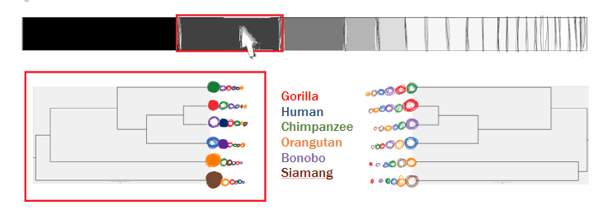

Part 2 : Comparing two trees

Design 2.1 : Metered Jawbreaker Comparison

This design has no loss of information and displays the values for the node labels while showing relationships. The center rectangle shows the node values for each of the two trees so direct comparisons can be made. If colors corresponding to organisms fill the same regions, like chimp and bonobo or siamang and orangutan, then they are both part of terminal branches. White spaces mean they are part of separate nodes. The relative sizes of the circles show the total distance represented in each tree, so we can see that the left-hand tree has a longer overall distance, and we can see by how much.

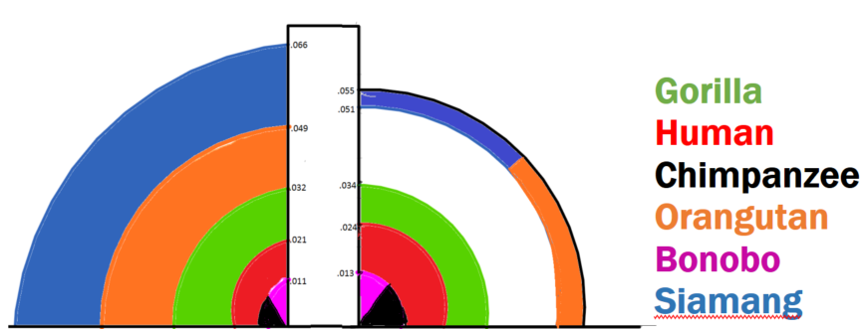

Design 2.2 : Matchbox Comparison

This design focuses on explicitly showing the information of relationships that are shared and the differences in distance within this shared region. In the teal box, the structure that is shared is shown. The colored bars on the tree and to the side represent the relative differences in length of the nodes for the organisms in the shared region. We can see the difference in distance for the bonobo and human is roughly 2/3 that of the distance for gorilla. Below, we can see the explicit difference in tree structure for where this matched box fits into the tree structure. If there were additional shared structures, they could be represented with another colored box in the top row and similarly placed in the trees to be compared below. This visualization gives an in-depth view of the shared regions, but does not show as much information for the regions with differences.

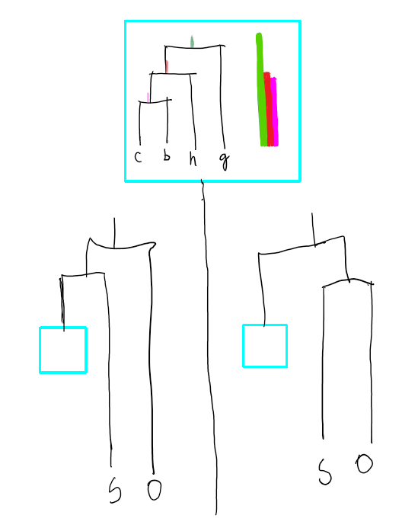

Design 2.3 : Pyramid Comparison
This design is similar to the other two in that it shows the data to scale and shows the relationships between the similarity and differences between the two trees. Each face of a triangle represents organisms on the same node, so the teal face of a pyramid on the right hand represents a separate node that is part of the tree. The red lines represent identical structures which are drawn to scale to show the differences with the eye as well as a meter to check actual values. This visualization shows the reason for the shorter distance better; the teal face on the right does not add to the height of the pyramid. The differences of the similar regions shown as a bar plot was added to this plot, as that information is useful and interesting.

