Car management application

Bundeskriminalamt - Oracle IAM Projekt

Author: <user>

Creation Date: November 29, 2018

Last Updated:  April 14, 2020

Document Ref:  <Document Reference Number>

Version: DRAFT 1a

**Approvals:**

|  |  |
| --- | --- |
| <Approver 1> |  |
| <Approver 2> |  |

# Document Control

## Change Record

1

| Date | Author | Version | Change Reference |
| --- | --- | --- | --- |
| 09-April-20 | Sylvert BERNET | Draft 1a | Initialization - Copied from previous document to use new template. |
|  |  |  |  |
|  |  |  |  |
|  |  |  |  |

## Reviewers

| Name | Position |
| --- | --- |
|  |  |
|  |  |
|  |  |
|  |  |

Contents

1 Document Control i

1.1 Change Record i

1.2 Reviewers i

2 Introduction 1

2.1 Scope and Purpose 1

2.2 Related Documents 1

3 Fonctionnal Scenarios 1

3.1 User roles 1

3.2 End-users scenarios 1

3.3 Front-desk employee scenarios (need to talk about it) 4

3.4 Admin scenarios 4

4 Car management application 7

4.1 Home Page 7

4.2 Page Design – Manage Car 8

4.3 Page Design – Report Vehicule 8

5 Appendix A – Car MANAGEMENT dATA Model 8

# Introduction

## Scope and Purpose

For security purpose, parked cars within company area need to be identified by front desk employees.

This document details the functional and technical specifications for specifications for the car management process.

Before describing the technical part, every end-user scenario will be covered. These scenarios will allow to identify the roles of every users type and how the car management can be integrated into the “Self-service applications” (for more information on this web application, please read the associated specification).

Finally, this document describes how the application car management will make possible the orchestration of all scenarios from a technical point of view. (Data model for this application can be found at the end of his document on **appendix XXX – Car Management data model**)

## Related Documents

The car management application is managed by the “**self-service applications**”. The specification for this application is available on the document “**XXX**”

# Fonctionnal Scenarios

## User roles

Three actors take part of the car management process:

* **End-user**: His role consists in entering information about his vehicle(s) in order to park safely within the company area. He can add a new vehicle, modify a vehicle or remove.
* **Employee front desk**: His role consists in checking car employee by having the list of all vehicle. He can consult at any time a car in order to see if a parked car within company area are valid.
* **Administrator**: His role consists in managing car employee. He can consult, remove any car in his scope.

## End-users scenarios

2 type of operation is allowed for active end-users:

**Create a car:**

1-a Insert Plate Number

1-b Check:

- Vehicle already exists

- Car plate restriction

2-a Choose Type

2-b Provide available vendor according to type

2-b Chose Vendor

2-c Chose Color

3 Insert Driver = Creator*

By accessing to car management application, user can create a new vehicle. User must fill out the following information by order:

1. First, the user must enter car plate number. By entering the car plate number, some validations are carried out:
   1. Checks if another vehicle with the same car plate number already exists in the system.
   2. Checks if the car plate number not contains a forbidden combination defined by the administrator.
2. Then, if validations check on the car plate number passed successfully, user can complete car information in the followings order:
   1. **Type of vehicle**: 4 types is available:
      1. Personal car (Personenkraftwagen)
      2. Motorcycles (Motorräder (Krad))
      3. Light motorcycles (Leichtkrafträder)
      4. Quad
   2. **Vendor:** according to the type of vehicle, user can choose out of a lookup of vendors.
   3. **Color:** Black, Blue, Green, Silver, Gray, Red, White, Yellow.
3. Finally, owner is automatically filled out with user identity

**Delete a vehicle**:

1-a Search a vehicle

1-b Criteria:

* Car plate, vendor, type, color
* Own by the connected user

2 Select the car

3- Delete

By accessing to car management application, user can delete his own vehicles.

1. First, the user can search for a car by entering criteria like the car plate number, the vendor, the type or the vendor. Only his own vehicles are displayed.
2. When cars are found with the selected criteria, user car select the car.
3. Once the car is selected, user is able to delete the car.

**NB:**

* For saving and creating car information, user must complete all required information above.
* At any time, user can close the creation process.
* It is no mandatory to fill out criteria. By default, all vehicle own by the connected user will be displayed.

(Modify a vehicle ??)

**Inactive user**

User status = Inactive

Remove all car belonging to this user

When an user identity is changing the status to inactive, all vehicle belonging to this user is deleted automatically (no matter if inactivity is only for a limited time).

## Front-desk employee scenarios (need to talk about it)

1-a Search a vehicle

1-b Criteria:

* Car plate, vendor, type, color
* Own by the connected user

2 Select the car

3- See information

<TODO: Define if front desk employee can have access on the same application as end-user, or another application (BI repport ???) >

## Admin scenarios

Admin user roughly has the same process than end-users but different scope and different rights.

3 type of operation is allowed:

**Create a car:**

1-a Insert Plate Number

1-b Check:

- Vehicle already exists

- Car plate restriction

2-a Choose Type

2-b Provide available vendor according to type

2-b Chose Vendor

2-c Chose Color

3 Insert Driver by searching active identity.

By accessing to car management application, admin can create a new vehicle. Admin must fill out the following information by order:

1. First, the admin must enter car plate number. By entering the car plate number, some validations are carried out:
   1. Checks if another vehicle with the same car plate number already exists in the system.
   2. Checks if the car plate number not contains a forbidden combination defined by the administrator. (Does Admin can bypass restriction ???)
2. Then, if validations check on the car plate number passed successfully, user can complete car information in the followings order:
   1. **Type of vehicle**: 4 types is available:
      1. Personal car (Personenkraftwagen)
      2. Motorcycles (Motorräder (Krad))
      3. Light motorcycles (Leichtkrafträder)
      4. Quad
   2. **Vendor:** according to the type of vehicle, user can choose out of a lookup of vendors.
   3. **Color:** Black, Blue, Green, Silver, Gray, Red, White, Yellow.
3. Finally, admin must fill out an owner. Only active identity inside the scope of the admin user can be entered.

**Delete a vehicle**:

1-a Search a vehicle

1-b Criteria:

* Car plate, vendor, type, color, Identity
* In the scope of the connected user

2 Select the car

3- Delete

By accessing to car management application, admin user can delete his end-user vehicles.

1. First, the user can search for a car by entering criteria like the identity, the car plate number, the vendor, the type or the vendor. Only vehicles inside the scope the admin user are displayed (ie: users inside the scope of the admin).
2. When cars are found with the selected criteria, admin user select the car.
3. Once the car is selected, user is able to delete the car.

**NB:**

* For saving and creating car information, user must complete all required information above.
* At any time, admin user can close the creation process.
* It is no mandatory to fill out criteria. By default, all vehicle inside the scope of the connected user will be displayed.

**Modify a vehicle**

(Pictures so so ugly… ☹ )

1-a Search a vehicle

1-b Criteria:

* Identity, car plate, vendor, type, color
* In the scope of the connected user

2 Select the car

3- Modify Car information:

Save

Modify car plate

Choose Type

Modify Driver

Chose Vendor

Chose Color

1-a Search a vehicle

1-b Criteria:

* Identity, car plate, vendor, type, color
* In the scope of the connected user

2 Select the car

3- Modify Car information:

1-a Search a vehicle

1-b Criteria:

* Identity, car plate, vendor, type, color
* In the scope of the connected user

2 Select the car

3- Modify Car information:

1-a Search a vehicle

1-b Criteria:

* Identity, car plate, vendor, type, color
* In the scope of the connected user

By accessing to car management application, admin user can modify any end-user vehicles in his scope:

1. First, the user can search for a car by entering criteria like the identity, the car plate number, the vendor, the type or the vendor. Only vehicles inside the scope the admin user are displayed (ie: users inside the scope of the admin).
2. When cars are found with the selected criteria, admin user can select the car
3. Once selected, admin user can modify:
   * Car plate number: the same checks are performed as the creation.
   * Type/Vendor: if the type changed, then the admin user need to select again then vendor and the color.
   * Color: the same color is displayed as the creation process
   * Driver identity: as the creation, only the user inside the scope of the admin is available.

# Configuration

## Administration role

This chapter will list all administration roles used in the target solution as well as their respective scopes and capabilities.

3 new custom admin role:

* Blablabla

Capabilities with custom admin role:

* Blablabla

Scope of the admin role:

* Blablabla

## Lookup

The following sections list all lookup that are created for managing car.

Lookup color, vendor, type, etc…

## Scheduled task / event handler

## When updating user attribute to inactive, the application must remove every car belonging to this user.

# Application UI

## Home Page

To give access to the new functionality, we need to add 2 new buttons. One in self-service home page and one in compliance home page (access by front-end user).

On the self-service home page, it should have the following look:

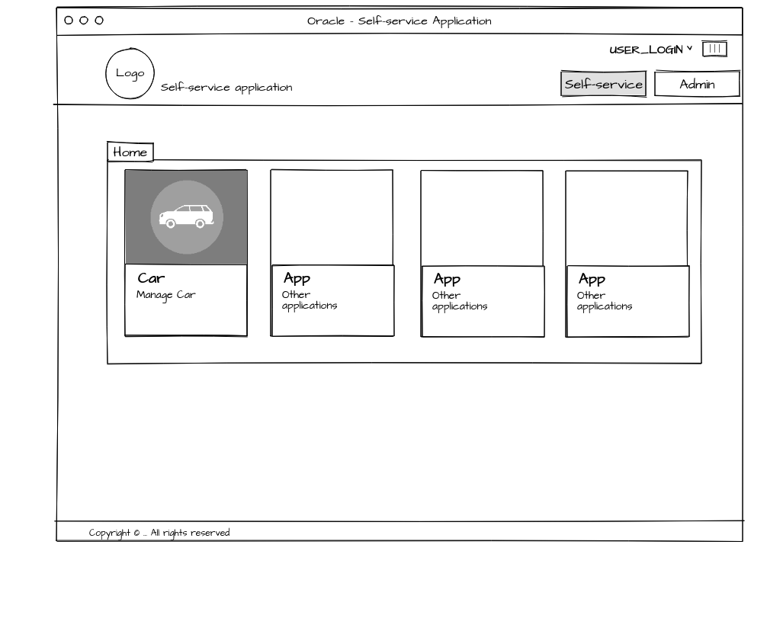

The button is accessible to users having the <ROLE_NAME>..

The new button is positioned as the 1st button in the 1st line of buttons. When clicking on the button, the new page described in the next chapter opens in a new tab of the self-service interface (see chapter X- Page Design).

On the compliance home page, it should have the following look:

<IMAGE>

The button is accessible to users having the <ROLE_NAME>..

The new button is positioned as the 1st button in the 1st line of buttons. When clicking on the button, the new page described in the next chapter opens in a new tab of the self-service interface (see chapter X- Page Design).

## Page Design – Manage Car

**List of the car**

The new page in the self-service home page should have the following look:

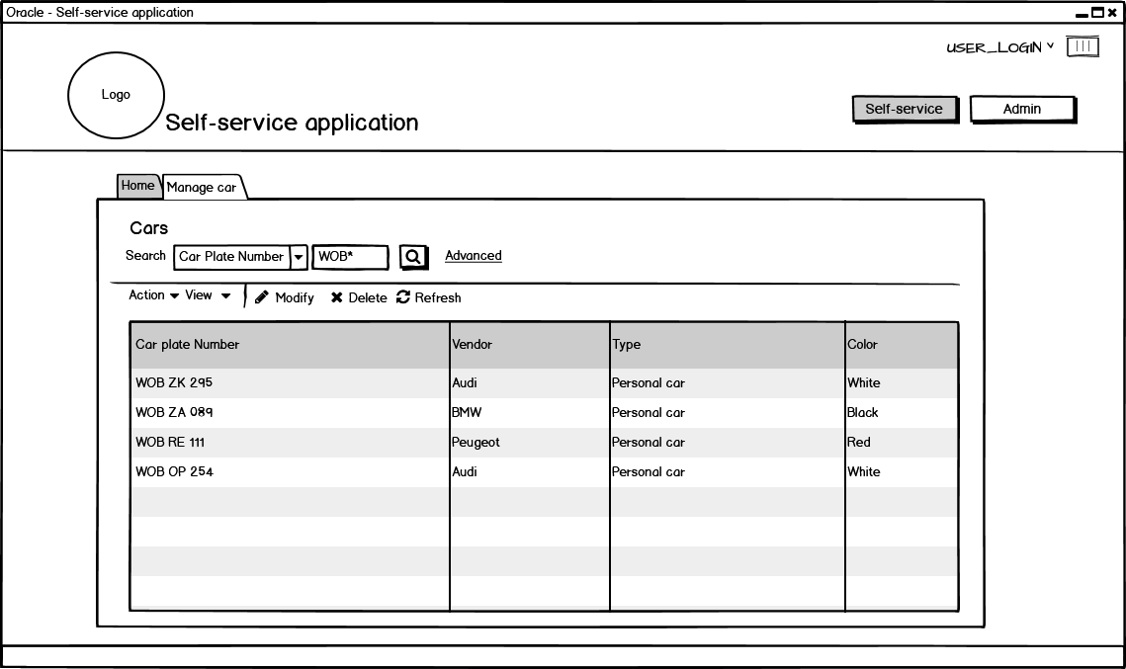

The page is divided in 3 parts:

* Car search
* List of actions
* List of the car corresponding to the previous search criteria

User can use the search criteria with the criteria car plate number, vendor, color, type of the car, name of the user (the last criteria is available only for admin users).

When clicking on search button, the application searches for all car following the previous search criteria. When at least, one car is found, the table displays the list of the car corresponding to this search in the scope of connected user. If no car is found, the list of the car is empty. By default, without any search criteria, every car in the scope of the user is displayed.

The table has the following columns:

* Car plate number
* Vendor, Type, Color
* Identity belonging of the car (see if it is possible to display this column only for admin user)

User has also the possibility to perform some action:

* By clicking on the button “Create”, a new page is displayed in order to add a new car to his list (see the next section: Create a car)
* By selecting a car, the button “Delete” become available. Clicking on the “Delete” button, remove the selected car. (see if message should be displayed).
* By selecting a car, the button “Modify” become available. Clicking on the “Modify” button, remove the selected car. (see the next section: Modify a car).
* By clicking on refresh button, the list is updated with the previous search criteria

**Create a car**

The create car page is a train divided in three part:

* Car plate number: user can enter his car plate number.
* Details: other attributes
* Summary: all attributes of the created car.

On every part of the train, this page is divided in two parts:

* The train position: show the user's current position in relation to the part describe above.
* The current navigation: corresponding to the part that the user needs to fill out.

**NB:** At any time, the user can go back to the previous page or cancel the car creation process.

The first part of the creation is the registration if the car plate number. It should have the following look:

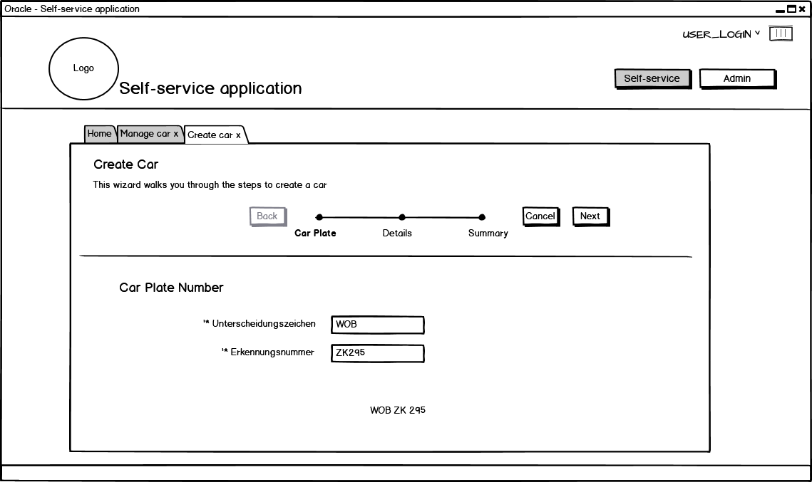

On this section, the user must fill out two values:

* Unterscheidungszeichen.
* Erkennungsnummer.

By entering these values, a series of checks is made. In case of error, an error message is displayed. (see the corresponding chapter to see the performing check on the car plate number).

If the entering values is correct, the button “Next” become available and the user can fill out the information on the next page:

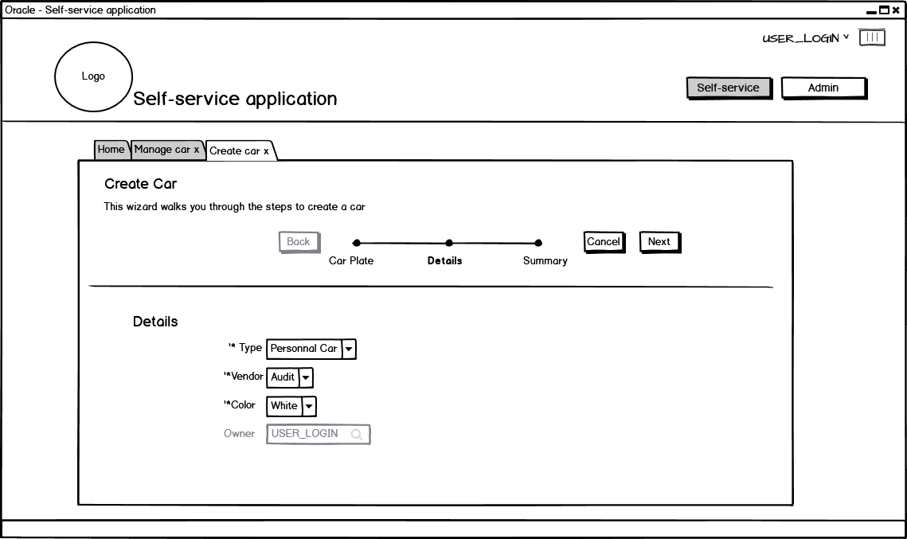

On this page, the user must fill out 4 value:

* Type: user can choose out a lookup of vehicle type (see the chapter on the Lookup value)
* Vendor: once the type is selected, the vendor section become available. According to the type of vehicle the user can choose out a lookup of vendors. (see the chapter on the Lookup value
* Color: the user can choose out a lookup of color (see the chapter on the Lookup value)
* Owner: for a normal user, this value is automatically filled out by the connected user. However, if the user is an admin, that user can choose any user within his scope. When clicking on the magnifying glass icon, a popup windows should be displayed for searching the corresponding user.

Once every filed is filled out, the button “Next” become available. When clicking on this button, the last page is displayed. It should have the following look:

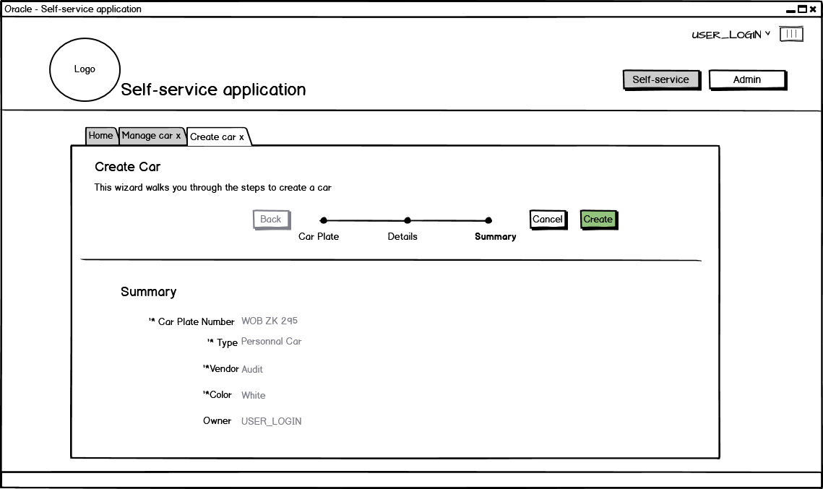

This page displayed the summary of the information filled out during the previous pages. By clicking on “Create” button, the car is added for the selected user and the train page disappears.

**Modify a car**

When clicking on modify button on the “manage car”, the following page should be dislayed.

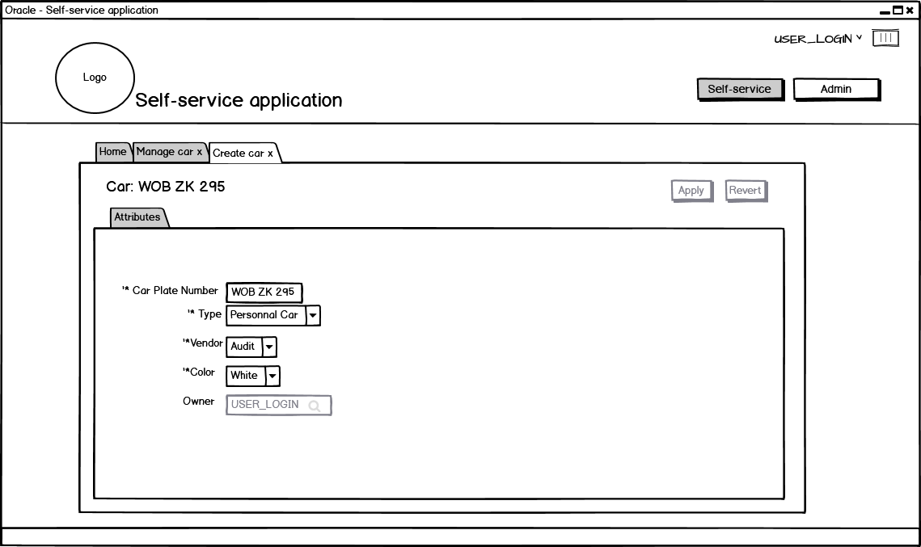

TOBECOMPLETED…

## Page Design – Report Vehicle

The new page in the admin home page should have the following look:

TOBECOMPLETED…

# Appendix A – Car management data model

Car plate -> Primary key

# Appendix B – SQL Table creation