**Project Title:** What’s Happening @lanta

# Team Name: {Atl}iens

**Members:** Kelli Bray, Tee Covington, Tyler Ellison, Vincent Dang

# Project Description:

A website that provides users information on different areas of interest, in Atlanta. The site will use geographical (Google Maps), data (US Census), and social app (FourSquare) APIs to provide general information and additional insight into different neighborhoods, around Atlanta.

# Sketch of Final Product:

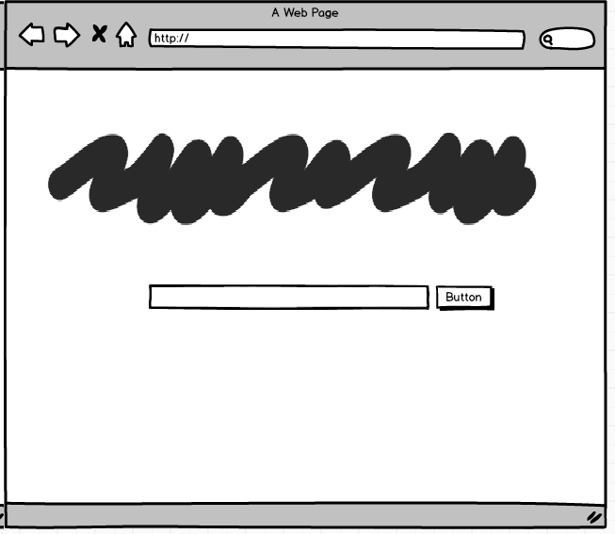

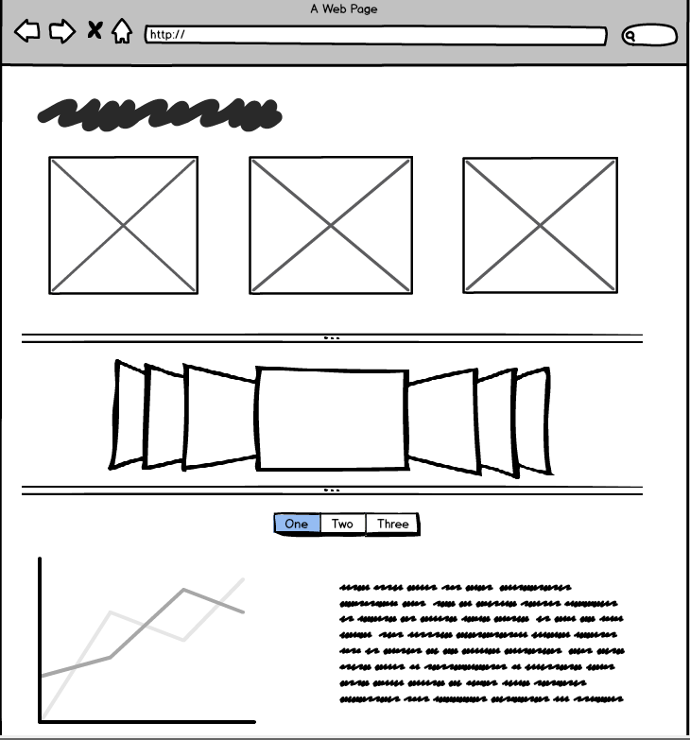

# APIs to be Used:

* Google Maps
* US Census Bureau
* FourSquare

# Rough Breakdown of Tasks:

1. Site Concept & Design
   1. Basic information
   2. Basic Layout
2. Site creation and Testing
   1. Home Page
      1. HTML
      2. CSS Styling
      3. Javascript/JQuery
   2. Additional Content Pages
      1. HTML
      2. CSS Styling
      3. Javascript/JQuery
   3. API integration using AJAX calls
3. Deploy site to Production