ENGINEERING APPENDIX
Context-First Kanban Workspace
Domain model, lifecycle semantics, reference architecture, API surfaces, data provenance, and phased POC build plan.

Audience | Product leads, UX, full-stack engineering, platform engineering, AI/ML, QA.
Companion to | Product Vision, PRD v1, and the concept diagram pack created for this project.

Purpose This appendix translates the product concept into explicit engineering seams. It is intentionally concrete enough to support a proof of concept, while still leaving room for implementation choices inside each service boundary.

How to use this appendix
Use Sections 2 to 5 to align on the data model and state semantics before implementation starts.
Use Sections 6 to 8 to split work across frontend, backend, connector, and AI orchestration tracks.
Use Sections 9 to 10 as the build sequence and the risk register for the POC.

Section map
- 1. Architectural stance and assumptions
- 2. Core domain model
- 3. Lifecycle rules and state invariants
- 4. Reference architecture and service boundaries
- 5. Data flow and provenance rules
- 6. API surface and command model
- 7. Permissions, trust, and AI control boundaries
- 8. Persistence, indexing, and audit strategy
- 9. POC delivery slices and team handoffs
- 10. Observability, test strategy, and open questions
Implementation bias Recommended POC stance: keep the first build as a modular monolith with explicit internal boundaries. That keeps the team fast while preserving a clean path to future service extraction.

1. Architectural stance and assumptions
The product is not a generic Kanban tool with an assistant bolted on. It is a board-anchored workspace that earns the right to expose the board only after enough project context has been assembled and reviewed.
That stance has several direct engineering consequences: project state must be explicit; planning output must remain traceable to context; the board must stay the main shell after unlock; and AI systems must operate within phase-specific boundaries rather than writing directly to arbitrary records.
Principle | Engineering consequence | POC implementation note
Progressive unlocks | Project state is first-class, not inferred only from visible screens. | Model project lifecycle separately from task lifecycle.
Shared human + AI context | Uploaded files, connector records, and planning records need one project-scoped access model. | Put all readable context behind one project identifier.
Board anchored after unlock | The board becomes the default view but still references planning and context surfaces. | Use one workspace shell with tab/panel emphasis, not multiple apps.
Traceable AI output | Tasks and summaries need source references and freshness markers. | Store citation bundles on planning summaries and task seeds.
Human control at boundaries | Unlock, cancel, and close remain approval actions. | AI proposes; humans approve state-changing gates.

Mental model The cleanest mental model for implementation is: Project = shell and rules; Context = readable evidence; Planning = structured proposal; Board = execution surface; Events = audit and telemetry.

2. Core domain model
The project record is the join point across context, planning, execution, and closure. Every other entity either belongs to the project directly or points back to it through a stable foreign key.
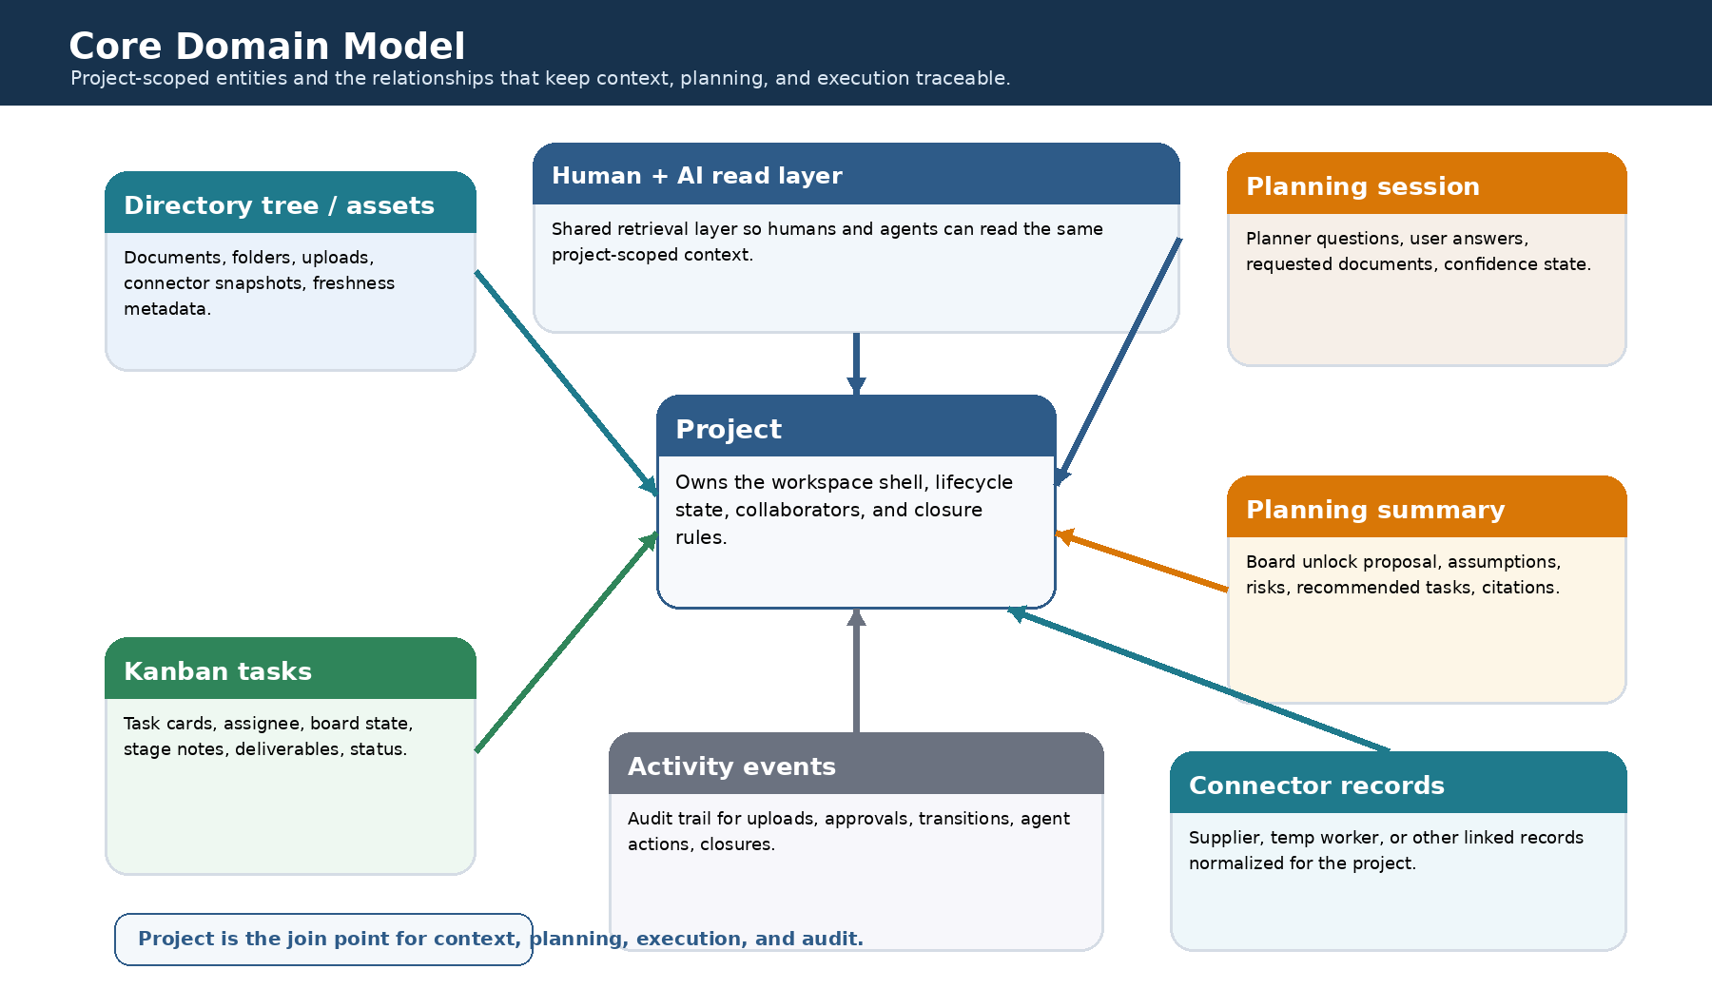
Figure 1. Core domain model for the POC. The project is the root scope for context, planning, tasks, connectors, and events.
Entity | Purpose | Minimum fields | Important links
Project | Owns shell state, collaborators, and closure rules. | id, name, owner_id, lifecycle_state, board_unlocked_at, closed_at | 1:N assets, planning sessions, tasks, connector records, events
Asset | Represents an uploaded file or generated document in the directory tree. | id, project_id, path, asset_type, storage_uri, readable_text, freshness_at | may be cited by planning summaries and tasks
PlanningSession | Captures the planner conversation and missing-context loop. | id, project_id, status, started_at, last_message_at, confidence | produces one or more planning summaries
PlanningSummary | Structured proposal for board unlock and task seeding. | id, project_id, session_id, summary_text, assumptions, risks, recommendation_state | has citation bundle; seeds tasks on approval
Task | Board card and workflow unit. | id, project_id, title, board_state, priority, assignee_id, cancelled_flag | references planning summary and task evidence
TaskArtifact / Deliverable | Files or structured outputs created during execution or review. | id, task_id, artifact_type, storage_uri, version | linked into task history and review records
ConnectorRecord | Normalized external record imported into the project scope. | id, project_id, connector_type, external_key, payload_json, freshness_at | acts like readable context with provenance
ActivityEvent | Append-only audit and telemetry stream. | id, project_id, actor_type, event_type, payload_json, created_at | supports replay, debugging, analytics

Recommended implementation detail: keep task-stage notes, QC notes, and completion summaries as separate typed records instead of overloading one free-form task description field. That makes stage-specific assistants easier to reason about and audit.
3. Lifecycle rules and state invariants
Project state and task state are related but not the same. Project state gates what parts of the workspace are unlocked; task state governs how work moves once the board is active.
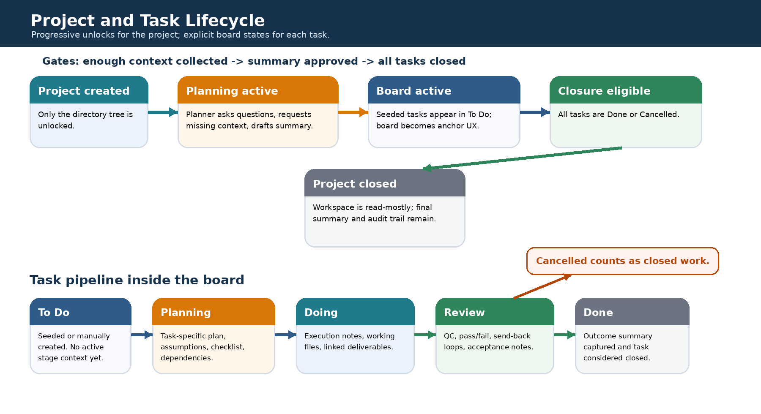
Figure 2. Project progression and task pipeline. Cancelled tasks count as closed work for closure checks.
Project states
State | Meaning | Enter when | Exit when
context_intake | Directory tree is the only unlocked project surface. | Project is created. | User chooses to continue into planning.
planning_active | Planner chat is active and board is still locked. | Project leaves context intake. | User approves a planning summary for board unlock.
board_active | Board is primary workspace; tasks can move through pipeline. | Unlock approved and initial tasks created. | All tasks are closed.
closure_eligible | No open tasks remain; closure action is available. | Every task is Done or Cancelled. | User closes the project.
closed | Workspace is read-mostly and auditable. | User confirms closure. | No exit for POC; reopening can be deferred.

Task states
Board state | Assistant mode | Expected output | Closed?
to_do | None or lightweight suggestions only. | Task exists but has not entered active stage work. | No
planning | Task planning assistant. | Plan, assumptions, dependencies, acceptance criteria. | No
doing | Execution assistant. | Work notes, deliverables, linked evidence. | No
review | QC / reviewer assistant. | Pass/fail outcome, send-back note, acceptance evidence. | No
done | Completion summarizer. | Outcome summary and final linked artifacts. | Yes
cancelled | Cancellation rationale helper. | Reason for cancellation and audit trail. | Yes

Hard rules Invariant set for the POC: a project cannot unlock the board without an approved planning summary; a task cannot be auto-moved to Done from Doing without passing through Review unless a human deliberately bypasses review; project closure must fail while any task remains in To Do, Planning, Doing, or Review.

4. Reference architecture and service boundaries
A modular monolith is the most practical POC shape. The product has enough moving parts to deserve clean internal seams, but not enough initial scale to require independently deployed services from day one.
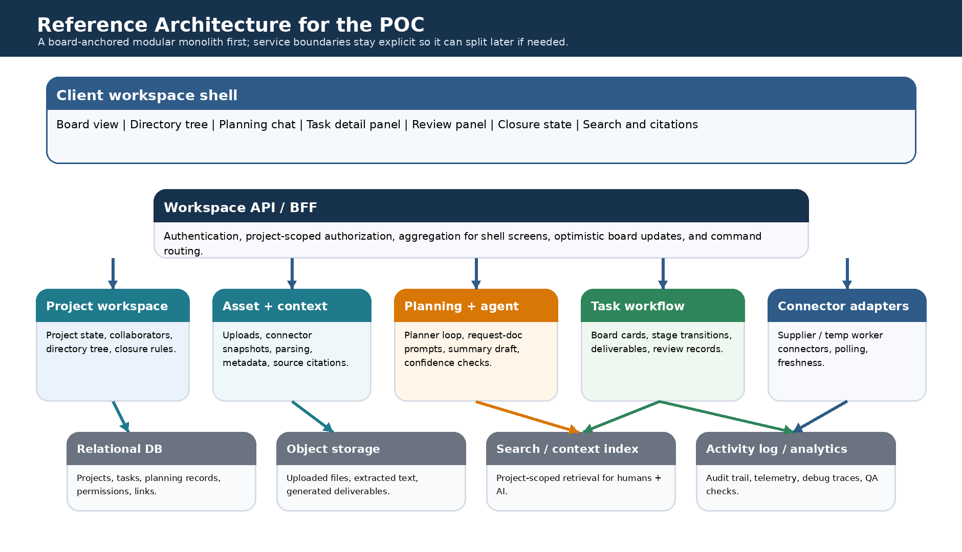
Figure 3. Reference architecture. Internal boundaries should be real even if the first deployment is one application.
Boundary | Owns | Does not own | Notes for the POC
Workspace shell / frontend | Board UX, directory tree, planning chat, task detail panels, visual lock states. | Business rule source of truth. | Keep one persistent shell so the board remains the anchor after unlock.
BFF / API layer | Project-scoped aggregation, auth checks, command routing, optimistic responses. | Long-running planner or connector logic. | Useful place for screen-shaped read models.
Project workspace module | Project lifecycle, collaborator membership, closure checks. | File parsing or external polling. | Treat project state machine as explicit code, not scattered conditionals.
Asset + context module | Upload metadata, directory tree, extracted readable text, citation references. | Board transitions. | This module should expose one retrieval surface for humans and AI.
Planning + agent module | Planner conversation state, confidence checks, summary drafts. | Task stage execution. | Separate planner prompts from task-stage prompts.
Task workflow module | Cards, transitions, deliverables, review records, done summaries. | Project closure decision outside rule evaluation. | Board transitions should emit events.
Connector adapters | External record sync and freshness metadata. | Core product state semantics. | Stubbed adapters are acceptable for the first demo.

Suggested internal interfaces: use commands for state changes such as UnlockBoard, SeedTasksFromSummary, MoveTaskToReview, CancelTask, and CloseProject; use query read models for board columns, task detail panels, and directory tree views.
Even in a monolith, treat the search/context index as a dependency boundary so retrieval behavior can evolve independently of the transactional database.
5. Data flow and provenance rules
The product promise depends on provenance. Users should be able to understand whether a planner suggestion came from an uploaded document, a fresh connector record, or a human-supplied clarification.
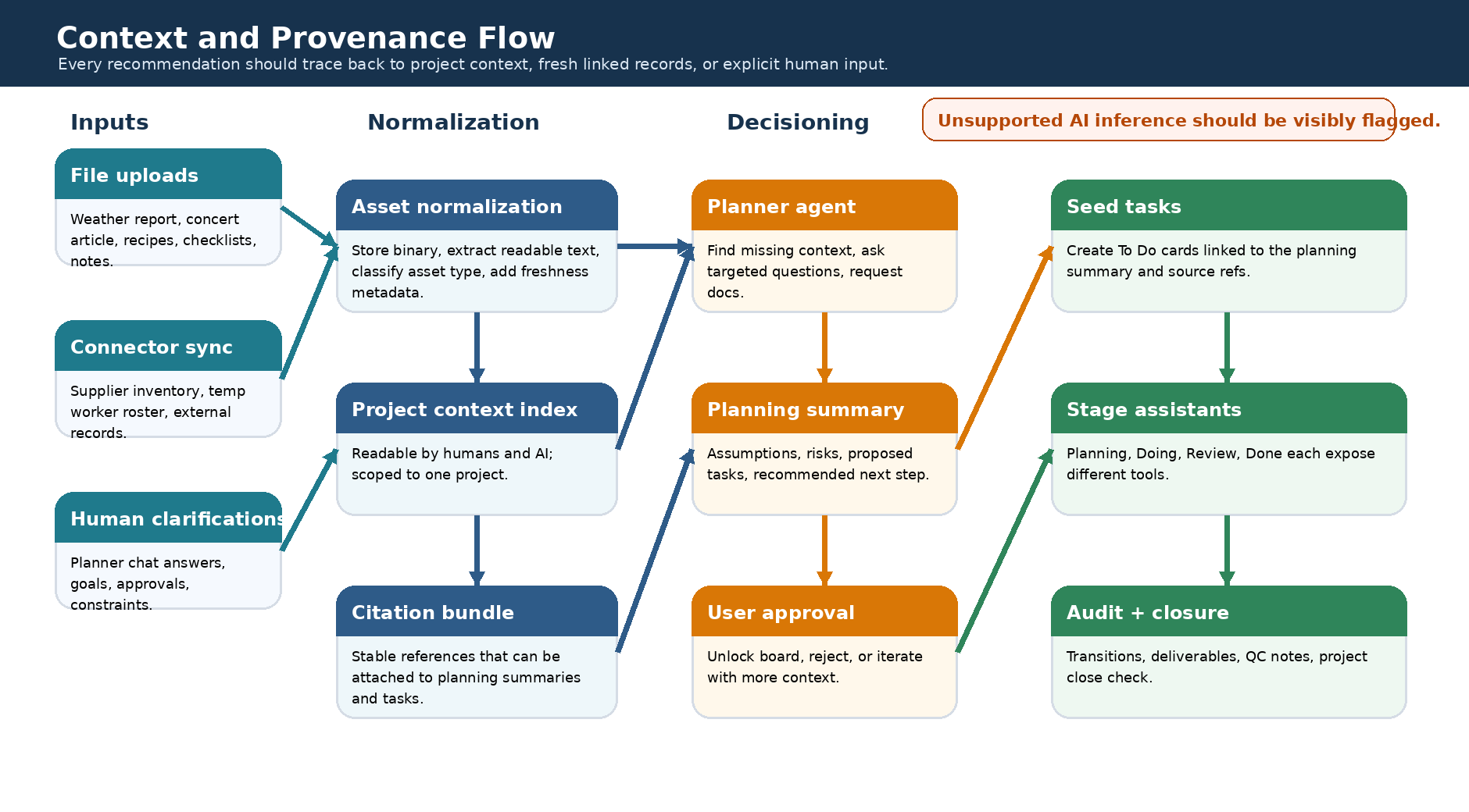
Figure 4. Context and provenance flow from raw inputs to board execution.
Rule | Why it matters | POC implementation move
Every planning summary stores source references. | Board unlock quality must be inspectable. | Persist cited asset IDs and quoted snippets or offsets where available.
Task seeds retain their origin summary. | The team needs to know why a task exists. | Store seeded_from_summary_id and optional source asset IDs on the task.
Connector freshness is visible. | Supplier and temp worker data can go stale. | Show freshness_at and last_sync_status in UI and APIs.
Unsupported inference is marked. | Users should not confuse speculation for grounded context. | If the planner infers beyond available evidence, tag it explicitly in the output payload.
Stage assistants write typed records. | Auditability is lost when everything becomes one chat blob. | Store planning notes, execution notes, review outcomes, and done summaries separately.

Pragmatic provenance For the POC, citations do not need to be sophisticated. A stable asset identifier plus a short quoted excerpt or record label is enough to make planning and task seeding feel grounded.

6. API surface and command model
The most important API decision is to separate screen reads from state-changing commands. Reads can be shaped for the shell. Commands should be explicit and side-effect aware.
Surface | Representative operations | Notes
Project workspace | GET /projects/{id}/workspace; POST /projects; POST /projects/{id}/close | Workspace read combines shell state, lock state, and closure eligibility.
Assets / directory tree | GET /projects/{id}/tree; POST /projects/{id}/assets; POST /assets/{id}/move | Tree payload should include file type, freshness, and readable-state flags.
Planning | GET /projects/{id}/planning; POST /planning/messages; POST /planning/summaries/{id}/approve | Approval endpoint is where board unlock begins.
Task seeding | POST /projects/{id}/seed-tasks | Can be called automatically after summary approval or explicitly by workflow.
Board | GET /projects/{id}/board; POST /tasks/{id}/move | Move endpoint should validate allowed transitions.
Task stage records | POST /tasks/{id}/plan-note; POST /tasks/{id}/execution-note; POST /tasks/{id}/review | Keep stage payloads typed, even if free-form text exists inside them.
Deliverables | POST /tasks/{id}/artifacts; GET /tasks/{id}/artifacts | Generated outputs and uploaded outputs can share one artifact shape.
Connectors | POST /projects/{id}/connectors/{type}/sync; GET /projects/{id}/connectors | Freshness and sync status matter more than connector sophistication in the POC.
Activity | GET /projects/{id}/events | Critical for debugging AI behavior and closure issues.

Command examples
UnlockBoard(project_id, planning_summary_id, approved_by)
SeedTasksFromSummary(project_id, planning_summary_id, task_templates[])
MoveTask(task_id, from_state, to_state, actor, reason_optional)
RecordReviewOutcome(task_id, decision, notes, linked_artifact_ids[])
CloseProject(project_id, closed_by)
7. Permissions, trust, and AI control boundaries
The AI should be powerful inside bounded tasks but not act as an unbounded co-owner of project state. The trust model for the POC should be understandable enough that QA can explain every important transition.
Actor | Can read | Can propose/write | Needs human approval for
Project owner | Everything in the project scope. | All project, planning, task, and closure actions. | Nothing beyond ordinary auth rules.
Collaborator | Everything granted by membership. | Task moves, notes, uploads, reviews if role permits. | Board unlock and project closure if not owner/admin.
Planner agent | Project context, planning chat, connector snapshots. | Questions, missing-doc requests, draft summaries, draft tasks. | Board unlock, final task deletion, project closure.
Task-stage assistants | Task, linked assets, relevant planning context. | Plan notes, execution drafts, QC suggestions, done summaries. | Cross-project access, project closure, collaborator changes.

UX trust cue User-visible wording matters: the UI should say that the planner 'recommends' an unlock and 'proposes' tasks. That language reinforces the approval boundary and matches the actual implementation model.

8. Persistence, indexing, and audit strategy
A simple split works well for the POC: relational storage for core metadata and lifecycle rules, object storage for files and generated artifacts, and a lightweight search/context index for readable retrieval.
Store | Best fit | Data examples | Why this split helps
Relational database | Transactional state and joins | projects, tasks, planning sessions, summaries, memberships, activity event headers | Reliable lifecycle checks and closure logic.
Object storage | Files and generated payloads | uploaded reports, exported summaries, deliverable files, original connector dumps | Cheap storage for binary assets and versionable outputs.
Search/context index | Readable retrieval | asset text, connector summaries, planning excerpts | Fast project-scoped lookup for humans and AI.
Append-only event log table | Audit + analytics | task moved, file uploaded, summary approved, project closed | Supports debugging and product telemetry without polluting core tables.

Recommended event topics
Event type | Typical payload | Triggered by
project.created | project_id, owner_id | new project flow
asset.uploaded | asset_id, project_id, path, asset_type | directory tree upload
planning.message_added | session_id, actor_type, message_id | planner chat
planning.summary_approved | summary_id, project_id, approved_by | user approval
board.seeded | project_id, task_ids[] | task seeding
task.moved | task_id, from_state, to_state, actor_type | board transition
task.cancelled | task_id, reason | cancellation action
project.close_attempted | project_id, blocking_task_ids[] | close button click
project.closed | project_id, closed_by | successful closure

9. POC delivery slices and team handoffs
The recommended build order follows the actual user journey. Each slice should leave a demonstrable artifact behind so the team can stack confidence instead of waiting for a single big integration moment.
Slice | What ships | Primary owners | Demo outcome
Slice 1: shell + assets | Create project, locked shell, directory tree, uploads, connector stub records. | Frontend, backend, storage. | A user can create a project and assemble readable context.
Slice 2: planning loop | Planner chat, requested-doc prompts, summary draft persistence. | AI orchestration, backend, frontend. | The planner can ask questions and prepare an unlock recommendation.
Slice 3: board activation | Summary approval, task seeding, visible board columns, task create/delete. | Backend, frontend. | Board unlocks and seeded tasks appear in To Do.
Slice 4: task pipeline | Planning, Doing, Review, Done, Cancelled transitions plus stage records. | Frontend, backend, QA. | A task can move end-to-end with typed notes.
Slice 5: closure + telemetry | Closure eligibility, close action, event log, basic dashboards. | Backend, product analytics, QA. | The system blocks premature closure and allows valid closure.

Recommended engineering handoffs
Frontend can mock the shell and lock states early with static JSON. That work does not need to wait for the planner or connector implementations.
Backend should stabilize project, task, and event schemas before deep AI integration begins. Otherwise the planner and stage assistants will write to unstable shapes.
AI work should start from narrow prompt contracts: planner summary payload, task planning note payload, review payload, and done summary payload. Those contracts are more important than prompt wording in the first iteration.
POC demo script Reference demo thread: the concert lemonade scenario. Seed the directory tree with the weather report, concert article, supplier records, temp worker records, and recipe notes; run the planner; approve the summary; seed the board; move at least one task through Review; cancel one non-essential task; close the project once all work is closed.

10. Observability, test strategy, and open questions
The POC should be testable without reading hidden agent prompts. That means the system must expose enough visible evidence for QA to understand why the planner asked for context, why tasks were seeded, and why closure was blocked or allowed.
Area | Minimum test / telemetry requirement | Success signal
Planning quality | Store planner questions, requested docs, summary approval result. | QA can trace seeded tasks back to the summary.
Board transitions | Emit task.moved and task.cancelled events with actor and reason. | Every card movement is reconstructable.
Closure logic | Log close attempts and blocking task IDs. | Failure cases are easy to diagnose.
Connector freshness | Track last sync status and last sync time. | Users can see when external context may be stale.
Assistant outputs | Keep stage records typed and timestamped. | Review outcomes and done summaries are distinguishable.

Open questions for the dev team
- Should the first POC use one generalized task detail panel with stage-specific subcomponents, or distinct panels for Planning, Doing, Review, and Done?
- How much citation detail is enough for the first release: asset IDs only, IDs plus excerpts, or IDs plus exact text offsets?
- Do connector records live inside the directory tree visually, or in a sibling section that is still readable as project context?
- Will the planner summary generate a fixed task set, or can the user choose from proposed task candidates before seeding?
- Should project closure generate a final project summary artifact automatically, or should that wait for a later phase?
Priority decision If the team needs one implementation decision to lock first, make it the state model. Clear project states, task states, and approval boundaries will make every later design and engineering decision easier.

Appendix A. Suggested sprint-zero backlog
This backlog is intentionally thin. Its purpose is to create the end-to-end skeleton quickly, not to finish the product.
Work item | Why it matters | Owner bias
Define project and task enums | Prevents later churn in UI, APIs, and AI contracts. | Backend + product
Stand up workspace shell with locked states | Lets design and engineering validate the interaction model early. | Frontend + design
Implement asset upload and readable-text extraction stub | Creates the shared context layer the planner depends on. | Backend + platform
Define planner summary payload contract | Allows agent work and board unlock flow to converge on one structure. | AI + backend
Implement task move command + event emission | Provides the first reliable workflow spine for the board. | Backend + QA

Appendix B. Minimal demo dataset
Data needed | Example
Project assets | Weather report PDF, concert news article, recipe notes, price list or prep checklist.
Connector-backed records | Supplier inventory snapshot, temp worker roster or availability list.
Planner clarifications | Expected turnout, weather risk tolerance, staffing constraints, pricing goal.
Seed tasks | Weather and footfall risk, supplier confirmation, staffing, batch prep, signage/pricing, QC checklist.

Prepared for internal development planning. This appendix is intended to be edited as architecture decisions solidify.

