Enhancing Multi-View Deep Embedded Clustering using Maximal Frequent Itemset Mining: Application to E-Commerce Store Segmentation
Van Dat Nguyen¹, Nhat Tung Le², Huong Bui¹

¹Faculty of Information Technology, HUTECH University, Ho Chi Minh City, Vietnam;
ngvdat.w@gmail.com, bd.huong@hutech.edu.vn
²Dong Nai Technology University, Dong Nai, Vietnam;
lenhattung@dntu.edu.vn

Abstract:
Multi-view Deep Embedded Clustering (MvDEC) has emerged as a promising approach for discovering latent structures within complex, high-dimensional, and heterogeneous data. However, most existing methods primarily rely on initial continuous features, failing to effectively exploit the frequent co-occurring feature combinations inherent in the data. To address this limitation, this study proposes a novel framework that integrates maximal frequent itemset mining—specifically the FP-Max algorithm—into the MvDEC pipeline. The proposed method simultaneously learns dual latent representations using Multilayer Perceptron (MLP) and U-Net architectures, subsequently generating binary features based on maximal frequent itemsets to enrich the representational space. Following this, Forward Feature Selection is applied to retain the most informative features. The final clustering process is executed within this augmented feature space using the K-Prototypes algorithm with Gower distance, and the performance is evaluated via the Silhouette score. Extensive experiments conducted on two real-world datasets—air pollution data and a Tiki e-commerce store dataset—demonstrate that the proposed method achieves superior performance compared to baseline approaches. A notable contribution of this research is its capability to capture latent semantic information via binary features, paving the way for promising applications in store segmentation and operational optimization within e-commerce platforms.
Keywords: Autoencoder, Feature Enrichment, FP-Max, Maximal Frequent Itemset Mining, Tiki E-commerce Dataset
- Introduction
The rapid expansion of digital ecosystems, particularly in e-commerce, has generated massive volumes of complex, high-dimensional, and heterogeneous data. Extracting meaningful latent structures from such data is a critical challenge in unsupervised machine learning . While traditional clustering techniques like K-Means have laid the foundation for data segmentation, they frequently struggle to handle clusters characterized by non-linear shapes, varying densities, and mixed data types. Consequently, modern approaches such as Deep Embedded Clustering (DEC) and Multi-view Deep Embedded Clustering (MvDEC) have garnered significant attention. By integrating deep representation learning, these multi-view models leverage complementary information from multiple data perspectives to construct a comprehensive embedding space, joint-optimizing representation learning and clustering tasks with remarkable efficacy.
Despite these advancements, existing MvDEC frameworks still exhibit a fundamental limitation: they primarily rely on continuous latent features while neglecting the discrete, highly correlated patterns embedded within the data. In complex environments like e-commerce, latent semantics often manifest as specific combinations of co-occurring features (e.g., a storefront simultaneously exhibiting high operational longevity, moderate revenue, and exceptional review quality). Continuous embedding spaces can blur these sharp, discrete boundaries. Frequent Itemset Mining (FIM), a well-established technique for discovering frequently co-occurring sets, offers a highly effective mechanism to capture these combinations. However, the integration of pattern mining techniques with deep representation learning remains largely unexplored in contemporary clustering research.
To bridge this research gap, this study proposes a novel framework that directly embeds maximal frequent itemset mining into the MvDEC pipeline to enrich the representational space. By discretizing the continuous embeddings and extracting maximal frequent itemsets as binary features, the model is empowered to explicitly capture latent semantic coordinations, thereby achieving highly separable and well-defined cluster boundaries.
To demonstrate the practical utility of this approach, we apply our methodology to a highly challenging real-world case study: store segmentation on Tiki, one of the leading e-commerce platforms in Vietnam. Storefronts in this ecosystem are profiled across independent yet complementary dimensions, including revenue, rating quality, followers, and operational longevity. Effective clustering within this domain is not merely a data analytics exercise; it serves as a foundational framework for strategic optimization. Accurately segmented store profiles enable platforms to personalize advertising campaigns, tailor logistics support, detect operational anomalies, and design cohort-based growth initiatives, thereby enhancing overall ecosystem sustainability .
Specifically, the main contributions of this research are summarized as follows:
- Novel Methodological Framework: We propose the Maximal-itemset Multi-view Deep Embedded Clustering (MiMvDEC) model, which successfully integrates maximal frequent itemset mining (via the FP-Max algorithm) into the multi-view deep learning pipeline. This novel integration enriches continuous latent representations by capturing hidden, semantically meaningful co-occurring patterns as binary features, thereby significantly enhancing cluster separability.
- Robust Feature Optimization for Mixed-Type Data: We introduce a rigorous refinement mechanism utilizing Forward Feature Selection (FFS) to systematically filter and retain only the most informative binary features. Furthermore, the final clustering process is optimized within this augmented, mixed-type representational space using the K-Prototypes algorithm paired with the Gower distance, effectively handling the complexities of heterogeneous data.
- Extensive Empirical Validation and Practical Applicability: We conduct comprehensive experiments on two diverse real-world datasets—a public air pollution dataset and a proprietary e-commerce storefront dataset from Tiki. The proposed method achieves superior clustering performance compared to existing baselines. Beyond technical metrics, this study provides highly actionable business insights for store segmentation, paving the way for targeted resource allocation, personalized marketing, and operational optimization within e-commerce ecosystems.
The remainder of this paper is organized as follows: Section 2 reviews related work; Section 3 details the proposed MiMvDEC methodology; Sections 4 and 5 present the experimental results and comprehensive cluster analysis on the respective datasets ; and Section 6 concludes the paper with directions for future research.
Clustering is a fundamental technique in unsupervised machine learning, enabling the discovery of latent patterns in data without the need for labels [1, 2, 3]. This technique plays a pivotal role across various domains, ranging from market segmentation and user behavior analysis to medicine and environmental research. However, when dealing with complex and heterogeneous data, such as in e-commerce, traditional methods like K-Means often struggle to handle clusters with non-linear shapes, high-dimensional spaces, uneven densities, or mixed data types.
In this context, modern approaches such as Deep Embedded Clustering (DEC) [4] and Multi-view Deep Embedded Clustering (MvDEC) [5, 6] have garnered significant attention due to their exceptional capabilities. Instead of relying solely on a single feature set, these methods leverage multiple complementary views from the same dataset to construct a more comprehensive representational space, accurately reflecting the underlying structure of the data. By integrating deep representation learning, multi-view clustering models like DEC and MvDEC can effectively capture complex features, generating an embedding space characterized by well-defined and highly separable cluster boundaries. These models have demonstrated remarkable efficacy in jointly optimizing representation learning and clustering tasks, particularly on non-linear, high-dimensional, and heterogeneous datasets—traits that are ubiquitous in real-world applications.
However, existing MvDEC models still exhibit limitations, as they primarily rely on raw input data without fully exploiting the latent frequent patterns embedded within it. These patterns typically manifest as combinations of co-occurring features, which can effectively highlight critical feature groupings within the embedding space. Frequent Itemset Mining [7], a well-established subfield in data mining, has rarely been integrated with clustering or deep representation learning. Integrating frequent itemset mining with multi-view clustering models offers a promising avenue to enhance clustering performance by enriching the representational space with binary features, thereby enabling the model to better discriminate complex structures within the data. Motivated by this observation, this study proposes a novel model that integrates maximal frequent itemset mining with the MvDEC framework to expand and enrich the representational space. The proposed methodology is structured into three primary phases:
- Phase 1: Two distinct autoencoder networks, comprising a fully connected MLP and a U-Net [6] with skip connections, are trained to learn two deep representations from distinct data views. This approach enables the model to simultaneously capture both local and global features, which are subsequently fused into a unified embedding space.
- Phase 2: The fused embedding space is discretized into categorical intervals and binary-encoded using one-hot encoding. The FP-Max algorithm [8] is applied to extract maximal frequent itemsets, thereby generating binary features that reflect meaningful co-occurring patterns within the data. These features are then filtered via Forward Feature Selection [9] to retain only the most informative ones.
- Phase 3: Clustering is performed on the augmented feature space, encompassing both the fused embeddings and the selected binary features. The K-Prototypes algorithm [10], utilizing the Gower distance, is employed to handle the mixed-type data more effectively.
To ensure practical applicability, this research focuses on store clustering on the Tiki e-commerce platform, one of the largest in Vietnam, characterized by high-dimensional and non-linear data. Each store is profiled across multiple dimensions, including revenue, average star rating, years of operation, follower count, and customer review proportions. These dimensions are simultaneously independent and complementary, constituting a multi-view data ecosystem that is highly conducive to deep representation learning and frequent pattern mining models.
The effective clustering of e-commerce stores yields substantial strategic value, encompassing the personalization of advertising campaigns, the adjustment of service policies, and the optimization of logistics support packages tailored to distinct store segments. Clusters exhibiting high growth potential and receiving favorable reviews can be prioritized for replication or leveraged as reference models for newly onboarded stores. Furthermore, the discovery of prevalent behavioral patterns among stores enables the platform to design cohort-based business support packages, thereby reducing costs and enhancing operational efficiency. Consequently, the clustering task transcends being merely a data analytics tool; it serves as a foundational framework for optimizing the e-commerce ecosystem, facilitating resource allocation, anomaly detection, user experience enhancement, and the promotion of sustainable growth.
The remainder of this paper is organized as follows: Section 2 presents the related work; Section 3 details the proposed method; Sections 4 and 5 discuss the experimental results and further analysis; and Section 6 provides the conclusion along with directions for future research.
- Related work
Deep Embedded Clustering (DEC) is an advanced unsupervised learning technique that combines deep neural networks with clustering objectives to generate low-dimensional representations optimized specifically for clustering. The pioneering work by Xie et al. [11] introduced DEC, utilizing an autoencoder to map high-dimensional data into a latent space, followed by the application of a clustering layer with a Kullback-Leibler (KL) divergence-based loss function to simultaneously refine cluster labels and latent representations. Building upon this foundation, Guo et al. [4] proposed Deep Embedded K-Means (DEKM), wherein the autoencoder constructs the embedding space, the decoder is discarded, and an orthonormal transformation matrix based on the eigenvectors of the K-Means within-class scatter matrix is applied. DEKM performs alternating optimization between representation learning and clustering, achieving superior performance on datasets such as MNIST, COIL-20, and REUTERS-10K. Additionally, methods like Deep Comprehensive Correlation Mining (DCCM) [12] and Deep Semantic Clustering by Partition Confidence Maximisation (PICA) [13] exploit data correlations or optimize partition confidence. However, these approaches primarily focus on single-view data, limiting their capability to process multi-view data or the discrete frequent patterns prevalent in practical applications such as e-commerce.
To overcome the limitations of single-view methods, multi-view learning has emerged as a crucial research direction, leveraging the complementary information and mutual correlations across different views of the same object. According to Yu et al. [14], multi-view learning methods are broadly categorized into four primary groups: classification, semi-supervised classification, clustering, and semi-supervised clustering. The principles of consensus and complementarity play a pivotal role in enhancing learning efficacy. Techniques such as autoencoders, canonical correlation analysis (CCA), subspace learning, and attention mechanisms have been widely applied to improve feature representation and fuse information across views. However, inherent challenges such as cross-view inconsistencies and the determination of optimal fusion strategies remain not fully resolved.
Multi-view Deep Embedded Clustering (MvDEC), proposed by Kassem et al. [5], employs two autoencoders to learn latent representations from distinct views, subsequently fusing them into a unified embedding space. MvDEC has demonstrated superior performance on high-dimensional, heterogeneous data, such as air pollution datasets, by exploiting complementary views to enhance cluster separability. Nevertheless, MvDEC continues to rely primarily on continuous features, failing to fully exploit co-occurring patterns—elements that can significantly highlight the latent structures within complex data.
In the field of multi-view learning, Attota et al. [15] proposed MV-FLID, an intrusion detection system (IDS) for IoT networks based on federated learning combined with multi-view learning. MV-FLID partitions the data into three perspectives: Bi-flow, Uni-flow, and Packet-level, trains separate models, and aggregates the results through an ensemble method. This system preserves privacy by retaining data locally on the devices and sharing only model parameters, simultaneously achieving higher accuracy than centralized machine learning approaches under heterogeneous data conditions. Similarly, Hussain et al. [16] developed a context-aware multi-view learning framework for activity recognition in IoT environments, leveraging data from multiple sensors (audio, visual, motion) to enhance classification accuracy. This framework integrates context awareness and is deployed on a cloud computing platform, improving performance compared to traditional single-view models.
Frequent Itemset Mining (FIM) is a core technique in data mining, aimed at discovering frequently co-occurring itemsets [7]. Algorithms such as Apriori [17] and FP-Growth [18] laid the foundation for this field, but they often generate numerous redundant itemsets, thereby increasing computational and storage overheads. Maximal Frequent Itemset Mining (MFIM) utilizing the FP-Max algorithm [19] addresses this issue by extracting only maximal frequent itemsets, reducing complexity while preserving essential information. Recently, Kannout et al. [20] proposed the Clustering-based FPRS framework, which combines FP-Growth with hierarchical clustering to resolve the cold-start problem in recommender systems, improving recommendation quality on sparse data. Similarly, Sinthuja et al. [21] introduced the CL-LP-MAX-tree algorithm, integrating clustering with a linear prefix tree structure to mine maximal frequent itemsets, thereby optimizing execution time and memory footprint on datasets such as Online Shopping, Chess, and Pumsb.
In the e-commerce domain, clustering plays a pivotal role in market segmentation and operational optimization. Gulzar et al. [22] proposed the Ordered Clustering Algorithm (OCA) to enhance recommender systems, utilizing a rating matrix to compute similarities and grouping users in descending order of similarity. This approach outperformed K-Means and hierarchical clustering in terms of accuracy, coverage, and F-measure on Amazon datasets. Furthermore, Wu et al. [12] enhanced the K-Medoids algorithm with the IKMC method, which optimizes centroid initialization, distance criteria, and update mechanisms, thereby achieving high efficacy in customer segmentation based on RFM analysis. Additionally, Wang and Jiang [23] proposed a recommendation approach based on Fuzzy C-Means, which allows each user to belong to multiple clusters with varying degrees of membership, improving recommendation accuracy compared to K-Means and collaborative filtering.
Despite the significant advancements achieved by the aforementioned studies, the integration of deep embedded clustering, multi-view learning, and frequent itemset mining remains limited. While MvDEC [5] provides a robust framework for multi-view clustering, it fails to exploit co-occurring patterns to enrich the latent representations. Similarly, FIM methods, such as the approach proposed by Kannout et al. [20], demonstrate efficacy in recommender systems but have yet to be widely applied in unsupervised clustering. Our proposed MiMVDEC method addresses these limitations by:
- Integrating the FP-Max [8] algorithm to extract binary features from latent representations, thereby enhancing cluster separability through co-occurring patterns.
- Applying Forward Feature Selection (FFS) to retain the most informative binary features, consequently elevating clustering efficacy.
- Combining multi-view deep learning with K-Prototypes clustering and advanced optimization techniques—such as orthonormal transformation and greedy optimization—to effectively process mixed-type data.
- Demonstrating practical applicability on the Tiki dataset, addressing inherent challenges in store segmentation and operational optimization.
By addressing these research gaps, our proposed method not only enhances clustering performance but also yields practically valuable insights for e-commerce platforms, thereby facilitating marketing personalization, resource allocation, and strategic decision-making.
- Proposed Method
In this study, we propose a novel clustering approach that integrates Multi-view Deep Embedded Clustering with Maximal Frequent Itemset Mining to enhance clustering quality. This proposed method builds upon the framework introduced by Kassem et al. [5]. However, the primary distinction in our approach lies in the incorporation of a feature mining phase subsequent to the fused representation learning stage, utilizing the FP-Max algorithm [8]. This enhancement facilitates the more effective discovery of highly discriminative latent features, thereby improving clustering accuracy.
3.1 Review of the Multi-view Deep Embedded Clustering method (MvDEC)
This method was developed to overcome the limitations of traditional clustering techniques when dealing with high-dimensional and heterogeneous datasets. The core of this approach leverages deep autoencoder architectures to learn latent representations from input features and fuse multiple distinct views of the data. Specifically, two separate autoencoders are designed to extract features from the same dataset. One autoencoder utilizes a fully-connected structure, while the other is based on a U-Net architecture [6], enabling the simultaneous extraction of both local and global features. Upon obtaining the two latent representations, the method combines these embedding vectors via arithmetic mean to generate a fused representation.
Subsequently, the K-means algorithm is applied to the fused representation to cluster the data and identify its cluster structure. Based on these clustering results, an orthonormal transformation is performed using the within-cluster scatter matrix to emphasize the cluster structure within the embedding space. The objective is to pronounce the cluster structure in the newly transformed representational space. Finally, the method deploys a greedy optimization mechanism to adjust the representation for more compact clustering, achieved by minimizing the intra-cluster variance and enhancing inter-cluster separability. The entire process operates under a joint optimization mechanism, where the representations and cluster labels are updated alternately until convergence is reached. Owing to this approach, MvDEC [5] demonstrates significantly higher efficacy compared to other methods in detecting complex cluster structures, particularly in high-dimensional and multi-density real-world datasets.
3.2 Methodology
Similar to the original MvDEC model, our method employs two independent autoencoder networks to learn latent representations from two distinct views of the same dataset. Specifically, the first view utilizes a fully-connected MLP autoencoder, focusing on the extraction of global features, whereas the second view employs a U-Net autoencoder, capable of preserving and reconstructing both low-level and high-level information owing to its skip-connection mechanism. The two derived latent representations are fused via arithmetic averaging, yielding a comprehensive, information-rich fused representation that more holistically reflects the latent structure of the original data.
In the subsequent phase, we enrich this representational space through Maximal Frequent Itemset Mining using the FP-Max algorithm [24]. Specifically, the fused representation is discretized using a K-Bins Discretizer and subsequently binary-encoded via one-hot encoding to construct the binary input dataset for FP-Max. This algorithm detects frequently co-occurring feature combinations, thereby generating synthesized binary variables that reflect meaningful coordinated patterns within the data.
However, not all generated binary features contribute positively to the enhancement of clustering quality. Consequently, we employ Forward Feature Selection (FFS) to systematically select the most informative variables. In each iteration, a candidate binary feature is temporarily appended to the fused representation, after which the entire dataset is re-clustered using the K-Prototypes algorithm [25]. The initialization parameters of the model are optimized via Grid Search [26], while the Gower distance [27] is utilized to concurrently process both continuous and discrete features. If the inclusion of the new feature yields an increase in the Silhouette Score [28] relative to the baseline, it is retained; otherwise, it is discarded. This approach enables the model to automatically filter information-rich binary features from numerous generated candidates, ensuring that the augmented representational space exclusively comprises elements that genuinely improve clustering efficacy.
3.2.1 Baseline Construction through Multi-View Representation Learning
In the initial phase of the proposed methodology, we focus on Multi-View Representation Learning and establish a baseline for the clustering process. Two independent autoencoder networks are designed to exploit distinct aspects of the identical input dataset. Specifically, View 1 employs a Fully-Connected Autoencoder, which is capable of extracting global features, whereas View 2 utilizes a U-Net-Inspired Autoencoder, leveraging skip connections to preserve and integrate both low-level and high-level information.
The detailed architecture of the two autoencoder networks is illustrated in Figure 1, where the numerical values at each layer denote the input and output dimensions of the feature vectors concerning the Tiki dataset. For each input sample $x_{i}$, the two encoders, $f_{1}\left(⋅\right)$ and $f_{2}\left(⋅\right)$, are trained independently to generate their respective latent representations according to the following formulation:
$$h_{i}^{\left(1\right)}=f_{1}\left(x_{i}\right), h_{i}^{\left(2\right)}=f_{2}\left(x_{i}\right)$$ | (1)
To integrate the information from these two views, we compute the arithmetic mean of the two representations to obtain the fused representation $h_{i}$:
$$h_{i}=\frac{1}{2}\left(h_{i}^{\left(1\right)}+h_{i}^{\left(2\right)}\right)$$ | (2)
The resulting fused embedding $\{h_{i}\}_{i=1}^{n}$ encapsulates a unified representational space that is rich in global characteristics while simultaneously preserving the local details of the original data.
Upon obtaining the fused embedding, we proceed to construct a Silhouette baseline to evaluate the initial clustering efficacy prior to integrating the feature mining steps utilizing FP-Max. This procedure is illustrated in Figure 2. Specifically, the fused embedding $h_{i}$ is clustered employing the K-Means algorithm under two centroid initialization configurations: random and k-means++. To ensure the stability of the results, each configuration is executed for 20 independent runs. In each iteration, the two autoencoder networks are trained from scratch to generate the representations $h_{i}^{\left(1\right)}$ and $h_{i}^{\left(2\right)}$, after which the fused embedding $h_{i}$ is computed, K-Means is performed, and the corresponding Silhouette Score is recorded as follows:
$$S=Silhouette\left(h,labels\right)$$ | (3)
Among all the iterations across both initialization methods, the maximum attained Silhouette score is designated as the Silhouette Baseline.
$$S^{'}=\max_{init ∈ \left\{random, k-means++\right\}, r ∈ \left[1, 20\right]}{S_{r, init}}$$ | (4)
The outcomes of the 40 independent runs (20 iterations per initialization strategy) are depicted in Figure 3, where it is evident that the k-means++ initialization yields greater stability and attains a substantially higher Silhouette score compared to random initialization. Consequently, these $S^{'}$ and $h_{i}$ values serve as the baseline for performance comparison following the feature space augmentation in the subsequent stage.

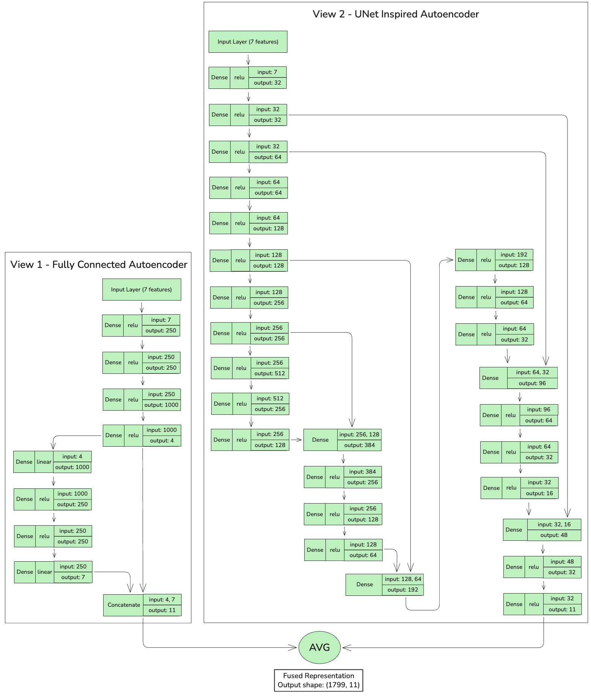
Figure 1: Overall architecture of the dual-view autoencoders (Fully-Connected and U-Net-Inspired)
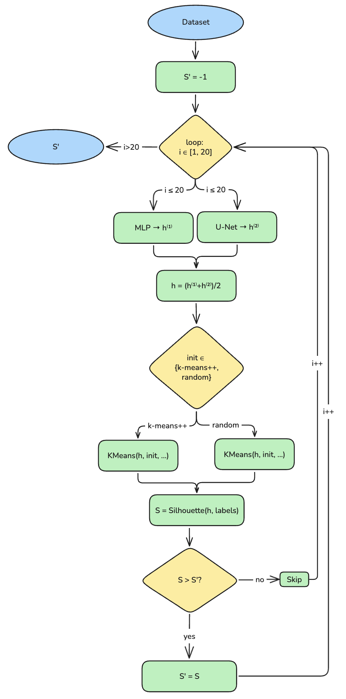
Figure 2: Workflow for deriving the Silhouette Baseline from fused embeddings.

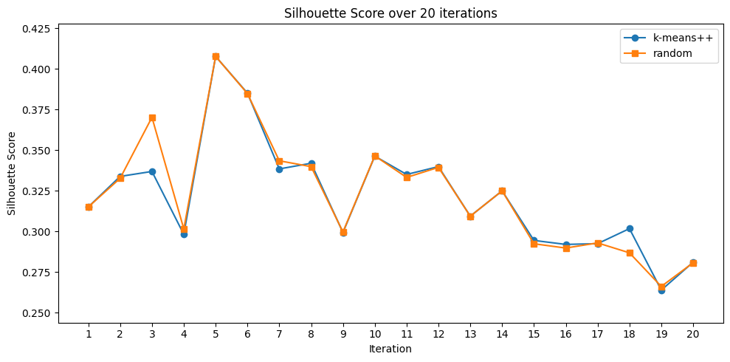
Figure 3: Silhouette scores over 20 runs on the Tiki dataset with K-Means on fused embeddings.
3.3.2 Mining Maximal-Itemset–Derived Binary Features via FP-Max
Upon obtaining the fused embedding space $\{h_{i}\}_{i=1}^{n}$, where $h_{i}∈R^{d}$, we enrich the representation by generating binary features derived from frequently co-occurring patterns (Figure 4). This pipeline comprises three sequential steps: discretizing $h_{i}$, applying binary encoding to construct transactions, and subsequently mining maximal frequent itemsets via the FP-Max algorithm.
Figure 4: Pipeline to derive binary features from fused embeddings

Step 1. Continuous Space Discretization: Each coordinate $h_{ij}$ of $h_{i}$ is mapped into categorical levels utilizing a K-Bins Discretizer. We evaluate three binning strategies (uniform, quantile, and k-means) along with the number of bins $∈\{3, 5, 7\}$. This procedure yields a categorical label matrix $D=\left[d_{ij}\right]$.
Step 2. Binary Encoding: From matrix $D$, one-hot encoding is applied to each categorical level to derive the binary matrix $B={\left[b_{i}\right]}_{i=1}^{n}∈\{0,1\}^{n×m}$, where $b_{i}$ denotes a "transaction" vector comprising $m$ items.
Step 3. Maximal Frequent Itemset Mining: The FP-Max algorithm is executed on the transaction set $\{b_{i}\}$ to identify itemsets $I_{j}$ that satisfy the minimum support threshold $θ$:
$$support\left(I_{j}\right)=\frac{\left|\{i:I_{j}⊆b_{i}\}\right|}{n}≥θ, θ∈\{0.10,0.15,…,0.60\}.$$ | (5)
Step 4. Binary Feature Generation: For each maximal frequent itemset $I_{j}$, a corresponding binary feature is defined, culminating in the feature set $\{f_{j}\}_{j=1}^{p}$. These features directly encode statistically significant co-occurring patterns intrinsic to the data. In the subsequent phase (Section 3.3.3), we combine $f_{j}$ with the fused embedding $h_{i}$ and employ Forward Feature Selection (FFS) to retain only the binary features that genuinely enhance clustering quality relative to the Silhouette baseline.
$$f_{j}\left(b_{i}\right)=\left\{\begin{aligned}1, I_{j}⊆b_{i} \\ 0, otherwise\end{aligned}\right.$$ | (6)
3.3.3 Forward Feature Selection in the Binary-Enhanced Embedding Space
Subsequent to the generation of binary features $f_{j}$ via the FP-Max step, not all of these features contribute positively to clustering efficacy. Consequently, we deploy Forward Feature Selection (FFS) on the fused embedding $h_{i}$ and the binary features $f_{j}$. The primary objective of this phase is to select a subset of binary features that genuinely enhance the Silhouette score relative to the baseline $S^{'}$ established in Section 3.2.1.
Forward Feature Selection (FFS) process: In the initial iteration, the baseline value $S^{'}$ is initialized using the Silhouette Score achieved by K-Means on the fused embedding in Section 3.2.1. Subsequently, each candidate binary feature $f_{j}$ is temporarily appended to the current representational space, forming the augmented data matrix:

$$H^{\left(t\right)}∈R^{n×\left(d+t\right)}$$ | (7)
where $d$ denotes the initial dimensionality of the fused embedding and $t$ represents the number of binary features selected up to the current iteration.
The entire augmented dataset $H^{\left(t\right)}$ is subsequently re-clustered utilizing the K-Prototypes algorithm, employing the Gower distance based on the dissimilarity formulation to concurrently process both continuous and binary features. We experiment with two initialization strategies, namely "huang" and "cao", to ensure the attainment of optimal clustering quality.
Update evaluation criteria: Following each K-Prototypes clustering iteration, the Silhouette score of the augmented space is computed as follows:
$$S^{\left(t\right)}=Silhouette\left(H^{\left(t\right)},\text{labels}\right)$$ | (8)
The feature $f_{j}$ is exclusively retained if $S^{\left(t\right)}>S^{'}$, indicating that it enhances clustering efficacy relative to the current baseline. Upon satisfying this condition, the value of $S^{'}$ is updated to $S^{\left(t\right)}$ to reflect the new performance benchmark for the subsequent iteration. Conversely, if $S^{\left(t\right)}≤S^{'}$, the respective binary feature is discarded. This iterative process proceeds until no remaining binary features can yield further improvements to the Silhouette score.
Final result: Following the FFS procedure, the final representational space is defined as:
$$H^{\text{final}}=\left[ h_{i} ∥ f_{j_{1}},f_{j_{2}},…,f_{j_{t^{*}}} \right],$$ | (9)
where $t^{*}$ denotes the total number of selected binary features.
This representational space is subsequently utilized for the final clustering phase, enabling the model to achieve an optimal Silhouette score and the most stable cluster structure. The comprehensive FFS procedure is illustrated in Figure 5.
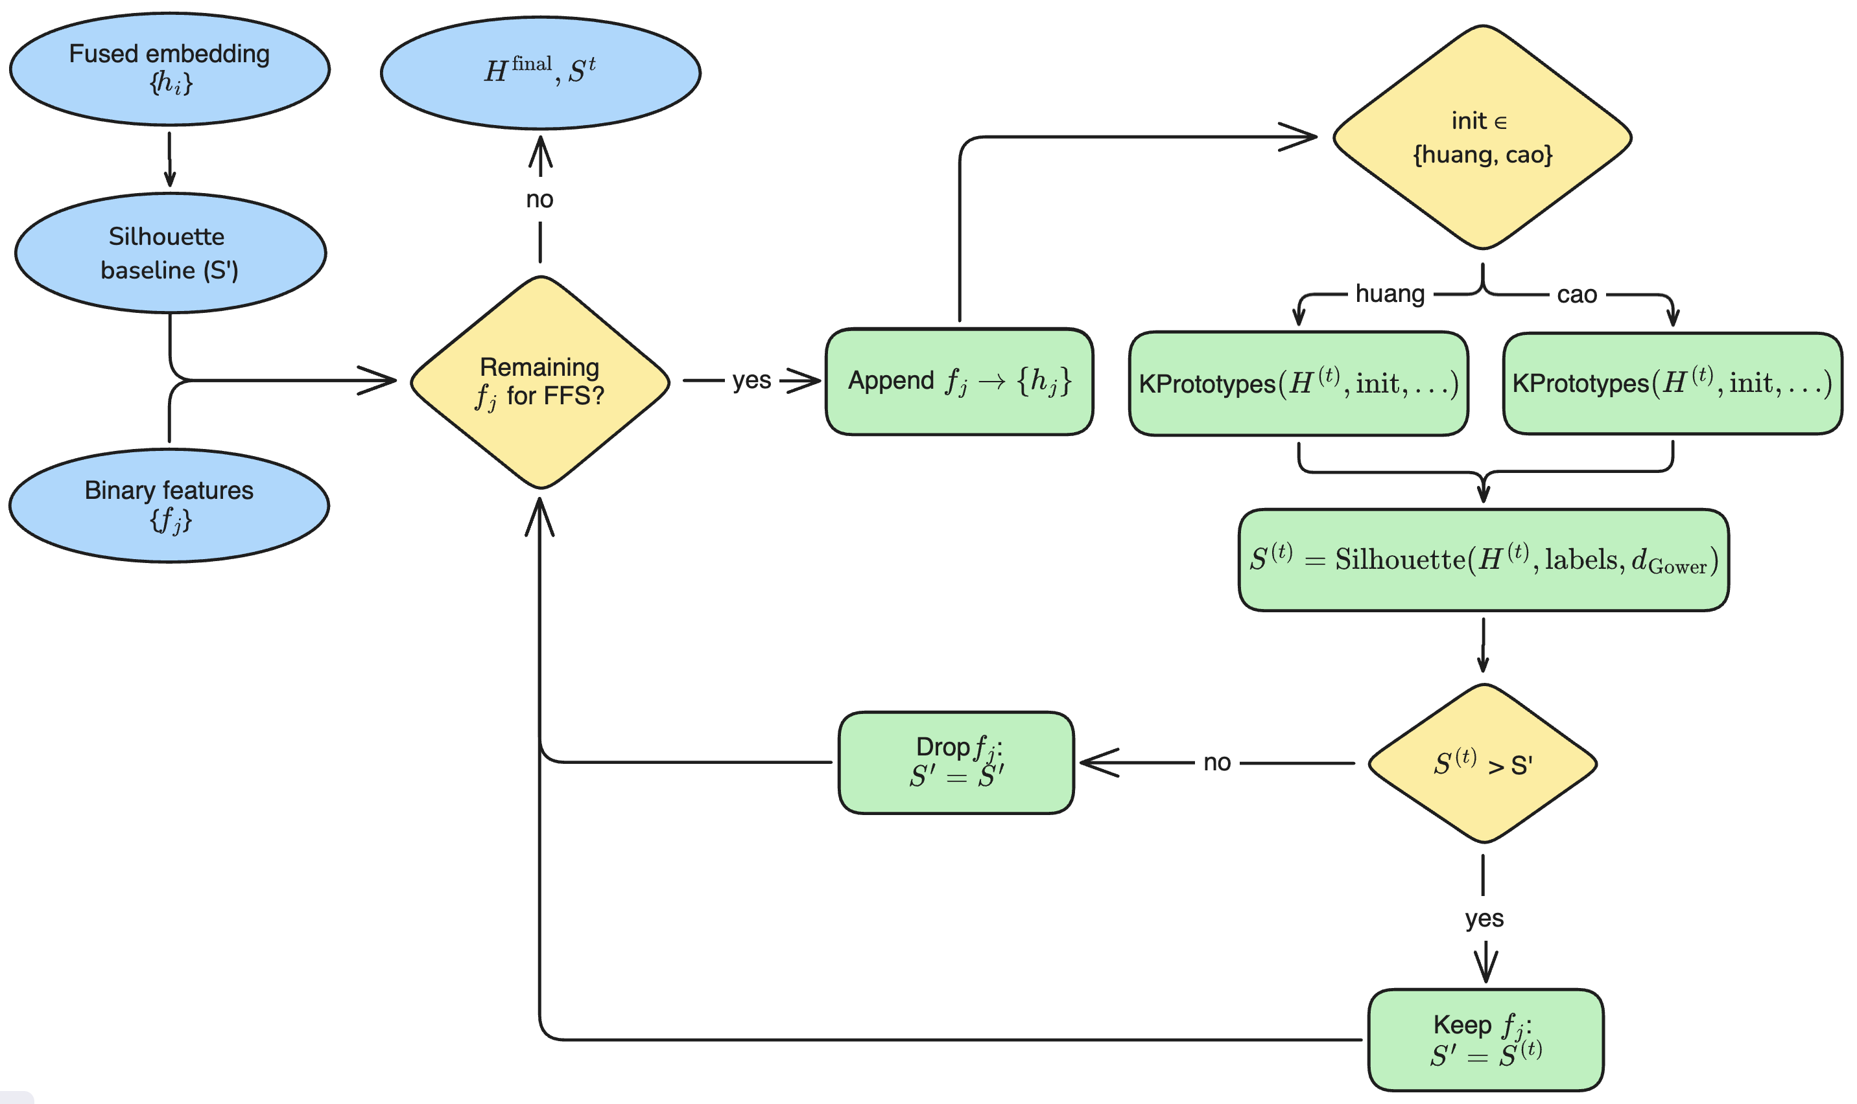
Figure 5: Process of integrating binary features through Forward Feature Selection.
- Performance Evaluation on the Air Pollution Dataset
To evaluate the empirical performance of the proposed method, we conducted experiments on the Luxembourg air pollution dataset (Kassem et al., 2025), with the number of clusters set to $k=4$. The clustering performance is measured utilizing the Silhouette score.
The evaluated methods encompass the following:
- K-Means: The traditional K-Means clustering algorithm.
- DEKM: Deep Embedded K-Means Clustering [4].
- MvDEC (single-view): Multi-view Deep Embedded Clustering applied to a single view [5].
- MvDEC (multi-view): Multi-view Deep Embedded Clustering utilizing multiple views [5].
- MiMvDEC (without FFS): An extended variant of MvDEC that incorporates binary features derived from FP-Max but omits the Forward Feature Selection process.
- MiMvDEC (Maximal-itemset Multi-view Deep Embedded Clustering): The proposed method, which integrates MvDEC with binary features derived from FP-Max and the Forward Feature Selection process.
Table 1: Comparison of Silhouette Scores Among Clustering Models on the Air Pollution Dataset
Model | K-Means | DEKM | MvDEC (single-view) | MvDEC  (multi-view) | MiMvDEC (without FFS) | MiMvDEC
Silhouette | 28.29 | 50.48 | 52.76 | 61.97 | 71.04 | 71.04

The results presented in Table 1 demonstrate that the traditional K-Means method achieves a Silhouette score of merely 28.29, reflecting its pronounced limitations in processing the complex cluster structures inherent in high-dimensional and heterogeneous data. Deep learning approaches, namely DEKM and MvDEC (multi-view), yielded substantial improvements, attaining scores of 50.48 and 61.97, respectively. The incorporation of binary features derived from FP-Max (MiMvDEC) further elevated the performance to 71.04, thereby substantiating the value of enriching the representational space with frequently co-occurring patterns.
- Case Study: E-Commerce Store Clustering
To validate the practical applicability of the proposed methodology, we conducted an empirical study on a dataset comprising 1,994 storefronts operating on Tiki, a prominent e-commerce platform in Vietnam. The primary objective is to uncover latent group structures among these stores based on their operational characteristics, thereby facilitating market segmentation, the optimization of marketing policies, and the formulation of strategic business recommendations.
5.1 Data Collection
The data acquisition process was conducted between January and March 2025 utilizing the Selenium framework, which facilitated the automated and systematic extraction of information from the Tiki.vn website. Each storefront within the dataset is characterized by a set of quantitative and qualitative features that reflect its operational behavior, popularity, and review quality. A comprehensive list of the primary features is delineated in Table 2.

Table 2: List of Features Collected from Tiki.vn Platform
Feature | Description
Seller Link | Path to the store (URL)
Store Categories | Store product categories
Product Link | Path to the products (URL)
Year Joined | Number of years the store has been selling on the Tiki platform
Average Rating | Average star rating of the store (on a 5-star scale)
Review Count | Number of reviews used to calculate the average rating
Followers | Number of users following the store's products
Total Review | Total number of 1- to 5-star reviews received by the store
One Star | Total number of 1-star reviews
Two Star | Total number of 2-star reviews
Three Star | Total number of 3-star reviews
Four Star | Total number of 4-star reviews
Five Star | Total number of 5-star reviews
Price | Price of each product
Quantity Sold before | Sales quantity of each product at the initial time point
Quantity Sold after | Sales quantity of each product after more than one month

5.2 Data Preprocessing
5.2.1 Data Cleaning
Data records exhibiting a high proportion of missing values, inconsistencies, or duplications were eliminated from the dataset. Additionally, categorical feature columns were temporarily excluded; these can be subsequently remapped onto the resulting clusters to facilitate more in-depth downstream analysis.
    - Feature Selection
Revenue Estimation: To approximate the revenue generated by each storefront over a one-month operational period, we rely on the differential in sales volume between two distinct observation points. Specifically, for each product $i$ associated with storefront $j$, the incremental revenue is computed according to the following formulation:
$$R_{ij}=\left(Q_{ij}^{\text{after}}-Q_{ij}^{\text{before}}\right)×P_{ij}$$ | (10)

where $Q_{ij}^{\text{after}}$ denotes the cumulative quantity of product $i$ sold after a one-month period, $Q_{ij}^{\text{before}}$ represents the quantity of product $i$ sold at the initial observation point, and $P_{ij}$ indicates the unit price of product $i$ at storefront $j$.
The total estimated revenue for storefront $j$, denoted as ${\text{Revenue}}_{j}$, is calculated by aggregating the incremental revenues across all products associated with that storefront:
$${\text{Revenue}}_{j}=\sum_{i=1}^{n_{j}}{R_{ij}}$$ | (11)

Upon computation, the $Revenue$ variable is generated to store the estimated revenue for each storefront. Intermediate columns, including $Price$, $Quantity Sold before$, and $Quantity Sold after$, are subsequently discarded to streamline the output dataset.
Wilson Score Lower Bound: In the context of online storefront analysis and clustering, the star rating proportion (1–5) serves as a crucial metric reflecting customer satisfaction. However, for storefronts with a sparse number of reviews, a 100% 5-star rating proportion can introduce statistical bias. To mitigate this issue, we employ the Wilson Score Lower Bound—a method for calculating the lower bound of the confidence interval for a success proportion in a binomial distribution, which intrinsically accounts for sample size. Assuming a 95% confidence level, the Wilson formulation is applied as follows:
$$\text{WSLB}=\frac{\hat{p}+\frac{z^{2}}{2n}-z\sqrt{\frac{\hat{ p}\left(1-\hat{p}\right)}{n}+\frac{z^{2}}{4n^{2}}}}{1+\frac{z^{2}}{n}}$$ | (12)
where $\hat{p}$ denotes the observed proportion of reviews (positive/negative/neutral), $n$ represents the total number of reviews, and $z ≈1.96$ is the z-score associated with a 95% confidence level.
This methodology is applied independently to three distinct review categories: Good Reviews (4–5 stars), Medium Reviews (3 stars), and Bad Reviews (1–2 stars). The resultant values are mapped to three corresponding new variables: Good Review Ratio, Medium Review Ratio, and Bad Review Ratio. Furthermore, we formulate an additional Rating Quality index to reflect the reliability of the average star rating. Specifically, the star rating is normalized to the $\left[0,1\right]$ interval, the Wilson formulation is applied utilizing the total review count, and the outcome is subsequently rescaled back to the 1–5 scale. Following this processing phase, the original columns, such as Rating, Review Count, Total Review, and the detailed counts for 1–5 star reviews, are discarded to ensure the compactness and efficiency of the input feature set.
    - Data Normalization
All continuous features are standardized via StandardScaler [29] to achieve a uniform scale (with a mean of 0 and a standard deviation of 1). This procedure eliminates unit discrepancies across variables, thereby ensuring that distance computations within the clustering algorithms proceed with enhanced accuracy and stability.
    - Outlier Handling
Following standardization, the dataset undergoes a two-step cleaning process. Initially, Winsorization [30] is employed to cap extreme values at a 5% threshold, mitigating the adverse influence of anomalous data points while preserving the overarching global structure. Subsequently, we apply the DBSCAN algorithm [31] to detect and eliminate isolated noise points that do not correspond to any defined cluster, ultimately augmenting the reliability of the clustering phase.
    - Determining the Optimal Number of Clusters
The determination of the optimal number of clusters, $k$, is established based on the Silhouette score to ensure the quality and separability of the clusters. For the Luxembourg air pollution dataset, we set $k=4$ in accordance with the validated configuration from the original study by Kassem et al. [5], which aligns with the data structure and facilitates direct comparisons with the baseline models.
Regarding the Tiki storefront dataset, we conducted systematic experiments with $k$ ranging from 3 to 10, incorporating two centroid initialization strategies (random and k-means++). Each configuration was executed over multiple iterations and evaluated via the average Silhouette score computed within the fused embedding space. The empirical results demonstrate that the optimal performance is attained at $k=5$ utilizing the k-means++ initialization strategy (Figure 6). Consequently, this specific value of $k=5$ is held constant across all subsequent experiments conducted on the Tiki dataset.
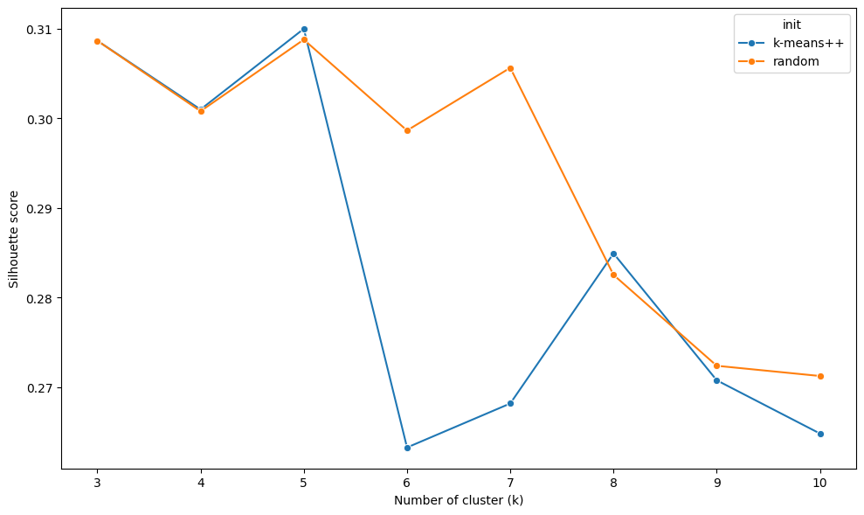
Figure 6: Optimal number of clusters and initialization method for K-Means
5.2.6 Preprocessed Dataset
Subsequent to the preprocessing and parameter selection phases, the input dataset comprises 1,799 storefronts characterized by 7 standardized and cleaned continuous features, rendering it primed for advanced clustering procedures and detailed cluster analysis. Table 3 delineates the feature descriptions, Table 4 presents the dataset prior to standardization, whereas Table 5 exhibits the dataset post-standardization.
Table 3: Explaination of Tiki Dataset
Feature | Description
Year Joined | Number of years the store has been operating on the Tiki platform.
Followers | Number of users following the store's products on the Tiki platform.
Rating Quality | Reliability-adjusted average star rating using WSLB to mitigate bias from low review volumes.
Revenue | Estimated monthly revenue (in VND) based on the increase in sold quantities across products between two observation points, multiplied by product prices.
Good Review Ratio | Proportion of positive reviews, adjusted using WSLB for statistical reliability.
Med Review Ratio | Proportion of neutral reviews, adjusted using WSLB for statistical reliability.
Bad Review Ratio | Proportion of negative reviews, adjusted using WSLB for statistical reliability.

Table 4: Tiki Dataset before normalization
Year Joined | Rating Quality | Followers | Revenue | Good Review Ratio | Med Review  Ratio | Bad Review Ratio
8 | 4.377676 | 1700 | 99846090 | 0.890341 | 3.783e-02 | 5.460e-02
2 | 3.859082 | 56 | 8801050 | 0.547854 | 3.101e-02 | 3.101e-02
6 | 4.341414 | 834 | 163114611 | 0.893567 | 8.923e-03 | 6.107e-02
5 | 4.018280 | 45 | 455000 | 0.438503 | 4.868e-17 | 4.868e-17
4 | 3.992363 | 36 | 1506000 | 0.803386 | 7.344e-03 | 3.718e-02

Table 5: Tiki Dataset after normalization
Year Joined | Rating Quality | Followers | Revenue | Good Review Ratio | Med Review  Ratio | Bad Review Ratio
0.060135 | 0.008283 | 1.806134 | 0.453583 | 0.631159 | 1.618767 | 1.080557
-0.07121 | -0.04745 | -1.81475 | 0.037897 | -0.49766 | 1.196371 | 0.308262
-0.00905 | 0.008283 | 0.599174 | 0.424516 | 0.64179 | -0.17215 | 1.292087
-0.04644 | 0.008283 | 0.599174 | -0.06668 | -0.09694 | 0.975558 | 1.761924
-0.07281 | -0.05365 | -0.60779 | 0.14473 | 0.34456 | -0.26997 | 0.50995

  - Evaluation
Table 6 presents the comparative results among the evaluated models. The traditional K-Means method achieves a Silhouette score of merely 30.99, demonstrating its limitations in processing complex and heterogeneous data. MvDEC exhibits a pronounced improvement, reaching a score of 40.97 by exploiting deep multi-view representations. Upon the incorporation of binary features derived from FP-Max, MiMvDEC (without FFS) attains a score of 50.86, thereby corroborating the benefits of enriching the representational space. Notably, our proposed method, MiMvDEC, achieves the highest Silhouette score of 55.79, significantly outperforming the other baselines. These findings affirm that the integration of maximal frequent itemset mining (FP-Max) and forward feature selection (FFS) substantially enhances the separability of storefront clusters within the Tiki dataset. Furthermore, they demonstrate the efficacy and practical applicability of the proposed methodology in market segmentation and the optimization of e-commerce operations.
Table 6: Comparison of Silhouette Scores Among Clustering Models on the Tiki Dataset
Model | K-Means | MvDEC | MiMvDEC (without FFS) | MiMvDEC  (our method)
Silhouette | 30.99 | 40.97 | 50.86 | 55.79

We performed a sensitivity analysis on the parameters $min_{s}upport$, binning strategies (uniform, quantile, k-means), and the number of bins (3, 5, 7) across the entire pipeline (mining and FFS) to ascertain the optimal configuration that yields the highest clustering quality. The final Silhouette scores obtained post-FFS are illustrated in Figure 7. The visualization demonstrates that, for the Tiki dataset, the optimal performance is achieved utilizing $n_{\text{bins}}=3$, the quantile binning strategy, and a $min_support$ threshold of 0.15.
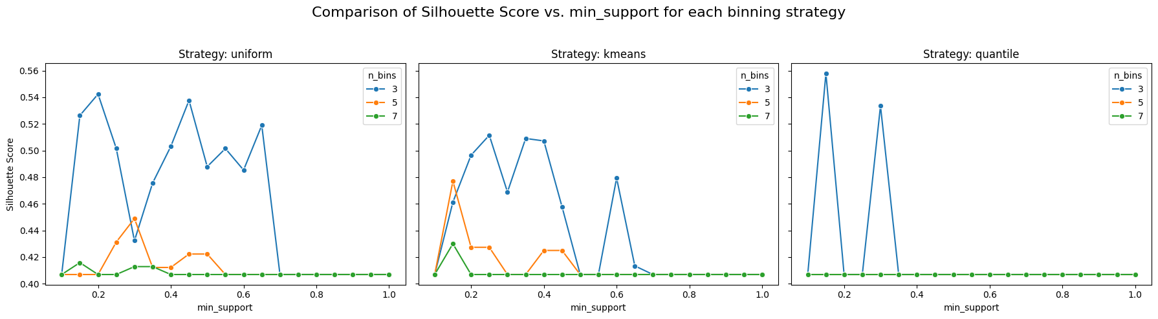
Figure 7: Final Silhouette Score after Forward Feature Selection as a function of min_support for three binning strategies (uniform, k-means, quantile) with n_{\mathrm{bins}}=3,\ 5,\ 7 on the Tiki dataset.
  - Cluster visualization
To visualize the clustering results and verify the separability among the groups, we applied two dimensionality reduction techniques: Principal Component Analysis (PCA) and t-distributed Stochastic Neighbor Embedding (t-SNE) in both two-dimensional (2D) and three-dimensional (3D) spaces. PCA projects the data onto a linear space that maximizes variance, whereas t-SNE prioritizes the preservation of local structures and is highly suitable for clusters exhibiting non-linear shapes. Both methods were executed on the fused embedding representational space (comprising 11 features: 7 original features derived from the initial dataset and 4 latent features extracted from the MvDEC autoencoder), utilizing the cluster labels from the configuration that yielded the highest Silhouette score (Figure 7).

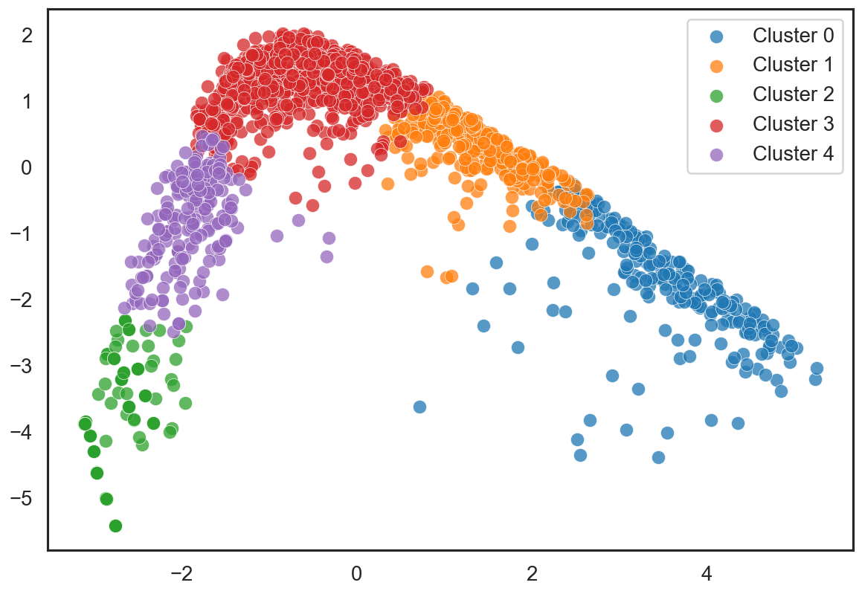  Figure 8: 2D Visualization of Clusters using PCA |  | 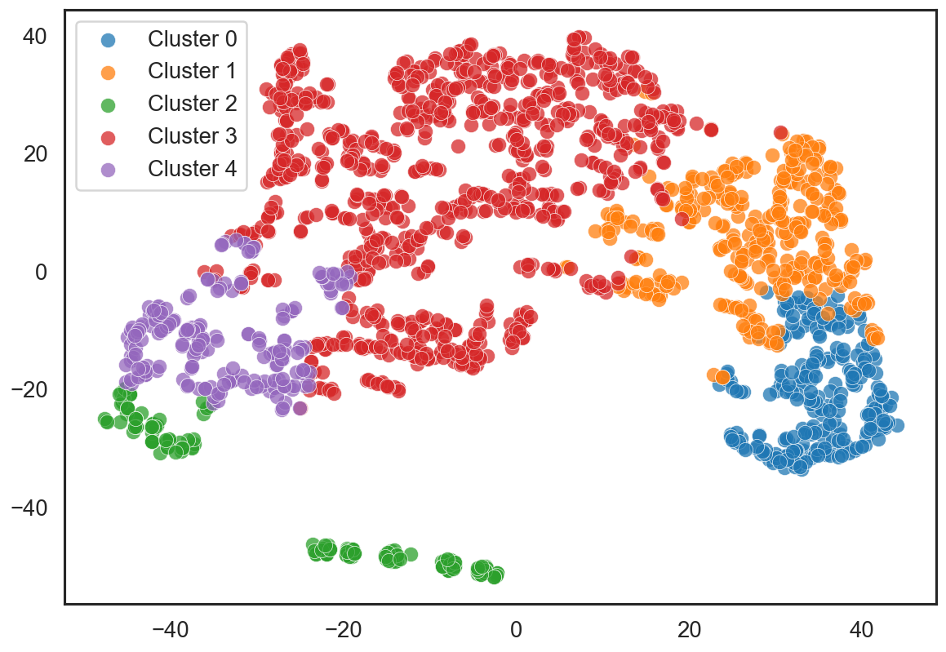  Figure 9: 2D Visualization of Clusters using t-SNE
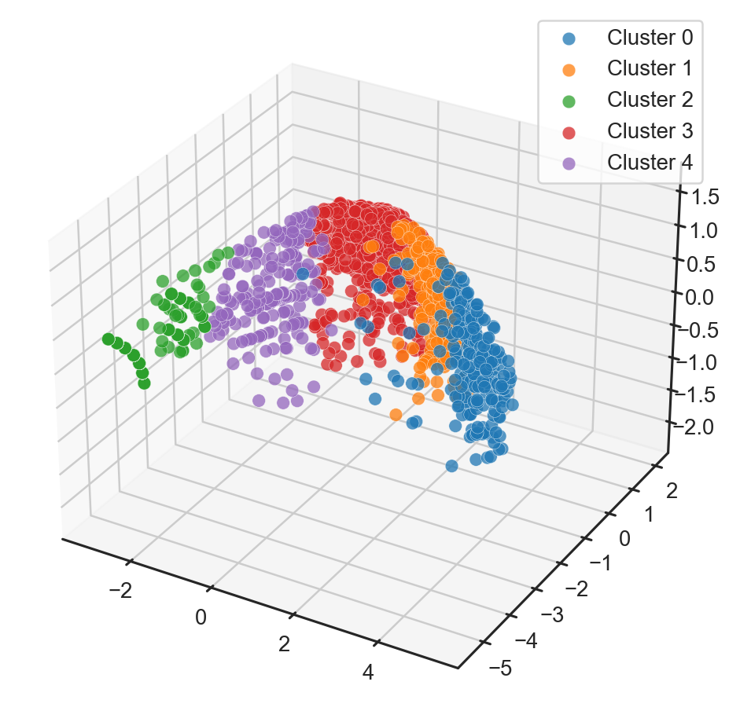  Figure 10: 3D Visualization of Clusters using PCA | 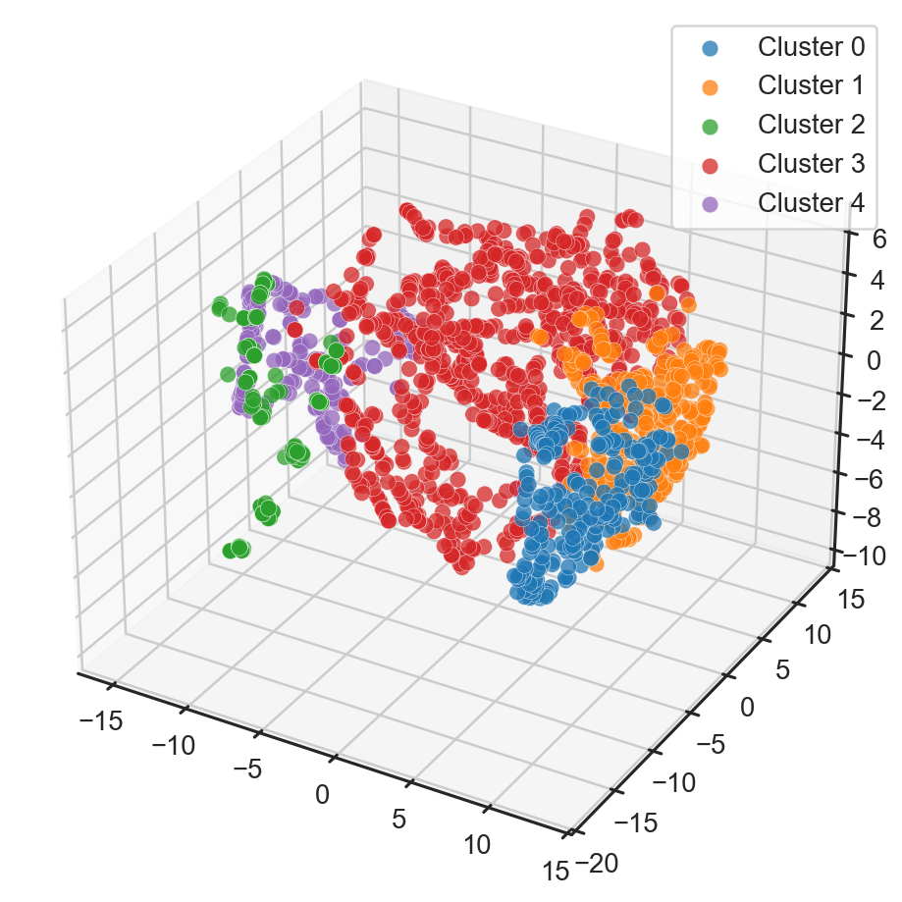  Figure 11: 3D Visualization of Clusters using t-SNE
The PCA results (Figures 8 and 10) indicate relatively distinct cluster separations. Notably, Cluster 2 (green) is entirely isolated in the lower-left quadrant, whereas Cluster 3 (red), being the largest cluster, is concentrated at the top, forming a curved arc. In the 3D space, the clusters are arranged along a continuous arc-like structure, with Cluster 0 (blue) positioned at one extremity and Cluster 2 (green) at the other.
Conversely, the t-SNE visualizations (Figures 9 and 11) provide a more granular depiction of density and intra-cluster distances. Cluster 2 (green) exhibits pronounced compactness, comprising two distinct sub-groups of points. Cluster 0 (blue) and Cluster 4 (purple) display high density with well-defined boundaries. In contrast, Cluster 3 (red) tends to be widely dispersed and occupies the largest spatial area, reflecting a high degree of behavioral diversity within this specific group. In the 3D space, the t-SNE projection reveals that Cluster 3 forms a toroidal structure, encapsulating and intertwining with the other clusters, whereas Cluster 2 retains its compact and isolated nature on the left side.
  - Cluster Interpretation
To interpret the semantics of the clusters derived from the proposed method, our profiling analysis is conducted utilizing the original preprocessed dataset (Table 5). The utilization of the original data, as opposed to the latent embedding space or augmented binary features, ensures transparency, enhances interpretability, and establishes a direct linkage to the practical business metrics of the storefronts on the Tiki platform.
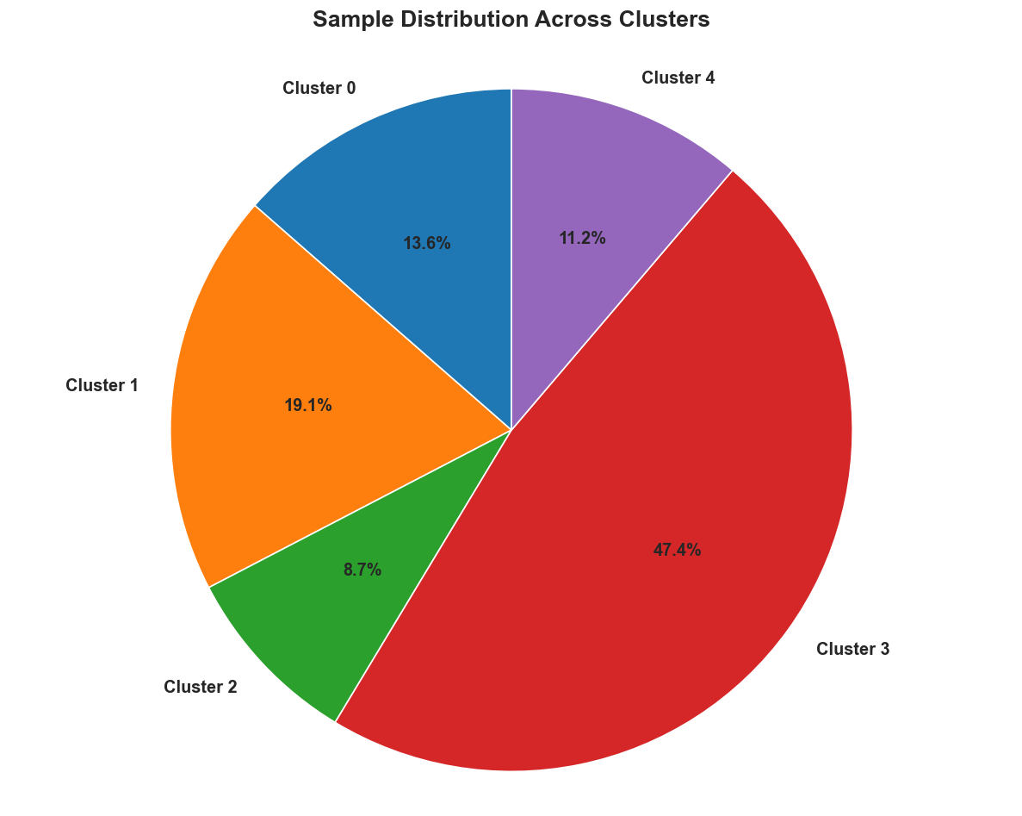
Figure 12: Percentage Distribution of Samples Across Clusters

The proportional distribution of samples across the clusters (Figure 12) reveals a pronounced imbalance: Cluster 3 encompasses the largest share (47.4%), whereas Cluster 2 represents the smallest fraction (8.7%). This distribution reflects the inherent diversity within the Tiki storefront ecosystem, characterized by a substantial cohort of stores exhibiting average performance metrics coupled with stable quality.
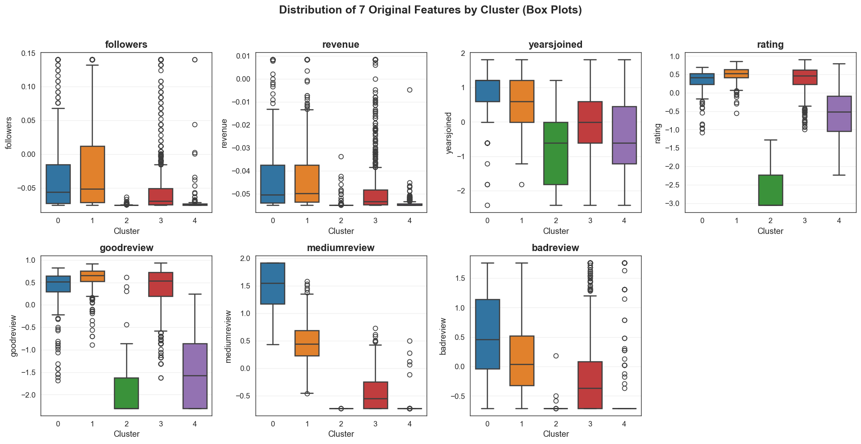
Figure 13: Distribution of Quantitative Features Across Clusters
Derived from the boxplots depicting the distribution of continuous features (Figure 13), we interpret each cluster as follows, with a specific focus on the median, interquartile range (IQR), and outliers to elucidate their defining characteristics:
- Cluster 0 – High-Engagement Established Stores with Mixed Feedback (13.6%): This cluster is distinguished by the highest values for Followers, Revenue, and Year Joined (characterized by elevated medians and numerous positive outliers), signifying a cohort of long-standing storefronts with robust customer engagement and substantial revenue generation. Regarding quality metrics, the Rating Quality and Good Review Ratio maintain high levels; concurrently, the Medium Review Ratio and Bad Review Ratio are also the highest among all clusters (exhibiting a wide IQR). This variance reflects a highly diverse spectrum of customer experiences, a phenomenon frequently associated with large-scale operations.
  - Strategic Recommendations: Priority should be given to sustaining customer loyalty via VIP programs or co-branding partnerships. Efforts must be concentrated on mitigating bad reviews through the implementation of real-time feedback monitoring systems and overarching service enhancements (e.g., logistics, customer support). Given this group's potential for significant revenue contribution, the allocation of premium advertising resources is highly advised.
- Cluster 1 – Top-Performing Premium Stores (19.1%): Analogous to Cluster 0, this group exhibits elevated metrics for Followers, Revenue, and Year Joined (evidenced by numerous positive outliers); however, it demonstrates distinct superiority in Rating Quality and Good Review Ratio (achieving the highest medians across all clusters), coupled with a substantially lower Bad Review Ratio. This cohort represents long-standing storefronts that consistently deliver peak operational performance and exceptional service quality.
  - Strategic Recommendations: These storefronts should be leveraged as "best practice" benchmarks for the broader ecosystem. It is advisable to establish strategic partnership programs or premium loyalty initiatives to solidify their market-leading position. Marketing campaigns should explicitly underscore their prestige and reliability (e.g., via case studies and testimonials) to effectively attract high-tier clientele.
- Cluster 2 – Struggling New Stores with Poor Performance (8.7%): This cluster registers the lowest values across the majority of features, characterized by minimal Followers, Revenue, and Year Joined. Furthermore, it demonstrates a low median for Rating Quality and the minimum values for both Good Review Ratio and Medium Review Ratio, accompanied by a disproportionately high Bad Review Ratio (notwithstanding a low overall interaction volume). This cohort represents newly established storefronts facing systemic challenges in both operational performance and service quality.
  - Strategic Recommendations: Immediate remedial interventions are imperative. These should encompass in-depth training programs (e.g., customer service and product management) alongside incubation support packages (e.g., complimentary advertising credits and logistics consulting). Rigorous monitoring is essential to mitigate seller churn, coupled with the deployment of aggressive promotional campaigns to stimulate store activity.
- Cluster 3 – Large Moderate Stores with Strong Quality (47.4%): As the most populous cluster, this group is characterized by low-to-moderate Followers and Revenue, alongside an average Year Joined. However, it exhibits a remarkably high Rating Quality and Good Review Ratio, coupled with minimal Bad Review Ratio and Medium Review Ratio. This cohort represents storefronts that deliver superior service quality but have yet to fully capitalize on their commercial potential.
  - Strategic Recommendations: Efforts should be concentrated on accelerating growth through targeted activation campaigns (e.g., personalized email/push notifications, strategic discounts, and product expansion suggestions). Providing advanced data analytics tools and platform-integrated advertising features is essential to enhance their market visibility. This cluster represents a significant opportunity to elevate Tiki's aggregate revenue without requiring extensive investment in quality improvement.
- Cluster 4 – Emerging Stores with Low Activity and Minimal Feedback (11.2%): This cluster is characterized by low values across Followers, Revenue, Year Joined, Rating Quality, and Good Review Ratio. Notably, it exhibits a very low Bad Review Ratio, primarily attributable to the limited volume of customer interactions. This cohort represents early-stage storefronts with low operational performance that have yet to accumulate significant negative feedback—a nascent phase where their full potential remains latent.
  - Strategic Recommendations: Support for initial development is crucial, encompassing structured onboarding programs, product listing optimization tools, and fundamental marketing assistance. It is essential to incentivize the collection of positive reviews to establish early-stage credibility, thereby preventing these stores from regressing into a struggling state similar to Cluster 2.
- Conclusion
In this study, we proposed MiMvDEC, a novel framework that integrates Multi-view Deep Embedded Clustering (MvDEC) [5] with Maximal Frequent Itemset Mining utilizing the FP-Max algorithm. This approach aims to enhance clustering quality when dealing with complex, high-dimensional, and heterogeneous data. By enriching the fused representational space with binary features extracted from maximal frequent itemsets—refined through a rigorous Forward Feature Selection process—the proposed methodology not only significantly improves cluster separability but also provides enhanced interpretability by exploiting semantically meaningful co-occurrence patterns within the data.
Empirical results across two real-world datasets confirm the superior efficacy of the proposed methodology. On the Luxembourg air pollution dataset, MiMvDEC achieved a Silhouette score of 71.04, significantly surpassing the original MvDEC (61.97) and other baseline methods. Most notably, on the Tiki e-commerce dataset comprising 1,799 samples and 7 primary features, our method attained a peak Silhouette score of 55.79, outperforming both the standard MvDEC (40.97) and the variant without FFS (50.86). Visualization analyses utilizing PCA and t-SNE, coupled with the detailed interpretation of the five identified clusters, demonstrate the model's capability to detect distinct business behavioral patterns. These findings provide a robust foundation for market segmentation strategies, personalized marketing, logistics optimization, and the promotion of sustainable growth within e-commerce platforms.
In summary, MiMvDEC not only offers a significant technical contribution to the field of multi-view deep embedded clustering but also demonstrates substantial practical utility within e-commerce environments. Future research directions may encompass: (1) Extending the integration to other frequent itemset mining algorithms or scaling to larger datasets; (2) Incorporating semi-supervised learning mechanisms to leverage partially labeled data; and (3) Implementing the framework on real-time e-commerce platforms to facilitate dynamic decision-making. These advancements promise to further enhance the capability to extract latent structures from complex data, delivering tangible benefits across various application domains.

REFERENCES

[1] | L. Ding, C. Li, D. Jin and S. Ding, "Survey of spectral clustering based on graph theory," Pattern Recognition, vol. 151, p. 110366, 2024.
[2] | Y. Wang, J. Qian, M. Hassan, X. Zhang, T. Zhang, C. Yang, X. Zhou and F. Jia, "Density peak clustering algorithms: A review on the decade 2014–2023," Expert Systems with Applications, vol. 238, p. 121860, 2024.
[3] | H. Yin, A. Aryani, S. Petrie, A. Nambissan, A. Astudillo and S. Cao, "A Rapid Review of Clustering Algorithms," arXiv preprint arXiv:2401.07389, 2024.
[4] | W. Guo, K. Lin and W. Ye, "Deep Embedded K-Means Clustering," in In 2021 International Conference on Data Mining Workshops (ICDMW), 2021, December.
[5] | H. Kassem, S. El Hajjar, F. Abdallah and H. Omrani, "Multi-view Deep Embedded Clustering: Exploring a new dimension of air pollution," Engineering Applications of Artificial Intelligence, vol. 139, p. 109509, 2025.
[6] | O. Ronneberger, P. Fischer and T. Brox, "U-net: Convolutional networks for biomedical image segmentation," in In International Conference on Medical image computing and computer-assisted intervention, 2015, October.
[7] | P. Fournier‐Viger, J. C. W. Lin, B. Vo, T. T. Chi, J. Zhang and H. B. Le, "A survey of itemset mining," Wiley Interdisciplinary Reviews: Data Mining and Knowledge Discovery, vol. 7, no. 4, p. e1207, 2017.
[8] | G. Grahne and J. Zhu, "High Performance Mining of Maximal Frequent Itemsets," in In 6th International workshop on high performance data mining, 2003, May.
[9] | F. Kamalov, S. Elnaffar, A. Cherukuri and A. Jonnalagadda, "Forward feature selection: empirical analysis," Journal of Intelligent Systems and Internet of Things, vol. 11, no. 1, pp. 44-54, 2024.
[10] | Z. Huang, "Clustering Large Data Sets with Mixed Numeric and Categorical Values," in In Proceedings of the First Pacific Asia Knowledge Discovery and Data Mining Conference, Singapore, 1997, July.
[11] | J. Xie, R. Girshick and A. Farhadi, "Unsupervised Deep Embedding for Clustering Analysis," in In International conference on machine learning, 2016, June.
[12] | Z. Wu, L. Jin, J. Zhao, L. Jing and L. Chen, "Research on Segmenting E-Commerce Customer through an Improved K-Medoids Clustering Algorithm," Computational Intelligence and Neuroscience, vol. 2022, no. 1, p. 9930613, 2022.
[13] | J. Huang, S. Gong and X. Zhu, "Deep Semantic Clustering by Partition Confidence Maximisation," in In Proceedings of the IEEE/CVF conference on computer vision and pattern recognition, 2020.
[14] | Z. Yu, Z. Dong, C. Yu, K. Yang, Z. Fan and C. P. Chen, "A review on multi-view learning," Frontiers of Computer Science, vol. 19, no. 7, p. 197334, 2025.
[15] | D. C. Attota, V. Mothukuri, R. M. Parizi and S. Pouriyeh, "An Ensemble Multi-View Federated Learning Intrusion Detection for IoT," IEEE Access, vol. 9, pp. 117734-117745, 2021.
[16] | T. Hussain, K. Muhammad, W. Ding, J. Lloret, S. W. Baik and V. H. C. De Albuquerque, "A comprehensive survey of multi-view video summarization," Pattern Recognition, vol. 109, p. 107567, 2021.
[17] | H. Xie, "Research and Case Analysis of Apriori Algorithm Based on Mining Frequent Item-Sets," Open Journal of Social Sciences, vol. 9, no. 4, pp. 458-468, 2021.
[18] | L. Shabtay, P. Fournier-Viger, R. Yaari and I. Dattner, "A guided FP-Growth algorithm for mining multitude-targeted item-sets and class association rules in imbalanced data," Information Sciences, vol. 553, pp. 353-375, 2021.
[19] | H. A. Alsaeedi and A. S. Alhegami, "An Incremental Interesting Maximal Frequent Itemset Mining Based on FP‐Growth Algorithm," Complexity, vol. 2022, no. 1, p. 1942517, 2022.
[20] | E. Kannout, M. Grzegorowski, M. Grodzki and H. S. Nguyen, "Clustering-Based Frequent Pattern Mining Framework for Solving Cold-Start Problem in Recommender Systems," IEEE Access, vol. 12, pp. 13678-13698, 2024.
[21] | M. Sinthuja, S. Pravinthraja, B. K. Dhanalakshmi, H. L. Gururaj, V. Ravi and G. J. Lal, "An efficient and resilience linear prefix approach for mining maximal frequent itemset using clustering," Journal of Safety Science and Resilience, vol. 6, no. 1, pp. 93-104, 2025.
[22] | Y. Gulzar, A. A. Alwan, R. M. Abdullah, A. Z. Abualkishik and M. Oumrani, "OCA: Ordered Clustering-Based Algorithm for E-Commerce Recommendation System," Sustainability, vol. 15, no. 4, p. 2947, 2023.
[23] | L. Wang and Y. Jiang, "Collocating Recommendation Method for E‐Commerce Based on Fuzzy C‐Means Clustering Algorithm," Journal of Mathematics, vol. 2022, no. 1, p. 7414419, 2022.
[24] | Y. Hu and R. Han, "An Improved Algorithm for Mining Maximal Frequent Patterns," in In 2009 International Joint Conference on Artificial Intelligence, 2009, April.
[25] | J. Ji, T. Bai, C. Zhou, C. Ma and Z. Wang, "An improved k-prototypes clustering algorithm for mixed numeric and categorical data," Neurocomputing, vol. 120, pp. 590-596, 2013.
[26] | B. H. Shekar and G. Dagnew, "Grid Search-Based Hyperparameter Tuning and Classification of Microarray Cancer Data," in In 2019 second international conference on advanced computational and communication paradigms (ICACCP), 2019, February.
[27] | Ö. Akay and G. Yüksel, "Akay, Ö., & Yüksel, G. (2018). Clustering the mixed panel dataset using Gower's distance and k-prototypes algorithms," Communications in Statistics-Simulation and Computation, vol. 47, no. 10, pp. 3031-3041, 2018.
[28] | K. R. Shahapure and C. Nicholas, "Cluster Quality Analysis Using Silhouette Score," in In 2020 IEEE 7th international conference on data science and advanced analytics (DSAA), 2020, October.
[29] | Z. L. Thakker and S. H. Buch, "Effect of Feature Scaling Pre-processing Techniques on Machine Learning Algorithms to Predict Particulate Matter Concentration for Gandhinagar, Gujarat, India," Int. J. Sci. Res. Sci. Technol, vol. 11, no. 1, pp. 410-419, 2024.
[30] | A. Abuzaid and E. Alkronz, "A comparative study on univariate outlier winsorization methods in data science context," Statistica Applicata-Italian Journal of Applied Statistics, vol. 36, no. 1, 2024.
[31] | D. Deng, "DBSCAN Clustering Algorithm Based on Density," in In 2020 7th international forum on electrical engineering and automation (IFEEA), 2020, September.

